**CSIS2270 - Lab #5**

20

***VLAN and Inter-VLANs Configurations***

**Name: Leandro Miranda Fahur Machado Student No.: 300326045**

**Introduction:** A Virtual LAN (VLAN) is a group of devices that are logically segmented by function, project team, or application, without regard to the physical locations of the users. In other words, VLANs are similar to physical LANs, but end stations can be grouped even if they are not physically located on the same LAN segment. A switch can be configured to support multiple VLANs, a VLAN can also be configured across multiple switches, and each VLAN is considered a logical network. Any broadcast packets are flooded only to end stations within a VLAN, and packets destined for stations that do not belong to the VLAN must be forwarded through a router.

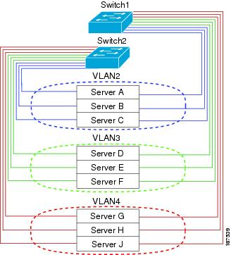The following figure shows VLANs as logical networks. In this diagram, the stations in the engineering department are assigned to one VLAN (VLAN2), the stations in the marketing department are assigned to another VLAN (VLAN3), and the stations in the finance department are assigned to yet another VLAN (VLAN4).

Figure 1

VLANs are usually associated with IP subnetworks such that all end stations in a particular VLAN belong to the same IP subnet. To communicate between VLANs, you must route the traffic through a router.

This lab is designed to provide you with hands-on experience on the design and configuration of VLANs, and you will learn how to configure and interconnect VLANS using Cisco switches and router.

**Objectives:**

1. To learn basic commands used in configuring Cisco switches.
2. To get familiar with the configuration of VLANs.
3. To have hands-on experience in setting up VLANs and inter-connecting VLANs using router.

**Equipment Required on the Cisco Packet Tracer program:**

1. Two PCs ( or more)
2. Cisco Router 1941
3. Cisco Switch 2960 (or 3560)
4. Straight Ethernet cables
5. Console cables

In this lab., you are required to set up two VLANs and to test the connectivity between them.

To setup the network,

* Connect your PC1 to port 1 of the Switch by using an Ethernet straight cable.
* Make sure that the firewall on the PC is switched off.
* To configure the switch, it is necessary to connect the PC to the switch by means of a console cable. Connect the Console cable to the RS 232 serial port of the PC and connect the other end of the cable to the Console port of the Switch)
* **DO NOT connect the switch to the router at this moment**.

**Part A. Configure VLANs on a single switch [_____/8]**

A network is given with a class B address 150.10.0.0, and it is required to set up a switch with 2 VLANs for the two departments in the company. Each VLAN will be associated with a separate subnet. The network should be configured based on the information given in Table 1. For this lab exercise, **only ten interface** ports will be assigned to each VLAN.

|  |  |  |  |  |  |  |
| --- | --- | --- | --- | --- | --- | --- |
| Dept. | VLAN ID | Switch ports | Subnet address | Subnet mask | Gateway address | Host addresses range |
| Engineering | VLAN 10 | fa0/1 – 10 | 150.10.10.0 | 255.255.255.0 | 150.10.10.254 | 150.10.10.1 - 253 |
| Marketing | VLAN 20 | fa0/11-20 | 150.10.20.0 | 255.255.255.0 | 150.10.20.254 | 150.10.20.1 - 253 |

Table 1

1. Use the Terminal on PC1 to configure the switch exactly like what you did in the previous lab when you configured the router (i.e go to the Terminal window on PC1 and make sure the bit per second rate is 9600 then click ok.) **(Alternatively, you can use the CLI on the switch itself)**
2. Click inside the Terminal command line window (the black one) and hit the enter key on your keyboard to get into the user mode and you will see the system prompt (*Switch>*) ***.*(Ignore this step if using CLI)**
3. The commands used for configuring the Cisco switches are very similar to those used for the routers. You can type “?” to get help on the commands available.
4. Switch configuration

1. To configure the switch, you must be in the *privilege exec mode*. Type enable to enter the privilege exec mode.

Switch>enable

1. Enter the global configuration mode.

Switch#config term

Switch(config)# Note the change in the system prompt

1. Change the hostname of the switch. Note the change in the system prompt.

Switch(config)#hostname Switch-A

Switch-A(config)#

1. Setup 2 VLANs.

Switch-A (config)#vlan 10

Switch-A (config-vlan)#name engineering Note the change in the system prompt

Switch-A (config-vlan)#exit

**Repeat the above steps to setup VLAN 20 for marketing in a similar way.**

1. Assign Ethernet interfaces to the VLANs.

Switch-A (config)#inter range fa0/1-10 (this will configure the ports from 1 to 10 all at once)

Switch-A (config-if)#switchport mode access

Switch-A (config-if)#switchport access vlan 10

Switch-A (config-if)#no shut

Switch-A (config-if)#exit

**Repeat these steps to configure interfaces (11-20) for VLAN 20 for marketing in a similar way.**

Note that to configure a single interface, you can use the command ***inter fa0/m*** where m is the interface number.

1. Exit the configuration mode and show the VLAN setup and running configuration to ensure the configurations you made are properly reflected on the system.

Switch-A (config)#exit

Switch-A #show vlan

Switch-A #show run

1. Testing the VLANs

To test the VLANs connectivity, you need PC1 and PC2 to be connected to the switch.

* Connect both PC1 and PC2 to VLAN 10, i.e. any port from 1 to 10 of Switch1. (Figure 2)

For each PC, assign a static IP address according to the information given in Table 1.  
For PC1 use IP address 150.10.10.1 with subnet mask 255.255.255.0, and gateway address 150.10.10.254. and for PC2 use IP address 150.10.10.2 with subnet mask 255.255.255.0, and gateway address 150.10.10.254. In general, you can assign any valid IP addresses from the range of host addresses shown in table 1. Write down the IP address of each PC.

|  |  |
| --- | --- |
|  | IP address |
| VLAN 10 (PC1) | **150.10.10.1** |
| VLAN 10 (PC2) | **150.10.10.2** |

* Can the two PCs on VLAN 10 ping each other? **Yes, they were able to ping each other.**
* Connect PC2 to VLAN 20, i.e. any port from 11 to 20. Assign a valid address to PC2 (Figure 3)
* What is the IP address you assigned to PC2 ? **150.10.20.2**
* Can PC1 and PC2 ping each other? **No, because they are in different VLANs.**
* If not, what is a possible reason that the ping is not successful? **In order for two different VLAN’s to communicate, they need a router to forward the packets from one another.**

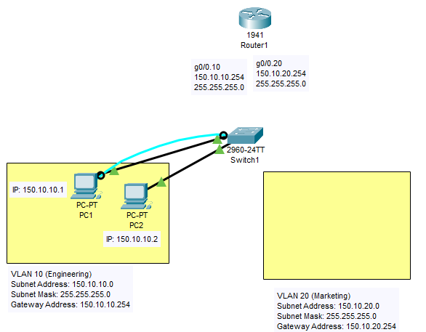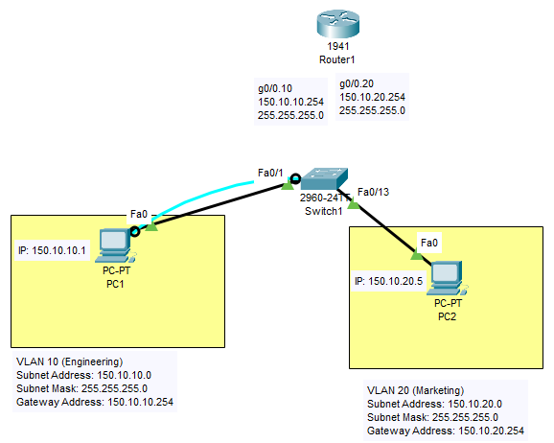

Figure 2 Figure 3

**Part B. VLAN Trunking [_____/6]**

As shown in Figure 1, a VLAN can be configured across multiple switches at different locations within a company. ***VLAN trunking*** is used to inter-connect the VLANs on a number of switches. A trunk is a point-to-point link between two network devices that carries packets from more than one VLAN. With VLAN trunking, you can extend your configured VLANs across the entire network. Most Cisco switches supports the IEEE 802.1Q protocol used to coordinate trunks on both FastEthernet and GigabitEthernet ports.

1. Configure port 23 on Switch1 as a trunk port for VLAN trunking.

Switch-A>enable

Switch-A#config term

Switch(config)#inter fa0/23

Switch-A (config-if)#switchport trunk encap dot1q (this line is required if you use switch 3560   
 and it can be skipped if 2960 switch is used)

Switch-A (config-if)#switchport mode trunk

Switch-A (config-if)#switchport trunk allowed vlan all

Switch-A (config-if)#exit

1. 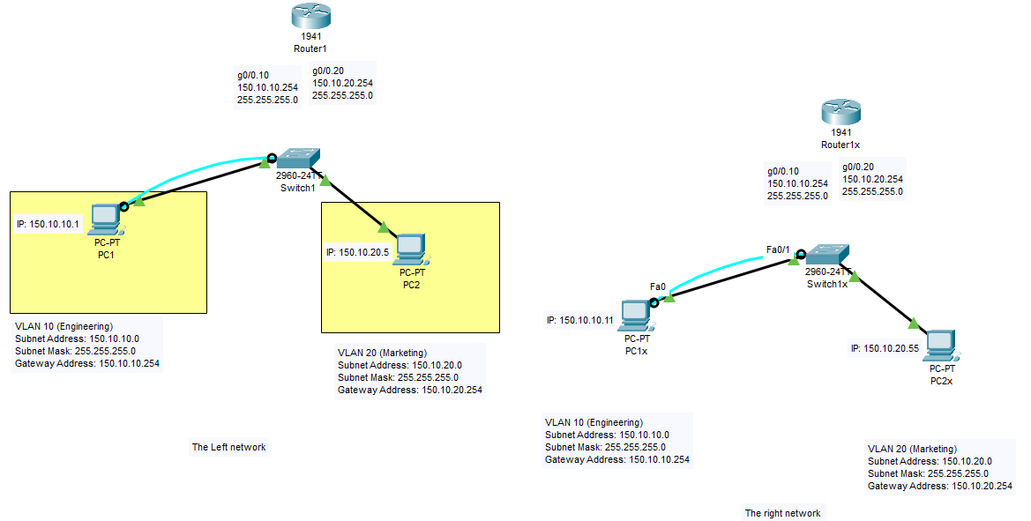Create a similar network exactly the same as the one you worked on so far and change the names of the PCs, switch and the router as follows: PC1x, PC2x, switch1x , router1x. (To save your time select your network in the workspace using the select tool from the main tool bar ,then click on the copy icon in the main tools bar followed by clicking the paste icon and you will get an exact copy of your network with the settings, just rename the devices as appropriate). Change the IP address for PC1x to 150.10.10.11 and the IP address for PC2x to 150.10.20.55 and keep the subnet mask and default gateway information unchanged for both PCs (Figure 4)

Figure 4

1. 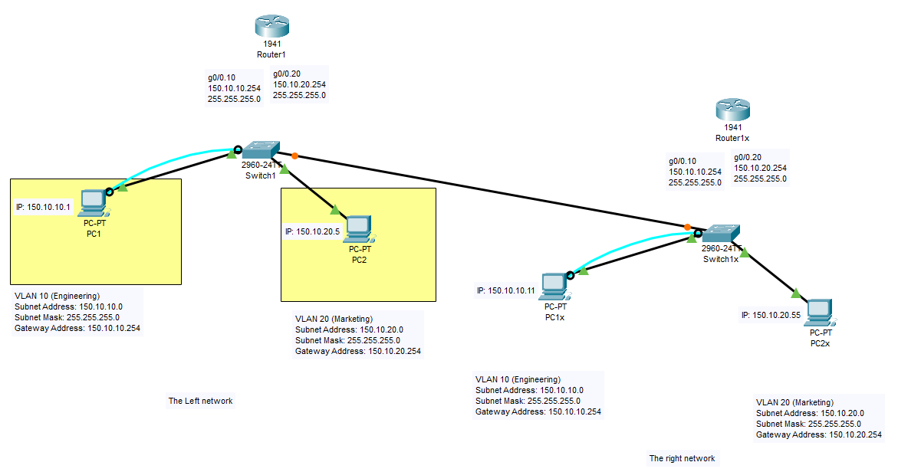Inter-connect Switch1 with Switch1x by connecting port 23 (in each switch) to each other with an Ethernet cable. (Figure 5)

Figure 5

1. Testing The connectivity

* Test the connectivity of the networks in figure 5 above and fill the following table.

|  |  |  |  |  |  |
| --- | --- | --- | --- | --- | --- |
| **PC** | **IP address** | **Can ping to** | | | |
| **PC1** | **PC2** | **PC1x** | **PC2x** |
| PC1 | **150.10.10.1** | **YES** | **NO** | **YES** | **NO** |
| PC2 | **150.10.20.2** | **NO** | **YES** | **NO** | **YES** |
| PC1x | **150.10.10.11** | **YES** | **NO** | **YES** | **NO** |
| PC2x | **150.10.20.55** | **NO** | **YES** | **NO** | **YES** |

1. If there are some unsuccessful pings, what is a possible reason that makes the ping is not successful?

**Yes, some PC’s were not able to ping each other for the same reason observed in previous questions. There is a need of a router, because the PC’s are in different VLAN’s.**

1. Remove the cable connecting the two switches.

**Part C. Inter-VLAN Routing [_____/6]**

Since each VLAN operates as a separate subnet, layer 3 routing is needed to support communication between VLANs. Inter-VLAN routing is hence carried out by connecting a router to the switch infrastructure. ***Router-on-a-stick*** is a type of router configuration in which a single physical interface manages traffic between multiple VLANs on a network. The router interface has to be configured to operate as a trunk link and is connected to a switch port which has configured in trunk mode. The router uses an 802.1q trunk link to place multiple ***sub-interfaces*** for the VLANs using a single physical link. A Sub-Interface is a logical interface partitioned off from a physical interface allowing multiple interface configurations on a single physical interface. The router receives VLAN tagged traffic on the trunk interface from the switch, and forwards the routed traffic out to VLAN tagged destination using the same interface.

1. Using an Ethernet straight cable, connect port 23 of the switch1 to g0/0 of the router1. (Figure 6)

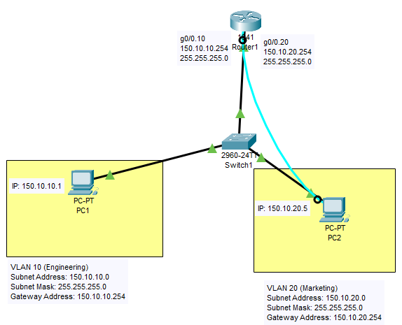

Figure 6

1. Note that port 23 has been configured as a trunk port as in Part B.
2. Connect the PC2 to the router using the console cable and use the Terminal on PC2 to configure the router.
3. Router configuration

* Each sub-interface is created using the “***interface*** *interface id****.****Subinterface_id”* command.  
  (interfaceID followed by a dot followed by the subinterface ID)  
  After that, VLAN ID is assigned using the ***encapsulation dot1q****vlan_id* command.
* Next, assign the gateway [IP address](http://orbit-computer-solutions.com/IP-Addressing.php) for the sub-interface using the command   
   ***ip address****ip_address subnet_mask*

The gateway addresses 150.10.10.254 and 150.10.20.254 will be used for the two VLANs   
 respectively.

* The following steps are to be repeated for all the router sub-interfaces that are needed to route between the VLANs configured on the network. Each router sub-interface needs to be assigned an IP address on a unique [subnet](http://orbit-computer-solutions.com/Subnetting-IP-addresses.php) for the routing to occur.

Router>enable

Router#config term

Router(config)#inter g0/0.10 ( 10 is the subinterface ID used for VLAN 10. Note the dot)

Router(config-subif)#encapsulation dot1q 10 ( 10 here is the VLAN ID )

Router(config-subif)#ip address 150.10.10.254 255.255.255.0

Router(config-subif)#exit

**(Repeat the above steps in a similar way for VLAN 20)**

Router(config)#inter g0/0

Router(config-if)#no shut

Router(config-if)#exit

1. Testing connectivity

* Connect PC1 to VLAN 10 and PCx to VLAN 20 of Switch1 as in the Figure 6 above
* Note down the IP address of each PC.

|  |  |
| --- | --- |
|  | IP address |
| PC1 on VLAN 10 | **150.10.10.1** |
| PC2 on VLAN 20 | **150.10.20.2** |

* Ping PC2 from PC1 , is the ping successful ? **YES**
* Ping PC1 from PC2 , is the ping successful ? **YES**
* If the pings are successful, give a reason for that. **The techniques of VLAN trunking and Inter-VLAN made possible, using a router and a switch, to forward packets from one VLAN to another.**

**Lab Submission instructions:**

1. Save your report file as yourFirstnameLastname_yourID_Lab5.docx.  
    (example: RupaManabala_1234_Lab5.docx)
2. Save your Packet Tracer file as yourFirstnamelastname_yourID_Lab5.pkt   
    (example: RupaManabala_1234_Lab5.pkt)
3. Put both files ( .pkt and .docx) in one folder and name it as   
    yourFirstnameLastname_yourID_Lab5
4. Compress the folder into a zip file
5. Send the compressed zip file to your instructor not later **11:59 PM** **of Saturday, February, 13th** on **Blackboard Only** strictly (Do not send labs by email please. Any lab submitted by email will be ignored).
6. Late submissions will not be marked and the student will lose the mark of that lab.
7. Students who don’t save lab files with proper names as indicated in 1,2,3 above, will lose 50% of the lab’s mark.