**CSIS 2270:**

**Slide 01: Introduction to Hardware Additional Information**

**PC Hardware Components:**

* I/O devices: external the case.
* Processing & storage devices: internal to the case.
* Central Processing Unit (CPU)
  + Processor, microprocessor
  + Reads input, processes data, writes data to storage.

**Hardware Vs. Software:**

A hardware is every computer physical component, i.e.: monitor, motherboard, memory, mouse, keyboard…

A software is a program that executes a set of instruction. It uses the hardware for four basics functions: input, process, storage and output.

**Hardware Components:**

* **Motherboard:** 
  + Largest and most important circuit board.
  + Contains the CPU, expansion slots and other devices.
  + Processing, temporary storage, communication and power.
  + All devices communicate with the mother board.
  + Peripheral device links to motherboard via cable.

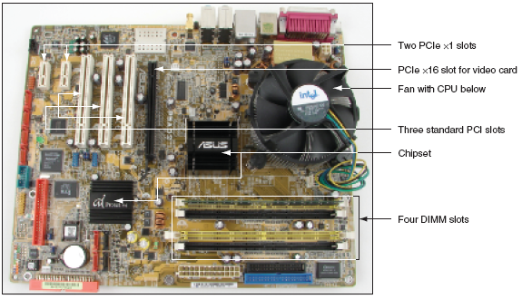

* **The Processor and the Chipset:**
  + CPU
    - Is inside the computer.
    - Performs most data processing.
  + Chipset
    - Group of two microchips controlling data flow.
* **Storage Devices:**
  + Primary storage (main memory)
    - Temporary (volatile) storage used by processor.
    - High speed data access speed.
    - RAM (Random Access Memory).
    - Located on motherboard, adapter cards.
    - Video memory: embedded on video card.
    - Dual line memory module (DIMM)

* + Secondary storage (permanent storage/non-volatile)
    - Enables data to persist after machine turned off.
    - Higher capacity but slower access speed.
    - Examples: hard drive, CD, DVD and USB.
    - Remote storage locations containing data and instructions.
    - Permanent (nonvolatile).
    - Hard drives.
    - Magnetic hard drives (Use Integrated Drive Electronics).
    - Flash memory (Solid State Drive - SSD).
    - ROM (Read-Only Memory).
    - USB Flash drives.
    - Parallel and serial ATA standards enable secondary storage enables devices to interface with the motherboard.

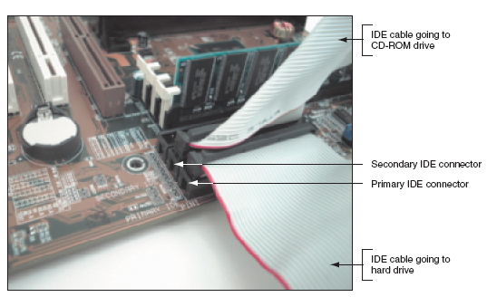

* **Motherboard Components used For Communication Among Devices:**
  + Traces
    - Fine lines on top and bottom of the motherboard’s surface.
  + Bus
    - System of pathways.
  + Data bus
    - Carries the data.
  + Buses for expansion slots:
    - PCI (Peripheral Component Interconnect).
    - AGP (Accelerated Graphics Port).
  + System clock
* **Expansion Cards:**
  + Cards that connect the CPU to an external device: video, phone lines, network cable, sound.
* **Instructions Stored on the Motherboard and Other Boards:**
  + BIOS
    - Data and instructions stored on the ROM chips.
    - ROM chips are types of firmware.
  + ROM BIOS
    - System BIOS: manage simple devices.
    - Startup BIOS: starts the computer.
    - CMOS setup: changes motherboard settings.
  + CMOS RAM: includes date, time and port configurations.
  + Flash ROM: ROM chips that can be overwritten.
  + Computer Bus:
    - system of communication pathways, protocols.
  + ROM BIOS:
    - helps starts the PCs; manages simple devices; change some motherboard settings.

**Slide 02: Network and the OSI Model**

**Benefits of Networks:**

* Resource sharing.
* Reduced Cost and Easier Installation of Software.
* Improved Communications.
* More Workspace Flexibility.
* Reduced Cost of Peripherals.

**Requirements of a Network:**

* At least two computers.
* A transmission medium.
* A communication agreement (Protocol).

**Classifying Networks:**

* Local Area Networks – LANs
  + High-speed: ~100Mbps to 10Gbps.
  + Single physical location.
  + All nodes located within a small geographical area.
  + Wi-Fi and Ethernet usually.
  + Home, Airport, Campus, School.
* Wide Area Network – WAN
  + Network that uses telecommunications network to interconnect sites that are geographically distributed throughout a region, country, or the world.
  + Multiprotocol Label Switching (MPLS), Frame Relay, Integrated Services Digital Network (ISDN).

**Functions & Terms:**

* **Hosts:** computer accessible over a network. It can be a client, a server or any other kind of computer.
* **Router:** networking device that forward packets between computer networks. It directs the traffic of packets over the internet.
* **Application:** software or program that runs on your computer.
* **Protocols:** Established set of rules that determines how data is transmitted between different devices in the same network.

**Organizing Networks with Layers:**

* Layer: is an abstraction of an interface that implements a service via its own internal layer actions or relying on services provided by a layer below.
* Deals with complex systems.
* Modularization eases maintenance.
* Simpler to update the system.

**Open System Interconnection (OSI):**

* The Open System Interconnection (OSI) reference model is used to define how the data communication occurs on computer networks.
  + Develop in 1984.
* This model is divided into layers, each of which provides services to the layer above.
* These layers are associated with protocols and devices.

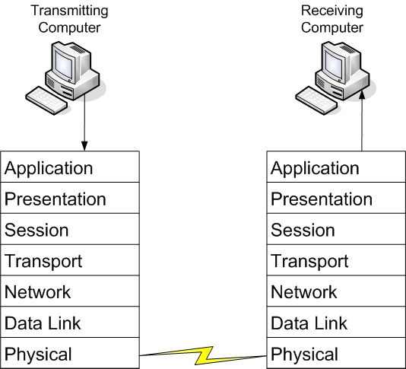

**The Model:**

1. Physical Layer: (Units of measurement **BITS**)
   1. Electrical signals.
   2. Mechanical connections.
   3. Includes but it is not limited to cables (e.g. UTP, fiber), connectors (RJ45), patch panels, and network interface cards (NIC).
   4. Topologies: Analog versus digital encoding, bit synchronization, baseband versus broadband, multiplexing, etc.
   5. Baseband: every computer on the LAN shares the same channel or frequency to transmit data.
   6. Broadband: multiple channels that can be utilized by the communications system
2. Data Link (Mac) Layer: (Units of measurement **FRAMES**)
   1. Transmits packets from node to node based on station address.
   2. Usually implemented on network interface cards and network devices such as switches.
   3. Data transfer between neighboring network elements:
      1. Ethernet 802.11 (WIFI)
      2. The layer decides how transfer is accomplished over the physical layer.
      3. It provides the Media Access Control (MAC) service.
      4. Decide which device is allowed to transmit at a given moment, e.g. CSMA/CD (Carrier Sense Multiple Access with Collision Detection) for Ethernet.
      5. Provides error checking service and flow control for transmission over the physical layer.
      6. To transmit data to a neighboring device, it does so through the use of physical addresses. (address burned into the ROM of the NIC)
      7. Every network adapter must have a unique Media Access Control (MAC) address.
   4. Media Access Control Address:
      1. The MAC for LAN is 6 bytes in length.
      2. The number is exhibited in 12 hexadecimal codes
      3. The first 6 hexadecimal codes are used to indicate the vendor of the network interface, also called the Organizationally Unique Identifier (OUI)
      4. The last 6 hexadecimal values ate unique numbers assigned by the vendor.
   5. Switches:
      1. A layer 2 switch is one of the most common type of switch used on a LAN. It will be used to connect all devices within a network.
      2. These switches use the MAC address of each host computers network adapter when deciding where to direct frames of data.
      3. Every port on the switch is mapped to the MAC address(es) of the computer(s) that physically connects to it.
3. Network Layer: (Units of measurement **PACKETS**)
   1. Routers data to different LANs and WANs based on network address.
   2. This layer is dedicated to routing data from the source to destination between different networks.
   3. Devices that exist on the network layer are routers.
      1. Routers provide connection between networks.
      2. Routing protocols are used to determine the best path from source to destination: RIP, OSPF, BGP.
   4. Protocols used for this layer include IP and IPX.
   5. This layer receives the logical addressing of hosts. The address chances to the network that the device is presently connected to.
   6. Switches:
      1. Devices on layer 3 are also known as routers; however, recent technology has implemented the routers used for intranet in a similar way as layer 2 switch, and those routers are referred to as layer 3 switch.
      2. Layer 3 switch determines paths for data using logical addressing (IP addresses) instead of physical addressing (MAC).
      3. Layer 3 switches forward packets, whereas layer 2 switches forward frames.
4. Transport Layer: (Units of measurement **SEGMENTS** or **MESSAGES**)
   1. Ensures delivery of entire file or message.
   2. Concerns with the end-to-end (host-to-host) data transmission.
      1. Transmits messages between hosts through logical addressing (IP address).
      2. Shields the upper layers from transport implementation details.
   3. The protocols provide services such as break up messages and send them through the subnet.
      1. Handles end-to-end flow control, error checking and recovery.
      2. When reliable service is provided, the protocols will ensure correct reassembly at the receiving end, making sure there are no duplicates or lost messages.
      3. TCP and UDP
         1. Two main transport protocols on Internet ate the **Transmission Control Protocol (TCP)**, which is a connection-oriented protocol providing reliable service, and the **User Datagram Protocol (UDP)**, which is connectionless.
         2. TCP example: web browser.
         3. UDP example: video streaming.
5. Session layer: (Units of measurement **DATA**)
   1. Starts, stop sessions. Maintains order.
   2. i.e., log on and log off.
6. Presentation Layer: (Units of measurement **DATA**)
   1. Encryption, data conversion: ASCII to EBCDIC, BCD to binary and etc.
   2. Translates the data format from sender to receiver that may be used.
   3. Includes data conversion, data compression and file encryption.
      1. ACSII and EBCDIC (text).
      2. Jpeg, Gif and TIFF (image).
      3. Mpeg and QuickTime (sound/video).
7. Application Layer: (Units of measurement **DATA**)
   1. Type of communication:
      1. Email.
      2. File transfer.
      3. Client/Server.

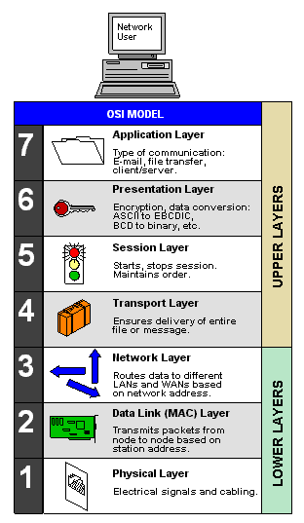

* 1. Provides network services to user applications and is where message begins.
  2. End-user protocols such as FTP, SMTP, HTTP, Telnet, and RAS work at this layer.
  3. This layer is not the application itself, but the protocols that are initiated by this layer.

**Communications Subnetwork:**

* Layer 1 through 3 of OSI model form the basis of the communication **subnetwork**.
  + Data are sent through neighboring devices (node-to-node)
* Regardless of what type of data transmission occurs in a computer network, the communication subnetwork will be employed.

**Connection Oriented Communications:**

* Connection-oriented (also known as CO mode) communications require that both end devices involved in the communication establish an end-to-end logical connection before data can be sent between the two.
* These connection-oriented systems are often considered reliable network services.
* If an individual packet is not delivered in a timely manner, it is resent.
  + These connection-oriented systems are often considered reliable network services.
  + If an individual packet s not delivered in a timely manner, it is resent.
    - i.e., Sending device needs to buffer up any data sent until an acknowledgement is received from the receiving device.
* TCP: port numbers are used to identify the applications on the computer.



**Connectionless Communications:**

* In connectionless communications (CL mode), no end-to-end connection is necessary before data is sent.
* Every packet that is sent has the destination address located in its header.
* This is sufficient to move independent packets, such as in the previously mentioned streaming media.
* But if a packet is lost, it will not be resent.

**Ports:**

* Ports acts as logical communications endpoints for computers.
* There are a total of 65,536 ports. [0 – 65,535].
* They are defined by the Internet Assigned Numbers Authority or IANA and divided into categories.

* Inbound ports:
  + Used by servers to accept incoming service requests.
* Outbound ports:
  + Used by client computers and are assigned dynamically by the operating system.

**TCP Model:**

* The TCP/IP (or TCP) model is similar to the OSI model.
* Most widely used nowadays.
* It is often used by software manufacturers who are not as concerned with how information is sent over physical media, or how data link is actually made.
* The model is composed of four layers.
* **Layer 01:** Data link layer (also simply known as the link or network access layer).
* **Layer 02:** Network layer (also simply known as the internet layer).
* **Layer 03:** Transport layer.
* **Layer 04:** Application layer.
  + The OSI physical layer is skipped altogether, and the application layer comprises the OSI application, presentation, and session layers.

