**Lab 3 Report**

By: Brandon Chin (A11845998), Leandro Lubrico (A12077909), and Kevin Chen (A10623152)

Q1. Briefly describe what you did to connect the modules

To connect the modules, we defined each modules inputs and outputs as modules that we could pass into each module. There are wires that are outputs to one module and inputs to another. In this case, we followed the module signature and made sure that there weren’t any concurrency issues.

Q2. Provide proof that it compiles in both Quartus and ModelSim

**Quartus**

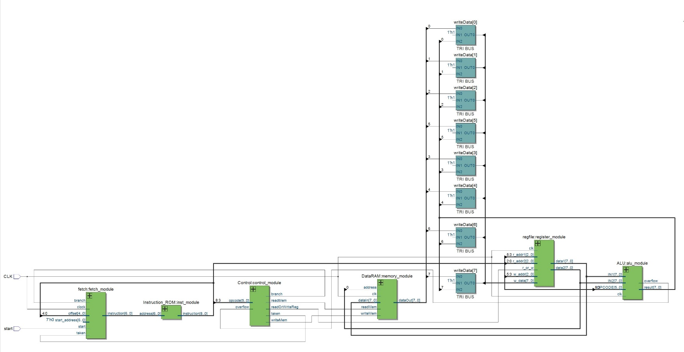

**ModelSim**

# Model Technology ModelSim ALTERA vlog 10.4b Compiler 2015.05 May 27 2015

# Start time: 20:44:06 on Nov 18,2016

# vlog -reportprogress 300 -work work C:/Users/chaos_000/Dropbox/CSE141L/cse141l/alu.sv

# -- Compiling module ALU

#

# Top level modules:

# ALU

# End time: 20:44:06 on Nov 18,2016, Elapsed time: 0:00:00

# Errors: 0, Warnings: 0

vlog -reportprogress 300 -work work C:/Users/chaos_000/Dropbox/CSE141L/cse141l/Control.sv

# Model Technology ModelSim ALTERA vlog 10.4b Compiler 2015.05 May 27 2015

# Start time: 20:44:06 on Nov 18,2016

# vlog -reportprogress 300 -work work C:/Users/chaos_000/Dropbox/CSE141L/cse141l/Control.sv

# -- Compiling module Control

#

# Top level modules:

# Control

# End time: 20:44:06 on Nov 18,2016, Elapsed time: 0:00:00

# Errors: 0, Warnings: 0

vlog -reportprogress 300 -work work C:/Users/chaos_000/Dropbox/CSE141L/cse141l/DataRAM.sv

# Model Technology ModelSim ALTERA vlog 10.4b Compiler 2015.05 May 27 2015

# Start time: 20:44:06 on Nov 18,2016

# vlog -reportprogress 300 -work work C:/Users/chaos_000/Dropbox/CSE141L/cse141l/DataRAM.sv

# -- Compiling module DataRAM

#

# Top level modules:

# DataRAM

# End time: 20:44:06 on Nov 18,2016, Elapsed time: 0:00:00

# Errors: 0, Warnings: 0

vlog -reportprogress 300 -work work C:/Users/chaos_000/Dropbox/CSE141L/cse141l/fetch.sv

# Model Technology ModelSim ALTERA vlog 10.4b Compiler 2015.05 May 27 2015

# Start time: 20:44:06 on Nov 18,2016

# vlog -reportprogress 300 -work work C:/Users/chaos_000/Dropbox/CSE141L/cse141l/fetch.sv

# -- Compiling module fetch

#

# Top level modules:

# fetch

# End time: 20:44:06 on Nov 18,2016, Elapsed time: 0:00:00

# Errors: 0, Warnings: 0

vlog -reportprogress 300 -work work C:/Users/chaos_000/Dropbox/CSE141L/cse141l/Instruction_ROM.sv

# Model Technology ModelSim ALTERA vlog 10.4b Compiler 2015.05 May 27 2015

# Start time: 20:44:06 on Nov 18,2016

# vlog -reportprogress 300 -work work C:/Users/chaos_000/Dropbox/CSE141L/cse141l/Instruction_ROM.sv

# -- Compiling module Instruction_ROM

#

# Top level modules:

# Instruction_ROM

# End time: 20:44:06 on Nov 18,2016, Elapsed time: 0:00:00

# Errors: 0, Warnings: 0

vlog -reportprogress 300 -work work C:/Users/chaos_000/Dropbox/CSE141L/cse141l/regfile.sv

# Model Technology ModelSim ALTERA vlog 10.4b Compiler 2015.05 May 27 2015

# Start time: 20:44:06 on Nov 18,2016

# vlog -reportprogress 300 -work work C:/Users/chaos_000/Dropbox/CSE141L/cse141l/regfile.sv

# -- Compiling module regfile

#

# Top level modules:

# regfile

# End time: 20:44:06 on Nov 18,2016, Elapsed time: 0:00:00

# Errors: 0, Warnings: 0

vlog -reportprogress 300 -work work C:/Users/chaos_000/Dropbox/CSE141L/cse141l/top.sv

# Model Technology ModelSim ALTERA vlog 10.4b Compiler 2015.05 May 27 2015

# Start time: 20:44:06 on Nov 18,2016

# vlog -reportprogress 300 -work work C:/Users/chaos_000/Dropbox/CSE141L/cse141l/top.sv

# -- Compiling module top

#

# Top level modules:

# top

# End time: 20:44:07 on Nov 18,2016, Elapsed time: 0:00:01

# Errors: 0, Warnings: 0

Q3: Lab 1 Assembly Code

; PRODUCT

load $r3, $r3 ; R[3] = M[R[3]] ($r3 = A)

load $r4, $r4 ; R[4] = M[R[4]] ($r4 = B)

load $r5, $r5 ; R[5] = M[R[5]] ($r5 = C)

; MULTIPLY A AND B

while1:

and $r4 ; $overflow = B & 1

bno if1 ; branch if LSB of B is 0

add $r1, $r3 ; add lower bits

bno if1 ; branch if no overflow

incr $r0 ; increment upper bits

add $r0, $r2 ; add upper bits

if1:

lsl $r2 ; shift upper bits of A left

lsl $r3 ; shift lower bits of A left

bno if2 ; skip if MSB lower bit is 0

incr $r2 ; add overflow to upper bits of A

if2:

lsr $r4 ; shift B right

eqz $r4 ; overflow = (B == 0)

bno while1 ; loop while B != 0

# MULTIPLY AB AND C

zero $r2 ; initialize $r2 to 0

zero $r3 ; initialize $r3 to 0

while2:

and $r5 ; $overflow = C & 1

bno if3 ; branch if LSB of C is 0

add $r3, $r1 ; add lower bits

bno if3 ; branch if no overflow

incr $r2 ; increment upper bits

add $r2, $r0 ; add upper bits

if3:

lsl $r0 ; shift upper bits of AB left

lsl $r1 ; shift lower bits of AB left

bno if4 ; skip if MSB lower bit was 0

incr $r0 ; add overflow to upper bits of AB

if4:

lsr $r5 ; shift C right

eqz $r5 ; overflow = (C == 0)

bno while2 ; loop while C != 0

store $r2, $r6 ; store upper bits in memory

store $r3, $r7 ; store lower bits in memory

halt

;STRING MATCH

;LOAD VALUES OF OPERANDS

load $r1, $r1 ; load pattern from memory

;OUTER LOOP THROUGH ALL INPUT BYTE STRINGS

s_while1:

load $r0, $r6 ; load first byte string from memory

;INNER LOOP THROUGH EVERY 4 BIT COMBO IN EACH STRING

s_while2:

match $r0, $r1 ; check if lower 4 bits of string match pattern

bof s_if1 ; if pattern match, branch

lsr $r0 ; if no match, s >> 1

incr $r5 ; increment inner loop index, j, by 1

lt $r4, $r5 ; check inner while condition (j < length)

bno s_if2 ; exit loop

bof while2 ; if (j < length) is true, loop inner

s_if1:

incr $r2 ; increment count by 1

s_if2:

incr $r6 ; increment outer loop index, i, by 1

lt $r6, $r7 ; check outer while condition (i < size)

bof s_while1 ; if (i < size) is true, loop outer

store $r2, $r3 ; store the count to memory

halt

; CLOSEST PAIR

; OUTER LOOP THROUGH EVERY VALUE IN ARRAY TO COMPARE

c_while1:

load $r0, $r2 ; x = array[i]

incr $r2 ; i++

zero $r4 ; j = 0

add $r4, $r2 ; j += i (so that j = i)

;INNER LOOP THROUGH EVERY OTHER VALUE IN ARRAY TO COMPARE TO

c_while2:

load $r1, $r4 ; y = array[j]

incr $r4 ; j++

dist $r1, $r0 ; calculate dist, overwrite y

lt $r1, $r6 ; check if dist < min

bno c_if1 ; if dist >= min, skip min update

zero $r6 ; min = 0

add $r6, $r1 ; min += dist

c_if1:

lt $r4, $r5 ; check if j < 20

bof c_while2 ; if j < 20 is true, then loop inner

lt $r2, $r3 ; check if i < 19

bof c_while1 ; if i < 19 is true, then loop outer

store $r6, $r7 ; store min in result address

halt

Q4: Machine code output

000011011

000100100

000101101

110011100

111000101

010001011

111000011

110010000

010000010

110000010

110000011

111000010

110010010

110001100

110100100

111010100

110101010

110101011

110011101

111000101

010011001

111000011

110010010

010010000

110000000

110000001

111000010

110010000

110001101

110100101

111010100

001010110

001011111

110111000

000001001

000000110

011000001

111100110

110001000

110010101

100100101

111000011

111101000

110010010

110010110

100110111

111110101

001010011

110111000

000000010

110010010

110101100

010100010

000001100

110010100

101001000

100001110

111000011

110101110

010110001

100100101

111111000

100010011

111110010

001110111

110111000