Entrega DevOps Fundamentals DIO

Service Conection:

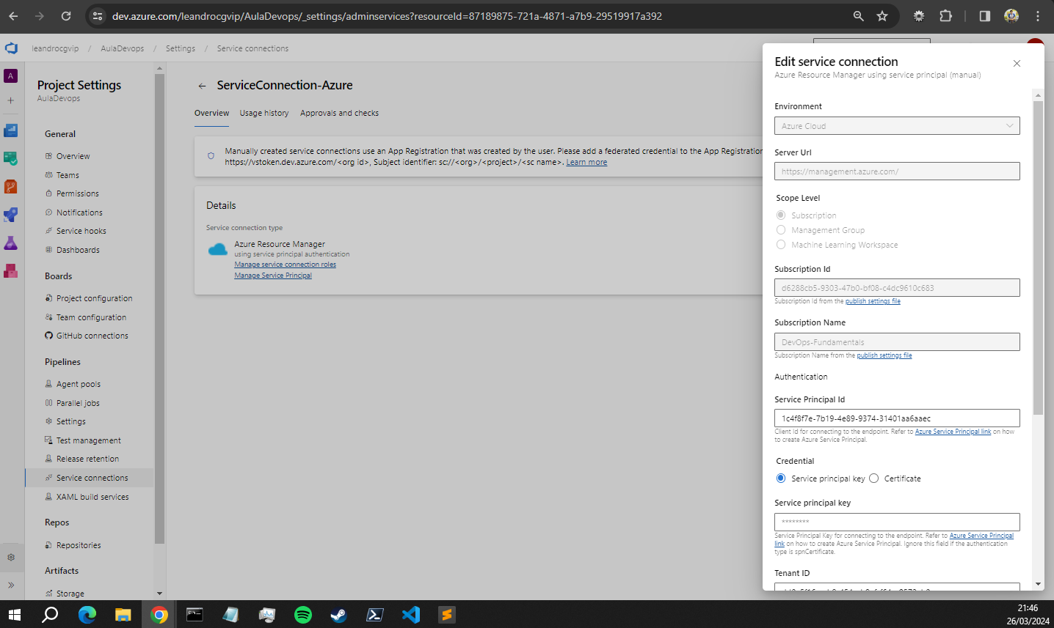  
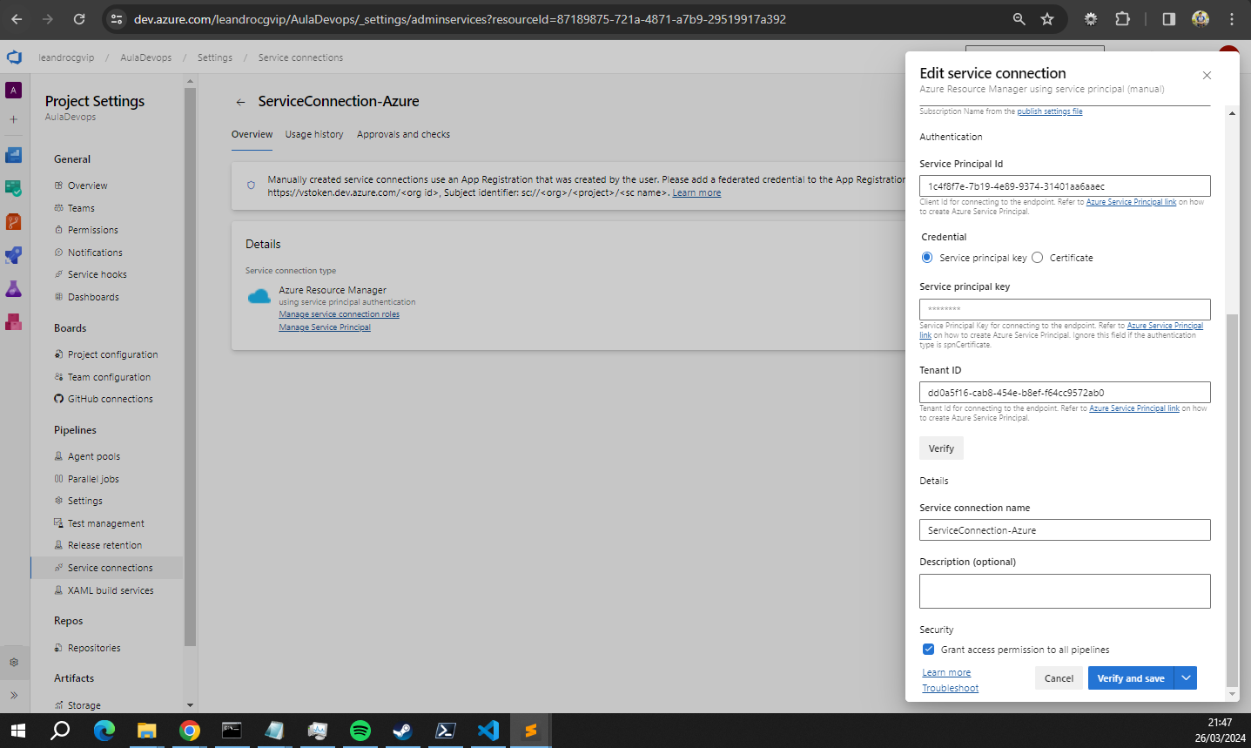

Pipelines  
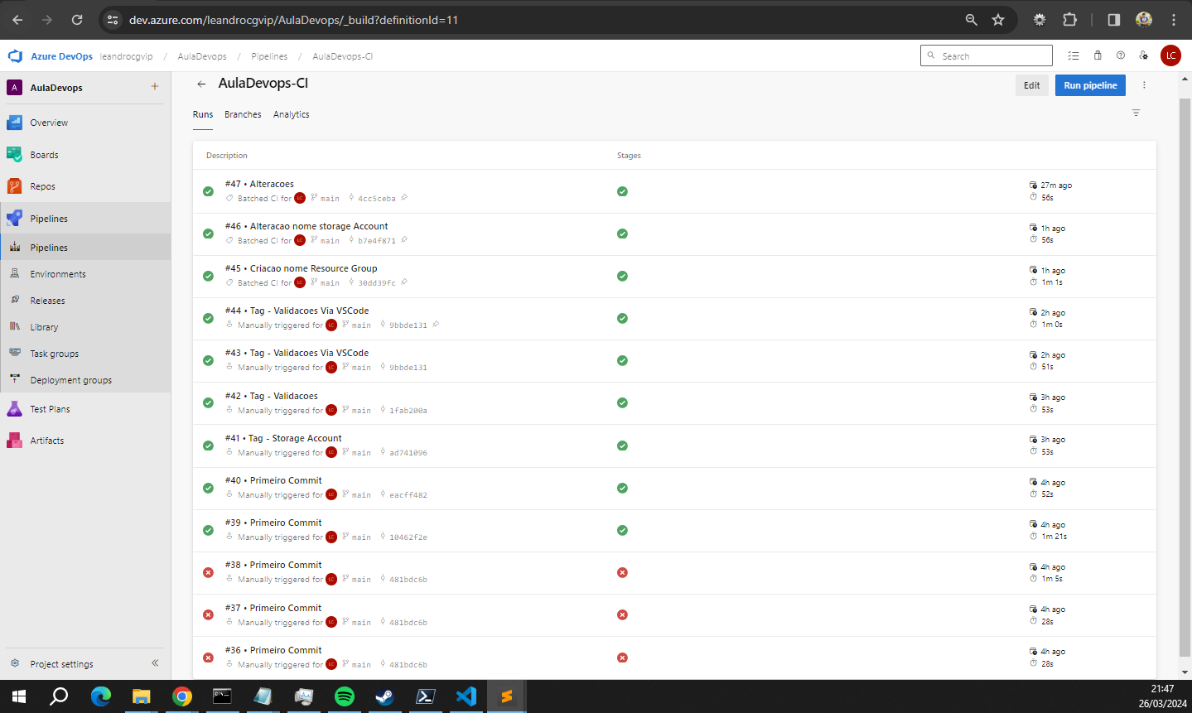

Piélines Release  
  
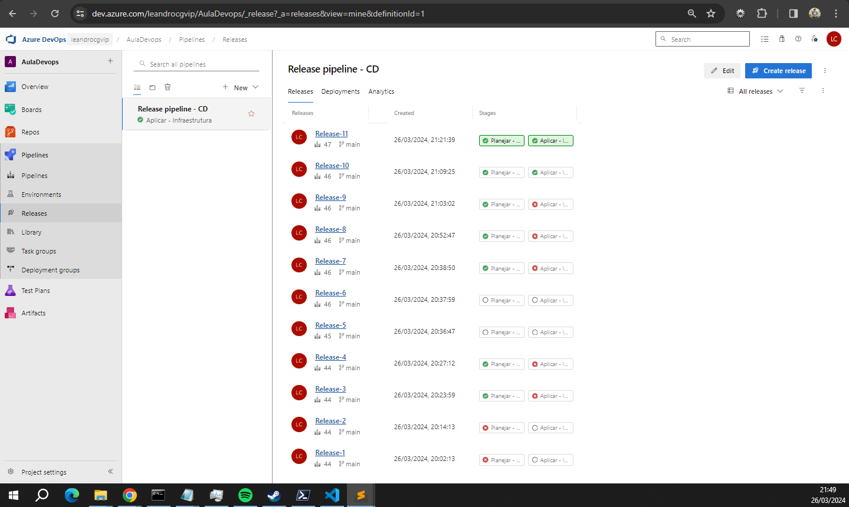  
  
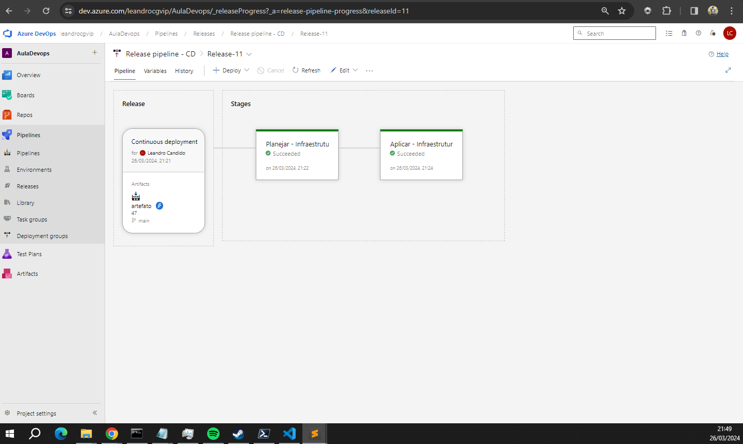

Criação do Resource Group com as tags na mesma tela  
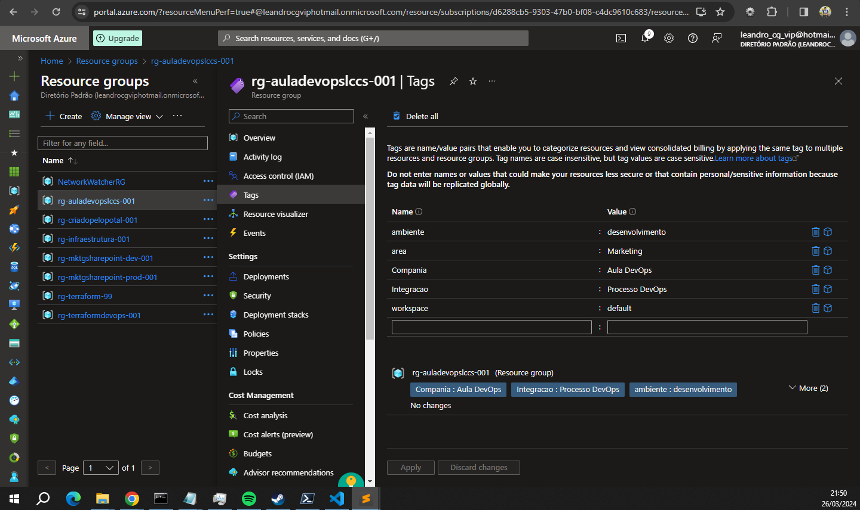

Endereço: <https://dev.azure.com/leandrocgvip/AulaDevops><https://gitlab.com/leandro.lccs/auladevopsfundamentals>