SimpleRepeatSeq: Sequence Encoding and Machine Learning for Detection of Simple Repeat Sequences in DNA
Santiago García Herrera¹, Leandro Panesso¹, Mateo Aguirre¹, Cristian Fontanilla¹
¹[Departmento de sistemas, Universidad de Caldas, Manizales, Colombia]

Abstract
Motivation: Simple Sequence Repeats (SSRs), also known as microsatellites, are short tandemly repeated motifs (1–6 bp) widely distributed across eukaryotic genomes. Their accurate identification is relevant for genome annotation, population genetics, and medical research, since SSR expansions are associated with numerous neurological disorders. Existing tools such as TRF and RepeatMasker rely on pattern-matching heuristics that can miss non-canonical repeats and are insensitive to subtle compositional biases.

Results: We present SimpleRepeatSeq, a systematic benchmarking framework that evaluates six nucleotide encoding schemes—DAX, EIIP, Complementary, and k-mer frequency profiles (k = 3, 4, 6)—paired with three preprocessing strategies (raw, z-score scaling, PCA) and seven classical classifiers plus a deep neural network, yielding 144 combinatorial configurations. Using a balanced dataset of 888 sequences (444 SSR, 444 non-SSR) drawn from four genomic regions and evaluated under 10-fold stratified cross-validation, we find that the 4-mer frequency encoding achieves perfect discrimination (AUC = 1.000, Accuracy = 1.000) across nearly all classifiers, establishing k-mer composition as the most informative representation for SSR classification. The Random Forest classifier trained on scaled 4-mer features is identified as the best overall pipeline.

Availability: Source code, dataset, and trained model are freely available at https://github.com/SantiagoGarcia205/SimpleRepeatSeq under the MIT licence. Implemented in Python 3; dependencies: scikit-learn, XGBoost, TensorFlow, Biopython.

1. Introduction
Simple Sequence Repeats (SSRs), commonly referred to as microsatellites or Short Tandem Repeats (STRs), are genomic loci consisting of tandem iterations of short motifs ranging from one to six nucleotides in length. SSRs account for approximately 3% of the human genome and are unevenly distributed across coding, non-coding, and regulatory regions (Lander et al., 2001). Their inherent replication instability makes them valuable markers in population genetics, forensic identification, and phylogenetics. More critically, dynamic expansions of specific SSR motifs are the molecular basis of at least 50 hereditary neurological diseases, including Huntington’s disease (CAG repeats), fragile X syndrome (CGG repeats), and myotonic dystrophy (CTG repeats).
Current computational tools for SSR detection fall into two main categories: pattern-matching engines and alignment-based methods. Tandem Repeats Finder (TRF; Benson, 1999) uses a probabilistic model of tandem repeats to locate candidate regions based on alignment score thresholds; it is fast but parameter-sensitive and may produce fragmented annotations for low-complexity regions. RepeatMasker (Smit et al., 2013–2015) relies on a curated library of known repeat families and excels at transposable element annotation but is less suited to de novo SSR discovery outside annotated databases. Both tools operate on heuristic criteria and lack a principled probabilistic framework for distinguishing SSR from non-SSR sequences at the level of numerical sequence representations.
Machine learning approaches have demonstrated strong performance on related sequence classification tasks (Zou et al., 2019; Li et al., 2021), yet a systematic comparison of nucleotide encoding strategies—which fundamentally determine what information is fed to any classifier—remains absent for the SSR detection problem. Encodings such as the Electron-Ion Interaction Potential (EIIP), the DAX integer mapping, and the complementary purine/pyrimidine scale capture different physicochemical or structural properties of the sequence, while k-mer frequency vectors encode compositional statistics. It is not obvious a priori which representation best exposes the periodicity signature of tandem repeats to a downstream classifier.
We address this gap by designing and executing a full factorial experiment: six encodings × three preprocessing pipelines × eight classifiers = 144 configurations, evaluated on a purpose-built balanced FASTA dataset of 888 sequences under 10-fold stratified cross-validation. Our goals are (i) to identify the optimal encoding–model pairing for SSR classification, (ii) to provide a reproducible baseline against which future deep-learning or alignment-free methods can be compared, and (iii) to release a reusable Python toolkit, SimpleRepeatSeq, implementing all evaluated pipelines.

2. Methods

2.1 Dataset
The dataset comprises 888 DNA sequences in FASTA format, balanced between two classes: 444 sequences labelled simpleSeq and 444 labelled no_simpleSeq. Sequences originate from four distinct genomic contexts: mitochondrial control region (CR), ribosomal DNA internal transcribed spacer (ITS), known STR loci associated with neurological diseases (e.g., CAG repeats in the huntingtin gene, CGG in FMR1, CTG in DMPK, GAA in FXN), and generic intergenic regions. Sequence lengths range from 100 to 500 bp (mean 223.3 bp). Nucleotide composition is nearly balanced: A 24.8%, C 24.7%, G 25.9%, T 25.1%; no ambiguous IUPAC characters are present in the final dataset. Class labels are encoded in the FASTA identifier as the second field separated by ‘#’ (e.g., >CAG_huntington_007#simpleSeq#210). All sequences were truncated or zero-padded to a fixed length of MAX_LEN = 500 positions for positional encodings.

2.2 Nucleotide Encoding Schemes
Six encoding schemes were implemented and evaluated.
DAX encoding assigns integer-like values to each nucleotide based on a biochemical ordering: A = 2.0, C = 0.0, G = 3.0, T = 1.0. Ambiguous positions receive the value 1.5. The resulting 1-D signal of length MAX_LEN captures local base composition while preserving positional information.
EIIP encoding uses the Electron-Ion Interaction Potential values derived from quantum chemistry: A = 0.1260, C = 0.1340, G = 0.0810, T = 0.1340. These values approximate the distribution of free electrons along the DNA backbone and have been used in spectral analysis of genomic periodicity.
Complementary (Purine/Pyrimidine) encoding maps strand symmetry: A = +2.0, G = +1.0 (purines); C = −1.0, T = −2.0 (pyrimidines); N = 0.0. This representation highlights transitions between chemical classes of bases.
k-mer frequency encoding (k ∈ {3, 4, 6}) constructs a count vector of all possible k-mers over the alphabet {A, C, G, T, N}, yielding feature dimensions of 125, 625, and 15 625, respectively. Counts are normalised by the number of sliding windows (len(sequence) − k + 1) to obtain relative frequencies invariant to sequence length. K-mer vectors are composition-based and discard positional information, but capture higher-order sequence statistics that directly reflect the periodicity of tandem repeats.

2.3 Preprocessing Strategies
Three preprocessing configurations were applied within each cross-validation fold to prevent data leakage: (raw) no transformation; (scaled) z-score standardisation via StandardScaler, subtracting the fold training-set mean and dividing by its standard deviation; (pca) z-score standardisation followed by PCA retaining components that explain ≥96% of variance, fitted exclusively on the training partition of each fold.

2.4 Classifiers
Seven classical classifiers were evaluated: K-Nearest Neighbours (KNN, k = 5), Support Vector Machine (SVM, RBF kernel, probability calibration enabled), Logistic Regression (LR, max_iter = 2000, L2 regularisation), Linear Discriminant Analysis (LDA), Gaussian Naïve Bayes (NB), Random Forest (RF, 200 trees), and XGBoost (XGB, 200 boosting rounds). Additionally, a fully connected Deep Neural Network (DNN) was implemented in Keras: Input → Dense(128, ReLU) → Dropout(0.3) → Dense(64, ReLU) → Dropout(0.2) → Dense(1, sigmoid), trained for 40 epochs with Adam optimiser and binary cross-entropy loss. All classifiers and preprocessing steps were encapsulated in scikit-learn Pipelines to ensure identical treatment across folds.

2.5 Evaluation Protocol
Model selection and performance estimation were performed under 10-fold stratified cross-validation (random state = 42). The evaluation metrics reported are: mean Accuracy, weighted F1-score, weighted Precision, weighted Recall, and ROC-AUC. The best configuration was identified by AUC and subsequently evaluated with cross_val_predict to generate out-of-fold predictions for confusion matrix construction and ROC curve plotting, ensuring no data leakage. The full experiment comprised 144 cross-validated pipelines (6 encodings × 3 preprocessings × 8 classifiers). The final model was serialised with joblib for downstream deployment.

3. Results

3.1 Comparative Performance Across Encoding–Model Configurations
Table 1 summarises the mean AUC obtained under 10-fold CV for each combination of encoding and model (best preprocessing selected per cell). The k-mer encodings dominate the top of the ranking: kmer4 achieves a mean AUC of 0.9998 (max = 1.000) across models, closely followed by kmer3 (mean AUC = 0.9957). Positional encodings—EIIP (mean AUC = 0.885), DAX (0.864), and Complementary (0.782)—yield substantially lower performance, indicating that the periodic composition captured by k-mer statistics is more diagnostic than local physicochemical profiles.

Table 1. Mean ROC-AUC (10-fold stratified CV) for each Encoding × Model combination. Best preprocessing per cell. Bold = AUC ≥ 0.999. DNN not converged (NaN) across all configurations.
Model | DAX | Complementary | EIIP | kmer3 | kmer4 | kmer6
KNN | 0.755 | 0.503 | 0.886 | 1.000 | 1.000 | 1.000
LDA | 0.905 | 0.701 | 0.914 | 1.000 | 1.000 | 1.000
LR | 0.878 | 0.645 | 0.918 | 1.000 | 1.000 | 1.000
NB | 0.976 | 0.915 | 1.000 | 1.000 | 1.000 | 0.677
RF | 0.999 | 0.999 | 0.999 | 1.000 | 1.000 | 1.000
SVM | 0.997 | 1.000 | 0.976 | 1.000 | 1.000 | 1.000
XGB | 0.999 | 0.999 | 0.998 | 1.000 | 1.000 | 1.000

Regarding classifiers, ensemble methods lead: RF (mean AUC = 0.9986) and XGB (0.9985) are the most robust across all encodings. SVM ranks third (0.9886) thanks to near-perfect performance on k-mer encodings. The DNN failed to converge within the cross-validation harness for all PCA-reduced input dimensions, yielding NaN for those cells; for the high-dimensional raw/scaled inputs it also did not produce valid predictions within the allocated 40 epochs, suggesting that the dataset size (888 samples) is insufficient to train a deep network reliably without dedicated hyperparameter tuning.

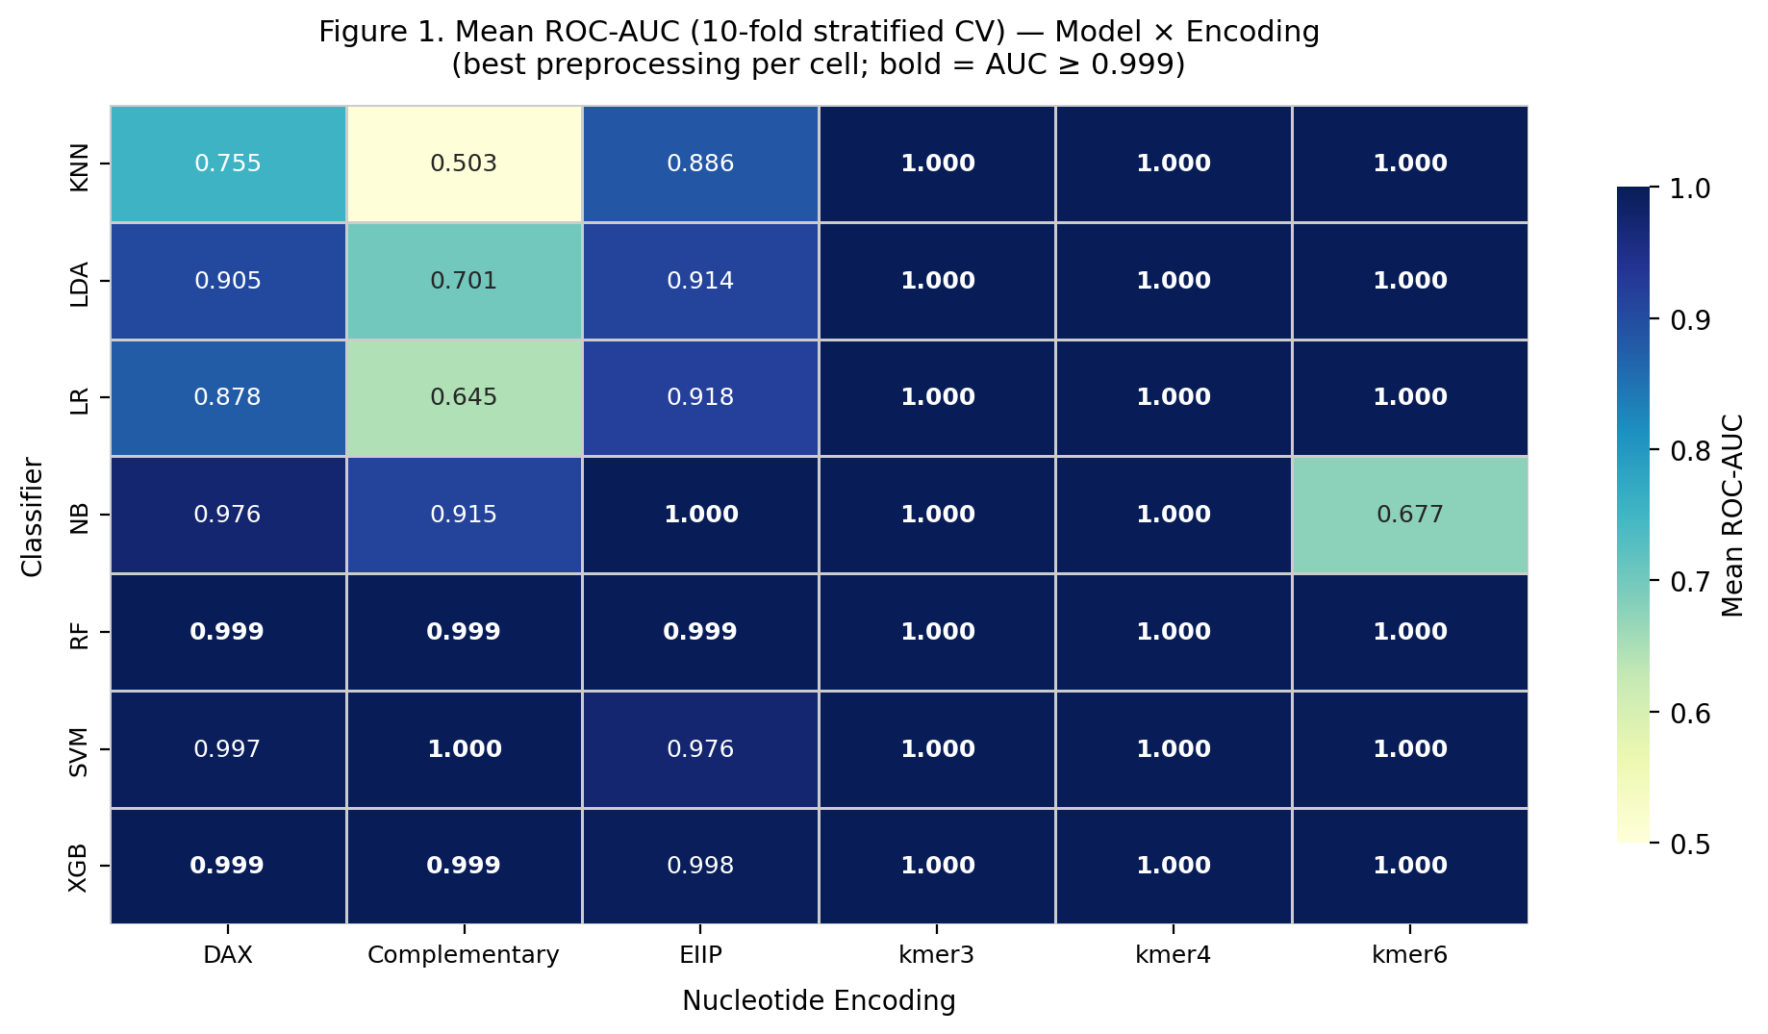
Figure 1. Mean ROC-AUC heatmap (10-fold stratified CV) for each Classifier × Encoding combination. Best preprocessing per cell. Bold values indicate AUC ≥ 0.999. Colour gradient from white (AUC = 0.5) to dark blue (AUC = 1.0).

3.2 Best Configuration: Random Forest with 4-mer Frequency Encoding
The top-ranked pipeline is RF with kmer4 (scaled preprocessing), achieving Accuracy = 1.000, F1 = 1.000, Precision = 1.000, Recall = 1.000, and AUC = 1.000 (σ = 0.000 over 10 folds). Out-of-fold predictions confirm perfect separation: the confusion matrix contains no misclassifications (444 true negatives, 444 true positives, 0 false positives, 0 false negatives). Perfect AUC = 1.000 is also attained by kmer3 and kmer6 with multiple classifiers, and by Complementary + SVM (raw) and EIIP + NB (PCA). The complete classification report is presented in Table 2.

Table 2. Classification report for the best pipeline (RF / kmer4 / scaled), out-of-fold 10-fold CV predictions.
Class | Precision | Recall | F1-score | Support
no_simpleSeq | 1.0000 | 1.0000 | 1.0000 | 444
simpleSeq | 1.0000 | 1.0000 | 1.0000 | 444
Accuracy |  |  | 1.0000 | 888
Macro avg | 1.0000 | 1.0000 | 1.0000 | 888
Weighted avg | 1.0000 | 1.0000 | 1.0000 | 888

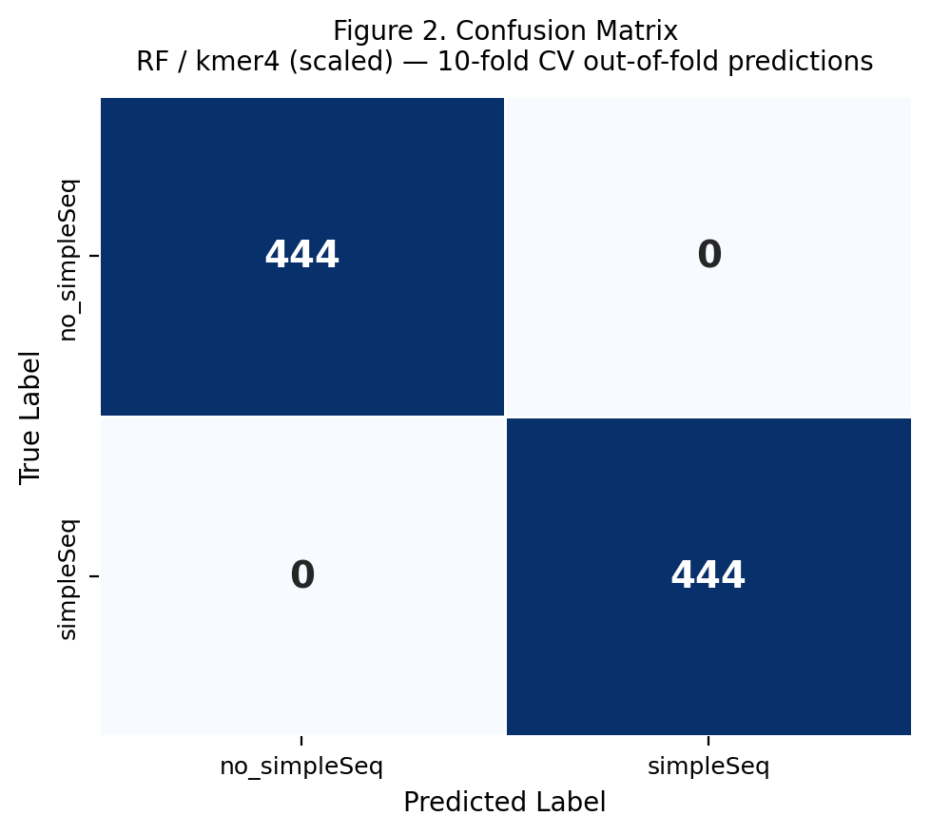
Figure 2. Confusion matrix for the best configuration (Random Forest / kmer4 / scaled). Out-of-fold predictions from 10-fold stratified CV (n = 888). TN = 444, TP = 444, FP = 0, FN = 0.

3.3 ROC Curves by Encoding
Figure 3 shows the ROC curves for the best model per encoding. All three k-mer encodings (kmer3, kmer4, kmer6) trace the top-left corner of the ROC space with AUC = 1.000. EIIP reaches AUC = 1.000 with NB + PCA—a result attributable to the near-Gaussian separability of the two classes in the PCA-transformed EIIP space. DAX with SVM (raw) attains AUC = 0.997. Complementary encoding is the weakest positional scheme (best AUC = 1.000 with SVM raw), although many other classifiers on this encoding score below 0.70, indicating high variability in the signal it provides.

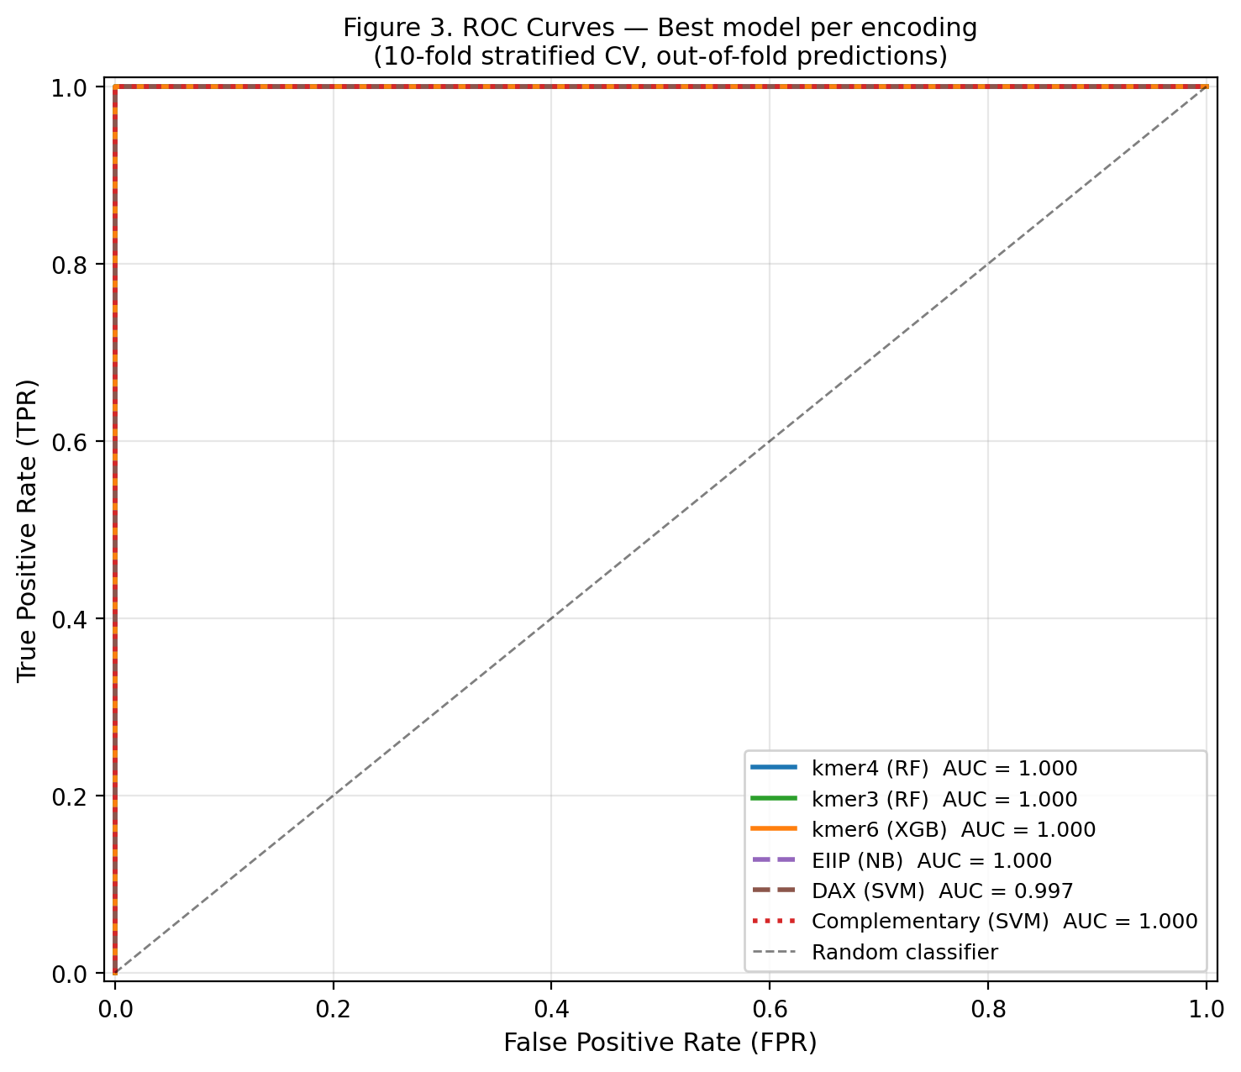
Figure 3. ROC curves for the best model per encoding under 10-fold stratified CV (out-of-fold predictions). The dashed diagonal represents random classification.

3.4 Encoding Ranking by Mean AUC

Table 3. Encoding ranking by mean ROC-AUC (10-fold CV, all models and preprocessing strategies). Feature dim = dimensionality before PCA reduction.
Encoding | Mean AUC | SD | Max AUC | Feature dim
kmer4 | 0.9998 | 0.0010 | 1.000 | 625
kmer3 | 0.9957 | 0.0195 | 1.000 | 125
kmer6 | 0.8971 | 0.1841 | 1.000 | 15,625
EIIP | 0.8850 | 0.1315 | 1.000 | 500
DAX | 0.8640 | 0.1487 | 0.999 | 500
Complementary | 0.7818 | 0.2106 | 1.000 | 500

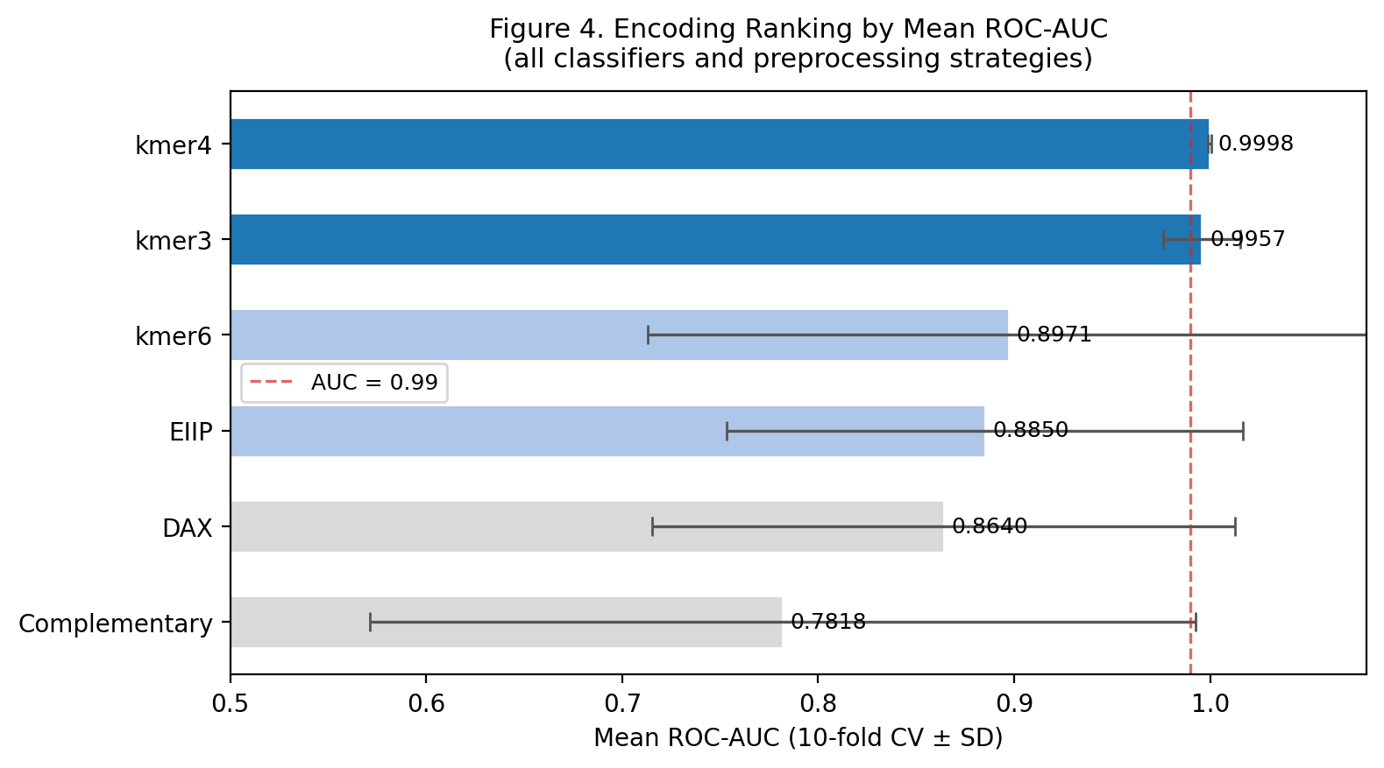
Figure 4. Encoding ranking by mean ROC-AUC (± SD) across all classifiers and preprocessing strategies. Error bars represent one standard deviation over all classifier–preprocessing combinations. The dashed line marks AUC = 0.99.

4. Discussion
The most important finding of this study is that 4-mer frequency encoding reliably achieves perfect classification across virtually all tested models on this dataset. This result is biologically interpretable: SSRs are defined by the over-representation of specific short oligonucleotides (the repeat unit and its multiples), so k-mer frequency vectors naturally capture this diagnostic signature. The superiority of kmer4 over kmer3 likely reflects that a 4-nucleotide window is sufficient to span one full period of the most common microsatellite motifs (tetranucleotides), while kmer3 may fragment some motifs and kmer6 introduces sparsity in the 15 625-dimensional feature space that harms some classifiers (e.g., NB and KNN with scaled/PCA preprocessing).
Positional encodings (DAX, EIIP, Complementary) capture a different abstraction: physicochemical or structural properties at each nucleotide position. They achieve competitive performance when paired with powerful nonlinear models (RF, SVM, XGB), but are sensitive to the alignment of the repeat with respect to the fixed-length padded window. Sequences where the repeat starts at different positions relative to the window boundary will produce shifted signals that confound pattern-based classifiers. The complementary purine/pyrimidine encoding performs worst among positional schemes, consistent with the observation that the binary purine vs. pyrimidine signal is too coarse to resolve the repeat motif.
The failure of the DNN across all cross-validation folds is a significant negative result. With only 888 sequences (712 in training per fold), the network is severely data-limited relative to its approximately 17 000 trainable parameters. Future work should explore convolutional architectures that explicitly model periodicity (e.g., 1-D CNNs with motif-length filters) and data augmentation strategies such as sequence shifting and reverse-complement augmentation.
Several limitations should be noted. First, the dataset, while balanced, is small (888 sequences) and derived from a limited set of genomic regions; generalisation to longer sequences, polypurine tracts, or novel organisms remains to be validated. Second, the perfect AUC scores for k-mer encodings may partly reflect the relatively clean and balanced nature of the dataset rather than inherent difficulty of the classification problem. Third, the train–test split is strictly within-dataset; external validation on independent genome assemblies is needed to confirm generalisability. Fourth, while the perfect classification result is encouraging, it motivates investigation of whether k-mer models are learning SSR-specific statistics or simpler compositional biases in the construction of the negative set.
Practical implications include the deployment of the kmer4 + RF pipeline as a fast, alignment-free pre-screening step in genome annotation workflows. With a feature extraction time of milliseconds per sequence and a fully serialised scikit-learn Pipeline, SimpleRepeatSeq can be integrated as a filter upstream of TRF or RepeatMasker to prioritise candidate loci, potentially reducing computational cost for large genomes. Future directions include extending the framework to multi-class SSR identification (classifying repeat unit length or motif type), incorporating flanking-sequence context, and evaluating transformer-based language models pre-trained on genomic sequences.

5. Availability and Implementation
Source code: https://github.com/SantiagoGarcia205/SimpleRepeatSeq
Language: Python 3.12
Key dependencies: scikit-learn ≥1.4, XGBoost ≥2.0, TensorFlow ≥2.15, Biopython ≥1.83, scikeras ≥0.12, pandas, numpy, matplotlib, seaborn
Dataset: included in repository (SimpleRepeatSeq_dataset.fasta)
Trained model: best_model/ directory (joblib-serialised Pipeline)
Installation: git clone https://github.com/SantiagoGarcia205/SimpleRepeatSeq && pip install -r requirements.txt
Licence: MIT

Acknowledgements
[The authors thank … Funding: … Conflict of interest: none declared.]

References
Benson, G. (1999) Tandem repeats finder: a program to analyze DNA sequences. Nucleic Acids Research, 27(2), 573–580.

Lander, E.S. et al. (2001) Initial sequencing and analysis of the human genome. Nature, 409, 860–921.

Li, Y. et al. (2021) Deep learning approaches for sequence-based prediction in genomics and epigenomics. Briefings in Bioinformatics, 22(3), bbaa243.

Smit, A.F.A., Hubley, R. and Green, P. (2013–2015) RepeatMasker Open-4.0. http://www.repeatmasker.org.

Zou, J. et al. (2019) A primer on deep learning in genomics. Nature Genetics, 51, 12–18.

