 | 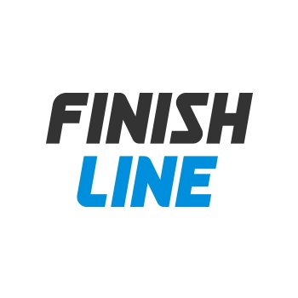
1.1 | WT Schedule Input |  |  |  | 07/07/2020 | L.PRADA | L.PRADA |  | -
1.0 | FOR INFORMATION |  |  |  | 07/03/2020 | L.PRADA | L.PRADA |  | -
REV. | PURPOSE |  |  |  |   DATE | BY | CHK. |  | APPD.


 |  |  | PROJECT NAME: Finish Line
 |  |  | PROJECT NUMBER: 20WT0002
 |  |  | DOCUMENT TITLE:
 |  |  | PROJECT SCHEDULE
NA Projects
All the information contained in this document is confidential and property of Certius and the totally or partial copy or reproduction of it is prohibited without previous authorization. |  | DOCUMENT N°: |  |  |  |  |  | Revision
 |  | 20WT0002-PLAN-SC-0001 |  |  |  |  |  | 1.1
 |  |  |  |  |  |  |  | Page 3 of 4
© CERTIUS
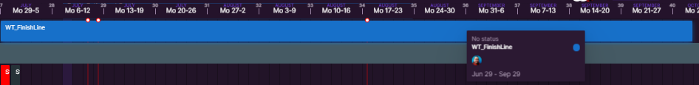
SCHEDULE - WATERFIELD TECHNOLOGIES

Estimated Finish Date
IVR Development Aug 17th
ChatBot Development Aug 20th
Overall QA Sep 8th
(Includes Waterfield
English QA and
Certius Spanish QA)
UAT Sep 29th

SCHEDULE - CERTIUS
National Holidays
July 9th and 10th
Aug 17th

