 | 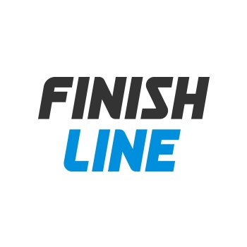
1.0 | FOR INFORMATION |  |  |  | 08/19/2019 | L.PRADA | L.PRADA |  | -
REV. | PURPOSE |  |  |  |   DATE | BY | CHK. |  | APPD.


 |  |  | PROJECT NAME: Finish Line
 |  |  | PROJECT NUMBER: 20WT0002
 |  |  | DOCUMENT TITLE:
 |  |  | PROJECT SCHEDULE
NA Projects
All the information contained in this document is confidential and property of Certius and the totally or partial copy or reproduction of it is prohibited without previous authorization. |  | DOCUMENT N°: |  |  |  |  |  | Revision
 |  | 20WT0002-PLAN-SC-0001 |  |  |  |  |  | 1.0
 |  |  |  |  |  |  |  | Page 3 of 4
© CERTIUS
SCHEDULE - WATERFIELD TECHNOLOGIES
Estimated Finish Date
IVR Development July 7th
ChatBot Development July 17th
Overall QA Aug 8th
(Includes Waterfield
English QA and
Certius Spanish QA)
UAT Aug 24th

SCHEDULE - CERTIUS
National Holidays
July 9th and 10th
Aug 17th

