**Julito Dela Cruz Surio**

03 Saint Vincent, Holy Spirit, Quezon City

Contact: 09557920558

July 23, 2025

Concentrix

Dear Jesalyn Guiampaca

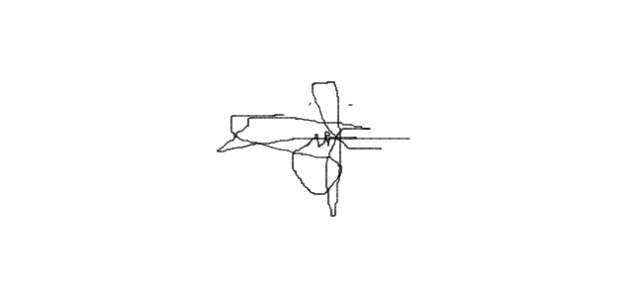I am immediately resigning from my position as a Customer Representative effectively since July 21, 2025 due to relocation of my current address. I’ve got a family problem that force me to make an unfortunate decision to go to my province for the main time in order to settled my problem and make a self realization, I enjoyed a year working with you and my colleague but also threaten me as part of a big family, I will keep and cherish the memories and learning that I’ve got during the days working with the company specifically to our LOB. I sincerely apologize about the negative impact to production but I hope and praying for your understanding about my situation.

Sincerely;

Julito D. Surio