CPE 372/641 Natural Language Processing

**Homework Assignment 1**

**Regular Expression, Finite State Automata and Minimum Edit Distance**

Due on February 8, 2020 via Piazza

*(please name your homework pdf file “hw1xxxxxxxxxxx(yourid))*

1. From the English money expressions that we saw below, complete the FSA to handle the amount up to $ 1,000,000. Make sure that “dollar” and “cent” have the proper plural endings when appropriate (6 points).



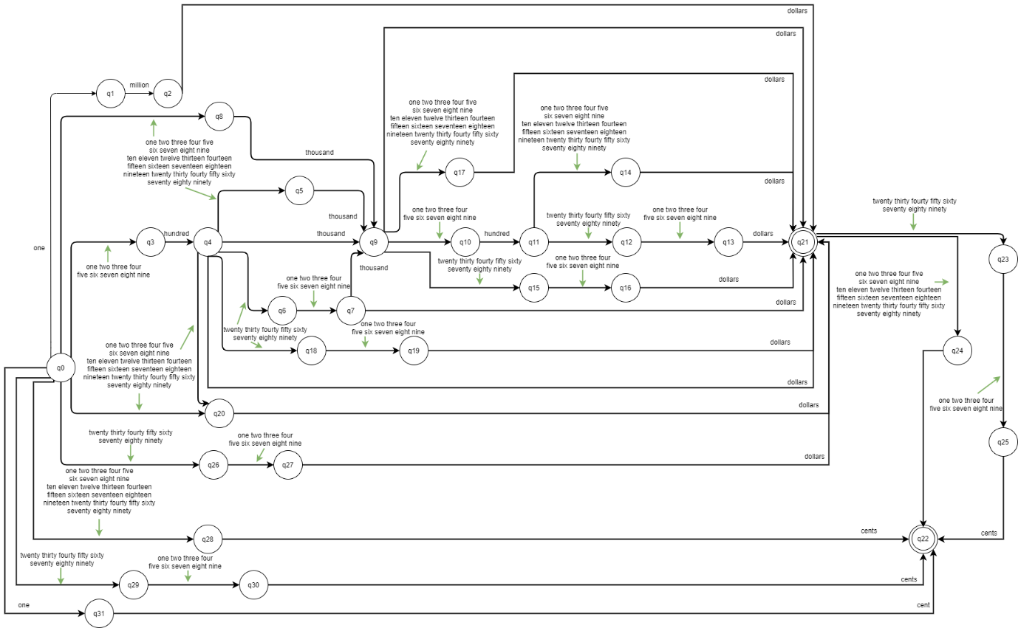

Link for FSA : <https://drive.google.com/file/d/1HyKP88EpC-Z6qtJnXtFPu7m6PhjCo1p3/view?usp=sharing>

1. Based on what we learn about minimum edit distance, compute the minimum edit distance matrix for OSLO – SNOW cost: insert=1, delete=1, substitute=1 (4 points).

