Phần 1
Câu 1:
a)
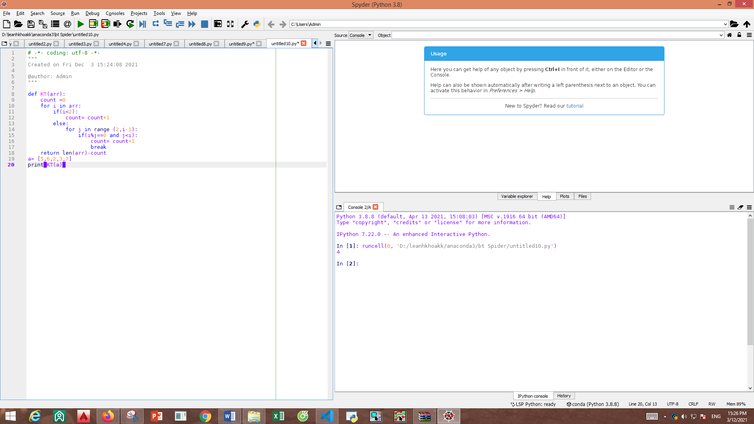
Phần 2:
Câu 2:PHẦN SQL
SELECT c.city, SUM(c.grade) sum_of_grade from customer c group by c.city - select * from customer c join salesman s on c.salesman_id = s.salesman_id where s.commission > 0.12 order by c. customer_id

