[Sumo Arena]
[The Countdown Begins]  Timer function in Champion  Type: When this actor is created  Name: Timer  Create a new Owner variable `timer` with default value 20  Set timer to 20  Countdown function in Champion  Type: Every x seconds  Name: Countdown  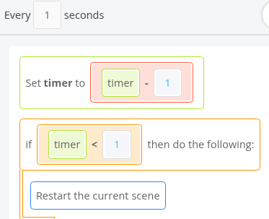  Label function in Champion  Type: When this actor is updated  Name: Labels  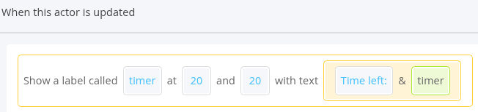  — Save Checkpoint —  [The Challengers Emerge!]  Create a Custom function `Direction` in Challenger  Type: Custom  Name: Direction  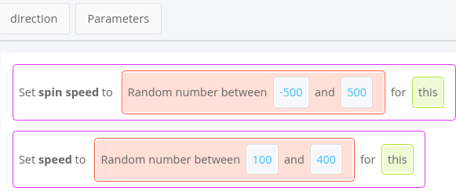  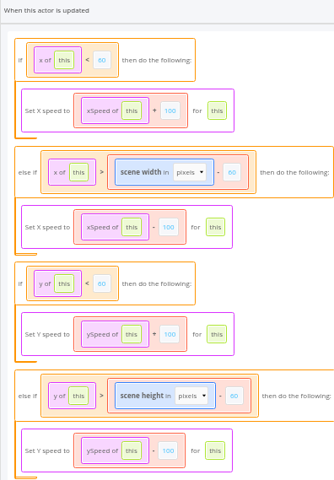  [That’s a knock Out!]  Create the Defeat function inside the Challenger  Type: When the actor is updated  Name: Defeat  Create a new game variable `score` with default value 0  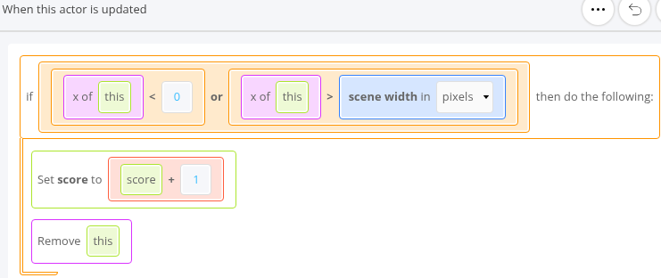  [A New Level]  Add scene  Name: Level 2  Cells across: 20  Cells Down: 20  Be sure to add a bunch of challengers to make it a challenge! Can you defeat them all within 20 seconds?  [Starting Over]  Our score should reset if we lose! We should also go to the first level so it is not too hard when we restart.  Edit the Countdown function in Champion  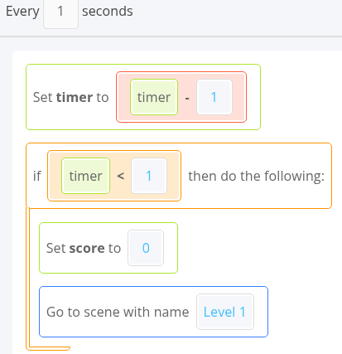  [High Score]  Let's have a record for how many challengers we've knocked out of the levels!  There won't be too much to having a high score!  1. Make a high score game variable.  2. Update the variable  3. Show the high score | [The Challengers Emerge!]  Create Start function inside Challenger actor  Type: When this actor is created  Name: Start  Drag `Call direction` from CUSTOM into the codebox  — Save Checkpoint —  Edit `Direction` function inside the Challenger actor  Drag `Do actions after some time` from `LOGIC` into codebox  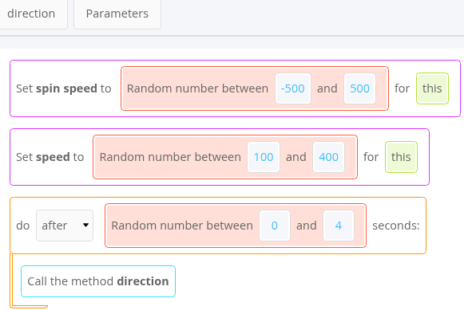  — Save Checkpoint —  [Not that easy!]  Let add some challenge: If the challengers sense that they are too lose to the edge, they will move away from it.  Create the Border AI function inside the Challenger actor  Type: When the actor is updated  Name: Boarder AI  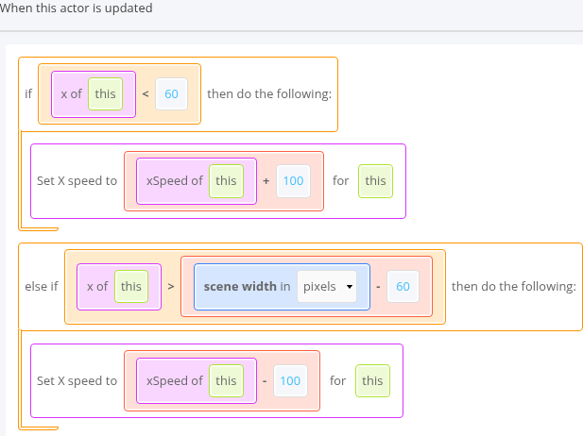  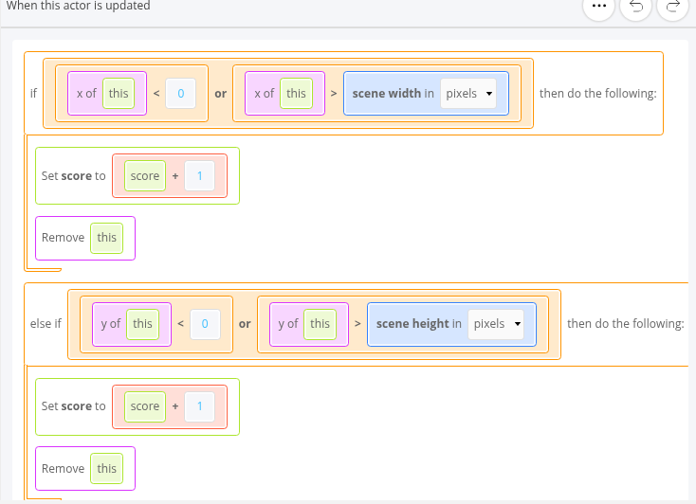  [How many so far?]  Challengers all done. Let’s make it possible to see how many challengers defeated.  Edit the Labels function inside the Champion  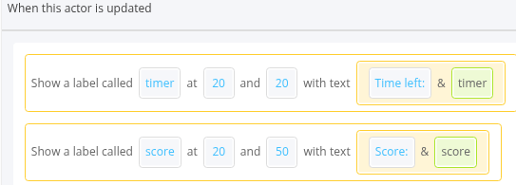  [ Onto the round]  If challenger<1, move onto the next level  Create the Win function under Champion  Type: When this actor is updated  Name: Win  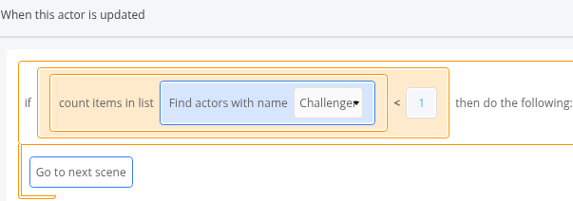  — Save Checkpoint —  [Extra content]  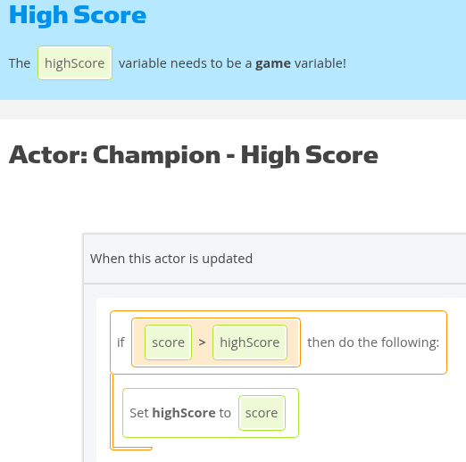  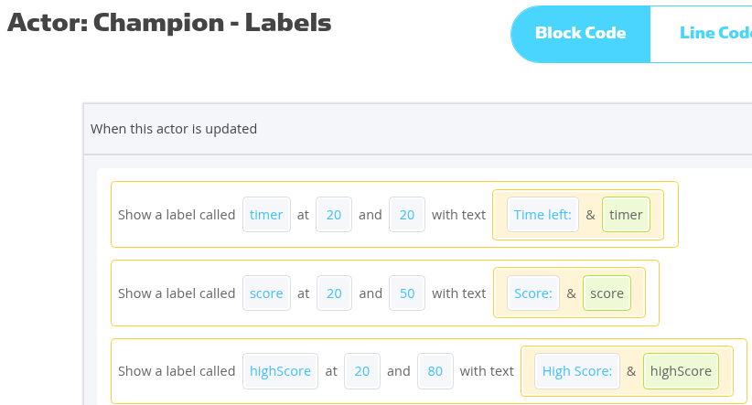  — Save Checkpoint —
Extension / Additional Notes
Purpose / Goal: [What are you trying to achieve?]
Key Concepts: [Variables / functions / events / conditions / etc.]
Important Changes: [What changed from last week?]
Troubleshooting / Gotchas: [Problems, fixes, things to remember]
Final Result: [What should work at the end?]
Good Luck!

