Jelly Jump
Demo
It's time to show students what they'll be creating this week!
Click here to play Jelly Jump!
How to Play
- Press down on the level in order to charge your jump
- Release for the slime to jump
- Hit the springs to bounce to the left
Objectives
- Reach the flag and move on to the next level in as few attempts as possible
Current Code
What code is currently in our game?
Jelly Actor
Setup
Some basic setup is done here. We're making the camera follow our slime around just in case the level is too big to fit on our screen. We also want to make sure we don't start flipping around. Our scene gravity is set to make us fall down at a speed of 800. There are some variables we set here as well. The charging variable is used to check if we can charge a jump and the speed variable is used for telling the game how much we want our slime to jump.
Release
This function is a little bit complicated! We'll be using it when we want our slime to jump into the air. We only want to jump if we're charging a jump. If we are, then we need to jump and since we want to move right, we'll also set the x speed in addition to jumping. Since our code later will change how big the slime is, we'll also set it back to the default - 1. Finally, the function tells the game we're no longer charging a jump.
Reset
This function is used to reset the value of two variables - charging and speed
Flag Actor
Setup
All this function does is it makes sure our flag never moves out of position when we don't want it to! It can't fall by gravity and can't accidentally hit any actors.

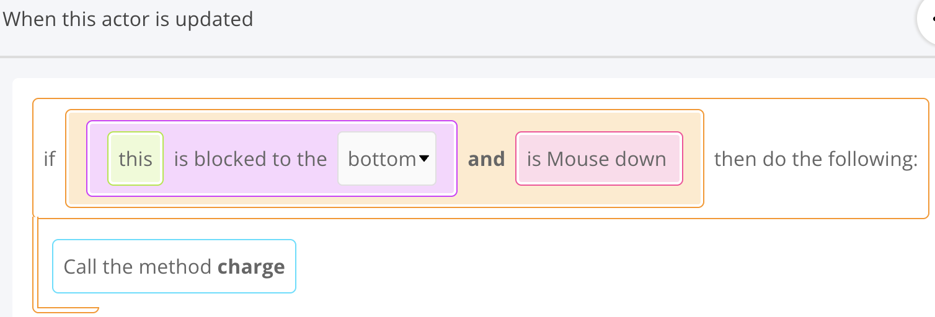
Jelly Actor
>1 tell the game what should happen when we try to charge our slime-> Create Charge function

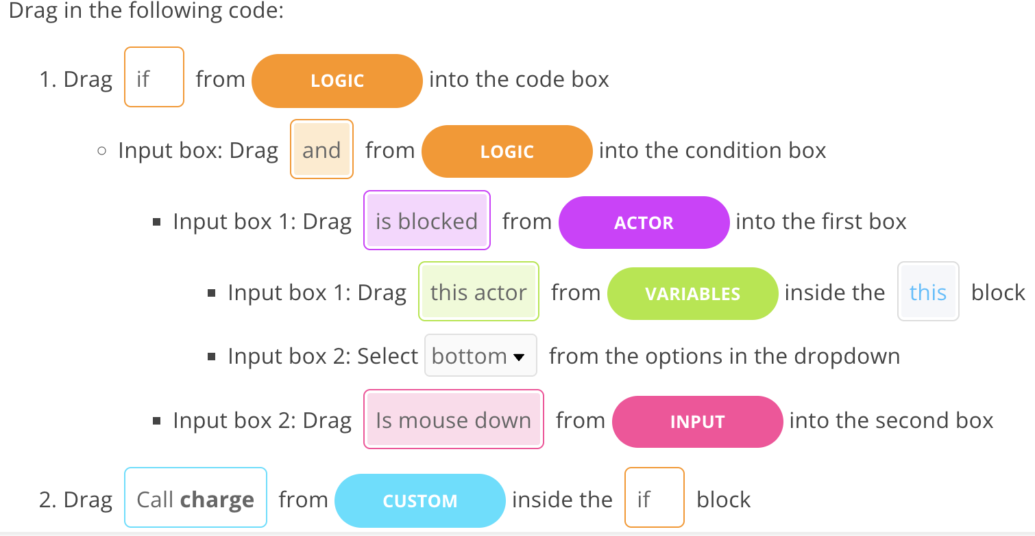

>2 Create the Jump function inside the Jelly actor

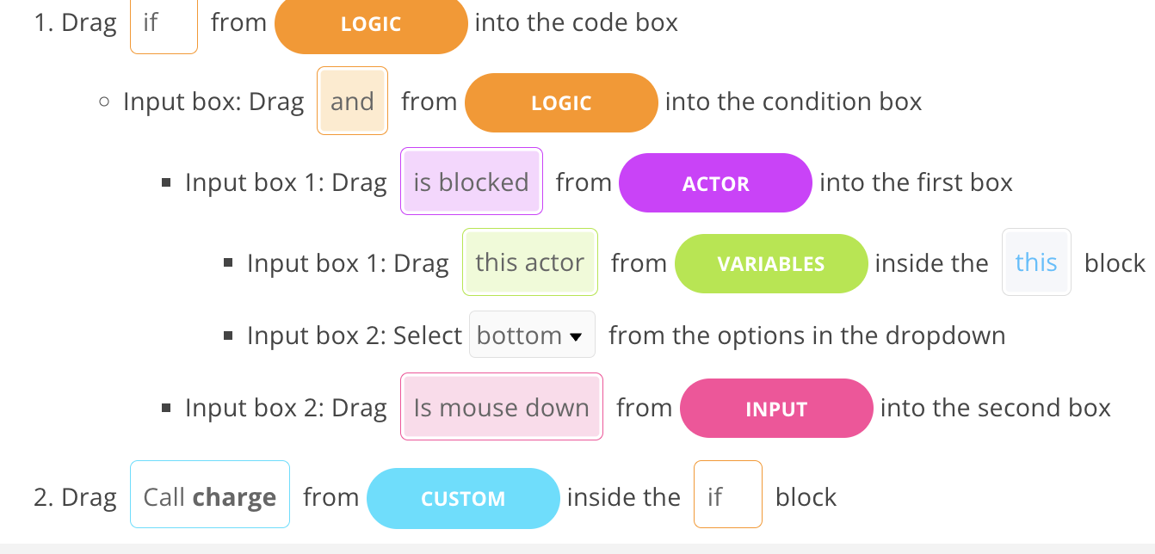

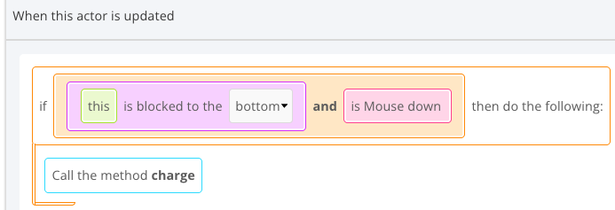

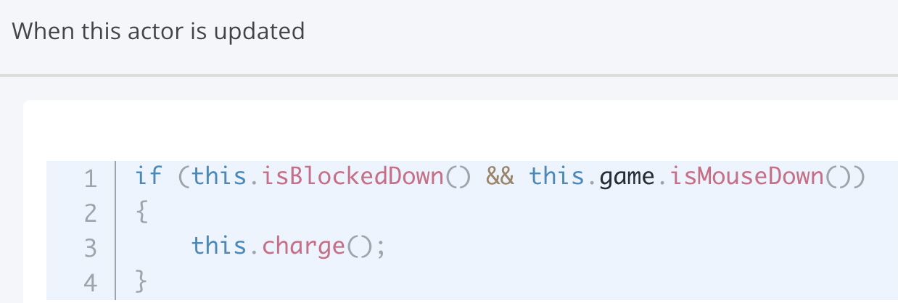

>3. Add Release function in Jump function
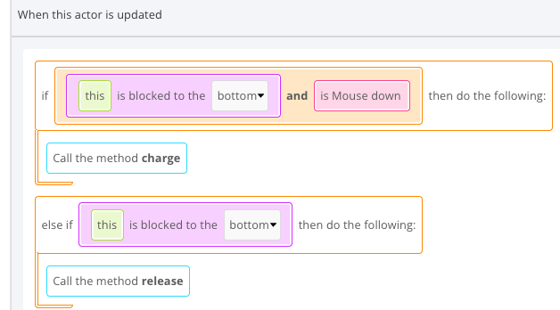
The above won’t work but why? Because we have not been charging. In our `Setup` function, it is set to false. Fortunately, we have another function called Reset which we can use to change the value to true!

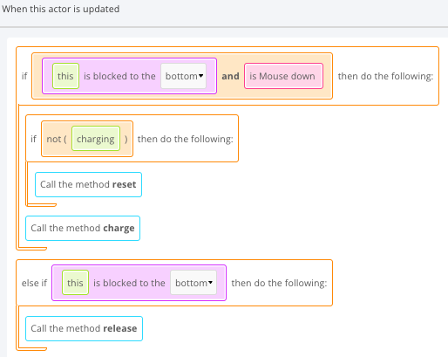
Now we can jump but we need to fix charging.
The Problem
If we charge for long enough, our slime acts funny.
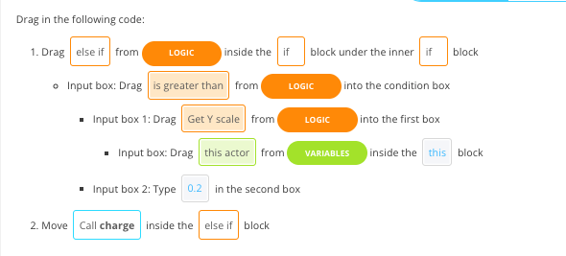
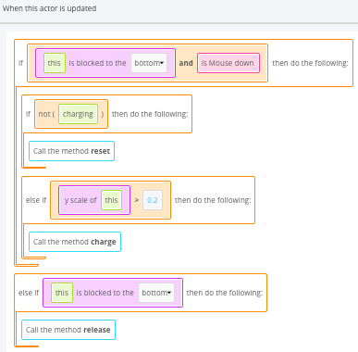
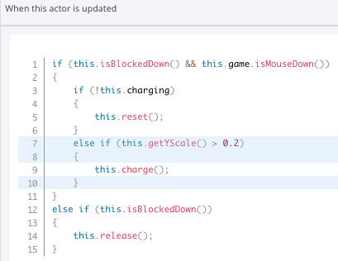
Let's make sure we can't do that with an extra check in our Jump function!

Hit save. Try jumping once. Then again.

Not working?
The code we'll be adding next might not do anything for you!
Whenever our slime is touching the ground, we should be able to jump. If you can only ever jump once in your whole game, you'll want to follow these steps!
If you're able to jump more than once, you can skip this. If you can't, though, follow along with the steps to fix the jumping!

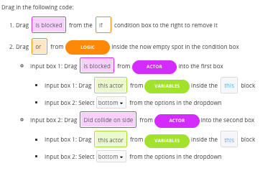

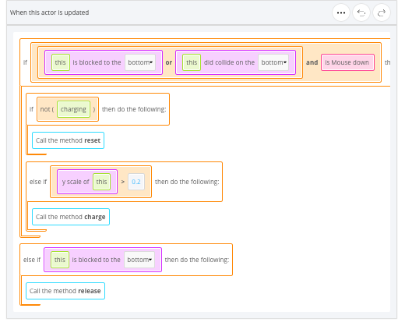
\

Test it out. Make sure you can jump multiple times

Create Restart function for Jelly Actor
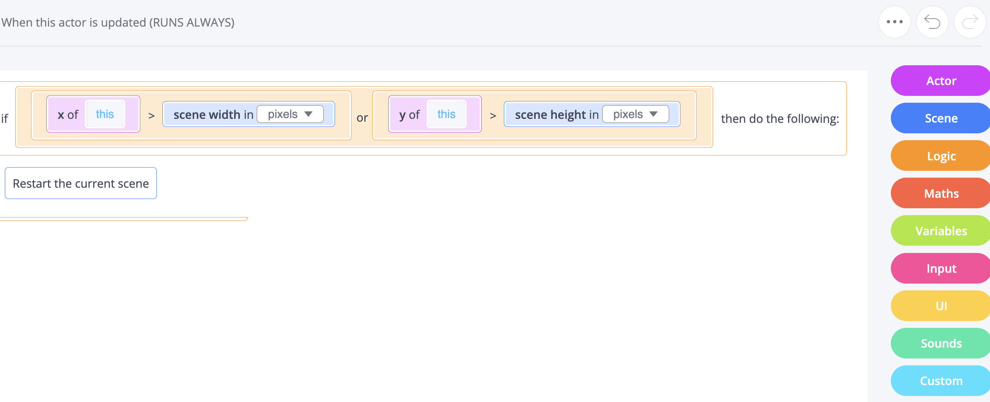
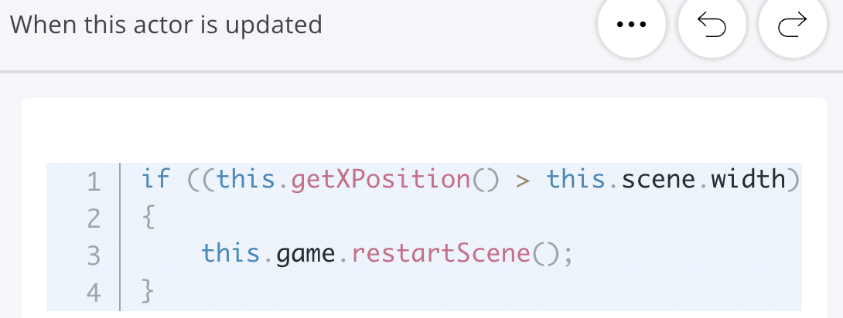

Flag Actor
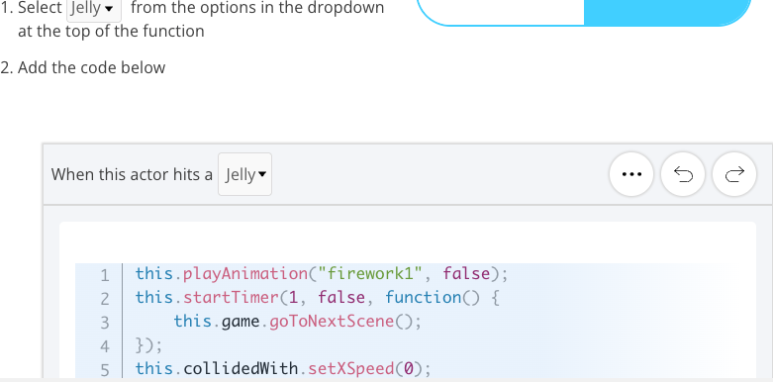
Create the Win function for flag actor
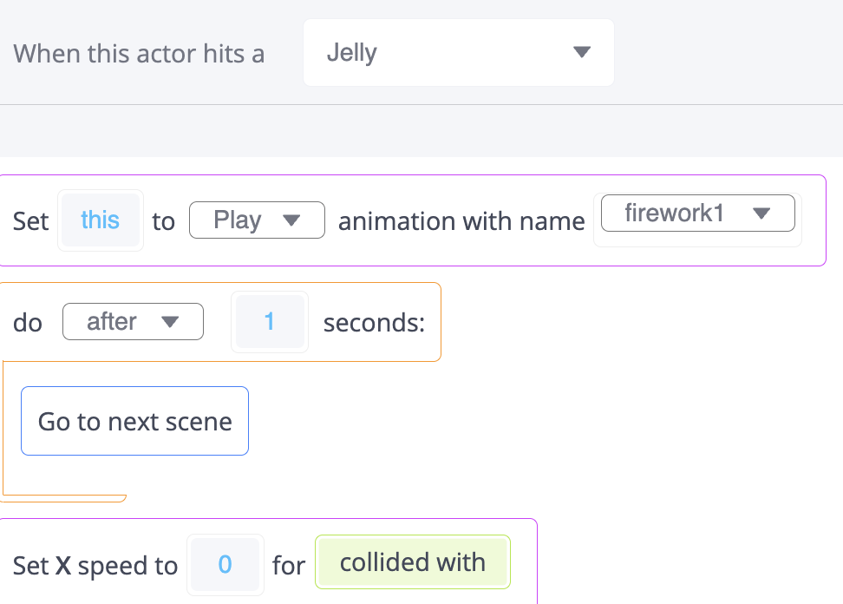

Create a new actor Spring

Go to Level 3

Drag in a copy of your Spring actor into the Level 3
You'll want to make sure that you place it in spots you'll want to bounce off.
This actor will bounce us to the left whenever we hit it so put it somewhere on the wall that you're aiming to jump to bounce off of!

Code a Setup function inside Spring actor (set gravity, sensor, direction etc)
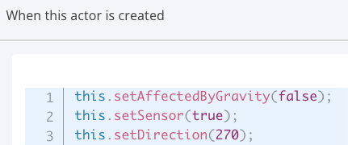
Back to Jelly actor, time to bounce when one actor hit another
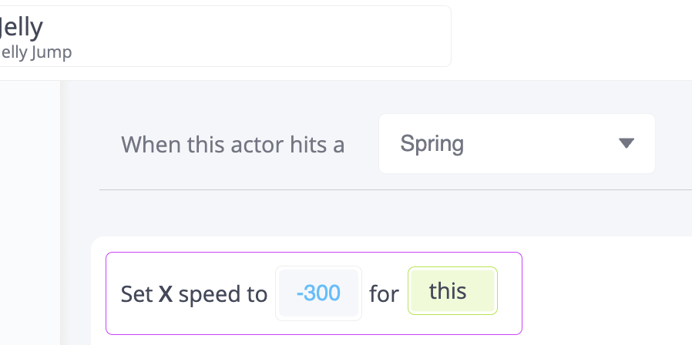

Slipping and Sliding
Right now, when we land on grass, we slide. It only really makes sense for that to happen in ice levels (like levels 2 and 3)
We'll be using a variable in our game so that it can check if we're allowed to slide or not. If it's not an ice level, then we'll set our x speed to 0 when we hit a tile.

Create a new game variable iceLevel first.

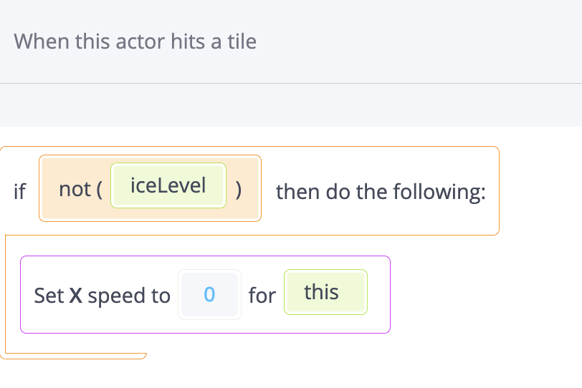

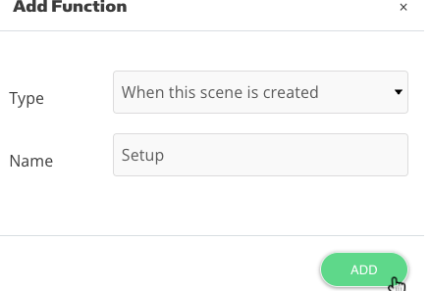
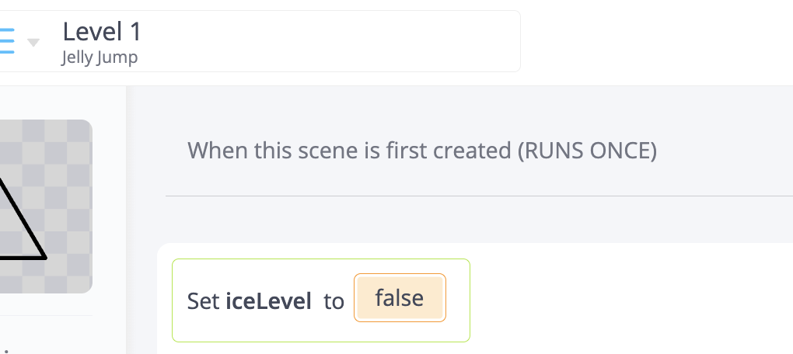
Back to level 1 scene create the setup function

Counting attempts. To this end, create 3 new variables.
We'll want to set all of them in the Setup function
The attempts variable should start off at 1.
The startX and startY variables should start off at where the slime is (get the x and y position!)

