|  |  |  |  |  |
| --- | --- | --- | --- | --- |
| Student Name |  | Student Number | |  |
| Unit Code/s & Name/s | ICTNWK543 Install, operate, and troubleshoot medium enterprise switches  ICTNWK542 Install, operate, and troubleshoot medium enterprise routers | | | |
| Cluster Name  *If applicable* | Network Infrastructure | | | |
| Assessment Name | Switches | Assessment Task No. | | 3 of 4 |
| Assessment Due Date |  | Date submitted | | / / |
| Assessor Name |  | | | |
| **Student Declaration:** I declare that this assessment is my own work. Any ideas and comments made by other people have been acknowledged as references. I understand that if this statement is found to be false, it will be regarded as misconduct and will be subject to disciplinary action as outlined in the TAFE Queensland Student Rules. I understand that by emailing or submitting this assessment electronically, I agree to this Declaration in lieu of a written signature. | | | | |
| Student Signature |  | | Date | / / |

|  |  |
| --- | --- |
| **Instructions to Student** | **General Instructions:**  This written assessment contains six (6) part:   1. ICTNWK542_ICTNWK543_AT3_Part1_yourname.docx 2. ICTNWK542_ICTNWK543_AT3_Part1PT_yourname.pkt 3. ICTNWK542_ICTNWK543_AT3_Part2PT_yourname.pkt 4. ICTNWK542_ICTNWK543_AT3_Part3PT_yourname.pkt 5. ICTNWK542_ICTNWK543_AT3_Part4PT_yourname.pkt 6. ICTNWK542_ICTNWK543_AT3_Part5RPT_yourname.docx   The answers required for these tasks shall be written in plain English, using language that is understandable by a person of a technical level suitable for the case study.  **Materials to be Supplied:**  For the student to successfully complete this assessment they will need to acquire:  A computer system installed with a current desktop operating system with appropriate internet browser, and office suite able to save in Microsoft Word .docx format  Internet access  Cisco Packet tracer software  Uptown IT documentation, located in the course hub in Connect    **Work, Health and Safety:**  TAFE Queensland student rules are designed to ensure that learners are aware of their rights as well as their responsibilities. All learners are encouraged to familiarise themselves with the TAFE Queensland student rules, specifically as they relate to progress of study and assessment guidelines.  Student rules: <http://tafeqld.edu.au/current-students/student-rules/>  **Assessment Criteria:**  To achieve a satisfactory result, your assessor will be looking for your ability to demonstrate the following key skills/tasks/knowledge to an acceptable industry standard:  Knowledge and understanding of cabling, subnetting, and initial switch configuration  Knowledge and understanding of VLANs, access ports and trunk lines  Knowledge and understanding of VLAN routing  Knowledge and understanding Spanning Tree Protocol (STP)  Understanding troubleshooting |

|  |  |
| --- | --- |
| **Submission details** (if relevant) | **Due:** Week 12 as per unit study guide  Insert your details on page 1 and sign the Student Declaration. Include this form with your submission.  Submit the listed files below as per the instructions in the Connect online learning system stated on the Assessment Task 1 page.  You are to submit six (6) files:   1. ICTNWK542_ICTNWK543_AT3_Part1_yourname.docx 2. ICTNWK542_ICTNWK543_AT3_Part1PT_yourname.pkt 3. ICTNWK542_ICTNWK543_AT3_Part2PT_yourname.pkt 4. ICTNWK542_ICTNWK543_AT3_Part3PT_yourname.pkt 5. ICTNWK542_ICTNWK543_AT3_Part4PT_yourname.pkt 6. ICTNWK542_ICTNWK543_AT3_Part5RPT_yourname.docx   TAFE Queensland Learning Management System:  Connect url: <https://connect.tafeqld.edu.au/d2l/login>  Username; 9 digit student number  For Password: Reset password go to: <https://passwordreset.tafeqld.edu.au/default.aspx> |
| **Instructions to Assessor** | **Student will Require:**  Simulated work environment where assessment can be conducted  Computer applications currently used in industry  Support resources, including online, manuals, organisations policies and procedures, and training booklets  A computer system with a suitable current OS and access to the internet  Cisco Packet tracer software and OS ISO files  **Work, Health and Safety:**  TAFE Queensland student rules are designed to ensure that learners are aware of their rights as well as their responsibilities. All learners are encouraged to familiarise themselves with the TAFE Queensland student rules, specifically as they relate to progress of study and assessment guidelines.  Student rules: <http://tafeqld.edu.au/current-students/student-rules/> |

|  |  |
| --- | --- |
|  | **Level of Assistance:**  Teachers and tutors should be available in class, and accessible by email for students working from home. Staff cannot directly show students answers but guide them to where to go to complete tasks individually. The teacher will make reasonable adjustment for students, as and when appropriate, after consultation with the Disability and Counselling team.  **Assessment Criteria:**  See Marking Criteria on Connect  Assessors of this unit must satisfy the requirements for assessors in applicable vocational education and training legislation, frameworks and/or standards. |
| **Note to Student** | An overview of all Assessment Tasks relevant to this unit is located in the Unit Study Guide. |

## PART 1 Cabling, Subnetting, and Initial Switch Configuration

**Case Study 1**

The initial portfolio file is a LAN at a business. The LAN consists of two fast switches (Distrib1 and Distrib2), three switches for end-devices (Access1, Access2 and Access3) and one router which is used to separate broadcast domains. The end-devices are broken into two main subnets: Human Resources (HR) and Sales. Each subnet has a number of PCs and one workgroup server. A diagram of the LAN is shown below.

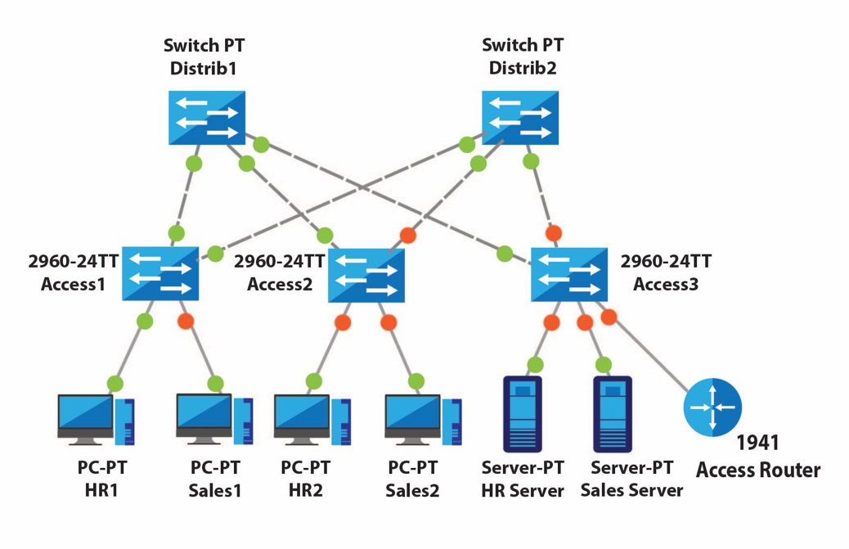

277956620 / TechnoVectors / shutterstock.com. Modified by TAFE Queensland

Here are all the subnets and the associated devices in the design.

* **HR:** Contains HR1 PC, HR2 PC, HR Server, and associated interface for the Access Router.
* **Sales:** Contains Sales1, Sales2, Sales Server and associated interface for the Access Router.
* **Management:** Contains virtual LAN interfaces for Access1, Access2, Access3, Distrib1, Distrib2 switches and associated interface for the Access Router.

Prior to commencement, please refer to the Uptown IT ICT policies and Procedure’s document.

Download the following files from the Connect LMS.

* ICTNWK542_ICTNWK543_AT3_Infromation_LHO_TQM_v1 – This file contains the IP address allocation and VLAN information.
* ICTNWK542_ICTNWK543_AT3_TasksTemplates_LHO_TQM_v1 – This file is a template file, which has to be renamed as ICTNWK542_ICTNWK543_AT3_Part1_yourname.

**For this first part of the assessment, you are to:**

1. Select a Network IP Address and subnet then apply the selected IP address allocation into at least three equal-sized subnets. Allocate one subnet for HR, one subnet for Sales and one subnet for Management. Make sure to show your workings of the subnet working exercise.
2. Allocate IP addresses and subnet masks to all devices in the network as follows:
3. The router will be in all subnets, and it must have the first usable IP address of all three subnets.
4. The PCs and servers must be given a default gateway, which is the router’s IP address on that subnet.
5. The switches virtual LAN interface 90 will be allocated IP addresses from the Management network.
6. Complete the tables with the names of all devices, their IP address, subnet mask and gateway IP address.
7. Submit template to supervisor (teacher / assessor) for approval prior to proceeding.

Save the template file as **ICTNWK542_ICTNWK543_AT3_Part1_yourname.**

**Creating a Packet Tracer file for Part 1**

Open Packet Tracer and complete the following:

1. Configure all end devices with the IP addresses, subnet masks and gateways from the table you have completed. You do not need to put IP addresses on the router. Confirm that the end device PCs and servers are configured correctly by logging into the devices and pinging between the devices in the same subnet.
2. Set up the initial configuration of the switches and the router:
3. Configure the hostname of each device. Use the labels in the diagram as your hostnames: Access1, Access2, Distrib1 etc.
4. Configure the privileged password to be ‘class’ and the password console and vty password to be ‘cisco’
5. For each switch, configure the virtual LAN interface 90 with an IP address from the Management subnetwork.
6. Copy the running configuration of each device to start-up configuration.

Save the Packet Tracer file as **ICTNWK542_ICTNWK543_AT3_Part1PT_yourname.**

**IMPORTANT**

**PART 5** of this assessment is a troubleshooting reflection requirement where you write a simple report of the problems you encounter, your methodology in diagnosing the problems, and how you went about rectifying them.

Therefore, as you proceed through Parts 1 to 4 keep notes of problems you have encountered, and how you identified and rectified them.

## PART 2 VLANs, Access Ports and Trunk Lines

For this part of the assessment, your teacher will provide you with a set of VLAN names and numbers which you need to apply to your network. This information can be found on Connect LMS in the file **ICTNWK508_AT2_Information_LHO_TQM_v1.**

With the Packet Tracer file, you created in Part 1, you will need to complete the following:

1. On each switch, configure the VLAN names and numbers.
2. Configure the ports that are connected to end-devices to be access ports which have the correct VLAN number.
3. Configure the links between switches to be trunk links that can pass traffic for all VLANs.
4. Configure the link between the Access3 switch and the router to be a trunk link. At the moment you can only configure the switch side of this link.
5. For each switch, configure the virtual LAN interface 90 with an IP address from the Management subnetwork.
6. Setup the default gateway for each switch using the Management network IP Address of the Access Router interface.
7. Copy the running configuration of each device to start-up configuration.
8. Confirm that the VLANs are working by using the appropriate ‘show’ commands on the switches to look at the VLANs, the state of each switch port and the trunk links. End devices in each VLAN must be able to ping all the other devices in the same VLAN.

Save the Packet Tracer file as **ICTNWK542_ICTNWK543_AT3_Part2PT_yourname.**

## PART 3 Inter-VLAN Routing

In the part of the assessment, you will configure the Access Router to act as the router that connects all the VLANs together. To do this, you need to open the Packet Tracer file, you saved in Part 2, and complete the following:

1. Bring up the appropriate physical interface on the router, but with no IP address.
2. Configure a sub-interface for each VLAN with an appropriate IP address, subnet mask and VLAN number.
3. Copy the running configuration of each device to start-up configuration.

Confirm that inter-VLAN routing is working when every end-device in the network can ping every other end-device in the network.

Save the Packet Tracer file as **ICTNWK542_ICTNWK543_AT3_Part3PT_yourname.**

## PART 4 Spanning Tree Protocol (STP)

In the fourth part of this assessment, you will set rapid spanning tree on all switches in the network, choose root switches, and configure a management VLAN. To do this, you need to open the Packet Tracer file, you saved in Part 3, and complete the following:

1. Enable spanning tree protocol (STP) on every switch in the network.
2. Configure Distrib1 to be the primary root switch for the HR network and the secondary root switch for the Sales network.
3. Configure Distrib2 to be the secondary root switch for the HR network and the primary root switch for the Sales network.
4. Copy the running configuration of each device to start-up configuration.

Save the Packet Tracer file as ICTNWK542_ICTNWK543_AT3_Part4PT_yourname.

## PART 5 Troubleshooting Reflection

As the last part of this assessment, you need to demonstrate that you have acquired:

* Troubleshooting skills to diagnose problems in your network,
* Apply a troubleshooting methodology to isolate and identify problems, and
* Rectify these problems.

To do this, prepare a short report (between one and two pages) about one significant problem that you encountered during the previous parts (1-4) of this assessment task. In your report, make sure that you provide these details:

1. What was the symptom (or symptoms) of the problem that you encountered?
2. What troubleshooting methodology did you use to help isolate and identify the problem?
3. Describe the steps that you took, in detail, to find the problem. Explain how these steps show the use of your troubleshooting methodology.
4. Describe the tools and commands that you used to diagnose the problem and test that you have solved the problem.
5. Seek review and respond to feedback from your supervisor, document the interaction.

Save the document file as **ICTNWK542_ICTNWK543_AT3_Part5RPT_yourname.**

## Submission checklist:

You are to submit the following six (6) files:

1. ICTNWK542_ICTNWK543_AT3_Part1_yourname.docx
2. ICTNWK542_ICTNWK543_AT3_Part1PT_yourname.pkt
3. ICTNWK542_ICTNWK543_AT3_Part2PT_yourname.pkt
4. ICTNWK542_ICTNWK543_AT3_Part3PT_yourname.pkt
5. ICTNWK542_ICTNWK543_AT3_Part4PT_yourname.pkt
6. ICTNWK542_ICTNWK543_AT3_Part5RPT_yourname.docx