Project Part 1: Designing a BNF Grammar for a Simple Programming Language
Course Code: BCS 222 |  | Course Name: Programming Paradigms
Date: 02/25/2025 |  | Time: 1
Location: |  | Instructor(s): Dr. Haythem El-Messiry
Number of Students: |  | Number of Pages:

Course Learning Outcomes | PLOs | Quizzes | Project | Mid term | Final exam
CLO1. Identify programming paradigms of functional, logic, and object-oriented programming languages. | 1 | X |  | X
CLO2. Design software using constructs of functional, logic, and object-oriented programming languages. | 3 |  | X | X | X
CLO3. Apply concurrency, synchronization and event handling constructs to solve synchronization problems. | 7 | X | X |  | X
CLO4. Analyze the behavior of programs written in functional, logic, and object-oriented programming languages. | 2 |  | X
CLO5. Exhibit effective writing and presentation skills in a teamwork project. | 4, 6 |  | X

Students (double-click to edit grades)

Objective:
The aim of the project is to explore the syntax of a simple programming language by defining its grammar using Backus-Naur Form (BNF). Students will design the BNF notation and implement a parser in Python to validate code snippets written in this language.
Project Details:
- Language Specification: Define a simple programming language that includes the following constructs:
  - Variable declaration (e.g., int a;, float pi;)
  - Assignment statements (e.g., a = 5;, pi = 3.14;)
  - Basic arithmetic operations (addition and subtraction)
  - Print statements (e.g., print(a);)
  - Control flow structures (if statements):
    - Conditional statements (e.g., if (a > 0) { print(a); })
- Define the BNF Grammar: Create a BNF grammar that describes the syntax of the language you designed.
- Implementation Requirements:
  - Write a Python program that uses the BNF grammar to parse a set of predefined code snippets.
  - The program should output whether each snippet adheres to the defined syntax and, if not, provide a meaningful error message.
- Code Snippets: Provide at least 5 code snippets illustrating valid syntax and 3 snippets illustrating common syntax errors.
- Documentation: Each student must submit a report that includes:
  - An explanation of the BNF grammar they created.
  - A brief description of how their parser works, including any libraries or techniques they used.
  - Example outputs from running their parser on the provided code snippets.
Deliverables:
- Python code implementing the parser.
- A well-documented BNF grammar specification.
- A report detailing the grammar design and implementation findings.
Grading Criteria:
- Correctness of the BNF grammar (25%)
- Functionality and correctness of the parser implementation (50%)
- Clarity and thoroughness of documentation (25%)

Rubric
Criterion | Needs Improvement  [0-3] | Good  [4-6] | Excellent  [7-10]
Coding & Report  (5%) | The code does not work properly, many requirements are missing, and the report does not detail the grammar design. | The code works partially and implements some of the requirements; the report shows some testing scenarios. | The code works fully and as expected per the requirements and the report shows all testing scenarios and full detail the grammar design.

BNF GRAMMAR

<Digit> = 0 | 1 | 2 | 3 | 4 | 5 | 6 | 7 | 8 | 9
<Alphabet> = A | B |C |D |E |F |G |H|I |J |K |L |M |N |O |P |Q |R |S |T |U |V |W |X |Y |Z | |a |b |c |d |e |f |g |h |i |j |k |l |m |n |o |p |q |r |s |t |u |v |w |x |y |z
<Math_OPS> = - | + | / | * | = | ^ | √ | %
<Boolean> = True | False
<Space> = " "
<Comp_OPS> = > | < | <= | >= | = | != | || | &&
<Special_Characters> = ! | @ | # | $ | % | ^ | & | * | ( | ) | _ | { | } | \ | | | [ | ] | : | ; | ‘ | “ | ? | / | > | < | . | , | - | + | = | √ | π

<Empty_Space> = "\n" | "\t" | " "

<NewLine> = \n

<Float> = <Integer> . <Integer>

<Integer> = <Digit> | <Integer> <Digit>

<SubCharacter> = <Digit> | < Special_Characters > | <Alphabet>

<Character> = <Letter> | <Character> <SubCharacter>

<SubString> = <Character> | <Float> | <SubString> <Character> | <Float>

<String> = <SubString> |< space>

<Type> = <Float> | <Integer> | <String>

<IdentifierStart> = <Alphabet> | _

<IdentifierEnd> = <Digit> | _| <Alphabet>

<identifier> = <IdentifierStart> | <identifier> <IdentifierEnd>

<Value> = <Integer> | <Float> | <String>

<Variable> = <Type> <identifier> = <Value>

<expr> = <Term> | <expr> < Math_OPS > <Term>

<Term> = <Factor> | <Term> * <Factor> | <Term> / <Factor>

<Factor> = <Integer> | <Float> | "(" <expr> ")"

<Print> = "print" "(" <expr> ")"

<IfStatement> = "if" <Condition> ":" <NewLine> <space> <StatementList> <NewLine> <ElseStatement>

<ElseStatement> = "else" ":" <NewLine> <space> <StatementList>

BNF GRAMMAR EXPLANATION:
The grammar defines a language with rules for constructing various elements, such as numbers, strings, identifiers, and expressions. It starts with basic building blocks like <Digit> for digits (0-9) and <Alphabet> for letters (A-Z, a-z). Mathematical operators (<Math_OPS>), boolean values (<Boolean>), comparison operators (<Comp_OPS>), and special characters (<Special_Characters>) are defined for use in expressions and conditions. The grammar also includes rules for spaces, newlines, and empty spaces to handle formatting. Composite structures like <Float> (for decimal numbers), <Integer> (for whole numbers), and <String> (for text) are built from these basic elements. Identifiers (<identifier>) are defined to start with a letter or underscore and can include letters, digits, or underscores. Variables (<Variable>) are assigned values of type <Integer>, <Float>, or <String>. Expressions (<expr>) are constructed using terms (<Term>) and factors (<Factor>), allowing for complex mathematical operations. Control structures like <IfStatement> and <ElseStatement> are included for conditional logic, and a <Print> rule is defined for outputting expressions.

CODE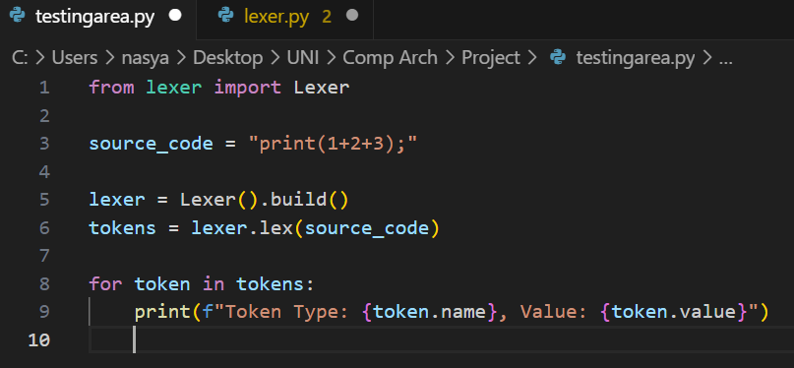
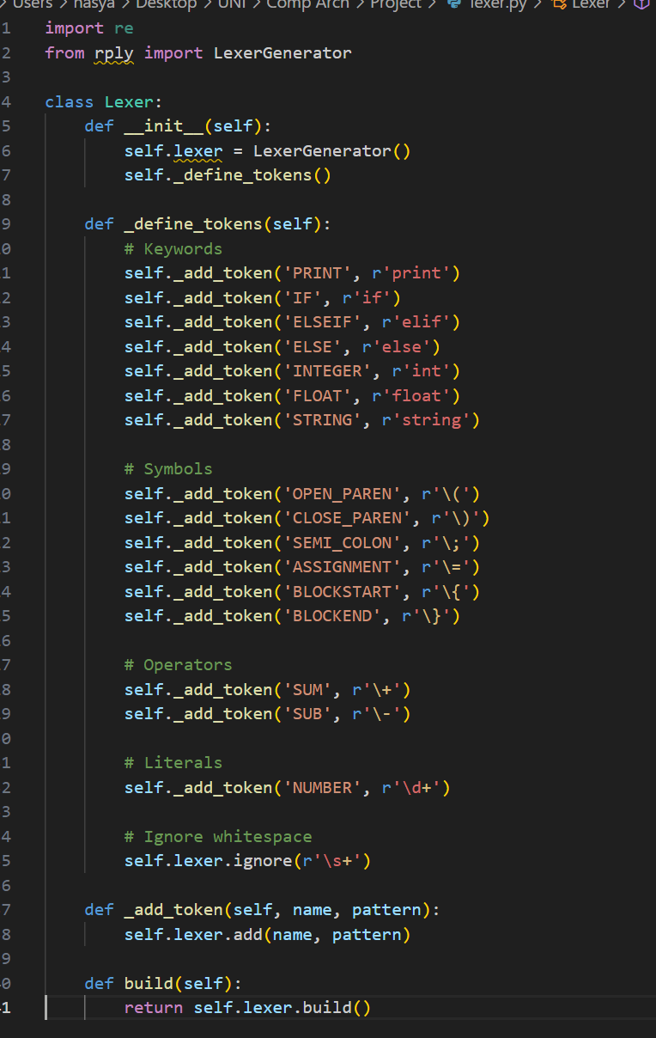

OUTPUT
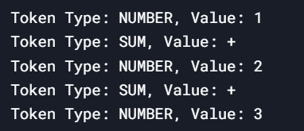

Code Explanation:

The LexerGenerator class of the rply library is used to generate a lexer (tokenizer) that makes it easier to define rules for tokens and process the input text. The self.lexer.add() method is used to specify the token patterns, such as NUMBER for digits and SUM for the addition operator, to which the lexer will look for. The purpose of this is to ignore spaces in the input; they shouldn't affect the tokens. This is achieved using the self.lexer.ignore() method. The build() method finalizes the lexer, making it ready to tokenize input strings. The lexer.lex() method takes in the input (in this case, 1+2+3) and returns a list of lexed tokens according to the rules defined in the lexer file. Each token is given a name (e.g., NUMBER) and a value (e.g., 1), and the type and content of the token can be determined by using these names and values. It shows an example use for reading a string of input, lexing it, tokenizing it and printing it out for debugging or further processing, which is very easy to do when you need to deal with a structured input string.

