**AIM: SCREENSHOT FOR ONLINE FEEDBACK SYSTEM PROJECT**

**Group members**

**Leanne Serrao**

**Pratiksha Ahire**

**Pranita Andhale**

**Ankita Gawade**

**Screenshots:**

1. **Main login page:**

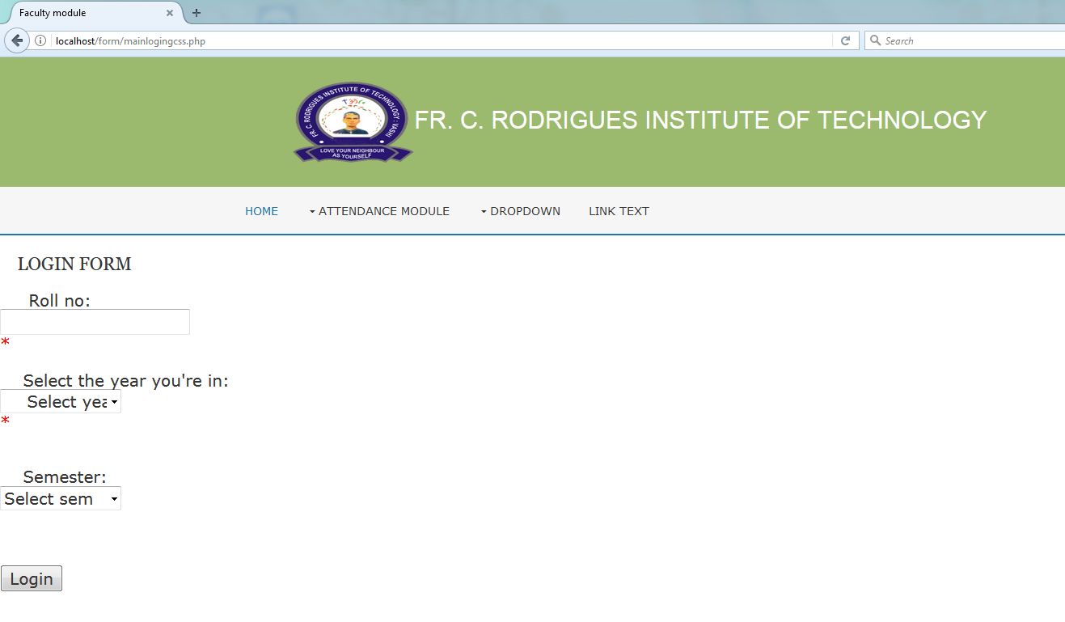$conn = new mysqli($dbhost, $dbuser, $dbpass, $dbname) or die($conn->connect_error);

