Part 1 Introduction to Sociology of the Family

Lecture 1 (11 August): Introduction to Sociology of the Family

Newman, David. 2009. “Defining Families.” Families: A Sociological Perspective, pp. 4-‐ 17. New York: McGraw-‐Hill.

  - Family in an elusive term; its meaning- not to mention how people feel about it and what they expect from one another within it- is socially constructed.
  - A family is always a household, but a household is not always family.
    - Thus, one person cannot be a family as sociological terms wise, families not only consist of individual people but also named relationships
  - Newman : What we believe to be "real" is always a matter of what we collectively define and agree upon as real
  - Berger& Kellner: Your relationships to others become family relationships when you refer to yourselves and treat each other as a family.
  - Hartman: not only those who fall outside the definition of family ineligible for certain benefits, but their relationships may be considered illegitimate, inappropriate or immoral as well
  - Klein & White: families tend to last for a considerably longer period of time as compared to other close groups, families are the only groups that virtually require lifetime membership.

Term | Definition
Households | Persons or groups of people who occupy a dwelling such as a house, apartment, single room, or other space intended to be living quarters.
Family | A group of two or more people related by blood, marriage or adoption and residing together
Nuclear family | A small family unit consisting of a marriage couple with or without children, or at least one parent and his or her children
Extended family | Relatives outside the nuclear family, such as grandparents, aunts, uncles and cousins
Commuter marriage | Marriage in which spouses spend at least several nights a week in separate residences
Kinship | Who is related to whom across generations
Patrilineal descent | Kinship system in which family connections are traced though the father's line
Matrilineal descent | Kinship system in which family connections are traced through the mother's line
Bilateral descent | Kinship system in which family connections are traced through both the father's and mother's line
Common-law marriage | Agreements by which couples who have not had their relationships validated religiously or civilly are considered legally married if they've lived together long enough
Polyandry | A marriage consisting of one wife and multiple husbands
Polygyny | A marriage consisting of one husband and multiple wives.
Social institutions | Patterned ways of solving problems and meeting the needs of a particular society
Fictive kin | People other than legal or blood relatives who play family roles by providing for the emotional and other needs of others

Gerson, Kathleen. 2010. “The Shaping of a New Generation.” The Unfinished Revolution: Coming Of Age in a New Era of Gender, Work, and Family, pp. 1-‐12. New York: Oxford University Press.

Story on Josh
  - Dad became alcoholic, subsequently when his mom got a job, kicked him out of the house. Dad came back, a better man
  - Transition between three types of households, traditional, single-parent, and dual earner
  - Gender revolution: new family forms invented as mothers goes to work, shifts in women's place and new forms of adult partnership have created more options.

Stats
  - By 2000, 60% of all married couples had two earners, while only 26% depended solely on a husband's income, down from the 51% in 1970.
  - In 2006, two-pay check couples were more numerous than male-breadwinner households had been in 1970.
  - In the same period, single-parent homes, majority headed by women, claimed a growing proportion of American households.
  - In 2007, 33 percent of non-Hispanic white children and 60 percent of black children lived with one parent (up from 10% and 41% in 1970)
  - Dual-income and single-parent homes outnumber married couples with sole breadwinners by a substantial margin.
  - Due to influences as divorce rates were increasing and a rising proportion of children were born into homes by single moms or cohabitating but unmarried partners, lifelong marriages (which were once the only socially acceptable option for bearing and rearing children, became one of several alternatives that now include staying single, breaking up or remarrying)
  - Home centred motherhood has been challenged

Factors for changing family types
  - More fluid marriages, less stable work careers, and profound shifts in mothers' ties to the workplaces

Women
  - Work as essential to avoid being trapped in an unhappy marriage or deserted by unfaithful spouse

C.Wright Mills
  - Core focus of "the sociological imagination"- the intersection of biography, history, and social structure.

Lecture 2 (18 August): Conceptualization of the Family

Bernardes, Jon. 1985. “Family Ideology: Identification and Exploration.” The Sociological Review, 33 (2), pp. 275-97. [Available on IVLE]

Manheim
  - The very existence of ' The Family' seems to be part of the 'total structure of the mind' of contemporary society in much the same way as notions of ownership and wage labour seem to be.
  - Suggests that contemporary dominant ideology, which legitimates current economic and social structure, should be conceptualised as also incorporating a total conception of 'family ideology'

Barrett
  - Ideology as part of 'lived experience'. Ideology is not merely a set of ideas but is rather, a necessary component of everyday social practice.
  - Referring to processes by which human social life is made meaningful, Barrett emphasizes beliefs and attitudes which are so deeply embedded in our consciousness that we can hardly avoid drawing upon them

Lynn Segal
  - Our traditional family model of married heterosexual couple with children- based on a sexual division of labour where the husband as a breadwinner provides economic support for this dependent wife and children, while the wife cares for both husband and children- remains central to all family ideology.

Arlene and Jerome Skolnick
Nuclear family model;
  - "the family is assumed to be universal'
  - To be a necessary condition for the survival and stability of any society
  - Elementary unit of society and
  - Biologically determined division of labour
  - Vital to adequate socialisation
  - Asserts that any other 'familial forms' are deviant, pathological and unworkable

"Family ideology"
  - Portrays 'the family' as a universal, biologically based human grouping, performing specific functions and responding to the exigencies of industrialism in terms of internal dynamics.
  - Considered as an vital institution by powerful dominant groups such as State and Church
  - Suggested that it functions to sustain industrial societies and modes of thought appropriate to industrial societies by means of 4 key elements;
    - Sustaining an individualistic mode of thought in contemporary societies
    - Sustaining an essentially naturalistic analysis of human behaviour
    - Facilitates and sustains major forms of differentiation in contemporary societies
    - Idolistic mystification of human social life; creates and venerates an idol of "the family" which mystifies the reality of so called 'family life'

Individualistic element of 'family ideology' (page 281)
  - Each structural location (father, daughter, ect) based upon individualistic orientated ascription, and while replacement or substitution is possible, it is not smooth (adopted child versus biological child)
  - Symbolic interactions has great emphasis on distinction between the "I" and a variety of "others"; delineation of "I" and "self" leads to the idea of private ownership and property
  - Notion of privacy, 'the family' it regarded as private or distinct from the public sphere, 'family' housing is the central means which individuals can exclude not only the wider society but also other 'family' members, and adults should have some 'time to themselves' or even private rooms
  - 'Family ideology' emphasises competition and striving for achievement in a material and individualistic context. The whole idea of 'work' involves the themes of competition, incentive and reward
  - Issue of power. 'family' interactions involves the development, refinement and use of power
  - Contemporary 'family ideology' is centrally based upon the idea of romantic love; and the notion of it is exclusively individualistic. One fall in love with another person rather than a group and exclusivity is extended into our notion of monogamous marriage and prohibition of bigamy and polygamy.
  - 'Family ideology' prescribes a 'healthy' attitude to sex and sexuality.

Naturalistic element (page 283)
  - 'family ideology' tends to come down heavily upon the nature side of the nature/nurture debate
  - Insist upon the biologically determinist view that all women are 'naturally' capable of bearing and raising children
  - Heterolistic as socially constructed

Differentiation element
  - Structures our view of human beings in terms of age, sex and gender
  - Separating the life of each person in terms of developmental sequences related to age (e.g. married to parent, middle age to old.)
    - Differentiation in terms of daily time and space; spatial differentiation which is the division of society into different households
  - Legitimates inequalities of power, authority and apparent wisdom
  - Structuring of personal goals. e.g. life revolves around the achievement of marriage, parenthood and setting up a home
  - Cultural and ethical level' families in less developed or less industrialised one are deemed as inferior

Idolistic mystification
- “Family ideology” is idolistic in that it presents an image or idol of “the family” which is distinct from the reality of the phenomenon it presents.
- Furthermore, it mystifies as it obscure the “lived reality” of our lives.
Gender ideology
  - A key component of both 'family ideology; and 'wage labour ideology'
  - Legitimating the sexual division of labour and ascription of gender identity

Wong, Theresa, Brenda S. A. Yeoh, Elspeth F. Graham and Peggy Teo. 2004. “Spaces of Silence: Single Parenthood and the ‘Normal Family’ in Singapore.” Population, Space and Place, 10 (1), pp. 43-58. [Available in electronic format]

  - Over the last few decades, ‘alternative’ family structures have become an increasingly visible part of the social landscape, and, as Ogden (1999) pointed out, these new forms result from changing demographic and socioeconomic behaviour.
  - Parts of Asia, in particular, have now entered into a period of low or replacement-level fertility. While demographic trends in Asia are often taken to emulate the demographic transition in North America and Europe in terms of falling birth rates, rising age at first marriage and increasing cohabitation, sexual relations outside of marriage, and divorce, the similarities stop at the descriptive level.
  - Hartman (1995) has couched the tension between the state and the family that can arise in these circumstances in terms of a dichotomy between individualism and familism, warning also against a familism in social policy that marginalises and ‘sacrifices’ women to the welfare of the family
  - The ‘family’ is ultimately constructed as the basis of society, from which the values of diligence and filial piety spring. The familism that characterises these societies largely emphasises the patriarchal basis of the family, rather than the concept of love-marriage or conjugalism (Grover and Soothill, 1999).
  - The ideological emphasis on the family is often enmeshed with nation building discourses which consider the ‘family’ as the ‘building block’ of the community and nation.
  - In Hong Kong, the shift towards conjugalism (emphasis on spousal relations) has been associated with industrialisation, economic growth and increasing cosmopolitanism (Young, 1995).
  - In Korea, similarly, new tensions are being expressed at the legal level, where there is dissatisfaction with the persistence of a ‘patriarchal familism’ in the Family Law (Lee, 1999).

  - In Singapore, the presumption of a dual-parent family has not changed. Indeed, the concern with below-replacement level fertility brings the family into focus again, as citizens, particularly women (Graham et al., 2002), are encouraged to bear more children, but only in the capacity of a ‘wife’ attached to a husband.
    - Just as women having fewer children is seen to threaten social survival, so divorcees and unwed parents are viewed as antithetical to the national ideology of the family as the foundation of nationhood.
    - By extension, the loss of ‘family strength’ as caused by divorce is perceived to lead to a loss of Singapore’s ‘vibrancy’, ultimately leading to a ‘decline’ in the standards of economic growth and living which Singapore has enjoyed (PuruShotam, 1998).
    - According to the Prime Minister, not only will trends such as divorce ‘weaken the family building blocks’ (Goh, 1993a), but single parents themselves are ‘disadvantaged in bringing up children as compared with dual-parent families’ (Goh, 1993b: 3)

Interviews
  - The concerns of single-parents are centred largely on their children’s abilities to cope with the fracturing of the ‘normal’ household structure.
    - Their anxieties reflect the recognition that, while they have conquered their individual problems using strategies of their own, their children are left to the vagaries of the national education system which actively espouses the values and rhetoric of the government (Chua, 1995).
  - Anticipated the tendency for teachers in school to speak of families unquestioningly as dual-parent ones, and has consequently made a conscious effort to circumvent the negative effects of the ‘normal’ family ideology espoused in the Singapore classroom
  - Judy’s concerns highlight an additional dimension to the perceived problems and hazards of balancing childcare and work – the emotional wellbeing of children. These concerns were expressed especially by mothers of children on the threshold of adolescence, a point at which communication between child and parent often becomes strained, and the notion of the ‘complete family’ is invoked as the ideal situation.
  - The interviews brought out the sentiment that while single mothers take the burden of child-minding upon themselves, surrendering to the possibility that they may never remarry, single fathers argued that the gap remains to be filled, and until they find a new ‘mother’ and ‘wife’, they could never be complete parents to their children.
  - The idea of single mothers with the perceived ‘baggage’ of children from a previous marriage is not unfounded. The rationalisations of Andrew, a widower with a young daughter, highlight a practical reason for preferring to remarry women without ‘attachments’:

Ho, writing on divorce in Singapore in 1979 (p. 7), said that ‘divorce is viewed as a personal tragedy which carries the implications of a marriage failure’, and divorced women are ascribed with ‘a certain degree of social stigma’ for their ‘presumed inability to keep their men’.

Lecture 3 (25 August): Theories and Methods

Nock, Steven L. 1992. “Studying the Family.” Sociology of the Family, pp. 2-23. Englewood Cliffs: Prentice-Hall. [Available on IVLE]

C.Wright Mills
  - Distinguished between personal troubles and public issues
  - Personal troubles occur within the character of the individual and his or her immediate relations with others. They have to do with the individual self and those areas of social life of which a person is directly and personally aware
  - Public issues involves the experiences of many individuals in many situations, and come from a society's institutional arrangements- the structure of its economy, its religions, its educational system, its political system and its family system
  - Sociological imagination- the ability to see private troubles as rooted in public issues, to understand many of our personal problems are part of the larger societal environment in which we live. (seeing the relationship between the personal, intimate details of private life and the larger historical trends that influence them)

Structural-functional framework:
Social darwinism
  - Individuals are basically selfish and greedy
  - Social institutions must curb this greed and selfishness or society will not function smoothly
  - However, institutions also promote inequality
  - Because the resources of society were scare and individuals had to compete for them, only the strongest, the most intelligent, or those most willing to work would rise to positions of power and privilege
  - Ultimately, this would benefit society, for such individuals would provide enlightened leadership
  - Inequality is the price societies must pay to ensure peace and order
  - Sociologists saw institutions as adaptable and able to adjust to new social conditions.

F.Ivan Nye decibes the social exchange framework
  - Human behaviour is rational; within the limits of available information, people act to maximise rewards and minimise costs.
  - All behaviour involves some costs. No matter how enjoyable something may appear, energy and time are consumed in this enjoyment.
  - Social behaviour is more likely to be repeated if it has been rewarding in the past.
  - Social exchanged are governed by principles of reciprocity. Those who receives rewards from others are expected to reciprocate. Similarly, those who give rewards to others expect to be reciprocated.
  - The more of something a person has, the less rewarding additional amounts of it are.

Jetse Spray describes conflict approach
  - Humans are self-oriented and therefore inclined, when they deem necessary, to pursue their own interests at the expense of others
  - The human environment is symbolic, consisting of ideals and symbols created by humans. Thus humans hope for and spire to achieve great symbolic heights
  - Competition is endemic to almost every social relationship.

Conflict is defined as a confrontation between individuals, or groups, over scarce resources or incompatible goals (Sprey)

Marx
  - Conflict arises because some members of society (the owners of the land and factories) can sell the food and goods produced, while other members (the workers) can only sell their own labour.
  - When factory owners sell his products, he gets more than it costs to produce them , while the worker cannot as he can sell only his labour.

Engels
  - Described monogamy as compared to the relation between owners and works.
  - To sell their sex and domestic labour in return for minimal support and security.

Symbolic interactionist framework summarised by Burr, Leigh, Day and Constantine
  - Humans live in a symbolic environment as well as a physical environment, and they acquire complex sets of symbols in their minds. Symbols are mental abstractions (such as words) that have meaning. The meaning of symbols are learned from interaction with others
  - Humans make value judgements. Not only do we learn what a symbol means, we also learn to evaluate it as good or bad, desirable or undesirable, attractive or repulsive.
  - Humans develop a sense of self. They come to hold an opinion of themselves as distinct from others; developed through the interaction with others.
  - Humans are actors as well as reactors. Humans do not simply respond to their environment, they create the environment of symbols to which they then respond.

Developmental framework
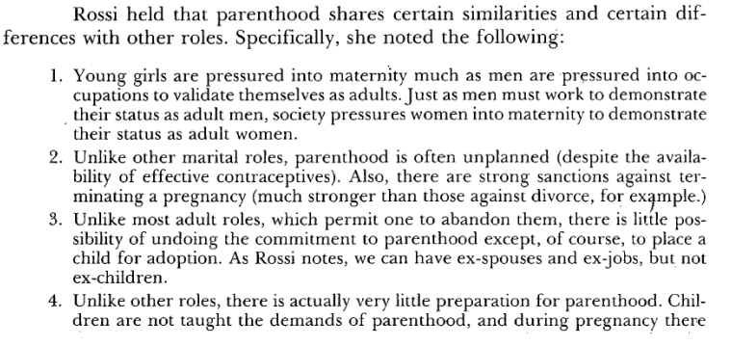
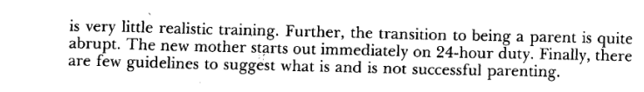

Part 2 Family Formation, Transitions, and Dissolution

Lecture 4 (1 September): Romantic Love and Courtship

Coontz, Stephanie. 2005. “Introduction” and “The Radical Idea of Marrying for Love.” pp. 1-14 and 15- 23. New York: Viking. [Available in RBR]

Introduction
  - Canadians authors argued that crisis in family life may be caused by too much family equality
    - May not be the case as in Japan, it is the lack of equality that puts women off marriages and childbearing
    - Traditional biases towards women has led to too much abortions of female foetuses such that every 117 boys there are only 100 girls. (gender imbalance)
    - Marriage is a way through which elites could hoard or accumulate resources, shutting out unrelated individuals or even "illegitimate" family members.
    - Consolidated wealth, merged resources, forged political alliances, and concluded peace treaties by marrying off sons and daughters.

Comment/assumption | Examples
Traditional were actually relatively recent innovations | Marriages have to be licensed by the state or sanctified by the church; but in ancient Rome a man and women can privately marry and still be recognised.
1950s marriages are exceptional | Single breadwinner, full-time homemakers, cultural consensus that everyone should marry at a younger age and baby booms.
When upper-class people married, there was an exchange of dowry, bridewealth, or tribute, making the match a major economic investment by the couple's parents and other kin | In Europe, from the early Middle Ages, through the eighteenth century, the dowry a wife brought with her at marriage was often the biggest infusion of cash, goods or land a man would ever acquire. Finding a husband was usually the most important investment a women could make in her economic future
The system of marrying for political and economic advancement was practically universal across the globe for many millennia | While throughout the ages, there are couples who loved one another deeply, it is not the sole reason or main reason for getting married.
True love were thought to be incompatible with marriages in some culture and times | In ancient India, falling in love before marriage was seen as a disruptive, almost antisocial act.  Greeks thought lovesickness was a type of insanity, a view adopted by medieval commentators in Europe  In the middle ages, the French defined love as a "derangement of the mind" that could be cured by sexual intercourse, either with the loved one or with a different partner.  In china, excessive love between husband and wife was seen as a threat to the solidarity of the extended family.  If the wife do not produce a son, parents may require him to take a concubine  Parents might even send her back if their son's romantic attachment to his wife rivalled his parents' claims on the couple's time and labour.
Couples were expected to keep married love under tight control | In many cultures such as the Romans, public displays of love between husbands and wife were considered unseemly. Some Greek and Roman philosophers even said that a man who loved his wife with "excessive" ardor was "an adulterer"
Love is a desirable outcome of marriage but not as a good reason for getting married in the first place | Hindu= "first we marry, then we'll fall in love"  Moralists of the 26th and 17th centuries argued that if a husband and wife each had a good character, they would probably come to love each other. (only after the families determine if the spouses are worthy to learn through their finances)
Exclusiveness in a relationships is rare in history | A women in ancient china might bring one or more of her sisters to her husband's home as backup wives  Eskimo couples often had co-spousal arrangements in which each partner had sexual relations with the other's spouse  In Tibet and parts of India, Kashmir and Nepal, a women may be married to two or more brothers. (totally different from the repulsiveness of non-sexual exclusiveness in modern American culture)
People rarely had high regard for marital intimacy | Chinese commentators on marriage discouraged a wife from confiding in her husband with news of her own activities and feelings but treated him like a "guest" even at home  Man who demonstrated open affection for his wife, even at home, was seen as having a weak character  Early 18th century, Americans look for spouses who do not pry too deeply and have good tempers
In many societies, marriage ranks very low in the hierarchy of meaningful relationships | In China, it was said that "you only have one family, but you can always get another wife"  Christian texts prior to the 17th century, love is usually referred to feelings towards God or neighbours rather than towards a spouse  In Confucian philosophy, the two strongest relationships in family life are between father and son and between elder brother and younger brother, not between husband and wife.
Sexual loyalty is not a high priority. The expectation of mutual fidelity is a rather recent invention. | Wife loaning versus male privilege  In Eskimo of northern Alaska, expressing jealously towards the sexual relationship is considered boorish  Several small-scale societies in South America have sexual and marital norms that are especially startling, people believed that any man who has sex with a women during her pregnancy contributes part of his biological substance to the child and also have paternal responsibilities

The system of marriage is no longer the same as before
  - For thousands of years, people had little choice about whether and whom to marry and almost no choice in whether or not to have children.
  - A husband owned his wife's property, earnings, sexuality and had the final word on all family decisions
  - A man who fathered a child out of wedlock was seldom responsible for the support of the child.
  - Women who bore a child out of wedlock could often survive only by becoming a concubine, mistress or prostitute.
  - People's political rights, jobs, education, access to property and obligations to other all were filtered through the institution of marriage.

Marriage today (Page 20)
  - They must love each other deeply and choose each other unswayed by outside pressure
  - Must make the partner the top priority in life, putting that relationship above any and all competing ties
  - Owe their highest obligations and deepest loyalties to each other and the children they raise
  - Parents and in-laws should not be allowed to interfere in the marriage
  - Couples should share their most intimate secrets and feelings
  - Sexually faithful
  - Express affection openly but also talk candidly about problems
  - Marriage is supposed to be free of coercion, violence and gender inequalities that were tolerated in the past

George Bernard Shaw
  - Marriage as an institution that brings together two people "under the influence of the most violent, most insane, most delusive, and most transient of passions. They are required to swear that they will remain in that excited, abnormal, and exhausting condition continuously until death do them part"

Carbone, June and Naomi Cahn. 2014. “Introduction” and “Section II: The New Terms.” Marriage Markets: How Inequality is Remaking the American Family, pp. 1-9 and 45-102. New York: Oxford University Press. [Available in electronic format]

Situation in America now
  - At the top, there are more successful man seeking to pair with a smaller pool of similarly successful women
  - In the middle and the bottom, there are more competent and stable women seeking to pair with a shrinking pool of reliable men
    - Recreation of class as there is increasing gender distrust.
  - In times of high unemployment or financial instability, job loss and downward mobility erode many of the economic and social distinctions between the stable working class and the poor. A generation or two ago, the family patterns of the middle looked much more like those of the top third of American society, but now they increasingly resemble the patterns of the bottom third.

Transformation in women's roles (page 46)
  - Especially in the middle class
  - Demand for women's labour has increased due to the shifts of economy to information and technology
  - Women with the highest incomes are more likely to marry and best able to contribute to their family's economic well-being
  - Enhanced women's autonomy within the family
  - All women became choosier about their spouses and may not even marry or stay married

Changing economic structure
  - Investing in both man and women's earning capacity, avoid early marriages and childbirth, achieve a measure of economic independence and finding the right life partner is the key to channel resources to the next generation
  - Family stability becomes increasingly difficult due to growing economic inequality

Page 49
  - Argues that inequality remakes the terms of family formation for everyone
  - Greater inequality has changed the ways men and women match up
  - Marriage is a culturally iconic symbol of commitment for heterosexual and same-sex couples, but the same factors affect the duration, stability and quality of other forms of cohabitation
  - Class-based changes in marriage, in a society that relies on marriage

Interrelationship of economics and differing class-based family strategies
  - Demonstrating how economic change affects gender ratios in a given market
  - Analysing the impact of the ratios on changes in family-formation strategies

Lecture 5 (8 September): Marriage and Cohabitation

Coontz, Stephanie. 2005. “The Many Meanings of Marriage” and “The Invention of Marriage.” Marriage, A History: How Love Conquered Marriage, pp. 24-33 and 34-52. New York: Viking. [Available in RBR]

Page 24-33
  - Marriage has been a universal social institution throughout recorded history except for the Na people of China
  - In human history, marriage united not just two individuals but two families, thus it is an transformation of biological functions of mating and reproduction.

Anthropologist Meyer Fortes
  - Marriage practices among humans "are universally subjected to rules"

Marriage have different functions and roles to play in various societies, and thus it becomes much harder to define marriages and reasons for existence.

Anthropologist George Peter Murdock
  - Marriage as a universal institution that involves a man and a women living together, engaging in sexual activity and cooperating economically
  - However, there are many exceptions to this kind of marriage arrangements
  - Examples of husbands and wives who live separately: Men of the Gururumba people in New Guinea sleep in separate houses and work separate plots of land from their wives.
  - Lower-class married couples in Austria take meals with their employers as they work as servants in separate houses.
  - Many African societies, husbands and wives do not pool in resources in a common household fund.

Royal Anthropological Institute of Britain
  - Marriage as "a union between a man and a women such that children born to the women are the recognised legitimate offspring of both partners
  - However, in West African societies, a women may be married to another women as a "female husband"
  - In numerous African and Native American societies, male-male marriages are recognised
  - Traditional Chinese marriages may have one partner already dead.
    - Independent women have to fight with one another for available dead men to marry
  - In Toda of southern India, a girl may marry as early as two or three to brothers, until when she's pregnant one of the brothers will give her a toy bow and arrow and promised her the next calf from his herd, and thus become the father of all subsequent children the women bore.

Suzanne Frayser
  - Sampled 62 societies
  - Marriage as " a relationship within which a society socially approves and encourages sexual intercourse and the birth of children"

Anthropologist Edmund Leach (page 28)
  - Marriage is more about regulating property than sex and child rearing
  - Marriage is "the set of legal rules" that govern how goods, titles, and social status "are handed down from generation to generation".

Deinstitutionalized/individualistic marriage – focus on individual needs
- Marriage as a relationship between two individuals is taken more seriously and comes with higher emotional expectations that ever before.
- But marriage as an institution exerts less power over people’s lives than it once did.
- It is no longer the main mechanism for regulating sexual behaviour, conferring differential economic and political rights, ordering the relations between the sexes, or organizing interpersonal rights and obligations, including reproduction and dependent care.

Gerson, Kathleen. 2010. “High Hopes, Lurking Fears.” The Unfinished Revolution: Coming of Age in a New Era of Gender, Work, and Family, pp. 103-23. New York: Oxford University Press. [Available in RBR]

2 opposing perspectives have emerged on how work and family tasks are negotiated
- See family decline and worries that the prevalence of single parents and working motherhood creates self-absorbed individualists wary of commitment and disinclined to sacrifice for others.
  - Decline of community that is draining civic participation and social cohesion
- Sees stalled movement towards women’s rights and a return to traditional families anchored by a new generation of stay-at-home women.
  - Women are giving up trying to “do it all” and choosing to “opt-out”

Permanent marriage not going to be the most prevalent option anymore
- Growing inclination to postpone marriage to focus first on establishing independent lives, combined with the stress on the quality of a relationship.
- Inflexible jobs and resistant partners as well as lack of childcare continue to place roadblocks on the path to balancing motherhood with a time-demanding career.

Equality is vague and elusive concept.
Young women are actually more fearful of traditional marriage

- Interviews
  - “Egalitarian” doesn’t mean a rigid organised division of everything all the time
  - Refers to a long term commitment to equitable, flexible, and mutual support in domestic tasks and workplace ties
  - Most people wish to create a flexible, egalitarian relationship

- Most people still want to get married, regardless of their sexual orientation, or marriage history and family background
  - Divorce strengthened the desire to marry and stay married for children whose parents divorced.
  - Desire for balance between work and family.
    - Women hope family obligations will not undermine their work prospects
    - Men hope work obligations will not interfere with family time
- Some people want to go back to the earlier era of traditional homes
    - May be okay for mothers to work but not to have a career
    - Shows softening of the gender division
  - Parenting pressures are high
    - Men more often argue that women should bear the first responsibility for caretaking
    - Cultural standard also makes mothers’ lives difficult.

Lecture 6 (15 September): Gender and the Division of Labor Part 1

West, Candace and Zimmerman, Don H. 1987. “Doing Gender.” Gender & Society, 1 (2): 125-51. [Available in electronic format]

  - Gender is a learnt behaviour
  - It is not as straightforward as it seems, as it is complex due to the implementation of "gender-behaviour to the situation"
  - Virtually any type of activity can be gender differentiated.
  - Society views gender as a black and white issue; either you are male or female.
  - Sex- application of socially agreed upon biological criteria for classifying persons as male or females.
  - Gender- is the activity of managing situated conduct in light of normative conceptions of attitudes and activities appropriate for one's sex category.
  - Presumption that essential criteria of the sex exist when we do gender or sex classification (Kessler and Mckenna)

Agnes is born a boy; raised as a boy but took female pills in order to suppress puberty and have female characteristics since 12.
Mind: Female Behaviour: Female? Body: Male

Sex - ascribed by biology: anatomy, hormones and physiology
Gender - achieved status: constructed through psychological, cultural, and social means

Argument: gender is not a set of traits, nor a variable, nor a role, but the product of social doings of some sorts

  - Human nature gives us the ability to learn to produce and recognise the masculine and feminine gender displays

Garfinkel:
Case study of Agnes
  - Gender is created through interaction and at the same time structures interactions

Thorne (1980)
  - Conceptualizing gender as a role makes it difficult to assess its influence on other roles and reduces its explanatory usefulness in discussions of power and inequality.
  - Drawing on Rubin(1975), Thorne calls for a reconceptualization of women and men as distinct social groups, constituted in "concrete, historically changing- and generally unequal-social relationships"

Other cultures have acknowledged the existence of "cross gender" and the possibility of more than one gender.

Kessler and Mckenna
  - Female and male are cultural events, rather than some collection of traits, behaviour or even physical attributes.
  - We operate with the moral certainty of a world of two sexes.
  - Sex and sex category are congruent.

  - Goffman (page 137)
    - Standardized social occasions also provide stages for evocations of the "essential female and male natures"
    - Organised sports as one of the institutionalised framework for the expression of manlines
    - Qualities associated with masculinity- such as endurance, strength and competitive spirit.

Goffman
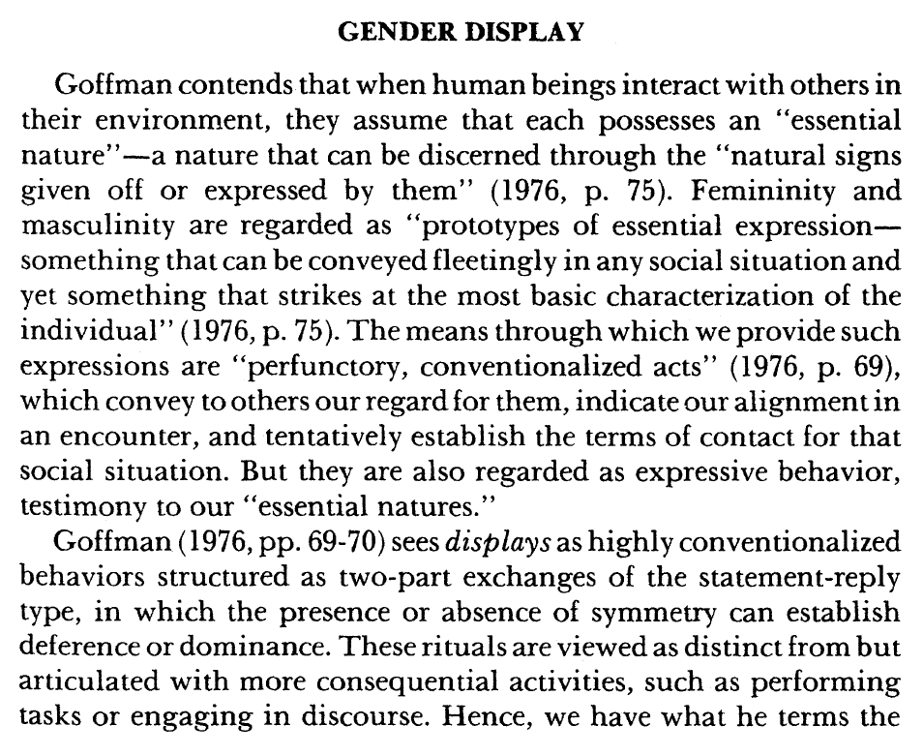
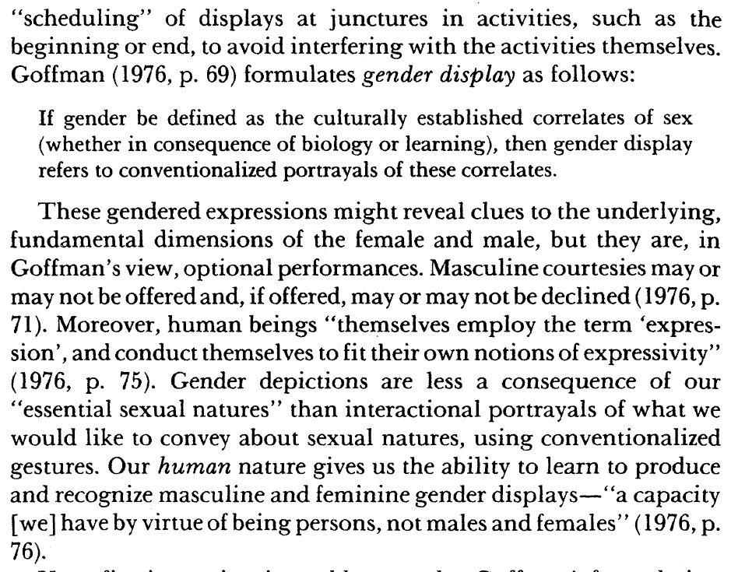
  - Each individual possesses an "essential nature"- a nature that can be discerned through the "natural signs given off or expressed by them"

Gerson, Kathleen. 2010. “Women’s Search for Self-Reliance” and “Men’s Resistance to Equal Sharing.” The Unfinished Revolution: Coming of Age in a New Era of Gender, Work, and Family, pp. 124-58 and 159-88. New York: Oxford University Press. [Available in RBR]

Chapter 6
Interviews
  - Hard to find the "perfect package" of a good relationship, a satisfying career and several children
  - Have to choose between marriage and family, on one side. Personal independence on the other
  - Most women choose self-reliant over traditional families despite differences in family backgrounds
  - Most see psychological, social and economic risks in following a course that might leave them isolated, overburdened or financially vulnerable
  - Some domestic mother conveyed a veiled sense of regret, leaving the impression that too much devotion to caring for others, can hinder the development of an independent self.
  - Afraid of being left alone or with too much housework
  - Lesson provided when a mother's domesticity led to financial decline or ruin
  - Long-run happiness and survival depend on establishing an independent base in the world of work
  - Loss of autonomy an unacceptable price for a relationship
  - By seeking economic, social and emotional autonomy, young women are actively redesigning marriage, work and motherhood.
    - Sustained work participation offers social integration and personal esteem
  - High standards for an acceptable partner.
    - Someone who will support their need for autonomy and also self-directed
  - Marital vows not a guarantee of lasting love or a legal structure to nourish it
  - "mommy gap" developing between middle class women, who defer parenthood and poor women, who are more likely to become young mothers

Self-reliant women define independence as knowing who they can depend on for what
Shortage of high-quality, affordable child care, along with men's reluctance to pull back from time-demanding jobs, leave women as the default caretaker

Neo-traditional women are juggling the pressure to be a devoted mother with the pressure to help with family finances and claim a separate self (page 154)
  - They define success as the whole package of family and work, not just moving up an organisation chart

Neither self-reliance nor domesticity can provide an ideal solution to women's search for both personal independence and lasting bonds
  - Any choice can leave women facing social disapproval and personal uncertainty

Notable minority prefer to fall back on domesticity
  - Resolve work-family conflicts by making traditional compromise than by living without a partner or trying to do it all

Lecture 7 (29 September): Gender and the Division of Labor Part 2

Hochschild, Arlie Russell. 2003. “Emotional Geography and the Flight Plan of Capitalism.” The Commercialization of Intimate Life: Notes from Home and Work, pp. 198-212. Berkeley and Los Angeles: University of California Press. [Available on IVLE]

Mid 1990s
  - 1/5 of the employees that the author talked to at Amerco say that family life had become like "work" and work had become more like "home"

Work-family Speed-up
  - Increasing number of mothers now work outside the home. Over half of mothers of children one year old and younger now work for pay
  - According to the 1999 international labour organisation report, workers are putting in longer hours than their counterparts a decade ago, and longer than their counterparts in Japan today
  - Americans work in jobs that generally lack flexibility. The model of "a job" and "career" is based on the image of a traditional man whose wife cares for the children at home. Men working hours are getting longer, and women are more likely to work continuously all year around, leading to a time bind

3 different stances towards the time bind
  - Cool modern stance. Speed up has become modern or even fashionable. Decline in time at home makes family life different or maybe even better
    - For the cool modern, the solution to rationalisation at work is rationalisation at home, which is to accept the reduction in time
  - Traditional- call for a women's permanent return to the home
    - Quasi-traditional - lower-rank mommy track for women at work
    - Due to the fact that women and men are different in essential ways and essential notions of time is different; "industrial" for men, "family" time for women
  - Warm modern stance see the speed-up as a problem but also hold onto an egalitarian ideal (at home and work)
    - They advocate a shorter working week, such as in France and Norway, and company-based family-friendly policies
    - Compressed working hours, paid parental leave, home-based work, flexible hours, regular or permanent part-time, job sharing
    - However, even though increasingly companies are offering such alternatives, few workers take up these alternatives due to job insecurities. Many fear then in lay-offs they will be the first to be targeted, and managers are known to be sabotages these policies
Giddens
  - Structures as fluid and changeable
  - For structures come with- and also "are"- emotional cultures. Thus, a change with emotional culture is required for a change in structure
  - Emotional culture is a set of rituals, beliefs about feelings, and rules governing feeling that induce emotional focus and even a sense of the "sacred". This sense of sacred selects and favour some social bonds over others, and selects and reselects relationships into a core of periphery of family life. Thus, families have a more or less sacred core of private rituals and shared meanings, which can vary enormously across time and space.
  - In the context of work-family speed-up, many people speak of actively managing, investing, and saving time in order to spend it.
    - Turning off phones and computers during dining time- temporal practice

John Gillis
  - Fairly recently that family has become a discrete private realm with a ritual life separate from that of the community.
  - The time bind privatises family even further by forcing families to cut out what is least important.
  - This thins out ties that bind families to the society, and thus peripheral ties with neighbours can be sacrificed

Jerry Useem
  - Rise in "new company town" has brought civic life ( gyms, single clubs, breast cancer support groups, Bible study groups) under the social umbrella of the workplace
  - At the same time, family time has reduced and becomes de-ritualised.
  - "one stop life" as a person can get almost everything he or she needs at the workplace

Marx
  - Jobs in the garment industries or fast food or retail work seem to reflect the aspect of capitalism in which Marx was most critical,
    - Take the work, ignore the worker
  - Paradox
    - Socialism for the rich and capitalism for the poor
      - At the top, companies invest a lot to keep the workers happy, while at the bottom, the company invests very little
      - Worker at the top goes to work to find entertainment, a sense of civic participation and even affection

Interviews
  - Working mom- family is not a haven but it is a workplace.

Reversal of family and work cultures
  - Trends in family
    - Cultural shifts that lessen people's need for marriage and reduce restraints against divorce
    - Working wives which work "two shifts" , one at home and one at work, and faces husband's resistance to helping fully with the load at home, a strain that often leaves both spouses feeling unappreciated.
  - Life at work
    - Workplace was where quite a few workers felt appreciated and honoured, and where they had real friends.
    - On the contrast, home is where there is less appreciation and a lot of mistakes are pointed out.
    - Courtship and mate selection are now moving into sphere of work
  - Capitalism
    - Not only an economic system but a cultural system
      - Challenge to the local family culture
      - Acts to maintain the emotional reversal of work and family
        - They "need more things" and need to earn more to buy more
        - Love is materialised as gifts are used to replace hours away from home

Gerson, Kathleen. 2010. “Reaching Across the Gender Divide” and “Finishing the Gender Revolution.” The Unfinished Revolution: Coming of Age in a New Era of Gender, Work, and Family, pp. 189-213 and 214-26. New York: Oxford University Press. [Available in RBR]

  - Indeed, a number of studies have shown that workers—whether women or men—fear that family-support options, such as parental leave and flexible
scheduling, entail substantial career risks
  - Though all workers are aware of these penalties, women are more likely to accept them for the sake of family life
  - Some people interviewed believed bottom-up approaches would work better than top-down ones:
    - That people say "this is what we want" than the company providing it
  - Young women and men from all backgrounds hope to build careers minimizing dominance from above
  - Young people from all class backgrounds hope to find innovative work settings offering more flexibility and personal control than traditional ones
    - self-employment as a route to greater parental involvement
    - Emerging force for change
    - The level of work autonomy maybe hard to enact as the ideals of family security and work-family balance
  - Although men want to make enough to keep their families secure, few place earnings above all else.
    - Young women also willing to exchange some earnings for more satisfying work
    - Young workers of all stripes seek economic rewards, but not necessarily income maximization. They are searching for work that balances “good enough” earnings with flexibility, autonomy, and time for the rest of life.

Gender convergence
  - By claiming the right to build unconventional work trajectories, young people are closing the gap between male “careers” and female “jobs.
  - After watching their parents struggle to blend work and family, a new generation recognizes the need to restructure the conditions of work if they are to reshape the balance between earning and caring.
  - Flexibility and autonomy at work offer individuals a way to avoid workaholism at one end of the spectrum and full-time domesticity at the other.
  - By bringing work home and care to work, they also seek ways to break through the spatial and temporal boundaries separating families from workplaces and communities

Partners (Page 201)
  - Men also realized that finding a work-committed partner means taking on more at home
    - While women continue to do more, men’s contribution to housework has doubled since the 1960s, increasing from about 15 percent to more than 30 percent of the total, while the time they spend caring for children has increased even more, especially because men are now more likely to multitask by combining leisure and child care.
  - Emerging partner ideals prompt more men and women to reject fixed gender divisions and separate spheres.

Work and family life
  - Egalitarian marriages (comes from the trend of thought that favours equality for all people)
  - Young workers view the workplace not as a refuge from family life but as a space where both might coexist
    - Some considered creating their own caretaking communities, where flexible work schedules for a group of parents would make collective child
rearing possible
  - Like many social shifts, however, blurring the distinction between public and private offers a double-edged promise.
    - Economic and technological changes may make it easier for young workers to coordinate their work and caretaking efforts, but they also make it easier for work to invade the time and space once set aside for private life
  - Strived for a "work-family career"
    - Though these efforts undermine traditional forms of masculinity and femininity, many young people see substantial offsetting advantages.
      - Women increasingly seek men who do housework and whom they consider physically attractive, while men now rank intelligence and education higher than cooking and housekeeping “as a desirable trait in a partner."
      - Wives are more satisfied and less likely to divorce when they share domestic and paid work with their husbands, and husbands and wives with egalitarian views have higher marital quality and fewer marital problems, even though (or perhaps because) they spend less time together

Cultural and morals wars
  - For most, “one size fits all” no longer provides a viable moral road map for navigating the shifting terrain of contemporary work and family life
  - Interviewees
    - Growing chorus of young voices who would like cultural debates to focus on social as well as individual responsibility
    - Wary of stigmatizing all but a few options, young adults from all backgrounds want a moral frame that respects differences while also providing a guide for individuals, families, and institutions
      - Most of these younger Americans (58 percent) agree the country needs “to work harder at accepting and tolerating people who are different, particularly gays” rather than “work harder at upholding traditional values.”

Chapter 9: Finishing the Gender Revolution

  - Current actions and future outlooks show how people’s “values” are actually a mix of abstract ideals and practical strategies.
    - Enacted values entail a complicated compromise between the lives people want to create and the lives they must construct out of existing social resources and constraints.
  - Sometimes a marriage deteriorated when parents clung to a strict division of labour despite an unhappy mother or a father unable to support the household. Sometimes dual-earner marriages became enmeshed in chronic power struggles and cycles of conflict when a mother had to “do it all” or a
father resented egalitarian sharing.
  - No declining in family values
    - In fact, even though marriage has never been more voluntary, it remains overwhelmingly popular.
      - As seen in the fight for marriages among same sex couples
  - Need for restructuring of care giving
    - Universal day care, mandated parental leave, and other child-supportive arrangements are integral aspects of social policy.

Lecture 8 (6 October): Parenthood

Hays, Sharon. 1996. “Prefix” and “The Mommy Wars: Ambivalence, Ideological Work, and the Cultural Contradictions of Motherhood.” The Cultural Contradictions of Motherhood, pp. ix-xiii and 131-51. New Haven: Yale University Press. [Available on IVLE]

  - Analysis of mothering as a historically constructed ideology
  - Systemically unpack and analyse the cultural model of mothering
  - Argument- contemporary cultural model of socially appropriate mothering takes the form of an ideology intensive mothering
    - Which is a gendered model that advises mothers to expend a tremendous amount of time, energy and mother in raising their children
  - Small sample size and diverse backgrounds
    - However, they display to share a specific set of ideas about good child rearing
    - Patterned ideas to the logic of child rearing and is able to anticipate responses

  - "Mommy wars"
    - Both stay at home and paid working mothers are angry and defensive
    - Do not respect one another
    - Supermoms will tend to describe stay-at-home moms as lazy and boring
    - Traditional moms regularly accuse employed mothers of selfishly neglecting their children
    - No-win situation for women of child-bearing years
      - If a women voluntarily remains childless, some will say she is cold, heartless and unfulfilled as a women
      - If a mother works too hard at her job or career, some will say she neglecting the kids
      - If she does not work hard enough, then she will be on the "mommy track" and her career advancement will be permanently slowed by the claim that her commitment to her children interferes with her workplace efficiency

  - Stay-home moms will argue that they have lots of good reason to stay at home; paid working mothers will say that they have good reasons to continue working
    - This leads to the socially necessary "ideological work"
      - Berger (1981a) uses this notion to describe the way that all people make use of available ideologies in their "attempt to cope with the relationship between the ideas they bring to a social context and the practical pressures of day-to-day living in it"
      - Selection among cultural logics in order to develop some correspondence between what they believe and what they actually do
      - Ideological work is simply a means of maintaining their sanity

  - Working to be recognised and also away from the child to gain motivation in life
    - They are equally concerned about the well-being of the children
    - Often feels guilty for leaving their children to care-givers who spend more time with them than they do
    - They often argue that leaving home for work is good for the children
      - Financial security of their children
      - Caregivers can give better experiences
      - Quality of time with the children actually increases as they appreciate children more that way
      - Children are still their primary interest, not power not money

  - Stay home moms often lose a sense of self
    - Have to deal with the impression of having nothing to do and they don't like it
    - But they often argue that employed mothers are allowing material and power interests to take priority over the wellbeing of their children
      - Which is immoral and also produces children with real problems

  - Both sides of the "mommy wars" ultimately shares the same set of beliefs and concerns
  - Gerson (1985) argues that there are ways in which paid working mothers do redefine motherhood and lighten their load
    - By sending kids to day care, legitimising their paid labour force participation and engaging in practical strategies to make child-rearing tasks less energy and time consuming
  - Author argues that working mothers are stressed to take compensatory strategies as a measure of the persistent strength of the ideology of intensive mothering

Top selling contemporary child rearing manuals
  - Consider mothers primarily responsible for raising children
  - Expectations of mothers to have a deep emotional commitment

Why the ideology of intensive child rearing persists
  - To serve the interests of not only men but also capitalism, the state, the middle class, and the whites
  - Protected and promoted because it holds a fragile but nonetheless powerful cultural position as the last best defence against what many people see as the impoverishment of social ties, communal obligations, and unremunerated commitments.

Dermott, Esther. 2008. “Paradoxes of Contemporary Fatherhood.” Intimate Fatherhood: A Sociological Analysis, pp. 7-24. Oxon: Routledge. [Available on RBR]

  - Thinking about fatherhood involves thinking about fatherhood, fathering and fathers.
  - Morgan (2003, 2004) has clarified the distinction between the three terms as referring respectively to: the public meanings associated with being a father; the actual practices of ‘doing’ parenting; and the connection between a particular child and a particular man (whether biological or social).

Three Paradoxes
  - The first paradox (attention and absence) is that, at a time when levels of father absence from the family are unprecedented (Coltrane 2004) there is increasing attention paid to fathers and fatherhood by academics, policy makers and social commentators.
  - The second paradox (creation and construction) is that while the tie between biological father and child is given primary status, there is also recognition that social fatherhood (without a biological link) is increasingly prevalent and that ‘good fathers’ are made, not born.
  - Third, (culture and conduct) is the issue first raised by Ralph La Rossa in the 1980s, namely that while cultural representations of fatherhood suggest a new model of ever increasing involvement and a move towards equal parenthood, the conduct of fathers suggests much less change in men’s activities and an obvious continuing division of labour between mothers and fathers.

  - In terms of influences on ‘exit’, ‘the question of the fragility of men’s relationships with their children has become more pressing’ (Collier and Sheldon 2006: 11). This is usually attributed to the end of the universality and permanence of marriage; significant numbers of fathers are not married to the mothers of their children and marital ties are less secure.
  - Given the tendency for children to remain resident with their mother after divorce or separation, at any one point in time there are considerable numbers of non-resident fathers, and even more biological fathers who will live apart from their offspring for some period.

The ‘absence’ of fathers has a number of dimensions
  - the physical absence of men from the households in which their children live;
  - an emotional distance from children’s lives;
  - a relinquishing of the role of financial provider and thereby economic absence.

Fatherlessness, as it has been termed, has been identified as the cause of a whole range of social problems for children, from low educational achievement to childhood delinquency, gun crime to promiscuity

Lecture 9 (13 October): Divorce and Remarriage

Family is the foundation of the state; and good family do not require the state to invest too much public funding to resolve problems.
  - Easier to govern a society of families rather than individuals.
  - Focus on the society- family formations and divorces
  - For Singapore, we have one of the lowest divorce rates globally
    - Literature on divorce is quite standard; negative effects are often documented
      - Adjustment issues for children, social-economic status changed due to the need to split income instead of sharing income, or the loss of one side of the income.
      - Divorce is a major disruption to social life
    - Traditionalist: always deem divorce as negative

  - Marriage cohesion framework
    - Identify rewards & costs of staying married
    - Rational choice perspective

  - Weakening social stigma behind divorces
    - Often a barrier for women more than men

  - Marital decline perspective
    - Individualistic perspective of marriage preoccupied with pursuit of personal happiness
      - Only care about the individual outcome
    - Must create culture that is supportive of marriage and commitment
    - Increase in pro-marriage programs, restriction on no-fault divorce
      - Make it harder for people to spilt to ensure that marriage is not trivialised.

  - Marital resilience perspective
    - Divorce as second chance at happiness
      - Emerged in the 1950s and 1960s
      - A healthy remarriage rate shows that the institution of marriage is continued to be believed in
      - Evolution of choice and opportunities for women led to strengthening of intimate relationships
      - Promote social policies that provide greater support to adults and children – regardless of family type
    - Empowering women

  - Transition in the meaning to marriage
    - Cultural means - rise in individualism, romantic love, significance of emotional satisfaction
    - Material trends- decrease in agricultural labour, decrease in child and adult mortality, increase in cost of living, increase in FLFPR
      - No need on economic dependence on family - leads to autonomy in marriage choices
    - Changes are very subtle and slow; society remains stable. It is not static
    - Social constructs of happy marriage, normal family, and ideal spouses.

Coltrane, Scott and Michele Adams. 2003. “The Social Construction of the Divorce Problem.” Family Relations, 52 (4): 363-72. [Available in electronic format]

  - Family values are (and have been) infused with power and politics (Allen, 2000; Coontz, 1992, 1997; Stacey, 1996; Walker, 2000), and debates about marriage and divorce resonate with moral overtones concerning social order, disorder, and changing gender roles (Cott, 2000).
  - Early in American history, marriage was associated with social order, harmony, and patriotic duty.
  - Marriage encouraged ‘‘citizenly virtue’’ by training people to care about others, acting as the symbolic key to mitigating the Enlightenment’s rampant individualism (Cott, 2000).
  - 19th century - Gender ideology also was undergoing change during this time, as the Victorian notion of separate spheres for men and women began to promote the ideal of mothers as the primary agents of family nurture (Hays, 1996). Thus in the early part of the century, children’s custody, previously automatically awarded to fathers, began to shift to mothers
  - As courts in the 19th century had looked to custody and enforcement of child support as an answer to what to do with the child of divorce, the answer for current divorce reformers has increasingly become ‘‘mandatory marriage [and reduced options for divorce] ‘for the sake of the children’’’
  - Attitudes towards children has changed
      - Previously perceived by their parents in terms of potential wealth and support, by the latter part of the 19th century children had become ‘‘economically worthless, but emotionally priceless’’ (Zelizer, 1985).
  - The coexistence of the demand for gender equality and the cultural remnants of separate gender spheres in American society produces contradictory tendencies that are not easily resolved in the individual or in the polity.

Straughan, Paulin Tay. 2009. “Looking Ahead – The Future of Family.” Marriage Dissolution in Singapore: Revisiting Family Values and Ideology in Marriage, pp. 105-26. Leiden and Boston: Brill. [Available in electronic format]

Social structural contradictions:
- Glorification of marriage vs actual practice of marriage
- Traditional gender role ideology vs contemporary women's roles
- Work and family conflict

Part 3 The Family in Context
Lecture 10 (20 October): Transnational Families

Yeoh, Brenda S. A. and Shirlena Huang. 1999. “Singapore Women and Foreign Domestic Workers:Negotiating Domestic Work and Motherhood.” In Janet Henshall Momsen (ed.), Gender, Migration and Domestic Service, pp. 277-300. London and New York: Routledge. [Available on IVLE]

Focus on the perspective of mistress and maid, women most intimately caught up in tussling with the "self/other" divide in (re)structuring the burden of the household reproductive sphere and (re)constituting women's identities
Neither the maid or the mistress has escaped the bind of domesticity through the take-up of paid work
  - Maid removed herself from "home" only to find herself further entrenched in another domestic world in a foreign country
  - Mistress only transferred the physical burden of domestic work but still have to fulfil a supervisory role ove rthe domestic arena, as well as the moral and emotional weight of reproducing the family

Contact Perspective
  - "emphasises how subjects are constituted in, and by, their relations to each other, …, not in terms of separateness or apartheid, but in terms of co-presence, interaction, interlocking understandings and practices, often within radically asymmetrical relations of power"
    - 'simply perpetuat[ing] the sexist division of labour by passing on the most devalued work in their lives to another women' and 'escap[ing] the sigma of 'women's work' by laying the burden on working women of colour'

Context in Singapore
  - Developing crisis in the reproductive sphere due to the entry for women to enter the work force
    - Also due to dwindling stocks of local servants, decline of extended household and shrinkage in help from extended family members to share out the domestic work
    - Becomes evenly spread among different classes
      - "this phenomenon may be interpreted as a dependence on maids, or that the maid culture has become a way of life in Singapore' (Toh and Tay 1996)
  - The presence of a housemaid perpetuates the traditional culture of domesticity, which valorises the "home" as a site of physical, emotional and moral nurturing for the family, and as a site of physical, emotional and moral nurturing for the family, and as a safe haven for children (providing a sense of "permanence" and "roots as some call it
    - Large contrast to the non-home based options, such as institutionalised childcare, babysitters, or using commercially prepared food
    - Maid can replace domestic vacuum at no extra cost unlike other alternatives as there is a "stretching" of the boundaries of domestic work
    - Ideals of a good mother can be seen in how maids are selected

  - Maid's role as substitute caregiver has produced a whole set of 'ambivalences' for women's identities as mothers
    - Mothers come to a conclusion that having a maid is the "only" solution to negotiating the demands of home and work, but still continue to wrestle with the everyday implications of the "solution"
    - Tensions over night-nursing occur due to the contradictions between the divisibility of mothering work and the notion that motherhood is inseparable from the personhood of the "real" mother

  - Domestic work is seldom the preferred vocation for maids
    - Growth of the "maid trade" is better explained by the intersection between the development of a transnational hierarchy of work and the "genderised mode of labour substitution" (Lleyer and Wee 1994)
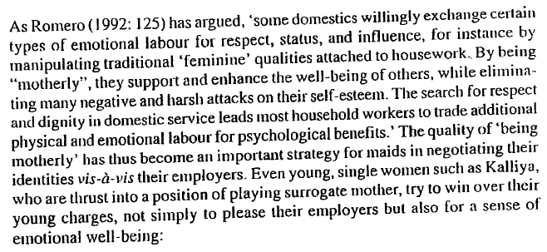
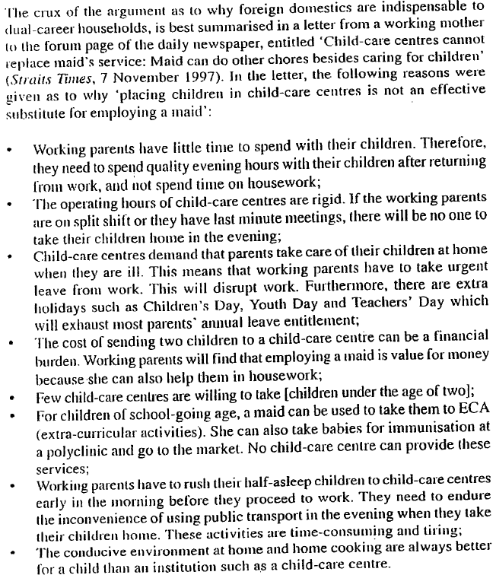

Hoang, Lan Anh and Brenda S.A. Yeoh. 2011. “Breadwinning Wives and ‘Left-‐Behind’ Husbands: Men and Masculinities in the Vietnamese Transnational Family.” Gender & Society, 25 (6): 717-‐39. [Available in electronic format]

Review of literature and analysis
  - Main problem: Study how man have to "cope" with the shift in household responsibilities triggered by wives' migration and breadwinning role
  - Argument: Negotiating dual roles of men public and privately; difference between the perception of what is expected of them and juggling roles due to absence of wives in the families.
  - Literature focuses on women migrants, ideas of masculinity, participation in the labor force and identity.
    - Challenges of transnational families, and how motherhood is perceived from a distance.
    - Impact of class, and how class affects how men take part in household chores differently : class differentiation
  - Respondents are on a single class only

Vietnamese context
  - Women has been economically productive (even before migration)
  - Paid work - masculinity, patriarchal society
  - Ideas of masculinity is "flexible", but can see the re-enforcement of gender roles through their decisions

3 analysis
  - Husband
    - A more dominant role from the wife
    - Even though they have a less economic standing than the wife, they insist that they are still the head of the family and the main decision maker
    - Tension reflected, hold onto paid work and take care of children.
    - Agreeing with the role of women, but men still want to work. (act of negotiation)
    - Refusal to take money from wives, even though it is for children

  - Breadwinner

  - Father
    - Rather egalitarian
    - Worried about how wives' migration can impact their children
    - Trying to negotiate both public and private entities

Gender norms and actions doesn't mean it is the true case

Lecture 11 (27 October): Public Policies

Donzelot, Jacques. 1979. “Government Through the Family.” The Policing of Families, pp. 48-‐95. London: Hutchinson of London. [Available on RBR]

Family is constituted a plexus (vessals) of dependent relations that were indissociably private and public, a social linkage that organised individuals around the possession of an état (shape/estate/condition/state) (at the same time a trade or profession, a privilege, and a status) which was granted and recognised by larger social groupings.
  - Smallest political organisation possible
  - State relies on family to ensure public order

  - The fact of not belonging to one posed a problem for public order.
  - As they have no ties and means to connect to the social machinery, they act as disturbers in this system of protections and obligations
  - No one to supply their needs and no one to hold them within the bounds of order

Head of the family was accountable for its members.
  - Held responsible towards the authorities that bound him
  - But also have discretionary power over those around him
    - Can determine children's careers, alliances and punish them
  - Disorder threatens the family through discredit
    - Shows that they are unable to control members within the prescribed limits

Philanthropy
  - Not only represent a private intervention into the sphere of so-called social problems, but must be considered as a deliberately depoliticising strategy for establishing public services and facilitates at a sensitive point midway between private initiative and the state.

Teo, Youyenn. 2015. “Differentiated Deservedness: Governance through Familialist Social Policies in Singapore.” TRaNS: Trans-‐Regional and National Studies of Southeast Asia, 3 (1), pp. 73-‐93

Singapore
  - "pro-family" but skeptical about welfare
    - Family remains as the first line of support
    - State insistence that Singapore must resist becoming a welfare state
      - Stance- welfare spending must be tightly managed because of moral hazards
        - Excessive welfare would erode the work ethic and encourage people to game the system, high taxes will discourage foreign investments
    - Critically-orientated and politically liberal scholars say that economic growth has been achieved through the suppression of civil society and repression of its citizens

Around the region
  - Shifts in Japan and South Korea
    - Specific needs for care resolved through more "social" interventions as migrate care workers are recruited into institutions of care
  - Singapore, Hong Kong and Taiwan
    - More individualist and familialist
      - Care workers are employed by and in individual households
      - Over the past four decades, the shift has been away from state funding to individual financing such that the Singapore state now pays for just a quarter of all health expenditure compared to about half in 1965 (Lim and Lee 2012).
      - Idea of self-reliance strong in Singapore
HDB
  - From a capitalist perspective, this system is nothing unusual.
  - In every city, the rich have greater access than the poor to housing; the type of housing one can buy depends on one’s wealth.
  - The logic of private property embeds within it the common sense of unequal access.
    - Yet, because of the Singapore state’s monopolisation of land, and the relative absence of escaping to cheaper areas within the country, the intensification of unequal access to, and yet universal aspirations for, HDB flats has become a major political problem for the state.
    - Thus the CPF system creates differentiations in access to public housing that are systematised, institutionalised and to some extent naturalised.
  - To be eligible for public housing, a citizen must form a “family nucleus” with another citizen or permanent resident (Housing and Development Board 2013).
    - The most straightforward route for qualification is via marriage.
    - Various rules around loans, the use of CPF for down payments and monthly mortgages, and income ceilings corresponding to flat size, also mean that the timing of marriage registration and weddings have to be planned with some precision.
    - Couples have to ensure that they have enough money in their CPF accounts to pay for the flats, that they will generate sufficient income in
the years to follow so that they have enough to service their loans, and also, in some cases, ensure that they do not wait too long in case their earnings go above the income ceiling and they become ineligible.
  - Public policy is so strongly oriented toward making marriage a key precondition for, and marital or blood ties so central to, access to home ownership and long-term housing security

Class implications of public support
  - Child Development Account: (CDA)
    - Differentiates parents along class lines
    - The more disposable income one has, the more one is able to put cash into an account, and the more matching funds one is entitled to. That higher-order children receive higher rates of co-savings is significant: people who can save that much money even when they have three or more children to support are likely to be significantly wealthier than those who cannot. The co-savings scheme thus directs more public support to those who can afford to save and less to those who cannot.

Governance
  - For Foucault, the new art of government that emerged in the eighteenth century was one in which the family is replaced by the population as the main object of governance. The family remains what Foucault calls “a privileged segment”, an “instrument for the government of the population” (Focault 1991: 100), but the wellbeing, the condition of the population as a whole – its “wealth, longevity, health, etc” becomes central to the purpose of government.
  - The family remains highly prominent, but contrary to what one might think from the state’s claims of ‘protecting
traditions’ and upholding ‘family values’, the management of family is not merely an end in itself but a means to governance (whether intended or not) over the Singaporean population.
  - As a mode of governance, differentiated deservedness articulates both deservedness and undeservedness; consistent with Foucault’s view of power, it operates not merely by punishing the deviant but also through producing the normal.
  - As a technology of governance, differentiated deservedness cuts to the core of individuals insofar as it compels
self-regulation. ‘Self-reliance’ and ‘family as first line of support’ as criteria for deservedness work at the level of everyday practices. It also works at a deep level of identity (e.g. a ‘working mother’) – shaping an individual’s orientations, tastes, sensibilities and self-worth. It shapes individuals’ decisions around work; their life plans around marriage; and their habits and beliefs about childrearing in families.
  - Singaporeans may not be having a large number of babies in accordance to pronatalist policies but their sensibilities, norms, wants, and desires about buying flats, marriage, childbearing, and employment, filial piety, etc., bear the strong marks of internalising ‘normal’ Singaporean ways of being.
  - While not all citizens are able to live up to the idealised ‘normal’, they are compelled to try and to measure themselves (and their ‘failures’) against it.
  - Being an individual in an individual family unit – with specific behaviours, plans, desires – is what brings about deservedness.
    - We see embedded in this logic a particular sort of agent with an individualised subjectivity: people are individuals, families are individual units – they should act for themselves, they must try to help themselves, they must be self-reliant, and their dependence on others must be minimised

Summary
  - Deservedness is not merely bestowed on all members within a static social category (e.g. women). Instead, deservedness depends upon practices that have gender and class implications. The policies not only emphasise different benefits for men versus women, or people with more versus less income, they give meaning to and demarcate gendered practices and class orientations by tying specific practices to social support. Heterosexuality, womanhood, employment, are necessary but in themselves insufficient conditions; instead, heterosexuality must be performed within marriage during relative youth; womanhood has to be practiced through marriage, employment, and motherhood; and employment must be continuous, stable, and result in sufficient income for oneself and one’s family
  - In this way, policies mark citizens as having different roles, responsibilities, and rights depending on specific interweaving of social categories and everyday practices. “Doing gender” (West and Zimmerman 1987) and indeed doing family in certain ways entitles one to specific forms of public support. Enacting heteronormativity – through marriage, through continuous employment, through having the right number of children that matches one’s socioeconomic circumstances, through cultivating dependence across generations with one’s parents or children – is key.
  - If differentiated deservedness is embedded in social policies, the inequalities generated by capitalist logic are not alleviated but deepened by state policies. If access to public goods varies too much in terms of affordability, and affordability in turn is too heavily dependent on one’s position in the capitalist economy, one’s advantage or disadvantage compounds.

