EC3371

Leanne

13 March 2017

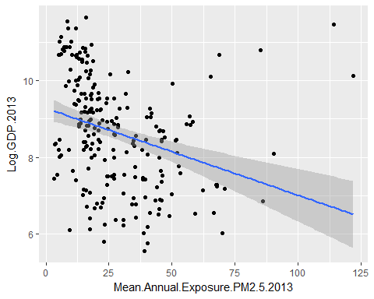

## Saving 5 x 4 in image

Note that the echo = FALSE parameter was added to the code chunk to prevent printing of the R code that generated the plot.