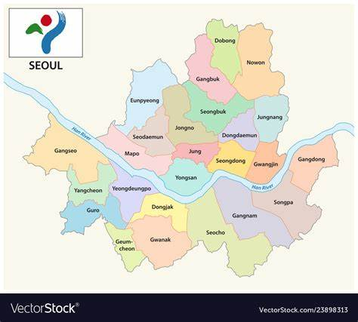

Clustering of Restaurants from Vancouver and Seoul

k- means Clustering

Lea Scharpf, | Business Analytics | 29.11.2022

# Introduction

Opening a restaurant in big capital cities can be quite a challenge. Not only good food needs to be saved in order to not go bankrupt, but also the people living there should value the food. To find the best location to open a restaurant depends on a lot of different factors. People in that area should earn enough money to be able to go to a restaurant. Next, if you want to open a restaurant with a cuisine from another country, some people from that country should live close to the restaurant, to be sure to have some customers. Also, it makes a restaurant more authentic, when people from that country enjoy the food. Third, there should not be too many competitors, since people than have to choose between your restaurant and others.

Therefore, we choose to cluster the restaurants from Vancouver and Seoul in order to find the best location to open a restaurant from a specific type of cuisine. The goal is to reduce business failures due to incorrect market analysis.

# Data import

To create such a clustering method, datasets from both cities including income, citizenship and a restaurant dataset are needed.

Kaggle provided the restaurant dataset for Vancouver:

* <https://www.kaggle.com/datasets/banaveenkumar/vancouver-restaurent-dataset>

The dataset for the income and the citizenship was found at Opendata Vancouver:

* <https://opendata.vancouver.ca/explore/?refine.theme=Demographics&disjunctive.features&disjunctive.theme&disjunctive.keyword&disjunctive.data-owner&disjunctive.data-team&sort=modified>

For the city Seoul the datasets were available on data Seoul:

* Korean dataset of restaurant:
  + <https://data.seoul.go.kr/dataList/OA-16094/S/1/datasetView.do?tab=S>
* Korean dataset of foreigner:
  + <https://data.seoul.go.kr/dataList/803/S/2/datasetView.do?tab=S>

# Preprocessing

After importing these data sets it was necessary to do preprocessing steps to clean the datasets.

## Vancouver dataset

Since the Vancouver census datasets consists of a lot of different spreadsheets, it was necessary to extract the important information. Therefore, two new datasets were created out of the census dataset only containing the necessary information.

Before preprocessing the datasets looked like this:

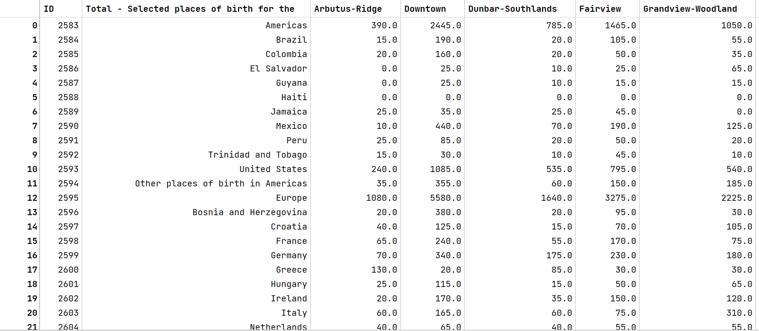

Figure 1- Dataset of citizenship before pre-processing

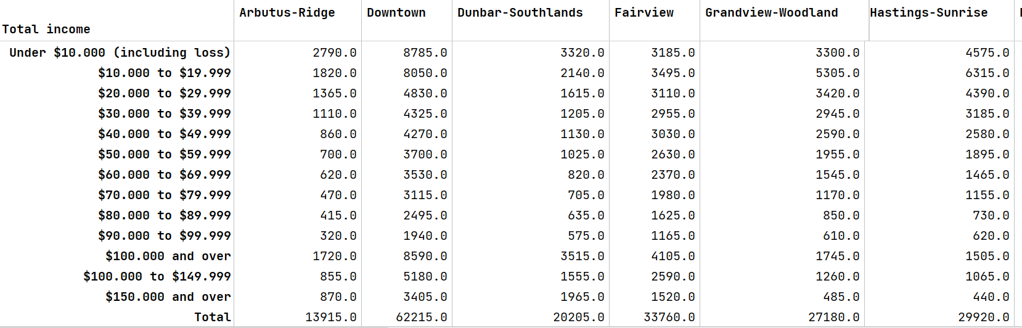

Figure 2- Dataset of income before pre-processing

* + 1. Pre-processing of Vancouver income dataset

The Vancouver income dataset contains the features: total income and the districts of Vancouver. 24 districts of Vancouver are included. Every instance is about the range of income, going from under 10 000$ in 12 steps up to 150 000$ income and more.

The row “$100.000 and over” needs to be dropped because it only contains the information found in the rows before and after.

We are only interested in the weighted average income from each district. Therefore, it is necessary to calculate the average income first and then calculate the total weighted average income for every district.

After applying these calculations, the dataset looked like this:



Figure 3- Vancouver dataset for income after pre-processing

* + 1. Pre-processing of Vancouver citizenship dataset

The citizenship dataset from Vancouver includes features of the place of birth and number of people of that birthplace in every district.

First, the ID column had to be dropped.

Then, I transposed the dataset to better calculate the average population of each district. Since we decided to do the clustering only for the categories: Western, Japanese, Koreans, Chinese, South- East Asians, I summarized these origins, calculated the total population and the percentage of the population in every district and dropped the rest. As Western people I included people from Europe, the USA and Canada. After the preprocessing the dataset looked like this:

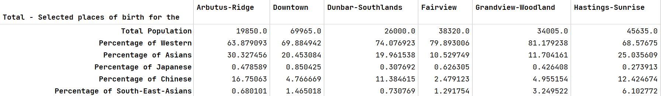

Figure 4- Vancouver citizenship after preprocessing

These two datasets are now ready to be merged.

To get a better overview of the districts of Vancouver a folium map was created with the help of Geopy. Geopy provides a class for popular mapping services. Nominatim is the service behind the popular OpenStreetMap that allows you to geocode for free. With geocode it is possible to get the longitude and latitude of a place. After merging and calculation the location the final dataset looked like this:

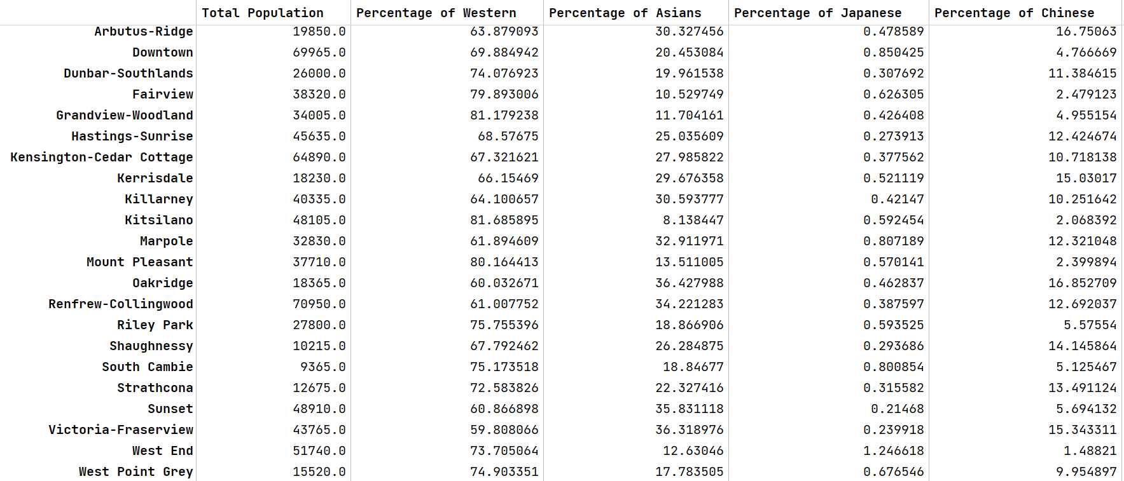 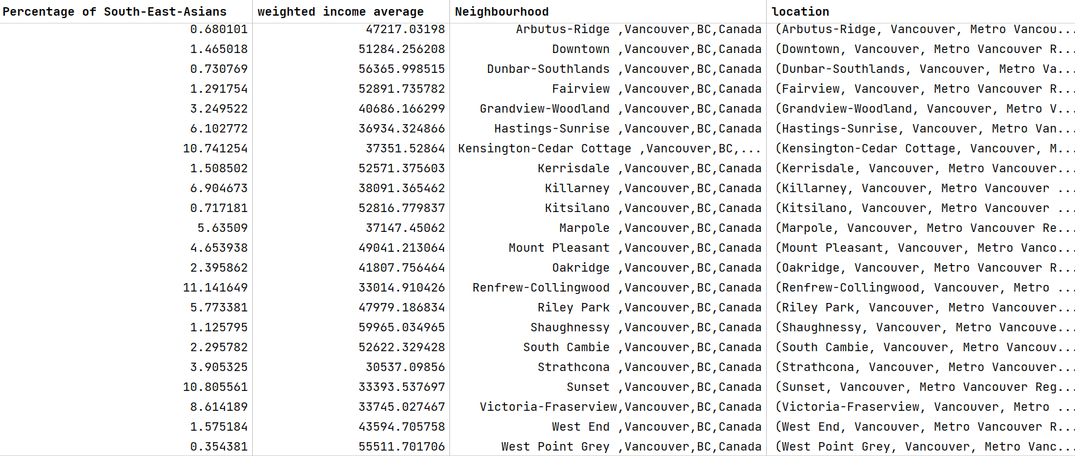

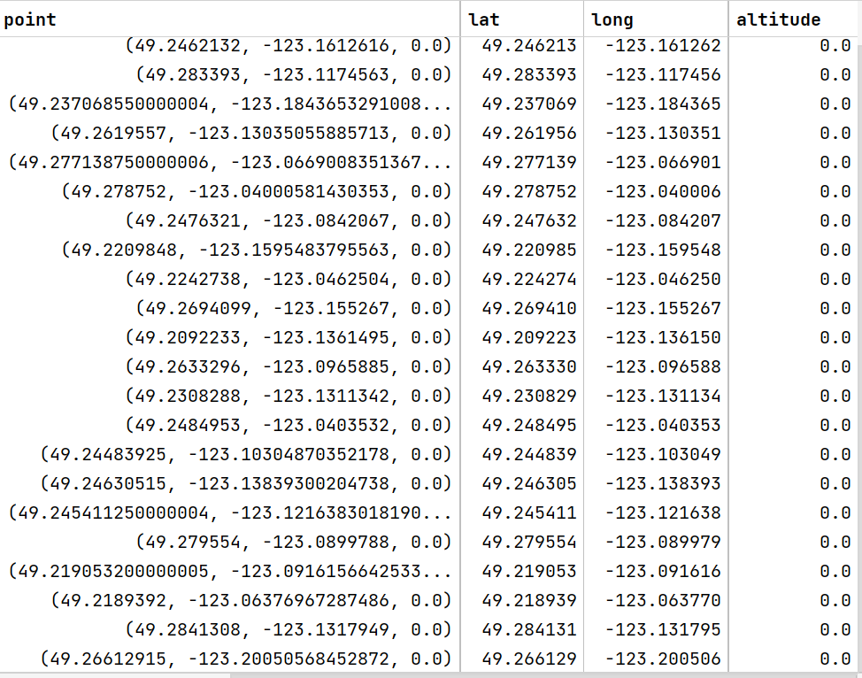

With Folium Map it is possible to create a map displaying every district:

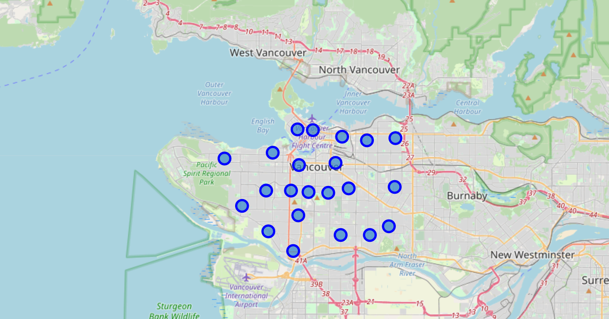

Figure 5- Folium Map of Vancouver districts

* + 1. Preprocessing of Vancouver restaurant dataset

The dataset provided from Kaggle contains

# Model and Training

## vancouver dataset