3 Working together across education, health and care for joint outcomes

# What this chapter covers

This chapter explains the duties local authorities and their partner commissioning bodies have for developing joint arrangements for commissioning services to improve outcomes for 0 to 25-year-old children and young people who have special educational needs (SEN) or disabilities, including those with Education Health and Care (EHC) plans.

It explains:

* the scope of joint commissioning arrangements
* how local partners should commission services to meet local needs and support better outcomes
* how partnership working should inform and support the joint commissioning arrangements
* the role that children, young people, parents and representative groups such as Parent Carer Forums and Youth Forums have in informing commissioning arrangements
* responsibility for decision-making in joint commissioning arrangements
* how partners should develop a joint understanding of the outcomes that their local population of children and young people with SEN and disabilities aspires to, and use it to produce a joint plan, which they then deliver jointly, and review jointly
* how joint commissioning draws together accountability arrangements for key partners
* the role of colleges as commissioners

# Relevant legislation

**Primary**

Sections 23, 25, 28 and 31 of the Children and Families Act 2014 The Care Act 2014

Section 2 of the Chronically Sick and Disabled Persons Act 1970 Schedule 2, Sections 17 and section 47 of the Children Act 1989 Section 2 of the Children Act 2004

National Health Service Act 2006 (Part 3, section 75 and 14Z2) Local Government and Public Involvement in Health Act 2007 Equality Act 2010 (including disability equality duty under s149) Health and Social Care Act 2012

# The legal framework

* 1. Section 25 of the Children and Families Act 2014 places a duty on local authorities that should ensure integration between educational provision and training provision, health and social care provision, where this would promote wellbeing and improve the quality of provision for disabled young people and those with SEN.
  2. The Care Act 2014 requires local authorities to ensure co-operation between children’s and adults’ services to promote the integration of care and support with health services, so that young adults are not left without care and support as they make the transition from children’s to adult social care. Local authorities **must** ensure the availability of preventative services for adults, a diverse range of high quality local care and support services and information and advice on how adults can access this universal support.
  3. Local authorities and clinical commissioning groups (CCGs) **must** make joint commissioning arrangements for education, health and care provision for children and young people with SEN or disabilities (Section 26 of the Act). The term ‘partners’ refers to the local authority and its partner commissioning bodies across education, health and social care provision for children and young people with SEN or disabilities, including clinicians’ commissioning arrangements, and NHS England for specialist health provision.
  4. Joint commissioning should be informed by a clear assessment of local needs. Health and Wellbeing Boards are required to develop Joint Strategic Needs Assessments and Joint Health and Wellbeing Strategies, to support prevention, identification, assessment and early intervention and a joined-up approach. Under section 75 of the National Health Service Act 2006, local authorities and CCGs can pool resources and delegate certain NHS and local authority health-related functions to the other partner(s) if it would lead to an improvement in the way those functions are exercised.
  5. To take forward the joint commissioning arrangements for those with SEN or disabilities described in this chapter, partners could build on any existing structures established under the Children Act 2004 duties to integrate services.
  6. The NHS Mandate, which CCGs **must** follow, contains a specific objective on supporting children and young people with SEN or disabilities, including through the offer of Personal Budgets.
  7. Joint commissioning arrangements should enable partners to make best use of all the resources available in an area to improve outcomes for children and young people in the most efficient, effective, equitable and sustainable way (*Good commissioning: principles and practice, Commissioning Support Programme, (Rev) September 2010*). Partners **must** agree how they will work together. They should aim to provide personalised, integrated support that delivers positive outcomes for children and young people, bringing together support across education, health and social care from early childhood through to adult life, and improves planning for transition points such as between early years, school and college, between children’s and adult social care services, or between paediatric and adult health services.
  8. Under the Public Sector Equality Duty (Equality Act 2010), public bodies (including CCGs, local authorities, maintained schools, maintained nursery schools, academies and free schools) **must** have regard to the need to eliminate discrimination, promote equality of opportunity and foster good relations between disabled and non-disabled children and young people when carrying out their functions. They **must** publish information to demonstrate their compliance with this general duty and **must** prepare and publish objectives to achieve the core aims of the general duty. Objectives **must** be specific and measurable.

# Scope of joint commissioning arrangements

* 1. Joint commissioning arrangements **must** cover the services for 0-25 year old children and young people with SEN or disabilities, both with and without EHC plans. Services will include specialist support and therapies, such as clinical treatments and

delivery of medications, speech and language therapy, assistive technology, personal care (or access to it), Child and Adolescent Mental Health Services (CAMHS) support, occupational therapy, habilitation training, physiotherapy, a range of nursing support, specialist equipment, wheelchairs and continence supplies and also emergency provision. They could include highly specialist services needed by only a small number of children, for instance children with severe learning disabilities or who require services which are commissioned centrally by NHS England (for example some augmentative and alternative communication systems, or health provision for children and young people in the secure estate or secure colleges).

* 1. Local authorities, NHS England and their partner CCGs **must** make arrangements for agreeing the education, health and social care provision reasonably required by local children and young people with SEN or disabilities. In doing so they should take into account provision being commissioned by other agencies, such as schools, further education colleges and other education settings. Partners should commission provision for children and young people who need to access services swiftly, for example because they need emergency mental health support or have sustained a serious head injury.
  2. Joint commissioning **must** also include arrangements for:
     + securing EHC needs assessments
     + securing the education, health and care provision specified in EHC plans, and
     + agreeing Personal Budgets
  3. Local joint commissioning arrangements **must** consider:
     + what advice and information is to be provided about education, health and care provision for those who have SEN or are disabled and by whom it is to be provided
     + how complaints about education, health and social care provision can be made and are dealt with, and
     + procedures for ensuring that disagreements between local authorities and CCGs (and NHS England for specialist services) are resolved as quickly as possible

The outputs of this work **must** be presented publicly in the Local Offer (see Chapter 4, The Local Offer, paragraphs 4.30 and 4.31).

**The joint commissioning cycle**

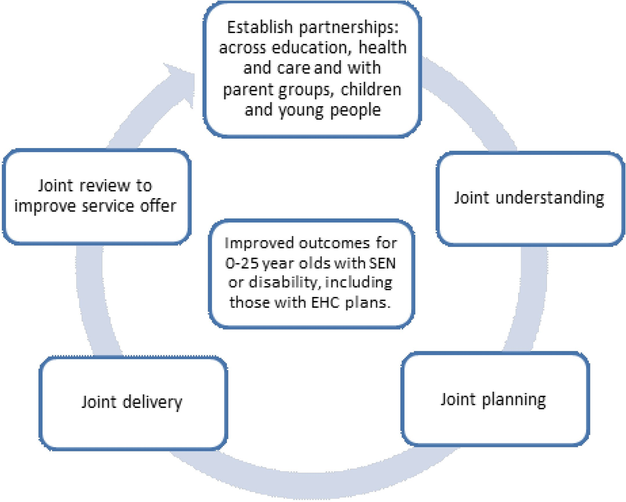

# Establishing effective partnerships across education, health and care

* 1. Local authorities **must** work to integrate educational provision and training provision with health and social care provision where they think that this would promote the wellbeing of children and young people with SEN or disabilities, or improve the quality of special educational provision. Local partners **must** co-operate with the local authority in this. The NHS Mandate, NHS Act 2006 and Health and Social Care Act 2012 make clear that NHS England, CCGs and Health and Wellbeing Boards **must** promote the integration of services.
  2. The Care Act 2014 also requires local authorities to work to promote the integration of adult care and support with health services.
  3. *Working Together to Safeguard Children (2013)* includes requirements for local agencies to work together to assess the social care needs of individual children and young people who may benefit from early help, and for local authorities and their partners to have a clear line of accountability for the commissioning and/or provision of services designed to safeguard and promote the welfare of children and young people.
  4. The local authority **must** review its educational, training and social care provision, consulting a range of partners including children and young people with SEN or disabilities, and their parents and carers. This consultation will inform the

development and review of the Local Offer (Section 27 of the Children and Families Act 2014).

* 1. The local authority **must** engage other partners it thinks appropriate to support children and young people with SEN and disabilities. This might include voluntary organisations, CAMHS, local therapists, Jobcentre Plus and their employment support advisers, training/apprenticeship/supported employment providers, housing associations, careers advisers, leisure and play services. Local authorities and CCGs should consider the role that private, voluntary and community sector providers can play in delivering services. More information is given on roles and responsibilities of key agencies from paragraph 3.70 onwards.

# Partnership with children, young people and parents

* 1. At a strategic level, partners **must** engage children and young people with SEN and disabilities and children’s parents in commissioning decisions, to give useful insights into how to improve services and outcomes. Local authorities, CCGs and NHS England **must** develop effective ways of harnessing the views of their local communities so that commissioning decisions on services for those with SEN and disabilities are shaped by users’ experiences, ambitions and expectations. To do this, local authorities and CCGs should engage with local Healthwatch organisations, patient representative groups, Parent Carer Forums, groups representing young people with SEN and disabilities and other local voluntary organisations and community groups.
  2. Under Section 14Z2 of the NHS Act 2006 each CCG **must** exercise its functions to secure that individuals to whom the services are being, or may be, provided, are involved in in planning commissioning arrangements, in the development and consideration of proposals for change, and in decisions affecting the operation of commissioning arrangements where implementation would have an impact on the manner in which services are delivered or the range of services available. Links to a range of useful resources to help them do this are provided in the References section under Chapter 3.

# Joint understanding: Joint Strategic Needs Assessments

* 1. There is a clear relationship between population needs, what is procured for children and young people with SEN and disabilities, and individual EHC plans.



Joint Strategic Needs Assessment/Joint Health and Wellbeing Strategy

Delivered by Health and Wellbeing Board. Considers needs of whole population.

Joint commissioning

Local authority/CCG applies JSNA analysis to 0-25 children and young people with SEN and disabilities to agree shared outcomes,

working with partners, eg children and young people and Parent Carer Forums.

Local offer

Local authority publishes a Local Offer setting out what support is available for 0-25 year olds with SEN or

disabilities.

EHC

Plan

An EHC plan starts by focusing on outcomes that are important to the individual. Any education, health or care provision required to meet a child/young person’s

needs related to SEN must be included in the plan (see Chapter 9).

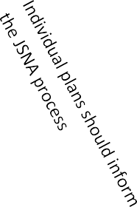

* 1. Each upper tier local authority (county council or unitary authority) has a Health and Wellbeing Board. The Health and Wellbeing Board is a strategic forum which provides leadership across the health, public health and social care systems. The board’s job is to improve the health and wellbeing of the local population and reduce health inequalities. Health and Wellbeing Boards have a duty to promote greater integration and partnership working, including through joint commissioning, integrated provision and pooled budgets. The membership of the board **must** include the Director of Children’s Services, Director of Public Health, Director of Adult Social Services and a minimum of one elected member from the local authority, a CCG representative and a local Healthwatch representative. Membership from communities and wider partners is decided locally.
  2. The Joint Strategic Needs Assessment (JSNA) is the means by which the Board understands and agrees the needs of all local people. It is the basis for the joint health and wellbeing strategy which sets the priorities for joint action. Further information about the JSNA is available on the GOV.UK website – a link is given in the References section under Chapter 3.
  3. The JSNA considers the needs of the local community as a whole, including specific analysis of the needs of vulnerable groups including disabled children and young

people and those with SEN, those needing palliative care and looked after children. Local partners across education, health and social care should work together to establish what targeted commissioning is needed to address the needs identified.

* 1. The JSNA will inform the joint commissioning decisions made for children and young people with SEN and disabilities, which will in turn be reflected in the services set out in the Local Offer. At an individual level, services should co-operate where necessary in arranging the agreed provision in an EHC plan. Partners should consider how they will work to align support delivered through mechanisms such as the early help assessment and how SEN support in schools can be aligned both strategically and operationally. They should, where appropriate, share the costs of support for individual children and young people with complex needs, so that they do not fall on one agency.

# Responsibility for decision-making in joint commissioning arrangements

* 1. Local authorities and CCGs have considerable freedom in how they work together to deliver integrated support that improves children and young peoples’ outcomes. However, local governance arrangements **must** be in place to ensure clear accountability for commissioning services for children and young people with SEN and disabilities from birth to the age of 25. There **must** be clear decision-making structures so that partners can agree the changes that joint commissioning will bring in the design of services. This will help ensure that joint commissioning is focused on achieving agreed outcomes. Partners **must** also be clear about who is responsible for delivering what, who the decision-makers are in education, health and social care, and how partners will hold each other to account in the event of a disagreement. The partners **must** be able to make a decision on how they will meet the needs of children and young people with SEN or disabilities in every case.
  2. Elected members, governing bodies of CCGs and chief executives across education, health and social care should provide leadership for integrated working. Arrangements for children and young people with SEN or disabilities should be specifically accountable to Lead Members for Children’s Services and Directors for Children’s Services in line with their statutory duties. It should be clear who can make decisions both operationally (for example, deciding what provision should be put in an EHC plan) and strategically (for example, what provision will be commissioned locally for disabled children and young people and those with SEN) in exercising statutory duties.