**Definite Focus Instructions**

Focus window-

First find cells under the eyepiece in bronc-widefield bright light.

Capture window-

Change filter set to EMCCD fixed confocal.

Select laser (here 488 nm).

Test ‘Live’, find a good focal plane and position with lots of cells.

Focus window-

Camera tab, Intensification: 200.

Scope tab, click ‘Set’ and change to 200 (19.8% lamp power) for using the bright light or 20 (1.9% lamp power) for laser exposure.

Capture window-­

‘Stop’ laser to protect sample while completing the next steps.

Zeiss display-

Press ‘XYZ’ button.

Definite Focus tab, note that Definite focus is off.

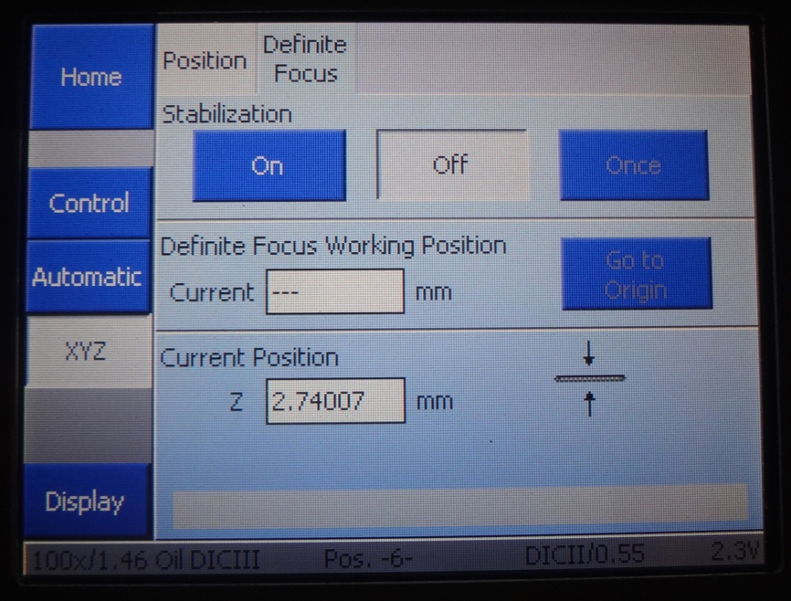

Focus window-

Focus tab (this starts off out of view, so click on the arrow to find it, and drag this tab over).

Autofocus Mode, check ‘Use Definite Focus to focus when autofocus is enabled’.

Check ‘Use individual offsets for multipoint capture’.

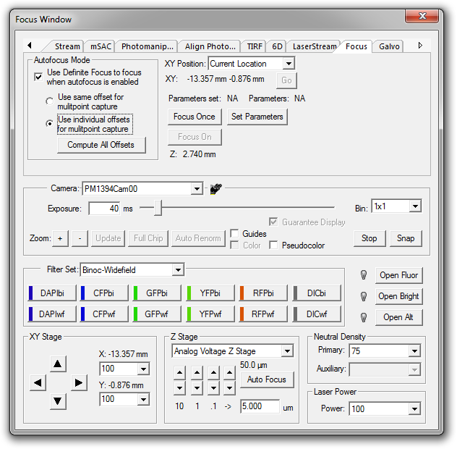

Zeiss display-

Stabilization, press ‘On’.

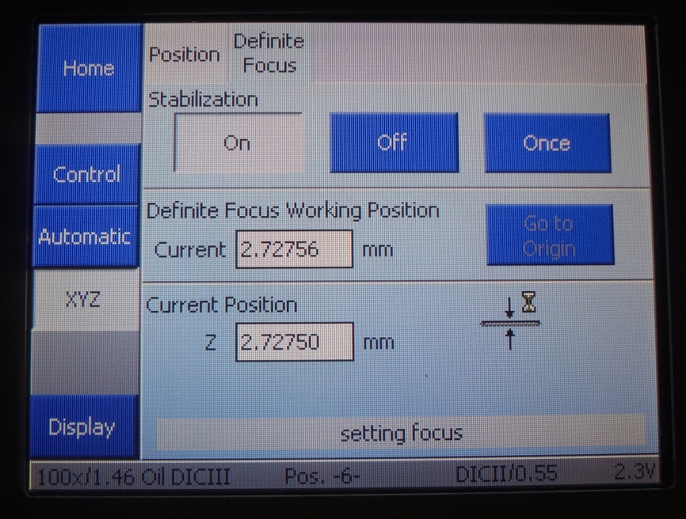

Capture window-

Choose laser exposure level (here 30 ms).

Click ‘Live’.

Find a central focal plane.

Focus window-

Z tab, click ‘Set’ reference.

XY tab, click ‘Set Point’.

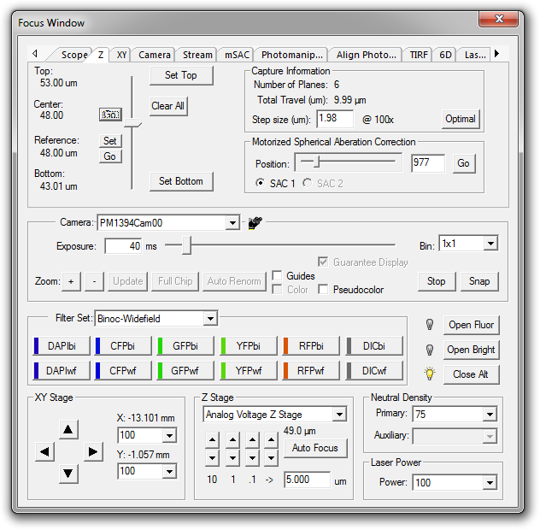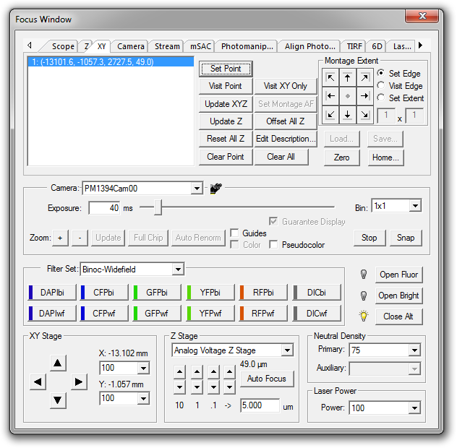

Focus tab.

Autofocus Mode, click ‘Compute All Offsets’.

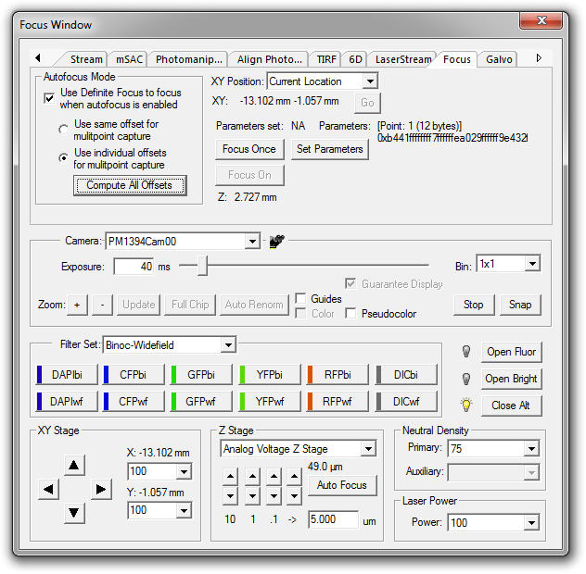

Capture window-

Capture Type, check ‘3D’.

3D Capture, check ‘Use reference position’.

3D Capture, Range (µm) 10

3D Capture, Step Size (µm): 0.25

3D Capture, check ‘Range around reference’.

3D Capture, check ‘Return to reference position after capture’.

Capture Type, check ‘Timelapse’.

Timelapse Capture, # of Timepoints: 50.

Timelapse Capture, Interval: 30 s.

Capture Settings, click ‘Advanced’ button.

Focus tab, check ‘Autofocus during timelapse/multipoint captures’.

Update focus every 1 image capture(s).

Click ‘OK’.

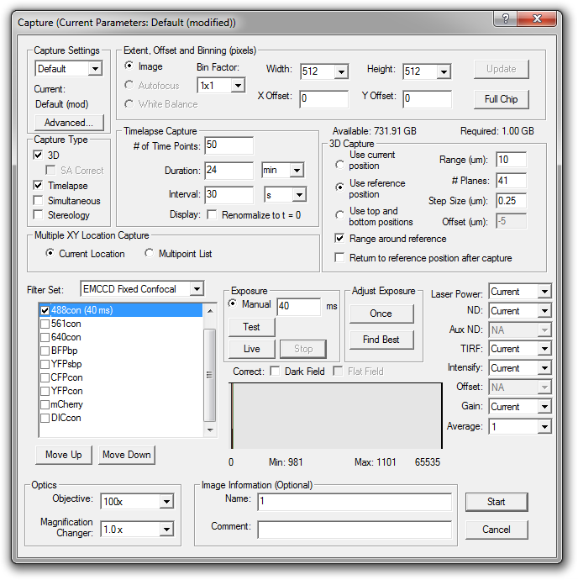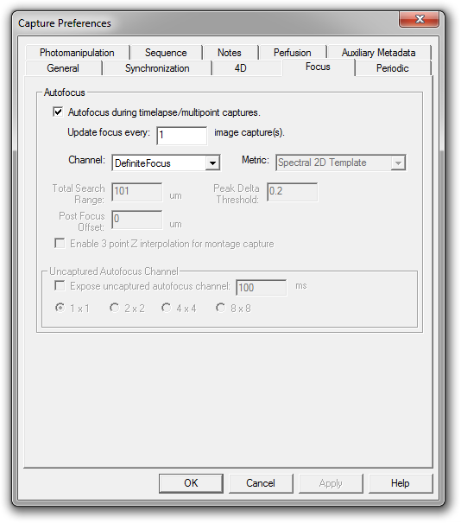

Capture window-

‘Image Information (Optional)’, Name: e.g. “URA3WT_t0”.

Click ‘Start’.

Watch the first two acquisitions as they are occurring to ensure that the same z-range is being captured, if the stage drifts poorly, restart the acquisition in a new location.

To repeat for the next timepoints

Zeiss display-

Load position.

Retrieve slide.

Oil lens.

Position new slide

Zeiss display-

Up arrow

Focus window-

Open bronc-widefield bright light.

Scope tab, click ‘Set’ and enter 200 (results in 19.8% lamp power).

Find a good focal plane and position with lots of cells.

Focus window-

Close bronc-widefield bright light.

Scope tab, click ‘Set’ and enter 20 (results in 19.8% lamp power).

Capture window-

‘Stop’ laser to protect sample while completing the next steps.

Focus window-

Z tab, click ‘Set’ reference.

XY tab, click ‘Clear Point’, click ‘Set Point’.

Focus tab, Autofocus Mode, click ‘Compute All Offsets’.

Capture window-

‘Stop’ laser to protect sample while completing the next steps.

‘Image Information (Optional)’, Name: e.g. “URA3WT_t1”.

Click ‘Start’.