**Slidebook export instructions**

Images to .tiff files:

To export Slidebook images first select the image (the z and t stack) and click the “Export” drop down menu and select “16-bit TIFF (OME)”.

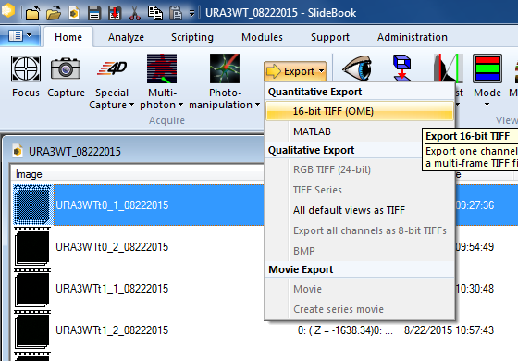

A new window will open. The “Image Range” should default to “Selected Image.” The image you selected should be checked.

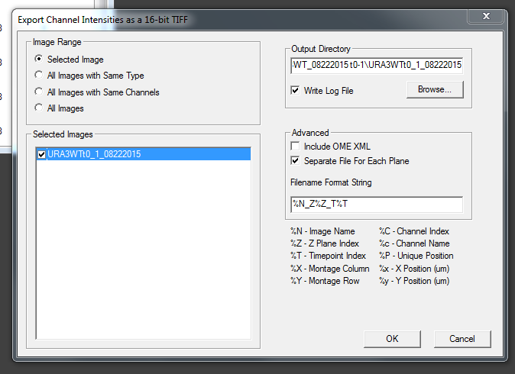

Click Browse to select the destination of the export. The image stacks should always be saved in their own folder.

Check “Separate File For Each Plane,” this is important for the programs that analyze the data in MATLAB.

Edit the “Filename Format String” so that it only has the name, z number, and t number. The string should look like this: %N_Z%Z_T%T.

Then click OK, and wait until it finishes. Note that the progress bar fills completely almost immediately but the export takes much longer.

If using other imaging software the name of the files needs to look like below and each z plane and time point must be separate, e.g. FILENAME_Z00_T00.tiff.