1. **Creating and Renaming Files/Directories**

**Tasks**

Create a directory named test_dir using mkdir.

Inside test_dir, create an empty file called example.txt.

Rename example.txt to renamed_example.txt using mv

**Sample Snaps and Explanations**

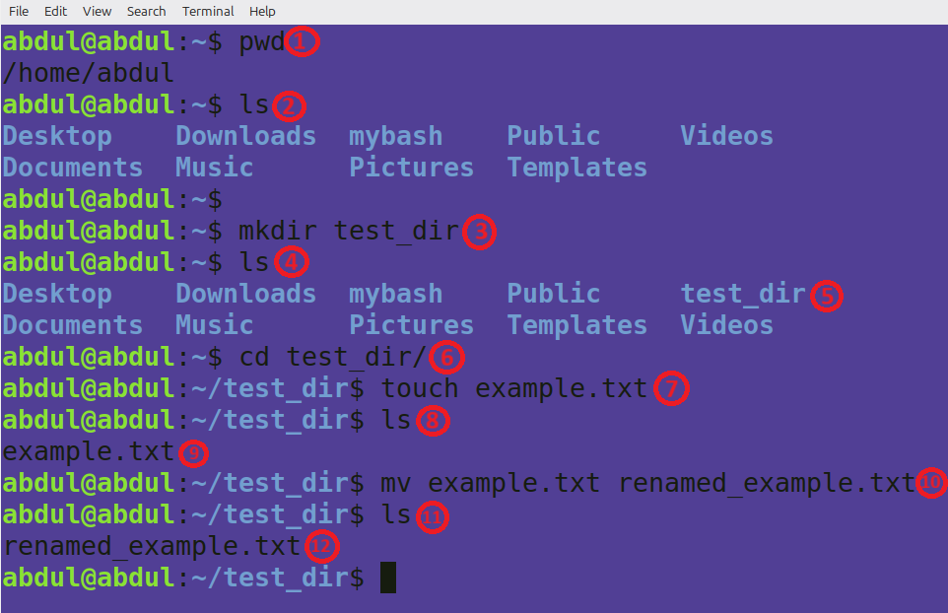

1. pwd – just to let you know the present working directory
2. ls – to show the contents of the preset working directory
3. mkdir test_dir – this creates a directory called ‘test_dir’
4. ls – to verify whether the new directory is successfully created.
5. We can see the new directory here.
6. cd test_dir/ - is to change the directory to the new directory that we have just created.
7. touch example.txt – creating an empty file called ‘example.txt’
8. ls – verifying the files just created
9. we can see that the file is being created.
10. mv example.txt renamed_example – this renames the file ‘example.txt’ to ‘renamed_example.txt’.
11. ls – verifying that file is renamed successfully
12. we can see the renamed file here.
13. **Viewing File Contents**

**Tasks**

Use cat to display the contents of /etc/passwd.

Display only the first 5 lines of /etc/passwd using head.

Display only the last 5 lines of /etc/passwd using tail.

**Sample Snaps and Explanation**

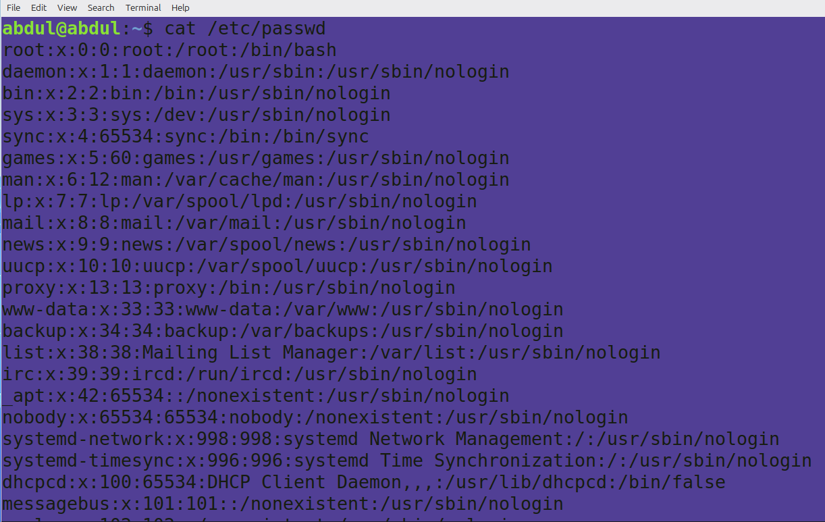

*‘cat’ command is used for displaying file contents*.

In this snap, ‘cat /etc/passwd’ command is to display the contents of ‘/etc/passwd’.

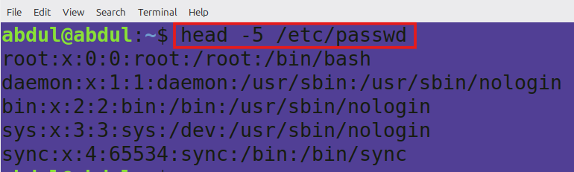

*‘head’ command is used to display top n lines of a file*

In the second snap, ‘head -5 /etc/passwd’ displays first 5 lines of ‘etc/password’

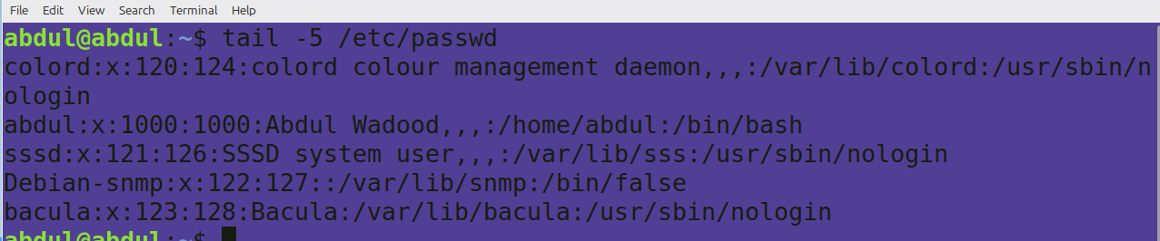

*‘tail’ command is used to display last n lines of a file.*

In the third snap, ‘tail -5 /etc/passwd’ displays last 5 lines of ‘etc/passwd’

**3.Searching for Patterns**

**Tasks**

Use grep to find all lines containing the word "root" in /etc/passwd.

**Sample Snap and Explanation**

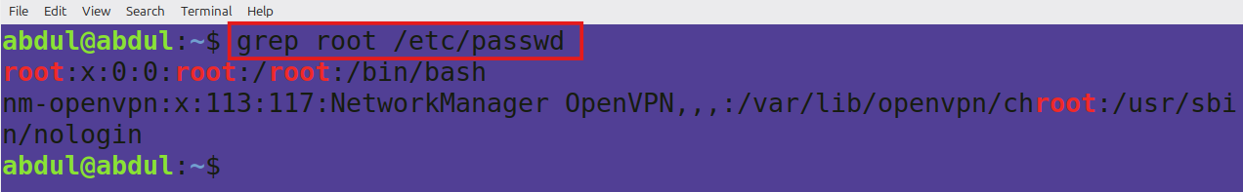

*‘grep’ command is used to find patterns in a file*.

In the above snap, ‘grep root /etc/passwd’ displays lines with the pattern ‘root’ in ‘/etc/passwd’.

4. **Zipping and Unzipping**

**Tasks**

Compress the test_dir directory into a file named test_dir.zip using zip.

Unzip test_dir.zip into a new directory named unzipped_dir.

**Sample Snap and Explanation**

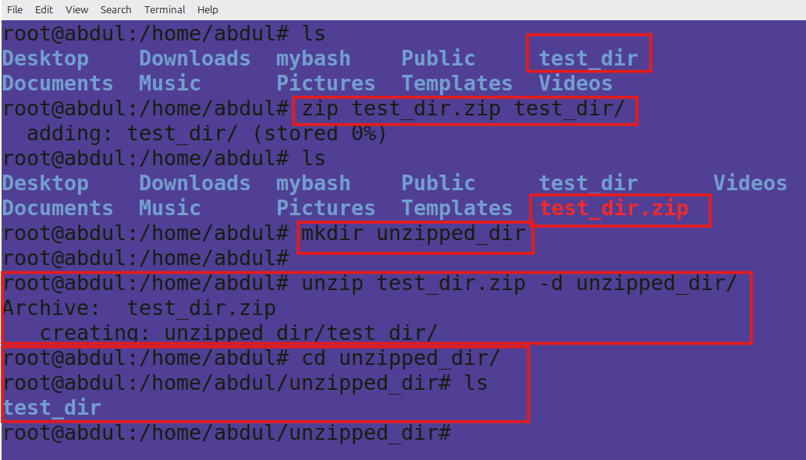

*ls- used to list contents of a directory*, first ‘ls’ command verifies the presence of our directory ‘test_dir’

*zip- used to compress files/folder*, ‘zip test_dir.zip test_dir/’ command compresses the folder test_dir into test_zip. In the next ‘ls’ command we can see that test_dir.zip file has been created.

*mkdir – used to create new directory*, ‘mkdir unzipped_dir’ command creates a directory called unzipped_dir which will later be used to move unzipped directory.

*unzip – used to de-compress files/folders,* ‘unzip test_dir.zip -d unzipped_dir/’ commands unzips or decompress the test_dir.zip file and move the unzipped directory to ‘unzipped’ directory.

5. **Downloading Files**

**Tasks**

Use wget to download a file from a URL (e.g., <https://example.com/sample.txt>).

1. 6. Changing Permissions

Create a file named secure.txt and change its permissions to read-only for everyone using chmod.

1. 7. Working with Environment Variables

Use export to set a new environment variable called MY_VAR with the value "Hello, Linux!".

**Sample Snaps and Explanations**

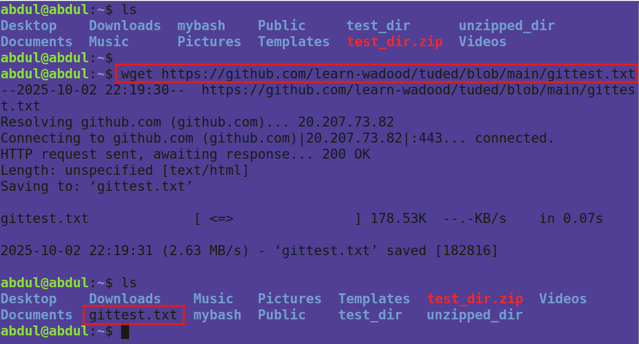

*wget- this command is used to fetch a files from the web.*

Here, I am trying to download a file called ‘gittest.txt’ from my github repository. As we can see, once we run the command, it shows the process and progress of copying the file and finally we verified the file presence through ‘ls’ command and we could see the file in our directory.

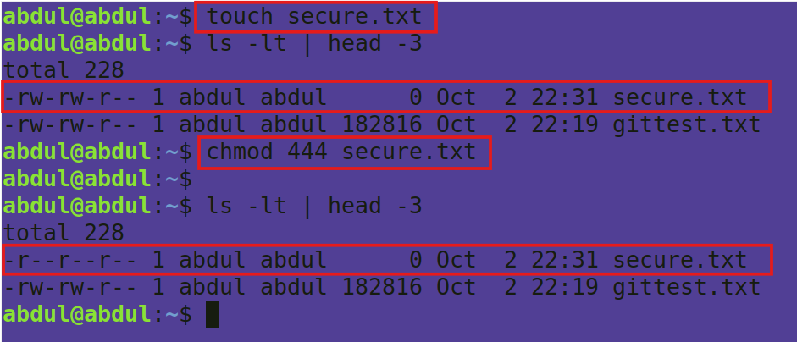

In this snap, I am trying to change the permission for the file ‘secure.txt’

*touch – this command is to create empty file*.

Here, I am creating a file called ‘secure.txt’. As we can see, the file has read(r) and write(w) permissions to both user and group initially.

*chmod – this command is used to change the file or directory permissions.*

*‘chmod 444 secure.txt’* -Here, I am changing the permissions for the file ‘secure.txt’ to have only read permission to everyone. We can see the permission details after the chmod command in the snap, it has only ‘r’ for everyone.

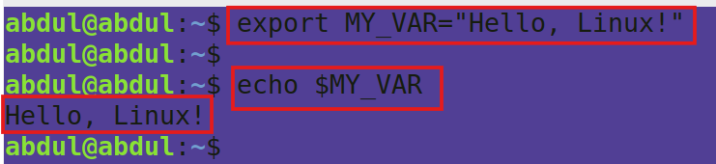

*export – this command is used to set environment veriables*

In the third snap of this section, export MY_VAR=”Hello, Linux!” is used to set and environment variable called MY_VAR with the value/string Hello, Linux!.

echo – used to print text or variables.

Here I am trying to print the variable MY_VAR