**AWS EBS :**

**What Is EBS?**

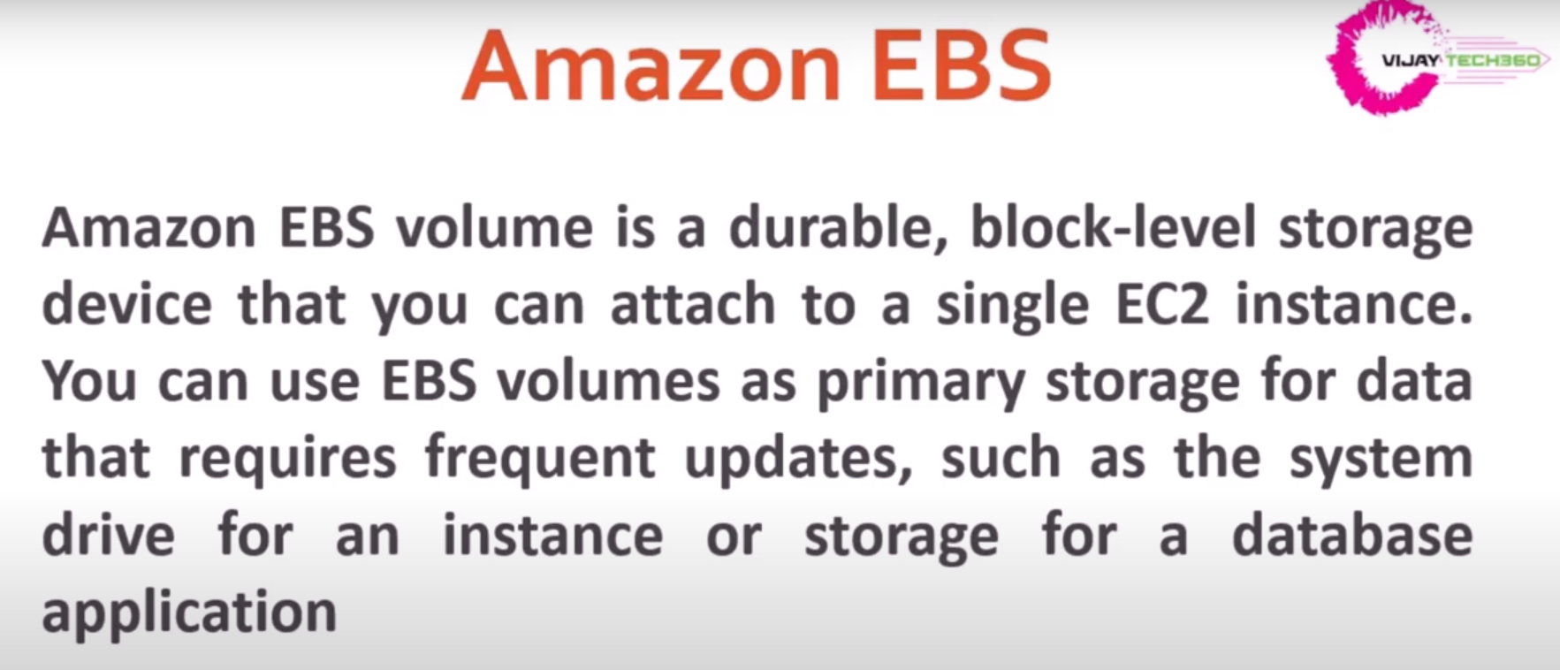

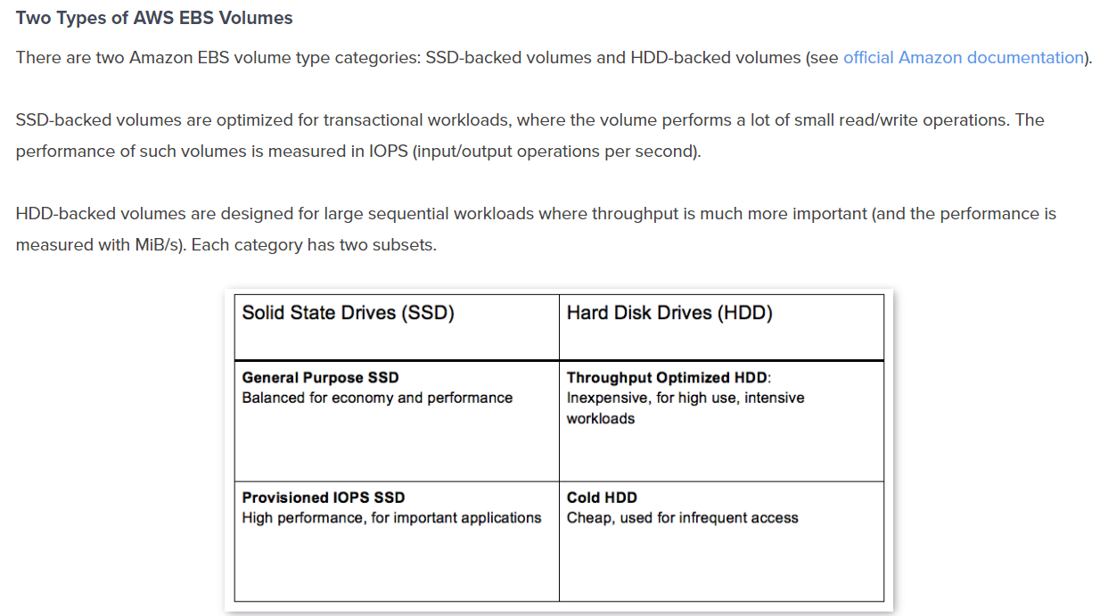

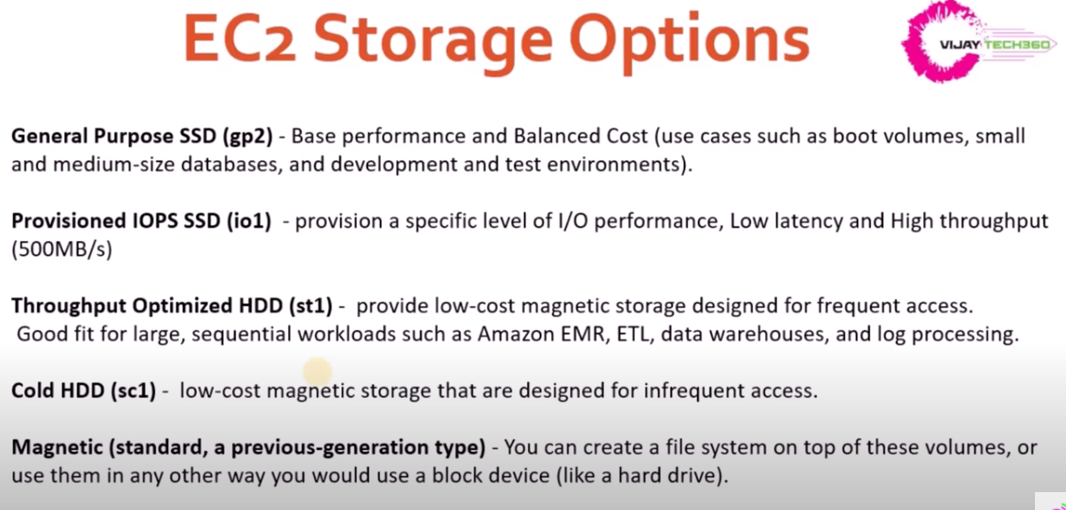

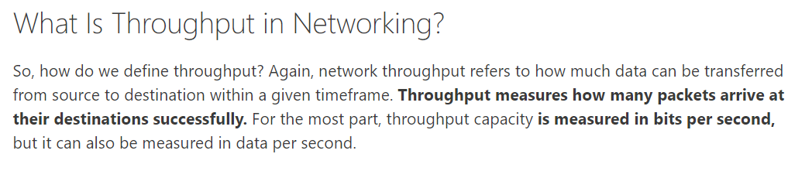

Ref : <https://cloud.netapp.com/blog/ebs-volumes-5-lesser-known-functions>

**EBS Mounting :**

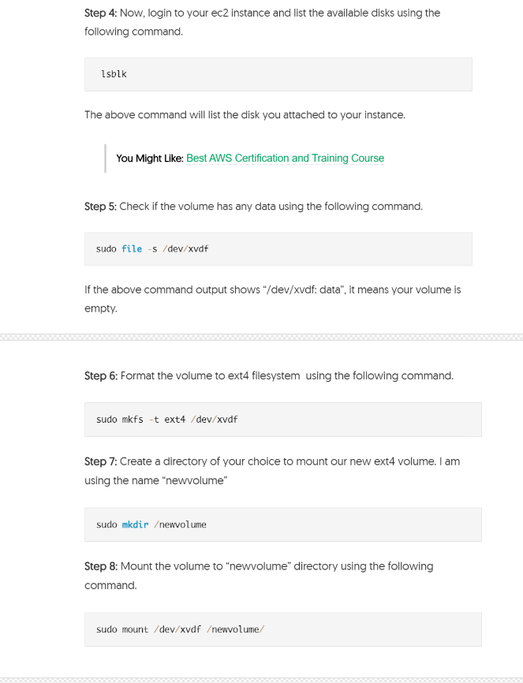

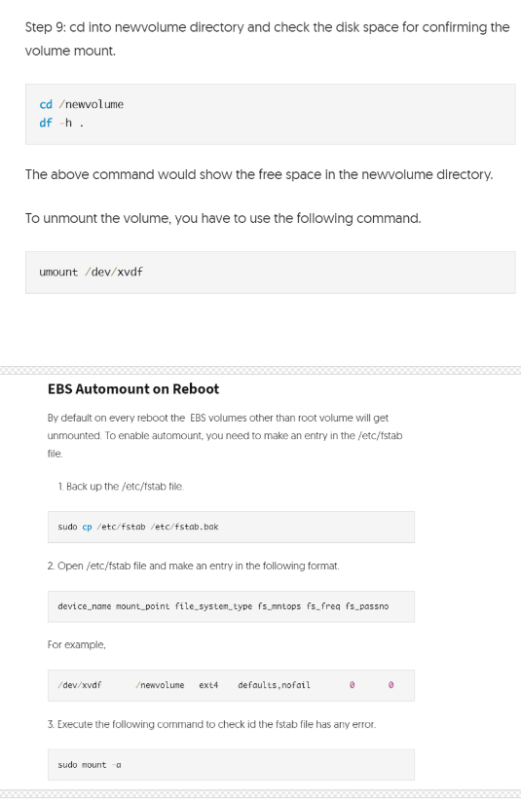

* Cross-Account Copying of Encrypted EBS Snapshots

Note : Cannot able to copy the snapshots if u r using the default KMS key..Need to create separate one and allow the different account with “Add another account “ option and check in Private snapshots in the destination account.

Ref : <https://www.youtube.com/watch?v=wtwUqKvSZDA>

* Note : You can able to increase the size of the EBS volume . But cannot able to decrease the size of EBS volume.
* There is no straight forward way to decrease the volume size. So, follow below way to decrease.

Ref : https://medium.com/@m.yunan.helmy/decrease-the-size-of-ebs-volume-in-your-ec2-instance-ea326e951bce