RANKFORGE
Local Development Setup Guide
Docker Desktop • PostgreSQL • pgAdmin 4 • Node.js Backend • Angular Frontend
A practical team handover guide to install, connect, run, and troubleshoot the local development stack.
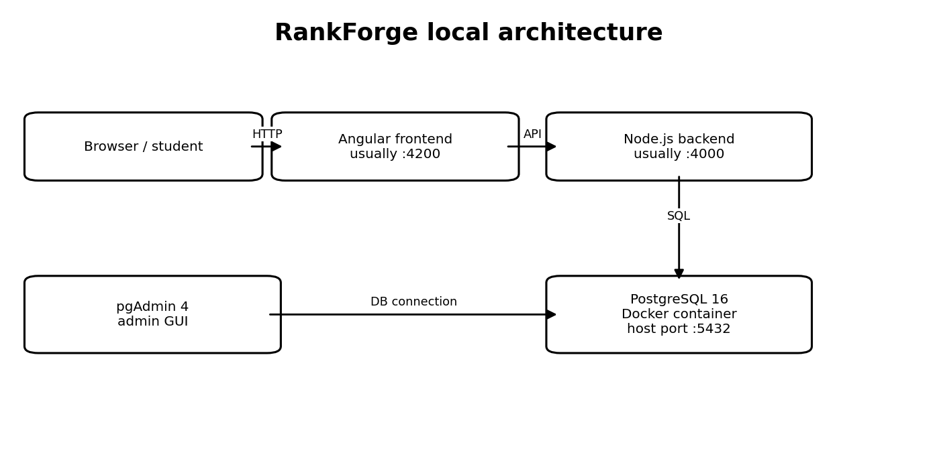
Confirmed local context: PostgreSQL 16 in Docker Compose; database `rankforge`; user `rankforge`; host port 5432. The backend has been run on port 4000; Angular commonly uses 4200. Verify scripts and environment settings in the current repository.

1. How the parts fit together
- Docker Desktop runs PostgreSQL in a container, making the database service consistent across developer machines.
- PostgreSQL is the actual database engine. It stores application data.
- pgAdmin is a graphical administration client. It connects to PostgreSQL but is not itself the database.
- The Node.js backend applies validation, authentication and business rules, then reads/writes PostgreSQL.
- The Angular frontend renders the website and calls the backend over HTTP. A student browser should not connect directly to PostgreSQL or pgAdmin.

2. Prerequisites and official downloads
Tool | Official download | Why needed
Docker Desktop | https://www.docker.com/products/docker-desktop/ | Runs PostgreSQL container
pgAdmin 4 | https://www.pgadmin.org/download/pgadmin-4-windows/ | Visual PostgreSQL management
Node.js | https://nodejs.org/en/download | Runs backend and frontend tooling
Git for Windows | https://git-scm.com/download/win | Clones and updates source code
VS Code | https://code.visualstudio.com/Download | Editor and integrated terminal

3. Install and start Docker Desktop
- Download Docker Desktop from the official link above and run the Windows installer.
- Accept the recommended WSL 2 backend if offered; restart Windows if requested.
- Launch Docker Desktop and wait until it says Docker is running.
- Open PowerShell or VS Code terminal and verify the CLI.
docker --version
docker compose version
If Docker daemon errors appear, start Docker Desktop and wait for it to become ready. For WSL errors, use Docker's official Windows/WSL troubleshooting. Do not delete volumes as a first fix.

4. Open the correct project folder
Run Docker Compose commands in the folder containing `docker-compose.yml`. The earlier local setup used:
D:\projects\L2C-rankforge-Emcet\
The outer parent folder may not contain the Compose file. Check the current directory with:
dir docker-compose.yml

5. PostgreSQL Docker Compose setup
The configured service is `postgres`, image `postgres:16-alpine`, database `rankforge`, user `rankforge`, host port `5432`, and persistent volume `rankforge_pgdata`.
services:
postgres:
image: postgres:16-alpine
restart: unless-stopped
environment:
POSTGRES_DB: rankforge
POSTGRES_USER: rankforge
POSTGRES_PASSWORD: ${POSTGRES_PASSWORD:-rankforge_dev_password}
ports:
- "5432:5432"
volumes:
- rankforge_pgdata:/var/lib/postgresql/data
healthcheck:
test: ["CMD-SHELL", "pg_isready -U rankforge -d rankforge"]
interval: 5s
timeout: 5s
retries: 10
volumes:
rankforge_pgdata:
The fallback password in the snippet is only for local development. For a safer team setup, put `POSTGRES_PASSWORD` in a private `.env` file and change Compose to `${POSTGRES_PASSWORD:?Set POSTGRES_PASSWORD in .env}`. Ensure `.env` is in `.gitignore`; commit only a placeholder `.env.example`.

Start and verify PostgreSQL
docker compose up -d postgres
docker compose ps
docker compose exec postgres pg_isready -U rankforge -d rankforge
Expected: container status `Up`/`healthy`, port mapping similar to `0.0.0.0:5432->5432/tcp`, and `accepting connections` from pg_isready.

Useful Docker commands
Command | Meaning
docker compose ps | Show services, status and ports
docker compose logs -f postgres | Follow database logs; Ctrl+C exits log view
docker compose restart postgres | Restart database container
docker compose stop postgres | Stop the database service
docker compose up -d postgres | Start service in background
docker compose down | Remove containers/network; named data volume is normally retained
docker compose down -v | Danger: removes named volumes and can delete local database data; avoid unless intentionally resetting

6. Install pgAdmin 4
- Open https://www.pgadmin.org/download/pgadmin-4-windows/.
- Download the Windows installer and run it.
- Finish the installer wizard, then launch pgAdmin 4 from the Start menu.
- If prompted, set/enter the pgAdmin master password. This protects pgAdmin's saved settings and is different from the PostgreSQL password.
Installing pgAdmin does not install a second database server. RankForge's PostgreSQL remains the Docker container.

7. Register/connect pgAdmin to RankForge
- In the left Object Explorer/Browser, right-click `Servers`.
- Choose `Register` → `Server…`.
- On the General tab, set Name to `RankForge Local`.
- Open Connection tab and enter the values in the table below.
- Optionally turn on `Save password?` on your own development machine.
- Click Save; expand `RankForge Local` to connect.
Connection field | Value
Host name/address | localhost
Port | 5432
Maintenance database | rankforge
Username | rankforge
Password | Actual password configured for the running database
SSL tab | Leave defaults for this local Docker connection unless your setup requires otherwise

Why localhost? Compose publishes container port 5432 to Windows host port 5432. If Node.js is running inside the same Compose network, its database host normally uses service name `postgres` instead of `localhost`.

8. If pgAdmin shows an access violation while saving
In this setup, pgAdmin showed `exception: access violation writing 0x0000000000000000` during Register - Server. The connection succeeded after adding a connection parameter.
- Open the Register - Server dialog and click the `Parameters` tab.
- Click the plus (+) button to add a row.
- Set Name to `gssencmode` and Value to `disable`.
- Keep the regular Connection tab values unchanged and click Save.
This disables GSS encryption negotiation for this local connection; it does not disable password authentication. Use it if the same client error appears. If it still crashes, restart pgAdmin and consider installing a fixed/current release from the official page.

9. Find tables and inspect data
Servers
└─ RankForge Local
└─ Databases
└─ rankforge
└─ Schemas
└─ public
└─ Tables
Right-click `Tables` and choose Refresh if the list is stale. The initial auth migration created tables including `users`, `sessions`, `auth_tokens`, `phone_otps`, `oauth_states`, and `schema_migrations`.
- Expand Tables.
- Right-click `users`.
- Choose View/Edit Data → All Rows.
- Inspect records and columns in the data grid.
Do not manually edit password hashes, session rows, OTPs or verification tokens. Use application flows for authentication changes.

Safe read-only SQL examples
-- Confirm database and user
SELECT current_database() AS database_name,
current_user AS connected_user,
version() AS postgres_version;
-- List public tables
SELECT table_name
FROM information_schema.tables
WHERE table_schema = 'public'
AND table_type = 'BASE TABLE'
ORDER BY table_name;
-- Count users
SELECT COUNT(*) AS total_users FROM public.users;

10. Run backend and frontend

Backend (Node.js)
Start PostgreSQL first. Then open a new terminal in the backend folder:
cd backend
npm install
npm run db:migrate
npm run dev
The migration command was already run successfully in the current developer setup. New team members should still follow the repository's README and migration scripts. `npm install` is needed when dependencies are not installed or package manifests/lockfiles changed.
The backend previously ran on port 4000. Health endpoints:
GET http://localhost:4000/api/v1/health/live
GET http://localhost:4000/api/v1/health/ready
The live endpoint checks the API process. The ready endpoint checks readiness and database connectivity. If the API cannot connect, check backend environment/config values and logs. Use the exact variable names and URL format present in the repository.

Database host depends on where backend runs
Backend location | Database host | Port
Node.js directly on Windows (`npm run dev`) | localhost | 5432
Node.js container in same Compose network | postgres | 5432

Do not put database credentials in Angular/frontend configuration. Browser-delivered frontend configuration is not secret.

Angular frontend
Open another terminal and use the scripts in `frontend/package.json`. A typical setup:
cd frontend
npm install
npm start
If `npm start` is not defined, inspect package.json and use the existing script (for example `ng serve`). Angular commonly serves at http://localhost:4200; verify this project's current configuration. Its API base URL should point to the local backend, commonly http://localhost:4000.

11. Internal request flow
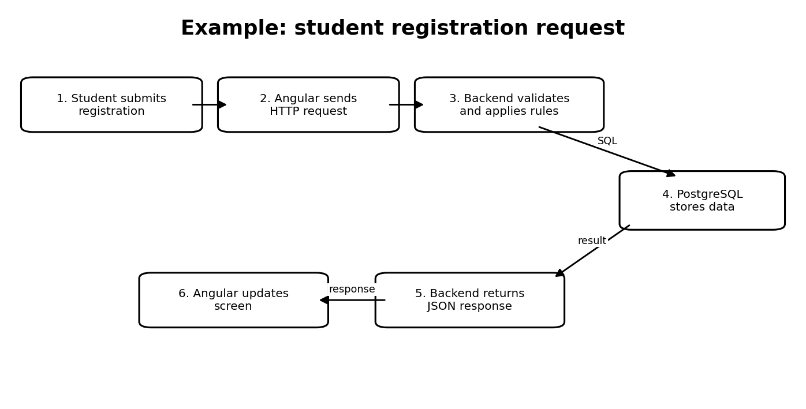
Example registration: student submits form → Angular sends HTTP request → Node.js backend validates input and applies rules → backend queries PostgreSQL → PostgreSQL returns data → backend responds with JSON → Angular updates the UI. pgAdmin is a separate developer tool for inspecting/querying the database; students never connect to it.

12. Recommended daily startup sequence
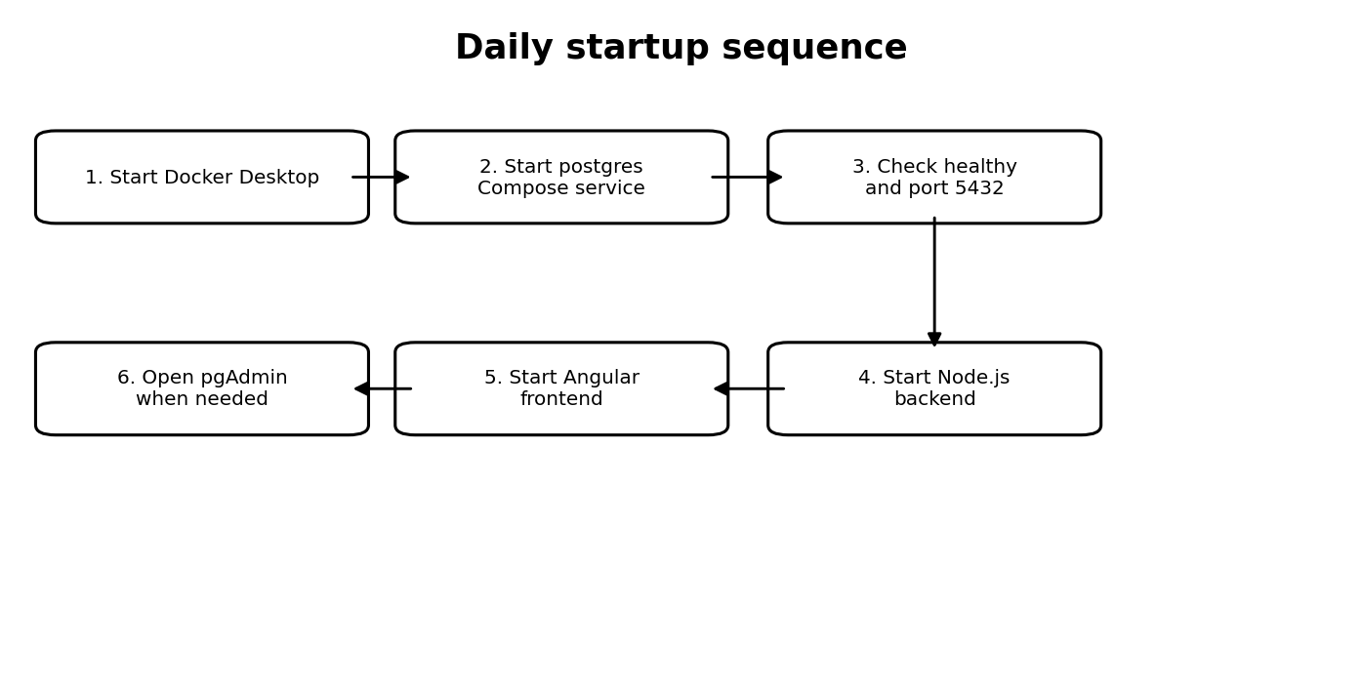
- Start Docker Desktop and wait until it is running.
- From the folder containing docker-compose.yml, run `docker compose up -d postgres`.
- Run `docker compose ps` and confirm the service is healthy.
- Start the backend in its own terminal.
- Start Angular in another terminal.
- Open the frontend in a browser. Open pgAdmin only when you need to inspect or administer database data.

13. Troubleshooting
Problem | What to check
No Compose file found | Terminal is not in the directory containing docker-compose.yml.
Docker daemon unavailable | Launch Docker Desktop and wait for readiness.
Connection refused | Check container status, port mapping, and whether host port 5432 is already in use.
Password authentication failed | Use the actual current database-role password. Changing Compose's POSTGRES_PASSWORD alone does not change an existing role password in an initialized volume.
Database does not exist | Verify target container and actual database name.
pgAdmin access violation | Parameters tab → add `gssencmode` = `disable`; restart pgAdmin if needed.
pgAdmin connects but backend fails | Check backend DB host, port, DB name, username, password, environment loading, and whether backend runs on host or in Docker.
No tables visible | Expand correct database/schema, refresh Tables, and verify migrations ran against this database.
Port 5432 already allocated | Identify the process using it. If host port changes, update pgAdmin and host-run backend settings too; don't delete data volumes.

14. Team security and data safety
- Never commit `.env`, database passwords, OAuth secrets, API keys, or production credentials.
- Commit `.env.example` with placeholders and explain required environment variables.
- Each developer should use their own local environment and local database volume.
- Do not expose PostgreSQL port 5432 to the public internet.
- Use backend APIs for application changes; do not manually create users by editing authentication tables.
- Keep database migrations in version control so all developers create a consistent schema.
- Avoid `docker compose down -v` unless intentionally deleting local database data.
- Before production: use strong secrets, HTTPS, restricted database networking, backups and tested restore procedures. Local settings are not production settings.

15. Quick reference
Item | Value / command
Project root | Directory containing docker-compose.yml
Compose service | postgres
Image | postgres:16-alpine
Database / user | rankforge / rankforge
Host PostgreSQL port | 5432
pgAdmin server label | RankForge Local
Backend port | 4000 (verify config)
Angular dev server | Usually 4200 (verify package scripts)
Start database | docker compose up -d postgres
Check services | docker compose ps
Check database readiness | docker compose exec postgres pg_isready -U rankforge -d rankforge
Apply migrations | cd backend; npm run db:migrate

Official references
- Docker Desktop: https://www.docker.com/products/docker-desktop/
- Docker Compose: https://docs.docker.com/compose/
- pgAdmin for Windows: https://www.pgadmin.org/download/pgadmin-4-windows/
- pgAdmin server connection dialog: https://www.pgadmin.org/docs/pgadmin4/latest/server_dialog.html
- Node.js: https://nodejs.org/en/download
- Git for Windows: https://git-scm.com/download/win
Document reflects the local RankForge setup described in the project conversation. Always check the current README, package.json files, Compose file, and backend config before assuming scripts or ports have not changed.

