1. Run the program. A desktop pet in the style of a white rabbit appears at a random position above the taskbar. Its lower end is flush with the upper end of the computer taskbar, just like a rabbit stepping on the taskbar.

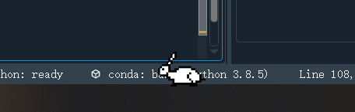

1. Over time, the rabbit can make different actions. (E.g. bowing to eat grass, jumping, turning)

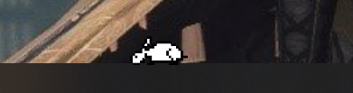

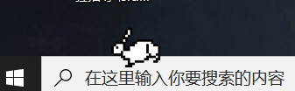

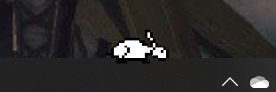

1. When you press and hold the left button of the mouse at the corresponding position, the rabbit will be bound to the mouse position, and the rabbit can be dragged anywhere on the desktop. When dragging, the logo of the mouse will change to the pattern of the palm. However, during manual testing, it was found that as long as the rabbit makes a jumping action, the rabbit will return to its original position. So overall, the function of dragging to change the position of the rabbit is not perfect.

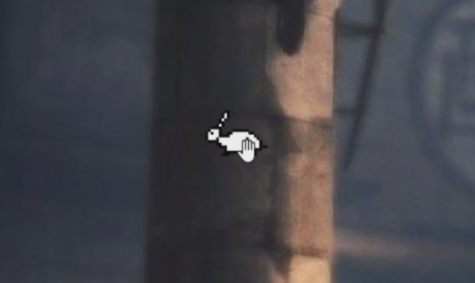

1. We also designed an exit option in the task tray. Right-click with the mouse, and "Exit" will pop up to realize the exit function of the desktop pet program. However, the design was a bit hasty, and the icons were not beautified. The program icons were transparent and the related program icons could not be seen.

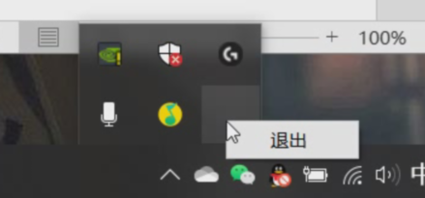

1. Above, the manual test of the rabbit desktop pet has been completed. It can be seen that the basic functions are perfect, and the program can also perform basic operations, but the two points of drag and tray icon need to be improved.