LangGraph
LangGraph is an open-source orchestration framework developed by LangChain that is designed for building stateful, multi-agent AI workflows using graph-based architectures. Unlike traditional linear, step-by-step AI chains, LangGraph allows developers to map out complex AI reasoning by using a combination of nodes and edges, effectively functioning like an advanced flowchart or GPS system for an AI’s brain.

How it Works ?
LangGraph structures an AI application as a graph containing three fundamental concepts:
1.Nodes: Units of computation or individual functions. Each node represents a specific step, such as an LLM call, a data retrieval action, or an execution tool
-Nodes define the modular components of the system and execute specific logic at each step.
e.g. “Greeting Node” welcomes the user.
“Classification Node” determines if the query is related to billing or technical support.

2. Edges: The pathways that connect your nodes, defining the data flow. Edges can be conditional, allowing the system to branch out or dynamically decide the next action based on what the LLM outputs
e.g. Example: If a chatbot user mentions “billing”, an edge should route them to the Billing Node.
If the query is about a “technical issue”, the edge should direct them to Technical Support Node.

3.State (StateGraph): A centralized, persistent memory shared across the entire graph. As information moves from node to node, it continually updates this core state, ensuring all agents have the exact context they need
-State management is crucial because it ensures that data is carried across different steps and that the system operates smoothly.
e.g.A chatbot tracking user interactions:
Stores the user’s initial query.
Keeps track of whether the issue has been resolved.
Maintains a conversation history so that responses can be more context-aware.
==================================================================================

Features:-
A.Cyclical Workflows & Loops: Standard frameworks struggle with loops. LangGraph natively supports cyclical graphs, enabling self-correcting AI behaviors where an agent can repeatedly review, critique, and refine its own output until a task is successfully completed

B.Human-in-the-Loop (HITL): It includes built-in "interrupt" configurations. This allows the AI workflow to pause automatically, wait for manual human approval or modification (e.g., confirming a financial transfer or reviewing an article draft), and then resume execution

C.Granular Low-Level Control: While LangChain provides pre-built, linear chains that act as a "black box", LangGraph offers low-level primitives. This gives developers total authority to customize cognitive architectures, manage data conflicts, and build enterprise-grade system

A helpful analogy is that if LangChain supplies the engine, tools, and integrations (such as prompt templates or vector databases), LangGraph acts as the GPS system that coordinates how those distinct pieces interact—especially when complex multi-step reasoning is required

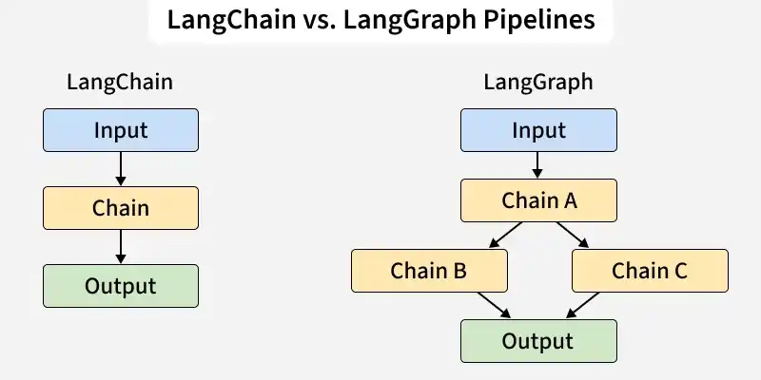

LangChain:-
-Primarily linear, sequential, and single-direction
-Limited, short-term conversational context
-Best for single agents or simple chatbots
-High-level abstractions

LangGraph:-
-Graph-based, cyclical, and multi-directional
-Advanced, persistent, centralized state schema
-Optimized for multi-agent collaboration and sub-graphs
-Low-level orchestration and precise control

Popular use cases include automated business pipelines, deep-research assistants that scrape and analyze web data, autonomous coding agents, and complex customer support routing

