Mahendran Shyamala

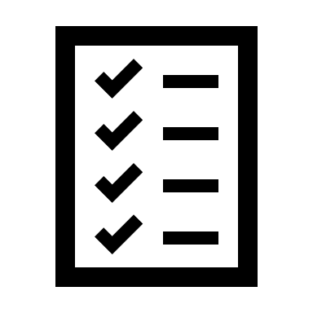

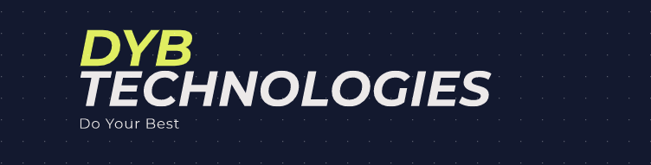

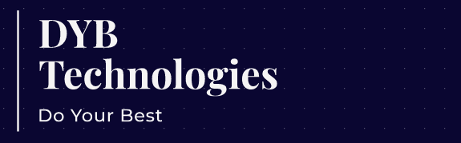

**DYB Technologies**

**Do Your Best**

A Software Automation Testing Training Institute

**DYB Technologies**

**Do Your Best**

A Software Automation Testi A Software

**DYB Technologies**

**Do Your Best**

**DYB Technologies**



**A Software Automation Testing Training Institute**

***Do Your Best***

**47/3 ,11th Avenue, Ashok nagar, Chennai 600 083.**

**Ph:8939234302**

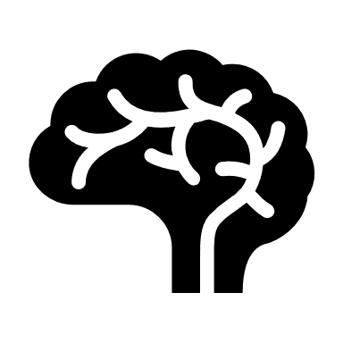

**Do Your Best**

**DYB Technologies**

A Software Automation Testing Training Institute

**DYB Technologies**

A Software Automation Testing Training Institute

**Do Your Best**

A Software Automation Testing Training Institute