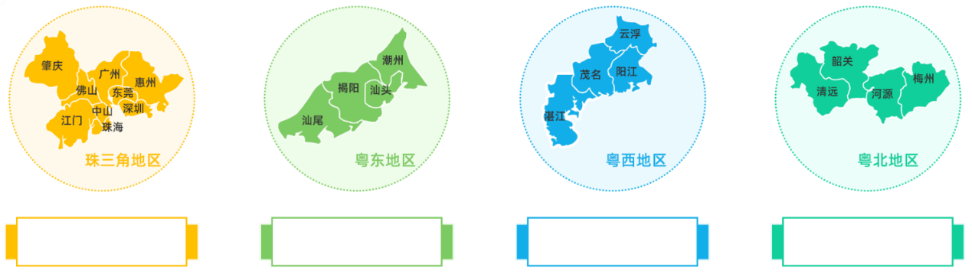
**人**%
**人**%
**人**%
**人**%

