GitHub Action CICD Pipeline Execution Steps:
Step 1. Git Repository and Branch
- Setup: Use a provided Python application repository on GitHub.
- Repository has a main branch and a staging branch.
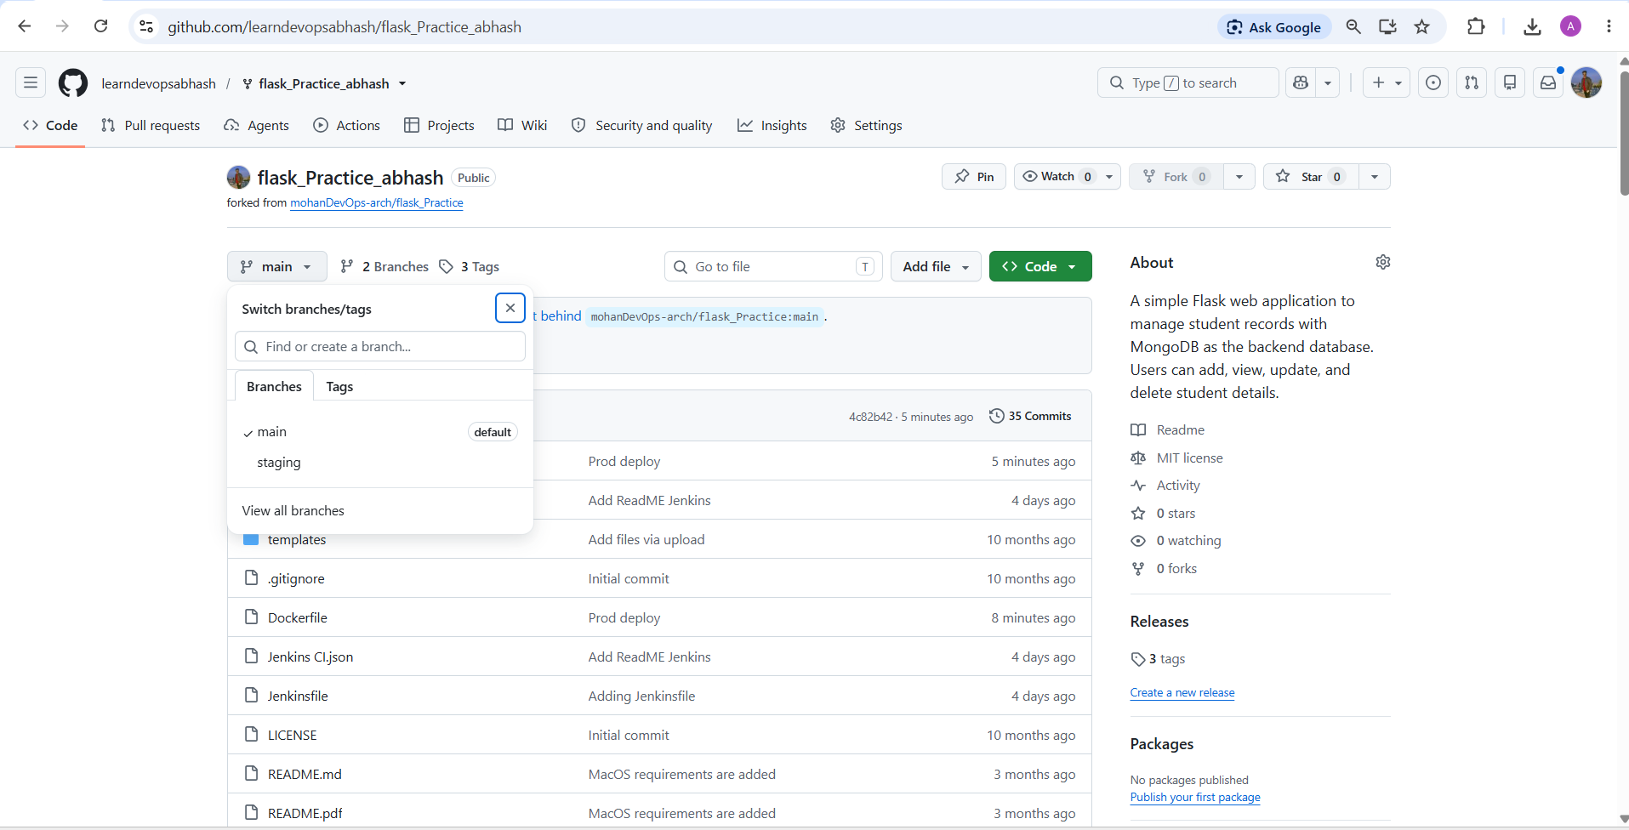

Step 2. GitHub Actions Workflow:
- Create a .github/workflows directory and YML file in your repository.
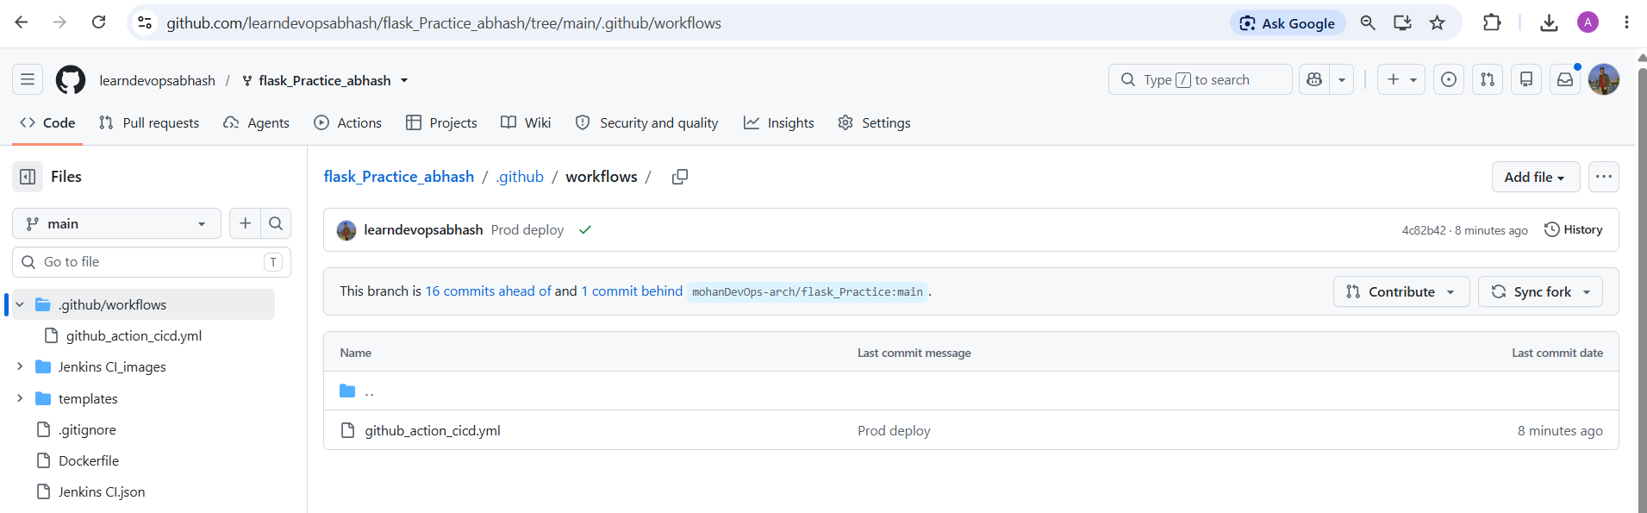
Step 3. Create Workflow Steps and other required file:
- Create workflow that performs Jobs:
name: GitHub Actions CI/CD Pipeline Flask App
on:
push:
branches:
- staging
- main
tags:
- 'v*.*.*'
jobs:
install-dependencies-and-test:
runs-on: ubuntu-latest
steps:
- name: Checkout code
uses: actions/checkout@v4

- name: Set up Python
uses: actions/setup-python@v5
with:
python-version: '3.12'

- name: Install dependencies
run: |
python -m pip install --upgrade pip
python -m venv .venv
source .venv/bin/activate
pip install -r requirements.txt

- name: Create .env file
run: |
echo "MONGO_URI=${{ secrets.MONGO_URI }}" >> .env
echo "SECRET_KEY=${{ secrets.SECRET_KEY }}" >> .env

- name: Run unit tests
run: |
source .venv/bin/activate
pytest -v

- name: Upload artifact
uses: actions/upload-artifact@v4
with:
name: Download .venv
path: .venv
include-hidden-files: true

deploy-to-staging:
if: github.ref == 'refs/heads/staging'
needs: install-dependencies-and-test
runs-on: ubuntu-latest
steps:
- name: Checkout code
uses: actions/checkout@v6

- name: Download artifact
uses: actions/download-artifact@v4
with:
name: Download .venv
path: .venv
include-hidden-files: true

- name: Set permissions for virtual environment
run: |
chmod -R +x .venv
- name: Create .env file
run: |
echo "MONGO_URI=${{ secrets.MONGO_URI }}" >> .env
echo "SECRET_KEY=${{ secrets.SECRET_KEY }}" >> .env
- name: Deploy to Staging Server
run: |
source .venv/bin/activate
nohup python app.py &
sleep 5
curl -fsS http://localhost:5000

deploy-to-production:
if: startsWith(github.ref, 'refs/tags/v') || github.ref == 'refs/heads/main'
needs: install-dependencies-and-test
runs-on: ubuntu-latest
steps:
- name: setup ssh agent
uses: webfactory/ssh-agent@v0.5.3
with:
ssh-private-key: ${{ secrets.PROD_SERVER_SSH_KEY }}

- name: Deploy to EC2
run: |
ssh -o StrictHostKeyChecking=no ${{ secrets.PROD_SERVER_USER }}@${{ secrets.PROD_SERVER_IP }} << EOF
cd /home/ubuntu
if [ ! -d flask_Practice_abhash ]; then
git clone https://github.com/learndevopsabhash/flask_Practice_abhash.git
fi
cd flask_Practice_abhash
git pull origin main
echo "MONGO_URI=${{ secrets.MONGO_URI }}" > .env
echo "SECRET_KEY=${{ secrets.SECRET_KEY }}" >> .env
sudo docker stop flask-app || true
sudo docker rm flask-app || true
sudo docker build -t flask-app .
sudo docker run -d --name flask-app --restart always -p 5000:5000 --env-file .env flask-app

EOF

- Create Dockerfile for production deployment:
FROM python:3.12-slim
WORKDIR /app
COPY requirements.txt .
RUN pip install --no-cache-dir -r requirements.txt
COPY . .
EXPOSE 5000
CMD ["python", "app.py"]

Step 4. Switch to staging branch
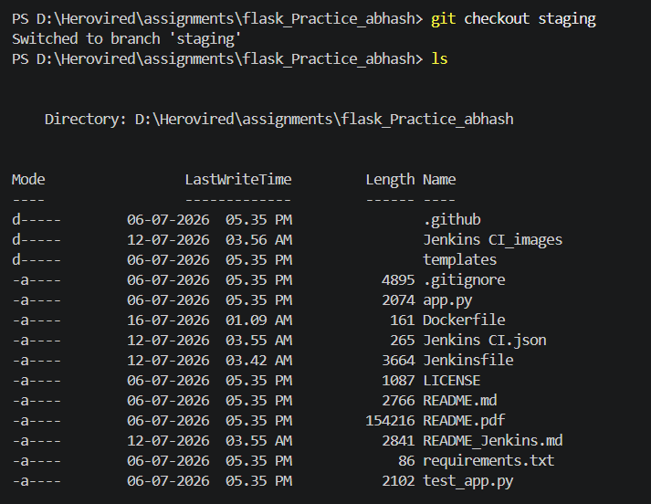

Step 5. Add, Commit and push to Staging
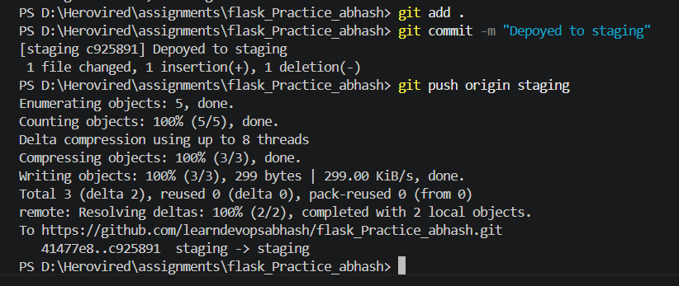

Step 6. Check Workflow
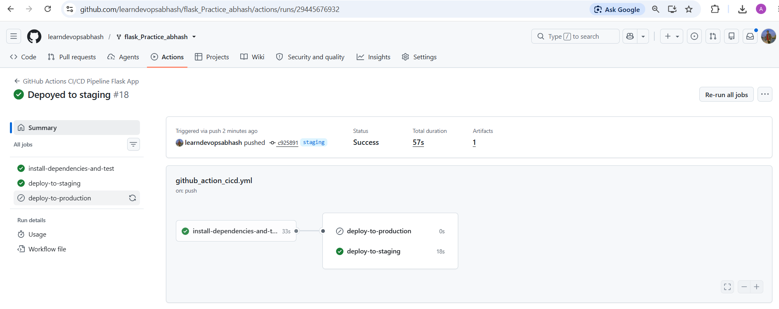
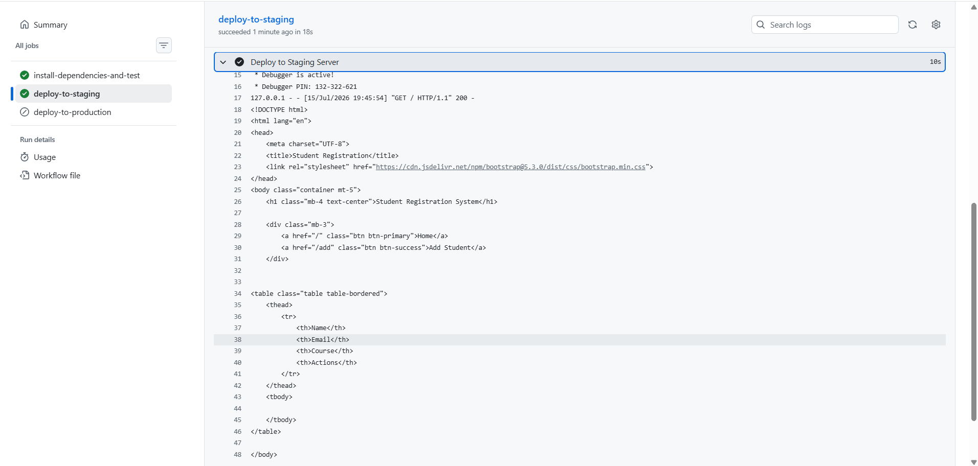

Step 7. Merge to Main branch and
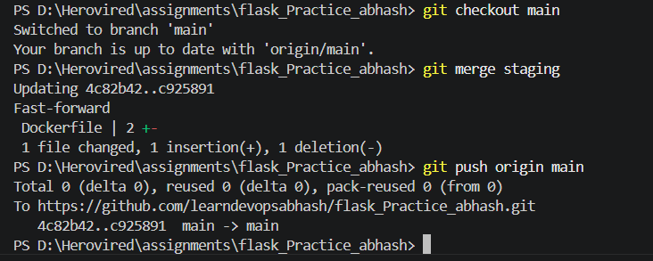

Step 8. Create a release for production deployment.
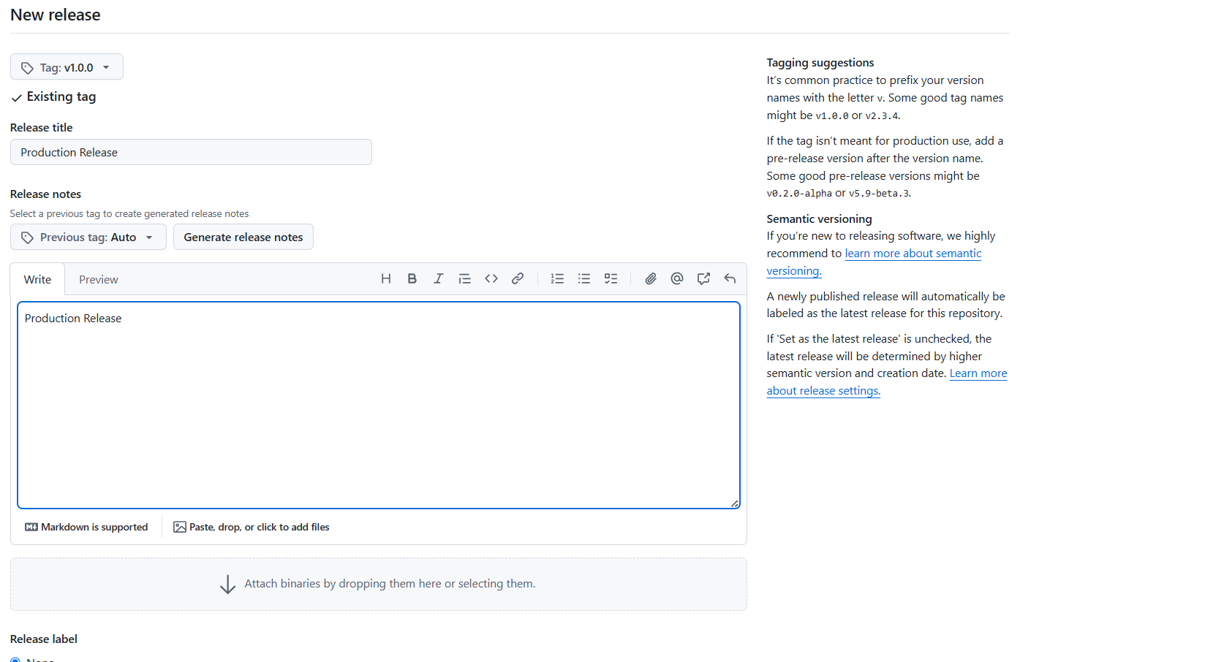

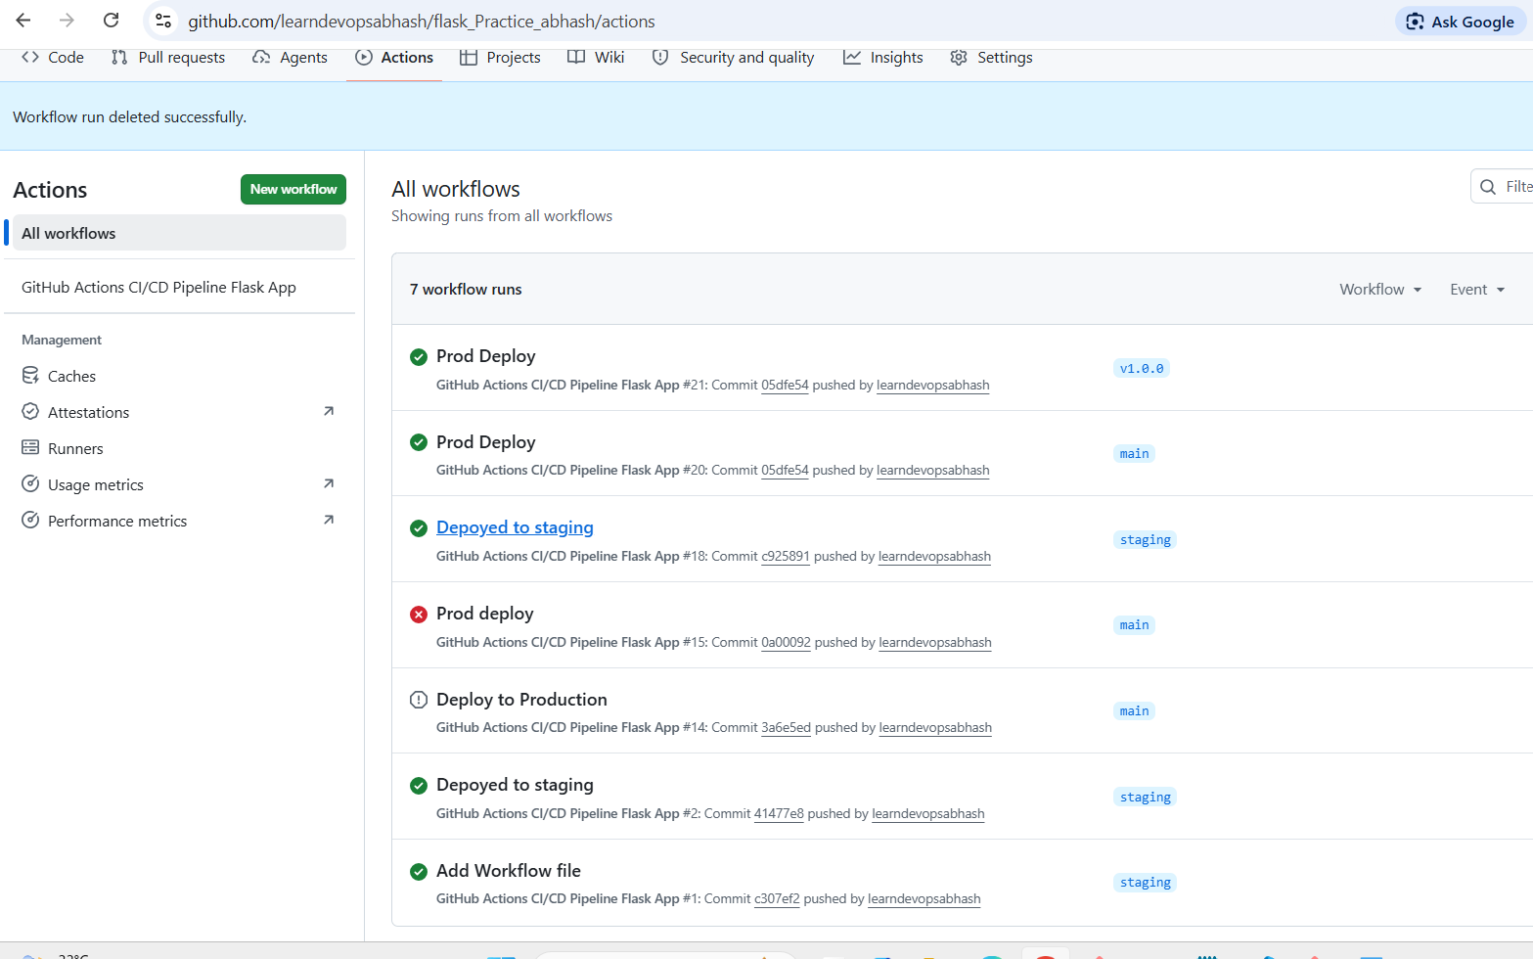

Step 9. Check Public application page and add some data.
