Experiment Report Template
South China University of Technology
《Course》Experiment Report
Experiment Title： lab1 Quick Sort
Name： 任苏成 Student ID： 201630588382
Class： Group：
Collaborator：
Teacher： Yan Xiao Yang
Description
【Objective and Requirement】
Objective：
Abstract of Experiment contents:
Use QuickSort algorithm to sort the array that has n elements that are constructed by the random() function.
Requirement：
Programs should be made by Object-Oriented Programming (OOP) method;
The results should be compared with ones of other algorithms, such as: Straight selection sort, insert sort, etc., and draw the graph to find their differences.
The template should be used for all kinds of data type, such as: integer, real, double, etc. in the program;
Write down the report in which there should be the execution results of the program.
【Environment】
Operating System：win10 program code C++
Content
【Procedure】
- Step：
We will use straight selection sort, insert sort, quick sort respectively. First, random generate 100000 samples which depend on the input. Second, sort by straight selection sort, insert sort, quick sort
Code
#include <iostream>
#include<stdlib.h>
#include<time.h>
#include<windows.h>
using namespace std;
template <class T>
class exp
{
public:
int N;
T *data;
T *newdata;
void initial()
{
cout<<"array size:";
cin>>N;
data=new T[N];
cout<<"the random data is:...(the size is too large)";
for (int i=0;i<N;++i)
{
srand((int)time(0)+i);
data[i]=rand()%(N*10);
}
cout<<endl;
}
void quicksort(double newdata[],int left,int right)
{
double t0=GetTickCount();
if(left>=right)
return;
int first=left;
int last=right;
T pivot=newdata[first];
while(first < last)
{
while(first < last && newdata[last] >= pivot)
{
--last;
}
newdata[first] = newdata[last];
while(first < last && newdata[first] <= pivot)
{
++first;
}
newdata[last] = newdata[first];
}
newdata[first] = pivot;
quicksort(newdata,left, first-1);
quicksort(newdata,first+1, right);
}
void selectionsort()
{
T newdata[N];
for (int i=0;i<N;++i)
{
newdata[i]=data[i];
}
double t0=GetTickCount();
for(int m=0;m<N-1;++m)
{
double a=newdata[m];
int id;
for(int n=m+1;n<N;++n)
{
if(a>newdata[n])
{
a=newdata[n];
id=n;
}
}
int temp=newdata[m];
newdata[m]=newdata[id];
newdata[id]=temp;
}
double t1=GetTickCount();
cout<<"The time of selection sort used is:"<<(t1-t0)/1000<<"s"<<endl;
}
void bubblesort()
{
T newdata[N];
for (int i=0;i<N;++i)
{
newdata[i]=data[i];
}
int t0=GetTickCount();
for(int m=0;m<N;++m)
{
for(int n=0;n<N-1;++n)
{
if(newdata[n]>newdata[n+1])
{
int temp=newdata[n];
newdata[n]=newdata[n+1];
newdata[n+1]=n;
}
}
}
/*for(int i=0;i<N;++i)
{
cout<<newdata[i]<<" ";
}*/
double t1=GetTickCount();
cout<<"After bubble sort:..."<<endl;
cout<<"The time of bubble sort used is:"<<(t1-t0)/1000<<"s"<<endl;
}
};
int main()
{
exp<double> E;
E.initial();
E.bubblesort();
E.selectionsort();
double newdata[E.N];
for(int i=0;i<E.N;++i)
newdata[i]=E.data[i];
double t0=GetTickCount();
E.quicksort(newdata,0,E.N-1);
double t1=GetTickCount();
cout<<"After bubble sort:..."<<endl;
cout<<"The time of bubble sort used is:"<<(t1-t0)/1000<<"s"<<endl;
}

- Data：
Random generates, we generate 100000 data.

- Major Procedure：
As above;

Conclusion
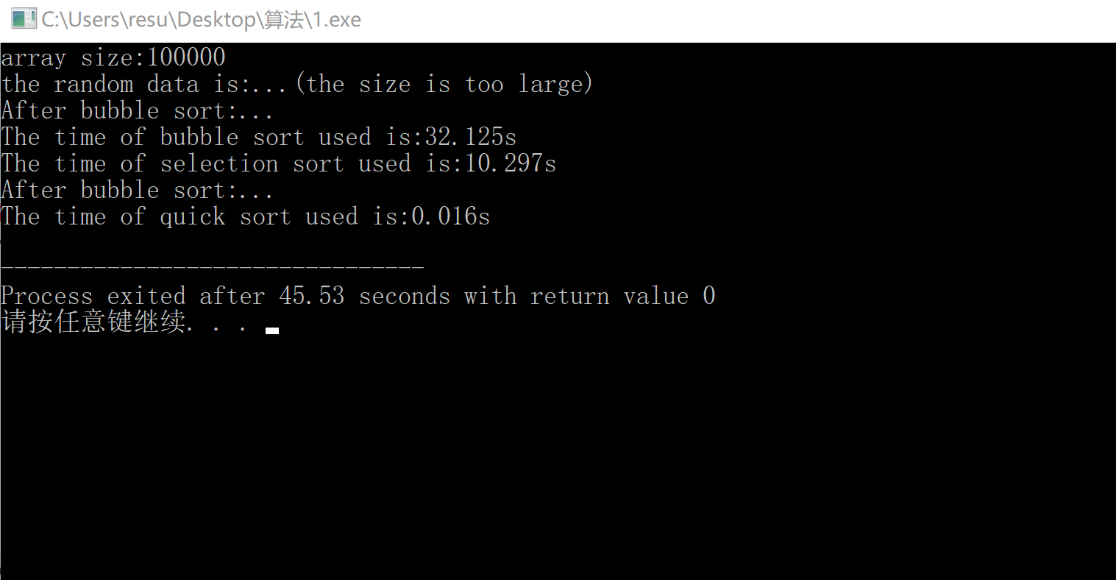
We can see that quick sort is much faster than bubble sort and selection sort.
Teacher’s Comments and Score
Comment：

Score： Signature：
Date：

