Experiment Report Template
South China University of Technology
《Course》Experiment Report
Experiment Title： lab2 knapsack problem
Name： 任苏成 Student ID： 201630588382
Class： Group：
Collaborator：
Teacher： Yan Xiao Yang
Description
【Objective and Requirement】
Objective：
Given some items with weight and profit, to finish the program to solve it using Greedy algorithm and Search tree algorithm, compare its performance.
Requirement：
The template should be used for all kinds of data type, such as: integer, real, double, etc. in the program;
Programs should be made using Object-Oriented Programming (OOP) method;
Write down the report in which there should be the execution results of the program.
Given some things with weight and profit, to finish the program to solve it using Greedy method and Search tree method.
【Environment】
Operating System：win 10, program code: C++
Content
【Procedure】
- Step：
I randomly generate samples, generate 20 samples which depend on the input. I use greedy algorithm. I divide profit and weight, and choose the largest one by one. In comparison, I use the tree search algorithm.
Code
#include <iostream>
#include<stdlib.h>
#include<time.h>
#include<map>
using namespace std;
template <class T>
class Knapsack
{
public:
int weight;
int n;
T *w;//weight
T *p;//profit
int *choice;
void initial()
{
cout<<"the number of all things:";
cin>>n;
cout<<"the upper bound of weight is ";
cin>>weight;
w=new T[n];
p=new T[n];
choice=new int[n];
for (int i=0;i<n;++i)
{
srand((int)time(0)+i);
w[i]=rand()%(2*n)+10;
}
for (int i=0;i<n;++i)
{
srand((int)time(0)+i*i);
p[i]=rand()%10+1;
}
cout<<"all things:"<<endl;
cout<<"weight profit"<<endl;
for(int i=0;i<n;++i)
{
cout<<w[i]<<" "<<p[i]<<endl;
}
}
void greedy()
{
map< T,T,greater<T> > m;
for (int i=0;i<n;++i)
{
m.insert(make_pair(p[i],w[i]));
}
T wei=0;
T pro=0;
map<int,int>::iterator m_iter;
cout<<"we choose:"<<endl;
cout<<"weight profit"<<endl;
for (m_iter=m.begin();m_iter!=m.end();++m_iter)
{
wei+=m_iter->second;
if(wei>weight)
{
wei-=m_iter->second;
continue;
}
pro+=m_iter->first;
cout<<m_iter->second<<" "<<m_iter->first<<endl;
}
cout<<"all profit:"<<pro<<endl;
cout<<"all weight:"<<wei<<endl;
}
int searchtree(int N,int W)
{
for(int i=N-1;i>=0;--i)
{
if(w[i]>W)
{
choice[i]=0;
return searchtree(N-1,W);
}
else
{
if(searchtree(N-1,W)>=p[i]+searchtree(N-1,W-w[i]))
{
choice[i]=0;
return searchtree(N-1,W);
}
else
{
choice[i]=1;
return p[i]+searchtree(N-1,W-w[i]);
}
}
}
return 0;
}
void print()
{
cout<<endl<<"tree algorithm";
cout<<"we choose:"<<endl;
cout<<"weight profit"<<endl;
T ap=0;
T aw=0;
for(int i=0;i<n-1;++i)
{
if(choice[i]==1)
{
cout<<w[i]<<" "<<p[i]<<endl;
ap+=p[i];
aw+=w[i];
}
}
cout<<"all weight:"<<aw<<endl;
cout<<"all profit:"<<ap<<endl;
}
};
int main()
{
Knapsack<int> K;
K.initial();
K.greedy();
K.searchtree(K.n,K.weight);
K.print();
}

- Data：
Result : random generate, generate 20 samples.

- Major Procedure：
As above;

Conclusion
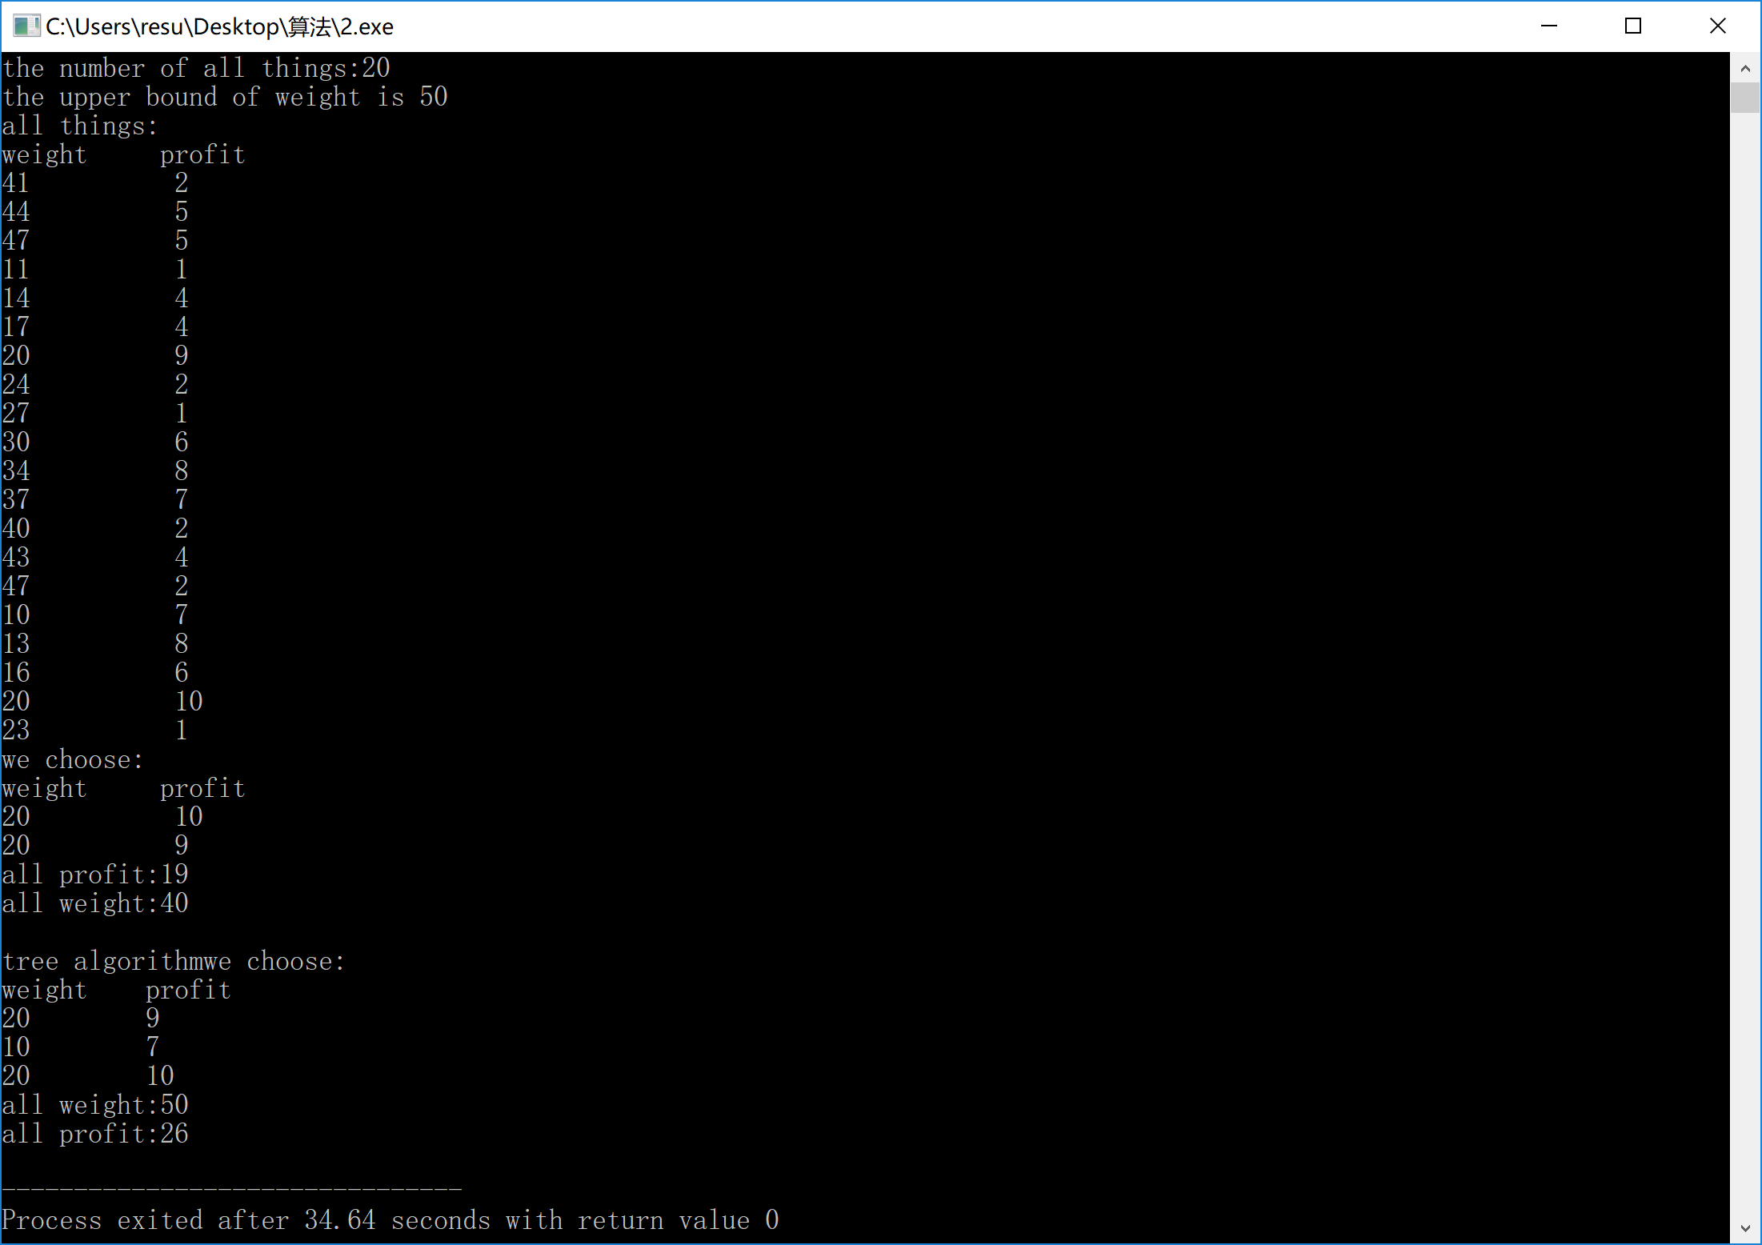
Teacher’s Comments and Score
Comment：

Score： Signature：
Date：

