Experiment Report Template
South China University of Technology
《Course》Experiment Report
Experiment Title：
Name： Student ID：
Class： Group：
Collaborator：
Teacher： Yan Xiao Yang
Description
【Objective and Requirement】
Objective：
Given a undirected Graph G=(V, E) like below, to calculate the minimum spanning tree using Kruskal’s algorithm and Prim’s algorithm.

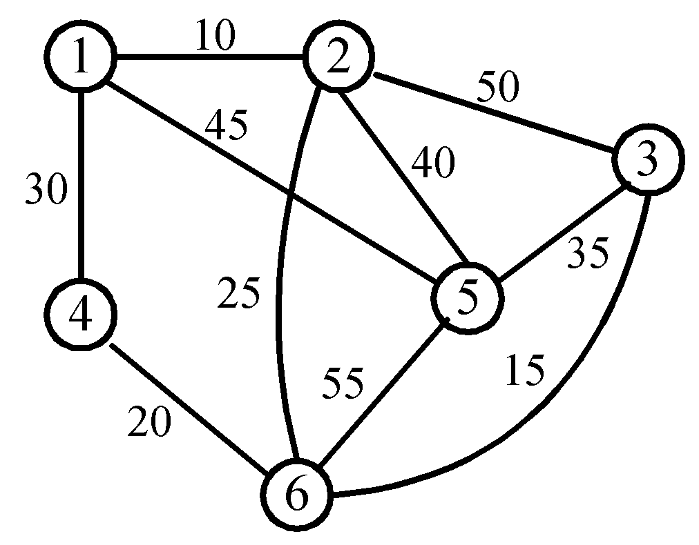
Requirements:
The template should be used for all kinds of data type, such as: integer, real, double, etc. in the program;
Programs should be made using Object-Oriented Programming (OOP) method;
Write down the report in which there should be the execution results of the program.
Requirements:
There should be the selection processes and their differences between two algorithms, besides the finally MST for the given graph in the report.
【Environment】
Operating System：win 10 program code C++
Content
【Procedure】
Step：
First, I translate graph into matrix, then use prim and Kruskal algorithm respectively to solve this program.
Code
#include <iostream>
using namespace std;
const int n=6;
template <class T>
class MST
{
public:
T graph[n][n];
void initial()
{
for(int i=0;i<n;++i)
{
for(int j=0;j<n;++j)
{
if(i==j)
graph[i][j]=0;
else
graph[i][j]=10000000;
}
}
graph[0][1]=10;
graph[1][0]=10;
graph[0][3]=30;
graph[3][0]=30;
graph[3][5]=20;
graph[5][3]=20;
graph[1][5]=25;
graph[5][1]=25;
graph[2][5]=15;
graph[5][2]=15;
graph[2][4]=35;
graph[4][2]=35;
graph[1][4]=40;
graph[4][1]=40;
graph[0][4]=45;
graph[4][0]=45;
graph[1][2]=50;
graph[2][1]=50;
graph[4][5]=55;
graph[5][4]=55;
cout<<"the number of point:"<<n<<endl;
cout<<"the graph(represent by the matrix) is"<<endl;
for(int i=0;i<n;++i)
{
for(int j=0;j<n;++j)
{
if(graph[i][j]==10000000)
cout<<graph[i][j]<<" ";
else if(graph[i][j]==0)
cout<<graph[i][j]<<" ";
else
cout<<graph[i][j]<<" ";
}
cout<<endl;
}
}
void prim()
{
cout<<"Prim:"<<endl;
int set[n];
for(int i=0;i<n;++i)
{
set[i]=n+1;
}
T len=10000000;
for(int i=0;i<n;++i)
{
for(int j=0;j<n;++j)
{
if(graph[i][j]<len&&i!=j)
{
len=graph[i][j];
set[0]=i;
set[1]=j;
}
}
}
cout<<"line1: "<<set[0]+1<<" to "<<set[1]+1<<", lenth: "<<len<<endl;
for(int k=1;k<n-1;++k)
{
T lenth=1000000;
int point0;
int point1;
for(int i=0;i<=k;++i)
{
for(int j=0;j<n;++j)
{
int flag=0;
for(int m=0;m<=k;++m)
{
if(set[m]==j)
{
flag=1;
break;
}
}
if(flag)
continue;
if(graph[set[i]][j]<lenth)
{
lenth=graph[set[i]][j];
point0=set[i];
point1=j;
}
}
}
cout<<"line"<<(k+1)<<": "<<point0+1<<" to "<<point1+1<<",lenth: "<<lenth<<endl;
set[k+1]=point1;
}
}

void kruskal()
{
cout<<"Kruskal:"<<endl;
int set[n];
for(int i=0;i<n;++i)
{
set[i]=n+1;
}
T len=10000000;
for(int i=0;i<n;++i)
{
for(int j=0;j<n;++j)
{
if(graph[i][j]<len&&i!=j)
{
len=graph[i][j];
set[0]=i;
set[1]=j;
}
}
}
graph[set[0]][set[1]]=10000000;
graph[set[1]][set[0]]=10000000;
cout<<"line1: "<<set[0]+1<<" to "<<set[1]+1<<", lenth: "<<len<<endl;
int p=1;
for(int k=1;k<n-1;++k)
{
++p;
T lenth=1000000;
int point0=-1;
int point1=-1;
int flag=0;
int f0=0;
int f1=0;
for(int i=0;i<=n;++i)
{
for(int j=0;j<n;++j)
{
if(graph[i][j]<lenth&&graph[i][j]!=0)
{
point0=i;
point1=j;
lenth=graph[i][j];
}
}
}
for(int m=0;m<=k;++m)
{
if(set[m]==point0)
{
++flag;
++f0;
}
if(set[m]==point1)
{
++flag;
++f1;
}
}
if(point0==1&&point1==5)
{
cout<<"line"<<p<<": "<<point0+1<<" to "<<point1+1<<",lenth: "<<lenth<<endl;
graph[point1][point0]=1000000;
graph[point0][point1]=1000000;
--k;
continue;
}
if(flag==2)
{
cout<<"reject line"<<p<<": "<<point0+1<<" to "<<point1+1<<",lenth: "<<lenth<<endl;
graph[point1][point0]=1000000;
graph[point0][point1]=1000000;
--k;
continue;
}
if(flag==1)
{
cout<<"line"<<p<<": "<<point0+1<<" to "<<point1+1<<",lenth: "<<lenth<<endl;
if(f0)
set[k+1]=point1;
else
set[k+1]=point0;
graph[point1][point0]=1000000;
graph[point0][point1]=1000000;
continue;
}
if(flag==0)
{
cout<<"line"<<p<<": "<<point0+1<<" to "<<point1+1<<",lenth: "<<lenth<<endl;
set[++k]=point0;
set[k+1]=point1;
graph[point1][point0]=1000000;
graph[point0][point1]=1000000;
continue;
}
}
}
};

int main()
{
MST<int> M;
M.initial();
M.prim();
M.kruskal();
}

- Data：
Result : I translate the graph into a matrix. Then I use prim and Kruskal algorithm respectively.
- Major Procedure：
As above;

Conclusion
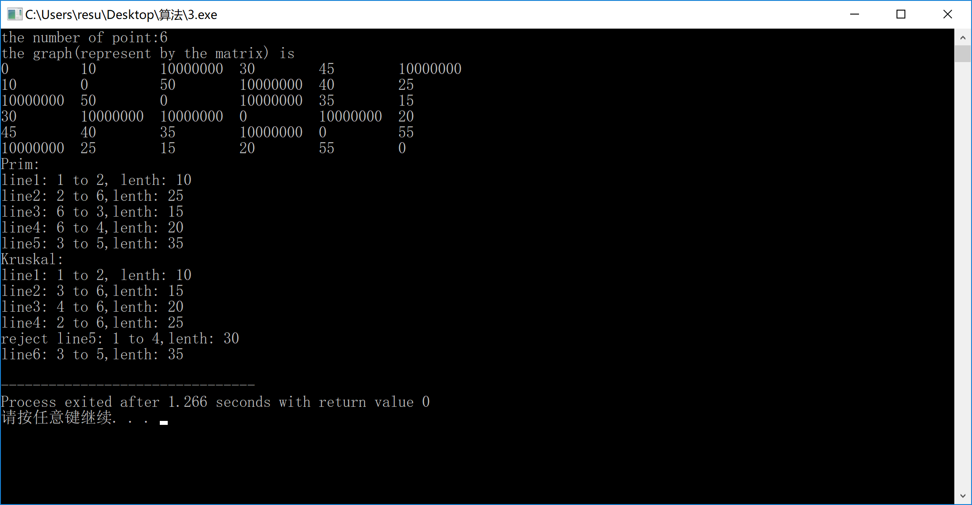
Teacher’s Comments and Score
Comment：

Score： Signature：
Date：

