Experiment Report Template
South China University of Technology
《Course》Experiment Report
Experiment Title： lab4 Binary search tree
Name： 任苏成 Student ID： 201630588382
Class： Group：
Collaborator：
Teacher： Yan Xiao Yang
Description
【Objective and Requirement】
Objective：
Given a binary tree T which has n elements, and a number called a, search if a exists in T or not
Write down the report in which there should be the execution results of the program.
Use different strategies to perform this algorithm, such as: the Breadth-first search(BFS), the Depth-first search(DFS) and the Best-first search(BFS) Search strategies
And compare the result difference solved by them.
Requirement：
The template should be used for all kinds of data type, such as: integer, real, double, etc. in the program;
Programs should be made by Object-Oriented Programming (OOP) method;

【Environment】
Operating System：win10 program code: C++
Content
【Procedure】
- Step：
First, input the number of samples, then random generate them. Second input the check query. I use BFS, DFS, best first search to search them all.
Code
#include <iostream>
#include <queue>
#include <stack>
#include <math.h>
using namespace std;
template <class T>
class SearchTree
{
public:
T *tree;
int n;
T S;
void initial()
{
cout<<"please enter the number of nodes:";
cin>>n;
tree=new T[n+1];
for(int i=1;i<n+1;++i)
{
tree[i]=i;
}
cout<<"please enter the number which you want to query:";
cin>>S;
cout<<endl;
}
void BFS()
{
cout<<"Breadth First Search:"<<endl;
queue<T> q;
int check=0;
q.push(tree[1]);
cout<<"search queue: ";
while(check!=S)
{
check=q.front();
q.pop();
cout<<check<<" ";
if(tree[2*check+1]>0)
{
q.push(tree[2*check]);
q.push(tree[2*check+1]);
}
else if(tree[2*check]>0)
{
q.push(tree[2*check]);
}
else
{}
}
cout<<endl<<endl;
}
void DFS()
{
cout<<"Depth First Search:"<<endl;
stack<T> s;
int check=0;
s.push(tree[1]);
cout<<"search queue:" ;
while(S!=check)
{
check=s.top();
s.pop();
cout<<check<<" ";
if(tree[2*check+1]>0&&tree[2*check+1]<=n)
{
s.push(tree[2*check+1]);
s.push(tree[2*check]);
}
else if(tree[2*check]>0&&tree[2*check+1]<=n)
{
s.push(tree[2*check]);
}
else
{}
}
cout<<endl<<endl;
}
void Best()
{
cout<<"Best First search:"<<endl;
int check;
cout<<"search queue:" ;
T w[n+1];
for(int i =0;i<n+1;++i)
w[i]=1000000;
w[1]=0+S-1;
check=tree[1];
while(S!=check)
{
int c=check;
for(int i=1;i<n+1;++i)
{
if(w[c]>w[i])
{
c=i;
}
}
check=c;
cout<<check<<" ";
int layer;
layer=w[check]-8+check;
if(tree[2*check+1]>0&&tree[2*check+1]<=n)
{
w[2*check]=layer+1+8-2*check;
w[2*check+1]=layer+1+8-2*check-1;
}
else if(tree[2*check]>0&&tree[2*check+1]<=n)
{
w[2*check]=layer+1+8-2*check;
}
else
{}
w[c]=1000000;
}
cout<<endl<<endl;
}
};
int main()
{
SearchTree<int> ST;
ST.initial();
ST.BFS();
ST.DFS();
ST.Best();
}

- Data：randomly generate
Result :
- Major Procedure：
As above;

Conclusion
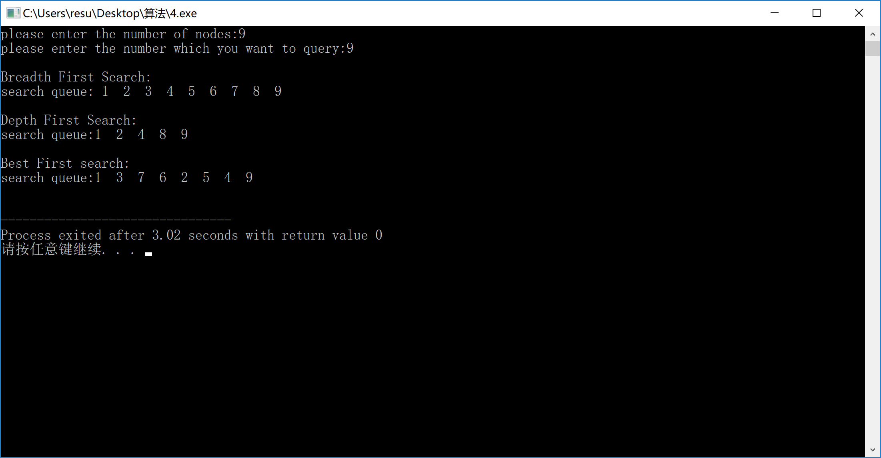
Teacher’s Comments and Score
Comment：

Score： Signature：
Date：

