Experiment Report Template
South China University of Technology
《Course》Experiment Report
Experiment Title： lab5 shortest-path algorithm
Name： 任苏成 Student ID： 201603588382
Class： Group：
Collaborator：
Teacher： Yan Xiao Yang
Description
【Objective and Requirement】
Objective：
Given a set V of vertices and a set E of edges with weights in a multistage undirected graph G=(E,V) like below, please find the shortest path between any two vertices in this graph using dynamic programming algorithm.
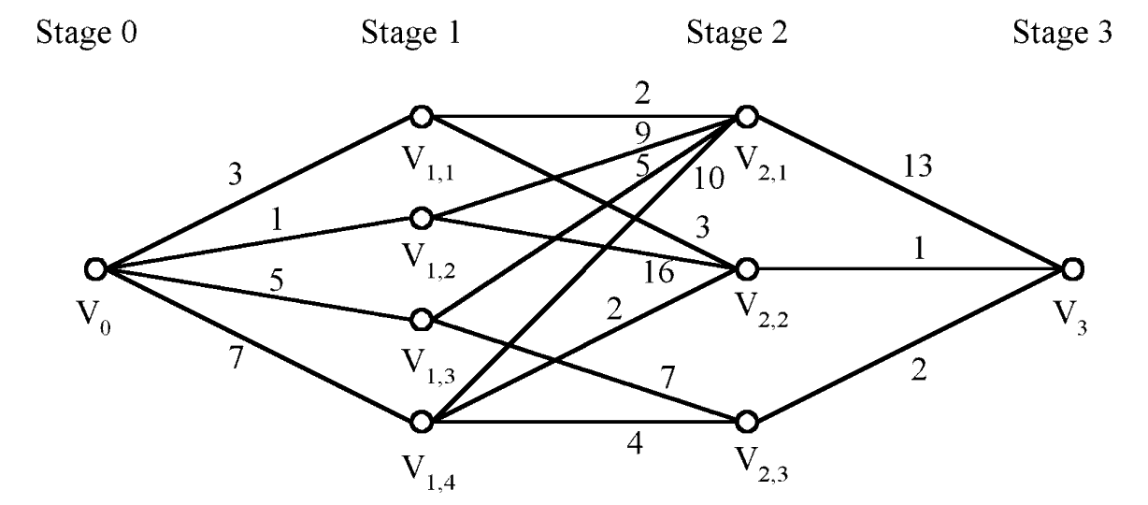
Requirement：
The template should be used for all kinds of data type, such as: integer, real, double, etc. in the program;
Programs should be made using Object-Oriented Programming (OOP) method;
Finish the backward and forward algorithms;
Write down the report in which there should be the execution results of the program.

【Environment】
Operating System：win10 program code: C++
Content
【Procedure】
- Step：
First, translate the graph into matrix. I use forward and backward to search
Code

#include<iostream>
using namespace std;
const int n=9;
template <class T>
class SP
{
public:
T graph[n][n];
void initial()
{
int a;
cout<<"please enter the number of node:";
cin>>a;
cout<<"please enter the number of edge:";
cin>>a;
cout<<"please enter the edge:"<<endl;
for(int i=0;i<n;++i)
{
for(int j=0;j<n;++j)
{
if(i==j)
graph[i][j]=0;
else
graph[i][j]=100000;
}
}
while(a>0)
{
int x,y;
T z;
cin>>x>>y>>z;
graph[x-1][y-1]=z;
--a;
}
}
void forward()
{
cout<<endl<<"forward:"<<endl;
T d[n];
for(int i=0;i<n;++i)
{
d[i]=graph[0][i];
}
d[0]=0;
for(int i=1;i<n;++i)
{
for(int j=0;j<n;++j)
{
if(d[i]>d[j]+graph[j][i])
{
d[i]=d[j]+graph[j][i];
}
}
}
for(int i=1;i<n-1;++i)
{
cout<<"The distance from v1 to v"<<i+1<<" is "<<d[i]<<endl;
}
cout<<"The distance from v1 to the end is "<<d[8]<<endl;
cout<<endl;
}
void backward()
{
cout<<"backward:"<<endl;
for(int i=0;i<n;++i)
{
for(int j=i;j<n;++j)
{
if(graph[i][j]!=100000)
{
graph[j][i]=graph[i][j];
graph[i][j]=100000;
}
}
}
T d[n];
for(int i=n-1;i>=0;--i)
{
d[i]=graph[n-1][i];
}
d[n-1]=0;
for(int i=n-1;i>=0;--i)
{
for(int j=n-1;j>=0;--j)
{
if(d[i]>d[j]+graph[j][i])
{
d[i]=d[j]+graph[j][i];
}
}
}
for(int i=n-2;i>0;--i)
{
cout<<"The distance from v9 to v"<<i+1<<" is "<<d[i]<<endl;
}
cout<<"The distance from v9 to the begin is "<<d[0]<<endl;
}
};
int main()
{
SP<int> S;
S.initial();
S.forward();
S.backward();
}

- Data：
Result :

- Major Procedure：
As above;

Conclusion
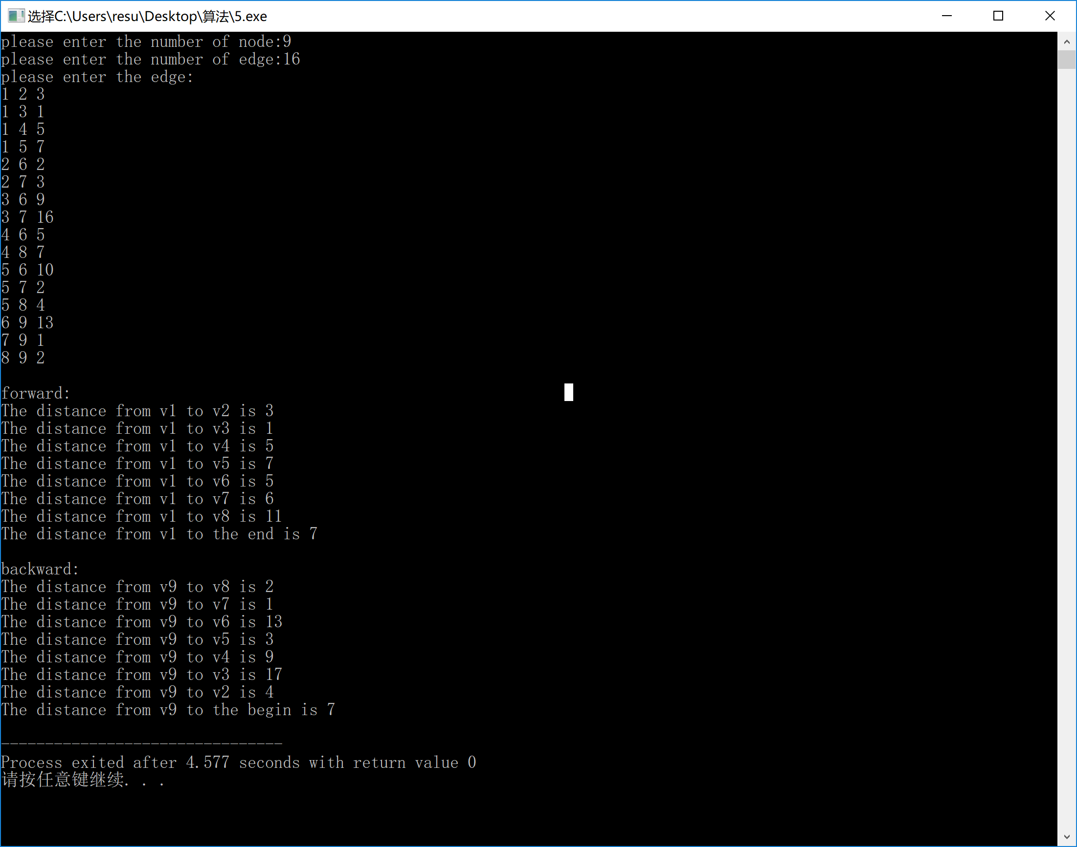
Teacher’s Comments and Score
Comment：

Score： Signature：
Date：

