Experiment Report Template
South China University of Technology
《Course》Experiment Report
Experiment Title： lab6 8-puzzle problem
Name： 任苏成 Student ID： 201630588382
Class： Group：
Collaborator：
Teacher： Yan Xiao Yang
Description
【Objective and Requirement】
Objective：
Given a random sequence for the numbers from 1 to 8 like below and use the tree search algorithm to find if there is the goal node or not after moving them.
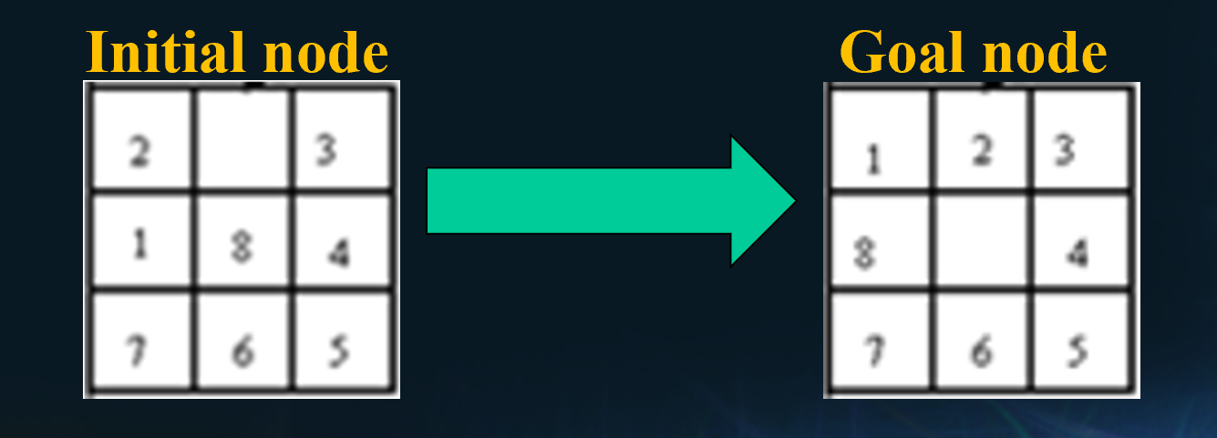
Requirement：
The template should be used for all kinds of data type, such as: integer, real, double, etc. in the program;
Programs should be made by Object-Oriented Programming (OOP) method;
Write down the report in which there should be the execution results of the program.

【Environment】
Operating System：win10 program code: java
Content
【Procedure】
Step：I use java to implement GUI, then I use A* algorithm. Comparing to BFS and DFS, A* is much faster. I use a 4x3 prior queue whose weight is the F(x) value to store data. The first 3X3 represents the chessboard. row4 column1 the depth, row4 column2 weight row4 column3 action. Action 1 2 3 4 stands for up, down, left and right. According to the action, I will set some possible move into 0 to represent impossible move. I will calculate f(x), g(x), and F(x), then store them respectively.
f(x)=depth, g(x)=the difference between current position and target position. F(x) = f(x)+g(x)

Code:
package exp6;
import java.util.Random;
import java.awt.event.ActionEvent;
import java.awt.event.ActionListener;
import java.util.Comparator;
import java.util.PriorityQueue;
import java.util.Queue;

import javax.swing.JButton;
import javax.swing.JFrame;
import javax.swing.JPanel;
import javax.swing.JTextField;
public class logic {
int data[][]=new int[4][3];//the first three rows stand for the graph;
//row4 column1 the depth, row4 column2 weight row4 column3 action
//action 1,2,3 4 stands for up down left right
int ans[][]=new int[3][3];
Comparator<int[][]> cmp=new Comparator<int[][]>() {
@Override
public int compare(int[][] a1, int[][] a2) {
// TODO 自动生成的方法存根
return a1[3][1]-a2[3][1];
}
};
Queue<int[][]> q=new PriorityQueue<>(cmp);
public void initial(){
q.clear();
int[] num=new int[9];
for(int i=0;i<9;i++)
{
num[i] = new Random().nextInt(9);
for(int j=0;j<i;j++)
{
if(num[i]==num[j])
{
i--;
break;
}
}
}
for(int i=0;i<3;++i)
{
for(int j=0;j<3;++j)
{
this.data[i][j]=num[i*3+j];
}
}
this.ans[0][0]=1;
this.ans[0][1]=2;
this.ans[0][2]=3;
this.ans[1][0]=8;
this.ans[1][1]=0;
this.ans[1][2]=4;
this.ans[2][0]=7;
this.ans[2][1]=6;
this.ans[2][2]=5;
this.data[3][0]=0;
int count=0;
for(int i=0;i<3;++i)
{
for(int j=0;j<3;++j)
{
if(this.data[i][j]!=this.ans[i][j])
++count;
}
}
data[3][1]=data[3][0]+count;
data[3][2]=0;
int[][] d=new int[4][3];
d=data;
q.add(d);
}
public boolean AbleToWin(int[][] data)
{
int now[]=new int[9];
for(int i=0;i<3;++i)
{
now[i]=data[0][i];
}
now[3]=data[1][2];
now[4]=data[2][2];
now[5]=data[2][1];
now[6]=data[2][0];
now[7]=data[1][0];
now[8]=0;
int judge = 0;
for(int i=0; i<8; i++)
{
if(now[i]==0)
continue;
for(int j=0; j<i; j++)
{
if(now[j]==0)
continue;
if(now[i]<now[j])
judge++;
}
}
return judge%2==0;
}

public int next()
{
boolean t=true;
int d[][]=new int[4][3];
d=q.remove();
for(int i=0;i<3;++i)
{
for(int j=0;j<3;++j)
if(d[i][j]!=ans[i][j])
{
t=false;
break;
}
}
if(t)
{
System.out.println("this is the answer");
return 1;
}
int possible_action[][][]=new int[3][3][4];
possible_action[0][0][0]=0;
possible_action[0][0][1]=1;
possible_action[0][0][2]=0;
possible_action[0][0][3]=1;

possible_action[0][1][0]=0;
possible_action[0][1][1]=1;
possible_action[0][1][2]=1;
possible_action[0][1][3]=1;

possible_action[0][2][0]=0;
possible_action[0][2][1]=1;
possible_action[0][2][2]=1;
possible_action[0][2][3]=0;

possible_action[1][0][0]=1;
possible_action[1][0][1]=1;
possible_action[1][0][2]=0;
possible_action[1][0][3]=1;

possible_action[1][1][0]=1;
possible_action[1][1][1]=1;
possible_action[1][1][2]=1;
possible_action[1][1][3]=1;

possible_action[1][2][0]=1;
possible_action[1][2][1]=1;
possible_action[1][2][2]=1;
possible_action[1][2][3]=0;

possible_action[2][0][0]=1;
possible_action[2][0][1]=0;
possible_action[2][0][2]=0;
possible_action[2][0][3]=1;

possible_action[2][1][0]=1;
possible_action[2][1][1]=0;
possible_action[2][1][2]=1;
possible_action[2][1][3]=1;

possible_action[2][2][0]=1;
possible_action[2][2][1]=0;
possible_action[2][2][2]=1;
possible_action[2][2][3]=0;

int loc[]=new int[2];
for(int i=0;i<3;++i)
{
for(int j=0;j<3;++j)
{
if(d[i][j]==0)
{
loc[0]=i;
loc[1]=j;
}
}
}
System.out.println(d[3][2]);
if(d[3][2]==1)
possible_action[loc[0]][loc[1]][1]=0;
if(d[3][2]==2)
possible_action[loc[0]][loc[1]][0]=0;
if(d[3][2]==3)
possible_action[loc[0]][loc[1]][3]=0;
if(d[3][2]==4)
possible_action[loc[0]][loc[1]][2]=0;
if(possible_action[loc[0]][loc[1]][0]!=0)
{
int d1[][]=d;
int count=0;
++d1[3][0];
System.out.println(loc[0]);
System.out.println(loc[1]);
int a=d1[loc[0]][loc[1]+1];
d1[loc[0]][loc[1]+1]=0;
d1[loc[0]][loc[1]]=a;
for(int i=0;i<3;++i)
{
for(int j=0;j<3;++j)
if(d[i][j]!=ans[i][j])
{
++count;
}
}
if(count==0)
{
System.out.println("this is the answer.");
return 1;
}
d1[3][1]=d1[3][0]+count;
d1[3][2]=1;
q.add(d1);
}
if(possible_action[loc[0]][loc[1]][1]!=0)
{
int d1[][]=d;
int count=0;
++d1[3][0];
int a=d1[loc[0]][loc[1]-1];
d1[loc[0]][loc[1]-1]=0;
d1[loc[0]][loc[1]]=a;
for(int i=0;i<3;++i)
{
for(int j=0;j<3;++j)
if(d[i][j]!=ans[i][j])
{
++count;
}
}
if(count==0)
{
System.out.println("this is the answer.");
return 1;
}
d1[3][1]=d1[3][0]+count;
d1[3][2]=2;
q.add(d1);
}
if(possible_action[loc[0]][loc[1]][2]!=0)
{
int d1[][]=d;
int count=0;
++d1[3][0];
int a=d1[loc[0]-1][loc[1]];
d1[loc[0]-1][loc[1]]=0;
d1[loc[0]][loc[1]]=a;
for(int i=0;i<3;++i)
{
for(int j=0;j<3;++j)
if(d[i][j]!=ans[i][j])
{
++count;
}
}
if(count==0)
{
System.out.println("this is the answer.");
return 1;
}
d1[3][1]=d1[3][0]+count;
d1[3][2]=3;
q.add(d1);
}
if(possible_action[loc[0]][loc[1]][3]!=0)
{
int d1[][]=d;
int count=0;
++d1[3][0];
for(int i=0;i<3;++i)
{
for(int j=0;j<3;++j)
if(d[i][j]!=ans[i][j])
{
++count;
}
}
if(count==0)
{
System.out.println("this is the answer.");
return 1;
}
int a=d1[loc[0]][loc[1]+1];
d1[loc[0]][loc[1]+1]=0;
d1[loc[0]][loc[1]]=a;
d1[3][1]=d1[3][0]+count;
d1[3][2]=4;
q.add(d1);
}
System.out.println("There is no answear, please initialize again.");
return 0;
}
public static void main(String args[]){
logic l = new logic();
l.initial();
JPanel p=new JPanel();
p.setSize(400,400);
JButton b1=new JButton("wait for initialize");
JButton b2=new JButton("wait for initialize");
JButton b3=new JButton("wait for initialize");
JButton b4=new JButton("wait for initialize");
JButton b5=new JButton("wait for initialize");
JButton b6=new JButton("wait for initialize");
JButton b7=new JButton("wait for initialize");
JButton b8=new JButton("wait for initialize");
JButton b9=new JButton("wait for initialize");
JButton init=new JButton("initialize");
JButton Next=new JButton("Next");
JTextField j=new JTextField(30);
p.add(b1);
p.add(b2);
p.add(b3);
p.add(b4);
p.add(b5);
p.add(b6);
p.add(b7);
p.add(b8);
p.add(b9);
p.add(init);
p.add(Next);
p.add(j);
JFrame f=new JFrame();
f.add(p);
f.setSize(400, 400);
f.setVisible(true);

ActionListener ll1=new ActionListener(){

@Override
public void actionPerformed(ActionEvent arg0) {
// TODO 自动生成的方法存根
l.initial();
b1.setText(" "+l.data[0][0]+" ");
b2.setText(" "+l.data[0][1]+" ");
b3.setText(" "+l.data[0][2]+" ");
b4.setText(" "+l.data[1][0]+" ");
b5.setText(" "+l.data[1][1]+" ");
b6.setText(" "+l.data[1][2]+" ");
b7.setText(" "+l.data[2][0]+" ");
b8.setText(" "+l.data[2][1]+" ");
b9.setText(" "+l.data[2][2]+" ");
if(!l.AbleToWin(l.data))
j.setText("there is no answer");
else
j.setText("There will be answer");
}

};
init.addActionListener(ll1);
ActionListener ll2=new ActionListener(){

@Override
public void actionPerformed(ActionEvent arg0) {
// TODO 自动生成的方法存根
l.next();
}

};
Next.addActionListener(ll2);
/*
boolean flag=true;
while(flag)//initial button is push
{
flag=false;
l.q.clear();
int d1[][]=new int[3][3];
d1=l.data;
l.q.add(d1);
boolean flag2=true;
if(l.AbleToWin(l.q.element()))
{
System.out.println("there is no result.");
break;
}
while(flag2)//push next
{
l.next();
}
}
*/
}
}

- Data：
Random generate. I will check if it is possible to have an answer.

- Major Procedure：
As above;

Conclusion
Initial state:
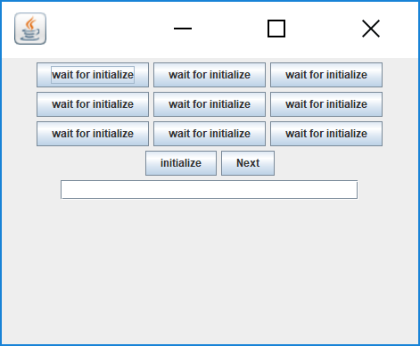
Situation one: there is no answer. If the reverse order pair is odd, there is no answer.
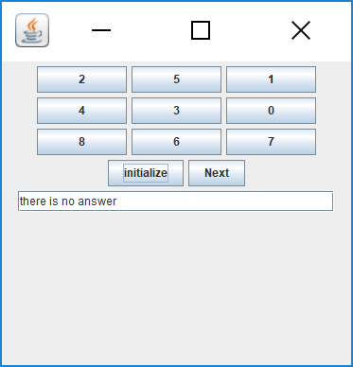
Situation two: use A*
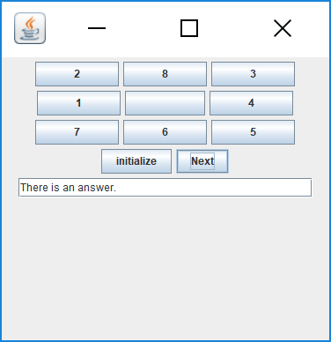
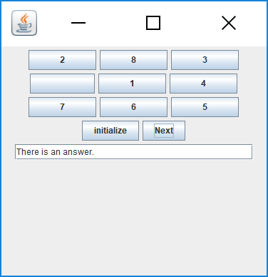
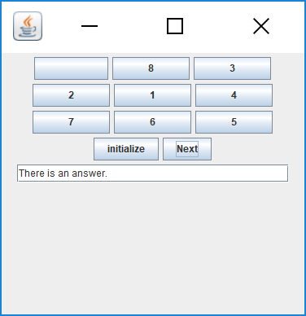
After many steps, I don’t show here, because of the length.
The final result is
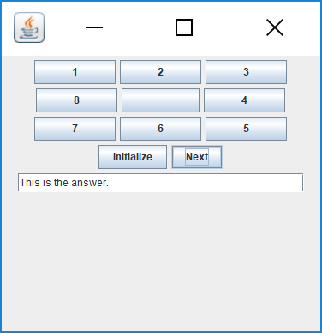

Teacher’s Comments and Score
Comment：

Score： Signature：
Date：

