**CAPSTONE PROJECT ON MOVIE RENTAL ANALYSIS**

**Contents**

OVERVIEW 3

THE PROCESS 4

OBJECTIVE 6

SIGNIFICANCE 7

DATA DICTIONARY 8

ER DIAGRAM 11

POWER BI PROBLEM STATEMENT 12

EDA PROBLEM STATEMENT 41

CONCULSION 56

# **OVERVIEW**

The Movie Rental Analysis project aims to uncover actionable insights from a movie rental company's transactional data to support strategic business decisions. Using data from various domains—customers, rentals, films, stores, and payments—the project explores patterns in rental behavior, customer preferences, revenue generation, and operational efficiency.

By applying data analysis and visualization techniques, we identify high-demand films, peak rental times, top-performing stores, and purchasing behavior of new vs. repeat customers. Additionally, demographic factors such as customer location and staff performance are examined to evaluate their influence on sales and satisfaction.

The findings support data-driven recommendations to improve inventory management, optimize staffing, target customer segments, and enhance overall business performance. The final outputs include summarized reports, compelling visual dashboards in Power BI, and clear business insights to aid decision-makers.

# **THE PROCESS**

**1) Dataset Acquisition from GitHub:**

The raw dataset for the movie rental business was sourced from GitHub, a trusted platform for open-source data. This provided access to structured data across multiple tables like customer, rental, payment, film, store, and staff.

**2) Data Loading:**

The datasets were imported into analytical tools (such as Power BI, Excel, or SQL) using built-in connectors or manual uploads, enabling efficient data handling and merging for analysis.

**3) Data Cleaning (ETL Process):**

An ETL (Extract, Transform, Load) process was used to remove duplicates, handle missing values, correct data types, and establish proper relational links among tables—ensuring data consistency and integrity.

**4) Tool Integration:**

Power BI was used for interactive dashboarding, SQL for data extraction and transformation, and Excel for preliminary analysis—offering a complete and scalable analytics environment.

**5) Problem Definition & Insights Generation:**

Business problems were defined such as identifying peak rental times, high-performing films, customer behavior trends, and staff/store efficiency. Insights were then generated through data-driven patterns and relationships.

**6) Exploratory Data Analysis (EDA):**

EDA was performed using visualizations and statistical summaries to uncover trends, outliers, correlations, and patterns that directly informed key business insights and decisions.

**7) Presentation & Reporting:**

Findings were presented using clear, interactive Power BI dashboards and executive-level summaries, making it easy for stakeholders to interpret results and take informed actions.

**8) Detail Documentation:**

Comprehensive documentation was maintained, covering data sources, methodology, queries, visualizations, business interpretations, and recommendations to ensure project transparency and reproducibility.

# 

# **OBJECTIVE**

The objective of the Movie Rental Analysis project is to extract actionable business insights from the company’s rental, customer, inventory, and store data to support data-driven decision-making. By analyzing customer behavior, rental trends, film performance, and store operations, the goal is to identify key drivers of revenue, customer retention, and operational efficiency. This analysis aims to empower the business to optimize inventory, enhance customer engagement, and strategically allocate staff and resources based on data-backed evidence.

# **SIGNIFICANCE**

In today's data-driven entertainment landscape, analyzing movie rental data holds significant value for businesses aiming to remain competitive and customer-centric. Movie rental analysis provides critical insights into customer preferences, rental patterns, and operational performance. With increasing digitalization and changing viewer behavior, understanding what content drives engagement and revenue is more important than ever.

From a business standpoint, this analysis helps identify the most popular films and genres, allowing inventory decisions to be more targeted and efficient. For example, recognizing which movies are frequently rented can support optimized stocking and reduce the costs associated with low-demand titles. Similarly, understanding seasonal or weekly rental trends enables better planning for promotional campaigns and customer outreach.

Furthermore, customer segmentation becomes achievable by analyzing repeat vs. new customers, enabling tailored marketing strategies. This supports personalized offerings, such as recommending specific genres or promotions based on rental history, thereby enhancing customer satisfaction and retention.

Staffing and store operations can also be optimized by identifying peak rental hours or high-performing locations. This ensures that resources are allocated appropriately, leading to improved customer service and operational efficiency.

Overall, the significance of movie rental analysis lies in its ability to transform raw transactional data into strategic insights. These insights support evidence-based decision-making across inventory planning, marketing, staffing, and customer engagement, ultimately driving profitability and customer loyalty in a competitive market.

# **DATA DICTIONARY**

**1.)Actor Table**

The actor table lists information for all the actors, including first name and last name of actors.

**2.)Address Table**

The address table contains address information for customers, staff, and stores.

**3.)Category Table**

The category table lists the categories that can be assigned to films.

**4.)City Table**

The city table contains a list of cities.

**5.)Country Table**

The country table contains a list of countries or regions.

**6.)Customer Table**

The customer table contains a list of all customers.

**7.)Film Table**

The film table lists all the films that may be in stock in the store.

**8.)Film_text Table**

The content of the film_text table is kept in synchrony with the film table by means of triggers on the film table INSERT, UPDATE, and DELETE operations.

**9.)Film_actor Table**

The film_actor table is used to support many-to-many relationships between films and actors.

**10.)Film_category Table**

The film_category table is used to support many-to-many relationships between films and categories.

**11.)Inventory Table**

A row in the inventory table represents a copy of a given film in a given store.

**12.)Language Table**

The language table lists all possible values for the film language and original language.

**13.)Payment Table**

The payment table records every payment made by the customer, including information such as the amount and rent paid.

**14.)Rental Table**

The rental table contains a row for each rental of each inventory item, which contains information about who rented what, when it rented it, and when it was returned.

**15.)Staff Table**

The staff table lists all staff information, including email addresses, login information, and pictures.

**16.)Store Table**

The store table lists all stores in the system.

# **ER DIAGRAM**

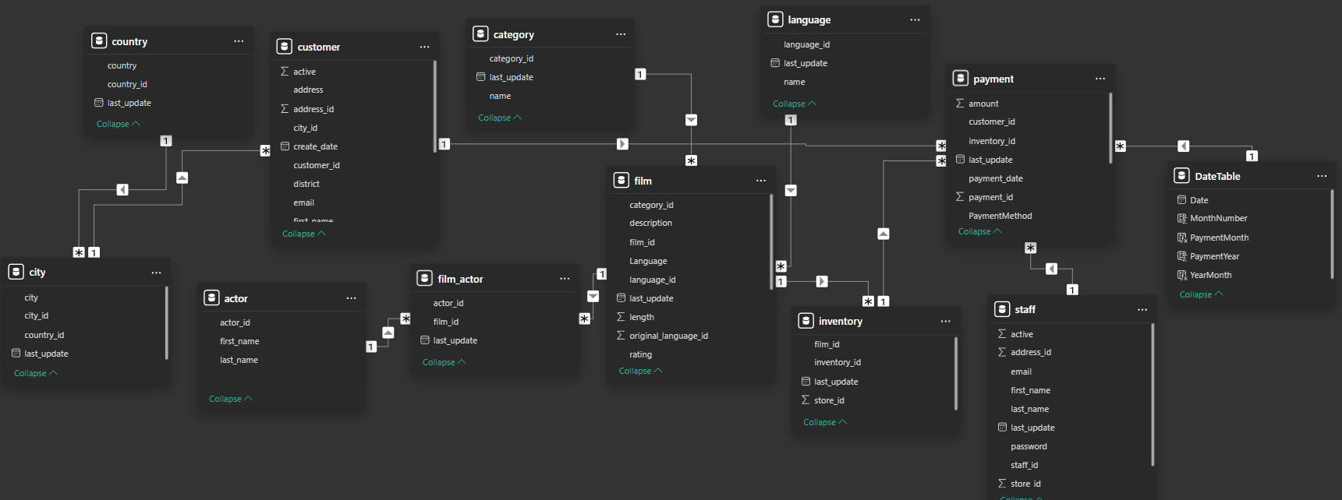

# **POWER BI PROBLEM STATEMENT**

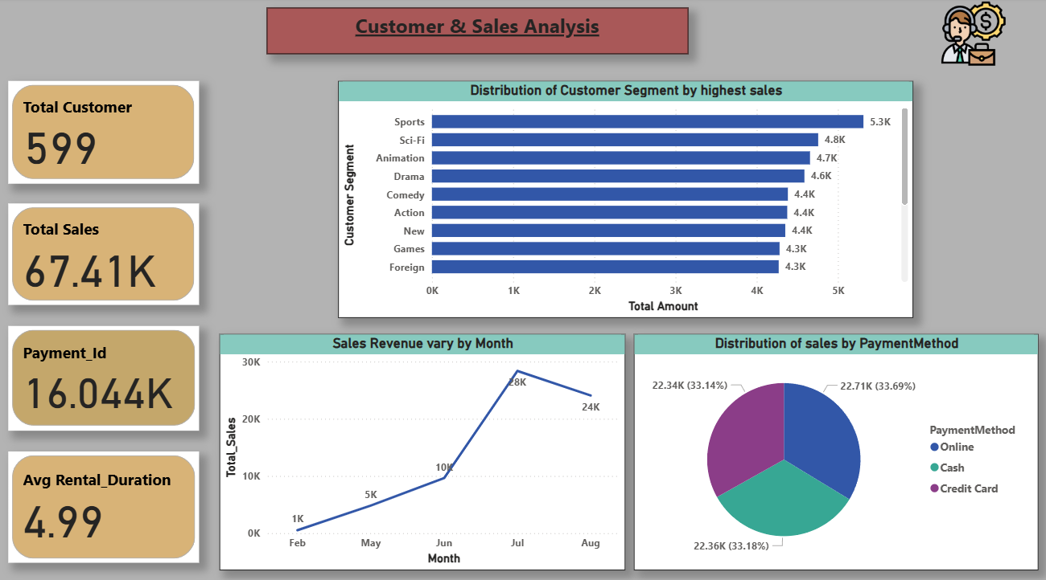

**How does the sales revenue vary by month?**

The line chart illustrates the monthly variation in sales revenue from February to August, revealing a strong upward trend followed by a slight decline. Sales began at ₹1K in February and steadily increased, reaching ₹5K in May and ₹10K in June, indicating consistent month-on-month growth. The revenue peaked in July at ₹28K, suggesting this month experienced the highest customer activity, possibly due to effective promotions, new film releases, or seasonal factors. However, there was a slight dip in August to ₹24K, which may indicate reduced demand, fewer marketing efforts, or other operational challenges. This trend highlights the importance of analyzing the success factors behind July’s performance to replicate them in future months, while also investigating the causes of the August decline to implement timely corrective actions. Understanding these revenue patterns enables the organization to make informed, data-driven decisions around marketing strategies, inventory planning, and seasonal forecasting to optimize business performance.

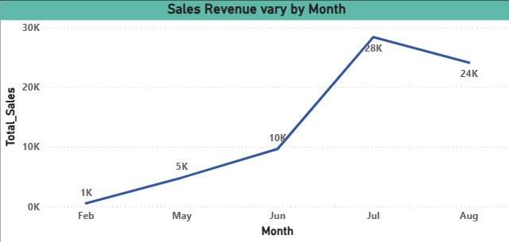

**What is the distribution of sales by payment method?**

The pie chart illustrates the distribution of sales by different payment methods—Online, Cash, and Credit Card—demonstrating a fairly even spread across all three options. Online payments accounted for the largest share at 22.71K (33.69%), followed closely by Cash at 22.36K (33.18%) and Credit Card payments at 22.34K (33.14%). This balanced distribution indicates that customers are using all payment methods almost equally, which reflects flexibility in payment preferences and a well-implemented payment system.

Key Takeaways:

* Online payments lead slightly, suggesting growing digital adoption.
* Cash payments remain significant, showing a portion of customers still prefer traditional methods.
* Credit Card usage is nearly equal, indicating customers’ comfort with card transactions.
* No method dominates the others, emphasizing the need to continue offering multiple payment options.

Recommendations:

* Continue supporting all three payment methods to maintain customer satisfaction.
* Consider promoting online payments further due to their growing preference and potential for automation.
* Monitor changes in this trend over time to adapt to evolving customer behavior (e.g., digital-first strategies).
* If cost differences exist among payment methods (e.g., transaction fees), optimize promotions accordingly to favor more cost-efficient channels.

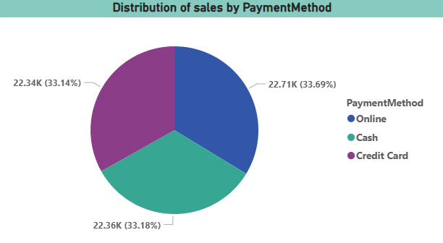

**Which customer segments generate the highest sales?**

The bar chart illustrates the distribution of customer segments based on total sales, highlighting which genres contribute the most to revenue. The Sports segment leads with 5.3K in total sales, followed by Sci-Fi (4.8K) and Animation (4.7K), indicating that these categories are the most popular among customers. On the lower end, Horror ranks the lowest with 3.7K in sales, suggesting limited customer interest. This distribution can guide the organization in tailoring inventory, promotions, and marketing strategies to meet customer preferences and boost profitability.

Key Insights:

* Top-performing genres:
* Sports is the highest revenue generator, followed by Sci-Fi and Animation.
* These genres should be prioritized in promotions, inventory planning, and customer engagement.
* Moderate performers:
* Genres like Drama, Comedy, Action, and New are closely tied in the mid-range, showing consistent demand.
* Low-performing segments:
* Horror, Documentary, and Family genres have the lowest revenue, suggesting they might need targeted campaigns or reassessment of inventory levels.

Recommendations:

* Focus marketing efforts and promotional bundles on top genres (Sports, Sci-Fi, Animation) to maximize revenue.
* Analyze customer preferences in low-performing segments to determine if content quality, availability, or customer taste is impacting sales.
* Consider seasonal promotions or cross-category bundling (e.g., Comedy + Family) to uplift slower segments.
* Regularly monitor and adjust genre offerings based on updated sales performance.

This data-driven segmentation enables the business to align offerings with demand, optimize content strategy, and boost overall customer satisfaction and profitability.

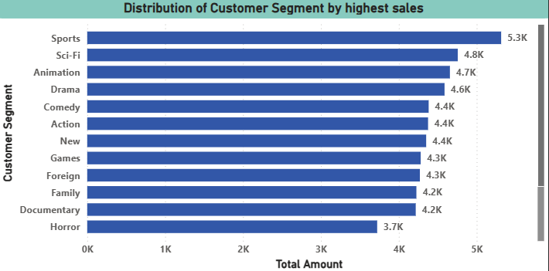

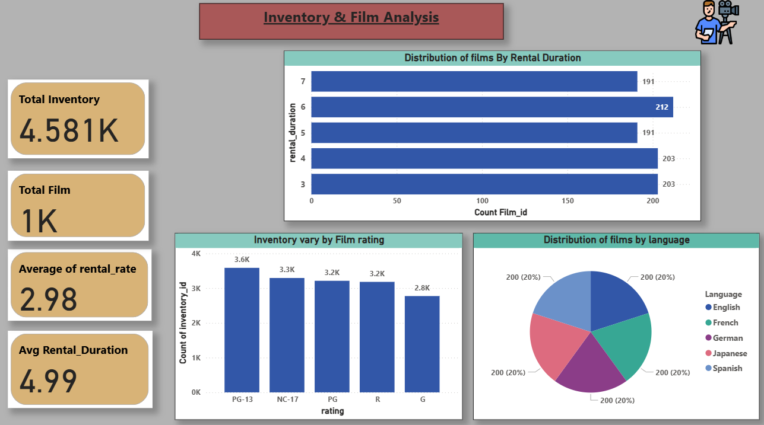

**What is the distribution of films by rental duration?**

The chart displays the distribution of films by rental duration, highlighting how many films fall into each rental period category. The rental durations range from 3 to 7 days, with the most common duration being 6 days, accounting for 212 films. Both 3-day and 4-day durations are also quite popular, each with 203 films, indicating a preference for shorter rental periods. On the other hand, 7-day and 5-day durations have fewer films (191 each), suggesting slightly lower demand or supply for these durations. This insight can guide rental policy and pricing optimization.

Key Insights:

* 6-day rentals are the most frequent, indicating customer or business preference for this duration.
* 3-day and 4-day rentals are also widely used, suggesting demand for shorter viewing periods.
* 5-day and 7-day rentals are the least common, though still substantial, implying limited but stable usage.

Recommendations:

* Optimize pricing and promotions around the 6-day rental duration to align with current usage patterns.
* Maintain a diverse mix of rental durations, especially 3–6 days, to cater to various customer preferences.
* Investigate reasons for lower demand in 5- and 7-day rentals — consider adjusting pricing, bundling, or content availability.
* Use this distribution to develop targeted marketing strategies (e.g., “3-Day Fast Watch” promos or “7-Day Extended Access” bundles).

By aligning rental durations with user demand, the organization can improve customer satisfaction, reduce idle inventory, and increase overall revenue.

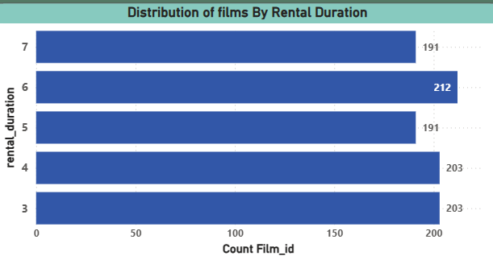

**How does the inventory vary by film rating?**

The chart displays the variation in inventory based on film ratings, with PG-13 films having the highest inventory count at 3.6K, followed by NC-17 (3.3K) and PG/R-rated films (3.2K each). The G-rated films have the lowest count at 2.8K, suggesting a lower focus on content suitable for all age groups.

Insights:

* PG-13 films dominate the inventory, indicating a preference for moderately restricted content.
* G-rated films are underrepresented, which could limit engagement with younger audiences.

Recommendation:

* Expand G-rated inventory to cater to families and younger viewers, broadening the customer base.
* Maintain a balanced stock of PG-13 and NC-17 films to sustain engagement with the core audience segment.

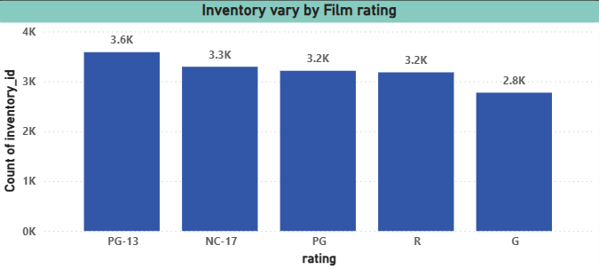

**What is the distribution of films by language?**

The pie chart titled "Distribution of films by language" shows a perfectly balanced film library. The total film count is evenly distributed across five languages: English, French, German, Japanese, and Spanish. Each language comprises exactly 200 films, representing 20% of the total collection.

Insights:

* The organization's film catalog is linguistically balanced, which demonstrates a commitment to a diverse library but may not align with market demand, as indicated by previous charts showing high revenue from countries not primarily speaking these languages.
* The equal distribution suggests a standardized content strategy that might not be fully optimized to capture higher-revenue opportunities in key markets, which could be underrepresented in the current language breakdown.

Recommendations:

1. Rebalance the film acquisition strategy to prioritize languages spoken in the highest-revenue countries, such as those in India and China, to better align the content library with proven market demand.
2. Analyze the rental performance and revenue generated by films in each of the five languages to determine if the current equal distribution is a sound strategy, or if resources should be reallocated to acquire more content in languages with a higher return on investment.

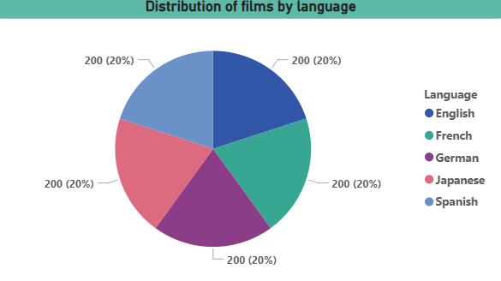

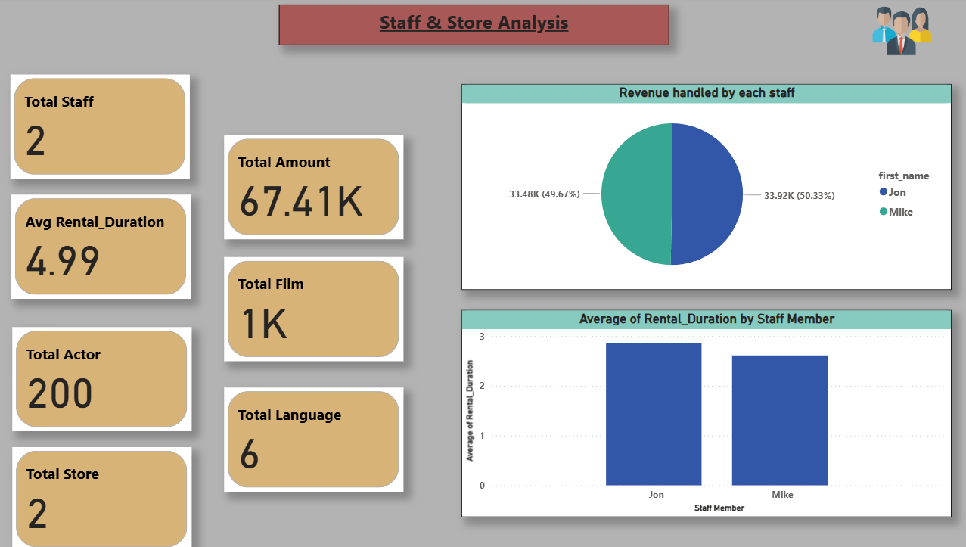

**What is the distribution of staff by employment duration?**

The pie chart shows that revenue handling between the two staff members, Jon and Mike, is almost equally distributed. Jon is responsible for 50.33% of the revenue (₹33.92K), while Mike handles 49.67% (₹33.48K). This near-equal split indicates a balanced workload and performance between both staff members.

Insights:

* Revenue management is nearly equally split, showing balanced staff efficiency.
* There is no major performance gap between the two, suggesting effective team distribution.

Recommendations:

* Continue monitoring performance parity to maintain fairness and motivation.
* Consider using this balanced performance as a model for future staffing and revenue delegation.

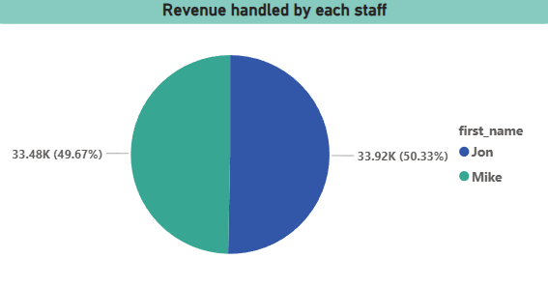

**What is the average rental duration by staff member?**

The chart displays the average rental duration managed by each staff member. Jon has a slightly higher average rental duration compared to Mike, suggesting that customers handled by Jon tend to keep rentals for longer periods. While the difference is not drastic, it might reflect slight variations in customer interaction or rental preferences.

Insights:

* Jon’s average rental duration is higher than Mike’s, indicating potentially better customer engagement or rental upselling strategies.
* Rental duration is consistent overall, reflecting stable rental policies across staff.

Recommendations:

* Analyze Jon’s interaction approach to identify practices that could be adopted by other staff for improving rental durations.
* Introduce rental extension incentives, leveraging staff performance to boost overall revenue.

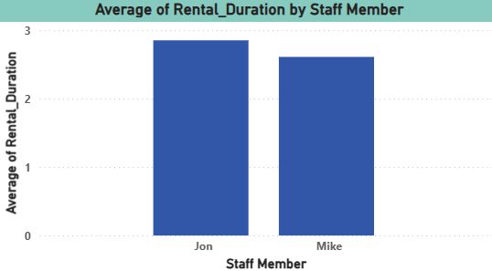

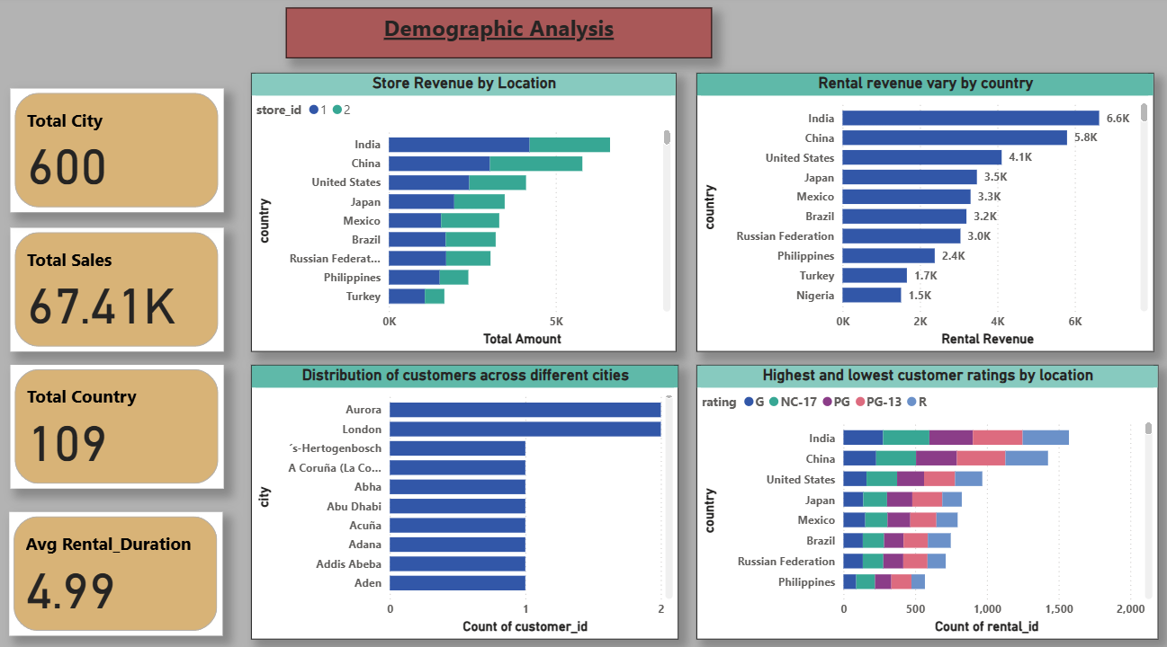

**How does the store performance vary by location?**

The bar chart illustrates store revenue distribution across various countries, broken down by Store 1 and Store 2. India and China lead with the highest combined revenues, exceeding ₹6K each, followed by the U.S., Japan, and Mexico. Most countries show a relatively balanced contribution from both stores, though a few (like the U.S. and Brazil) show more skewed performance toward one store.

Insights:

* India and China generate the highest revenue, indicating strong market presence and customer engagement.
* Revenue distribution between stores is generally balanced, suggesting consistent store performance globally.

Recommendations:

* Invest more in top-performing regions like India and China to further boost returns.
* Investigate underperforming countries (like Turkey and Nigeria) for opportunities to optimize operations or marketing efforts.

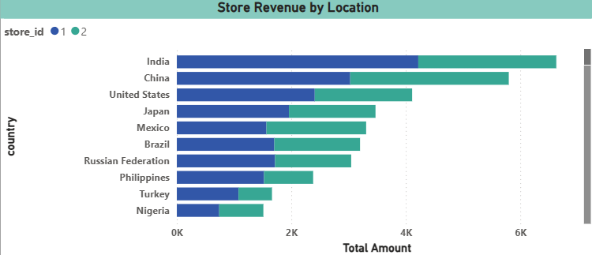

**What is the distribution of customers across different cities?**

The chart highlights the distribution of customers across various cities. It shows that Aurora and London have the highest number of customers, while all other cities have only a single customer. This indicates a concentration of customer base in just a few urban locations, which may reflect either market demand patterns or store presence.

Insights:

* Aurora and London lead in customer count, suggesting stronger market penetration or store availability.
* Other cities have minimal presence, possibly untapped markets or underserved areas.

Recommendations:

* Focus marketing and retention efforts in Aurora and London to maintain and grow the existing customer base.
* Explore expansion strategies in low-representation cities to identify growth opportunities and diversify the customer base.

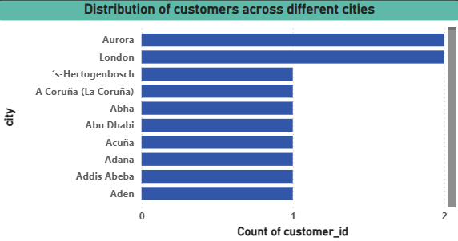

**How does the rental revenue vary by country?**

Based on the provided bar chart, India and China are the top performers in rental revenue, generating 6.6K and 5.8K respectively, far surpassing other countries. The United States follows as the third-highest with 4.1K. Revenue from the remaining countries drops off considerably, with Argentina at the bottom of the list with 1.4K.

Insights:

* The rental market has its strongest performance in Asian countries, particularly India and China, indicating a significant and potentially untapped customer base in this region.
* There is a clear tiering in revenue, with a high-performing top tier (India, China, US), a mid-tier (Japan, Mexico, Brazil, Russian Federation), and a lower-tier of countries with significantly less revenue.

Recommendations:

1. Focus on strategies to further capitalize on the dominant markets of India and China, such as increasing investment or expanding services, while also exploring the potential for growth in the next tier of countries.
2. Analyze the reasons for the low performance in countries like Argentina, Nigeria, and Indonesia to determine if there are opportunities for improvement or if resources should be reallocated to higher-performing regions.

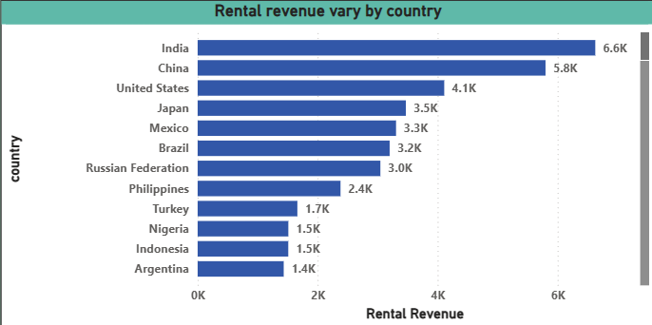

**Which locations have the highest and lowest customer ratings?**

This chart illustrates the volume of customer rentals categorized by movie ratings across various countries. India and China exhibit the highest overall rental volumes, with a noticeable preference for 'R' and 'PG-13' rated content. The United States follows as the third-largest market. In contrast, countries like Nigeria, Argentina, and Indonesia show significantly lower rental activity across all rating categories.

Insights:

* The highest rental demand, particularly for mature 'R' and 'PG-13' rated content, is concentrated in the Asian powerhouses of India and China, followed by the United States.
* There's a substantial disparity in customer engagement across regions, with a significant drop-off in rental volumes for countries lower down the list, suggesting either lower market penetration or a mismatch in content offerings for these regions.

Recommendations:

1. Prioritize the acquisition and promotion of 'R' and 'PG-13' rated content to further solidify market share and revenue in high-demand countries like India, China, and the United States.
2. Conduct targeted market research in low-performing countries such as Nigeria, Argentina, and Indonesia to understand specific content preferences, local regulations, or market barriers that could be hindering rental volumes, enabling data-driven decisions on whether to adjust content strategy or reallocate resources.

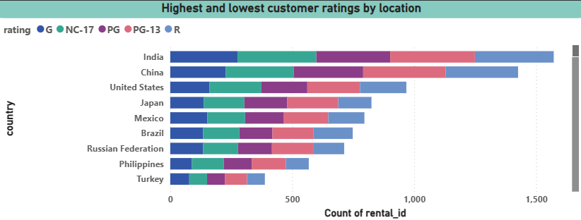

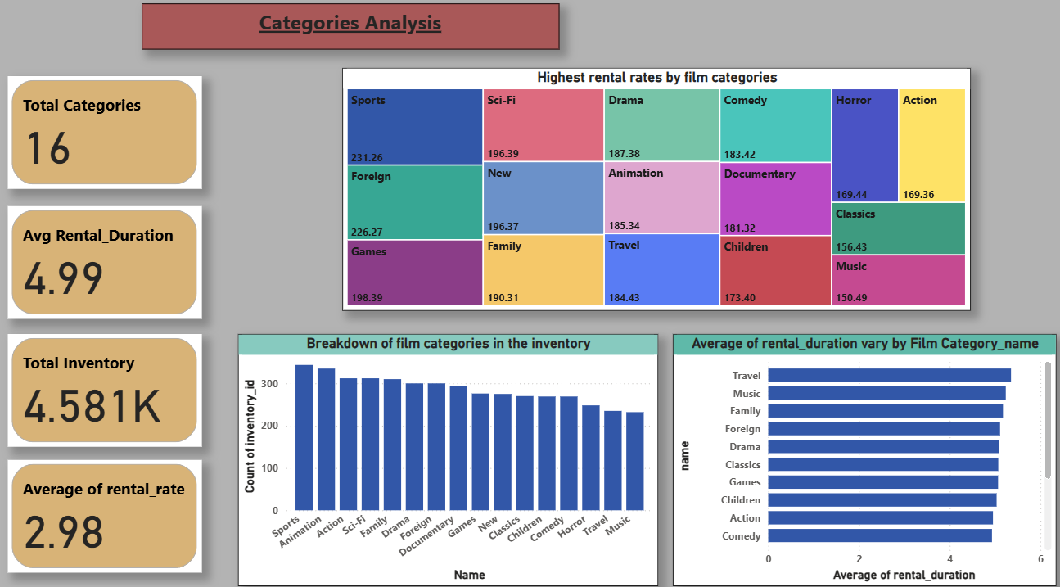

**Which film categories have the highest rental rates?**

This treemap illustrates the highest rental rates across various film categories, revealing that 'Sports' and 'Foreign' films command the highest rates at 231.26 and 226.27, respectively. 'Games', 'Sci-Fi', and 'New' releases also show strong performance, while categories such as 'Music' and 'Classics' have the lowest rental rates.

Insights:

* Specialized content like 'Sports' and 'Foreign' films are highly valued by customers, indicating a strong willingness to pay a premium for niche content over broader categories.
* Traditional popular genres such as 'Action', 'Horror', and 'Music' surprisingly yield lower rental rates, suggesting that while they might have high volume, their perceived value per rental might be less compared to the top-tier categories.

Recommendations:

1. Increase focus on acquiring and promoting content within the 'Sports' and 'Foreign' film categories, given their proven ability to generate the highest rental rates, which can significantly boost overall revenue per transaction.
2. Re-evaluate the pricing strategy for categories with lower rental rates like 'Music', 'Classics', and 'Horror'. Consider implementing dynamic pricing, promotional bundles, or subscription models to enhance their profitability without necessarily reducing rental volume.

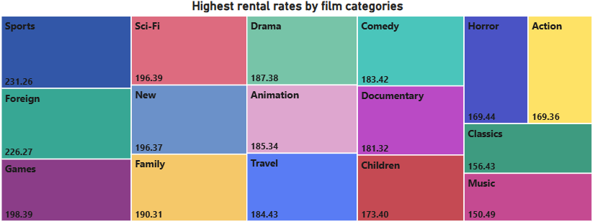

**How does the average rental duration vary by film category?**

The bar chart demonstrates that the average rental duration for films remains remarkably consistent across all categories. While 'Travel' films show a marginally higher average rental duration and 'Comedy' films a slightly lower one, the overall variation among all listed categories is minimal, generally falling within a tight range of approximately 4.7 to 5.4 units of time.

Insights:

* Customer rental duration behavior is largely consistent irrespective of the film genre, indicating that the type of content does not significantly influence how long a customer keeps a rented film.
* Given the negligible variation in rental duration, differences in revenue or popularity across film categories are likely driven by factors such as the volume of rentals, the per-rental rate, or content acquisition costs, rather than how long customers hold the film.

Recommendations:

1. Focus data-driven strategies on optimizing aspects beyond rental duration, such as increasing rental volume for popular categories or adjusting pricing models, as this metric shows little differentiation for decision-making.
2. Investigate other performance metrics like total revenue, customer acquisition per category, or content demand trends, as these will provide more actionable insights for strategic planning than average rental duration.

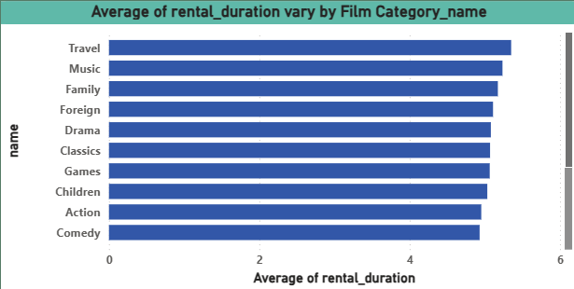

**What is the breakdown of film categories in the inventory?**

The chart shows the distribution of film categories in the inventory, where Sports and Animation lead with the highest count of inventory, followed closely by Action, Sci-Fi, and Family categories. On the other hand, Travel and Music categories have the lowest presence, indicating less investment or demand in these genres.

Insights:

* Inventory is heavily focused on action-packed and family-friendly categories like Sports, Animation, and Action.
* Travel and Music categories are underrepresented, suggesting a niche or low-priority interest.

Recommendations:

* Monitor performance of top categories to ensure their high inventory aligns with customer demand and sales.
* Evaluate viewer interest in Travel and Music genres before phasing them out or considering promotional strategies to boost their visibility.

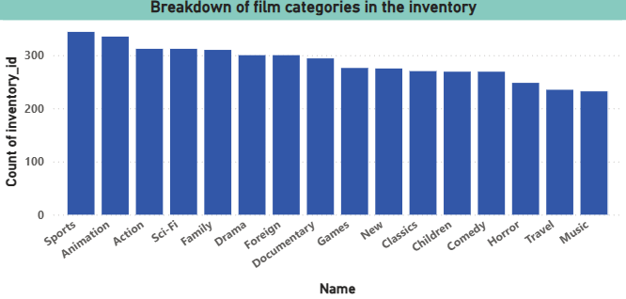

# **EDA PROBLEM STATEMENT**

**What are the purchasing patterns of new customers versus repeat customers?**

This chart underscores the immense value of **repeat customers**. While the "Sum of total_purchases" for repeat customers is substantial, the "Sum of total_amount_spent" is significantly higher, indicating their considerable individual transaction value.

This data emphasizes that repeat customers are highly lucrative. Businesses should prioritize robust **customer retention strategies**, loyalty programs, and personalized engagement to cultivate this segment. Focusing efforts on nurturing existing relationships with repeat customers promises a higher return on investment than solely acquiring new ones, driving sustainable revenue growth.

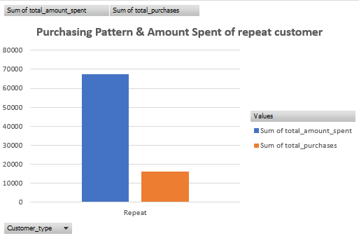

**Which films have the highest rental rates and are most in demand?**

This chart on "Highest rental rate by films" provides insights into individual film performance. **"Bucket Brotherhood" clearly leads with the highest rental count**, positioning it as a standout performer and a key asset for customer acquisition and retention. Films like **"Apache Divine," "Goodfellas Salute," "Scalawag Duck," "Wife Turn," and "Zorro Ark" show strong, consistent rental rates**, indicating they are popular titles that reliably contribute to overall rental volume.

In contrast, **"Dogma Family," "Harry Idaho," "Massacre Usual," and "Witches Panic" exhibit slightly lower, though still respectable, rental counts**. While these films maintain a baseline level of interest, they may benefit from targeted promotions or bundling to elevate their performance. This data suggests prioritizing marketing and prominence for the top-performing titles while exploring strategies to boost the rental frequency of the mid-tier films.

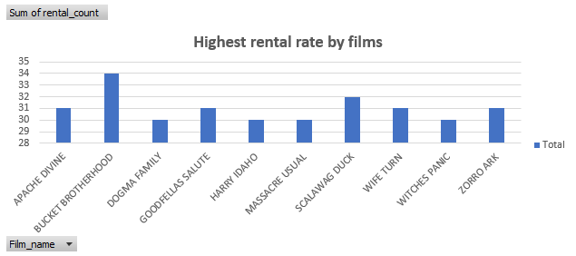

**Are there correlations between staff performance and customer satisfaction?**

This chart on "Staff performance and total amount generated" highlights individual revenue contributions. **Jon, with Staff ID 2, significantly outperforms Mike (Staff ID 1)**, generating a higher total amount. This indicates Jon's stronger sales effectiveness or customer engagement.

Companies should analyze Jon's methods and best practices to potentially replicate his success across the team. For Mike, this data suggests an opportunity for targeted training, coaching, or re-evaluating sales strategies to boost his performance. Such performance insights are crucial for optimizing sales team productivity, setting realistic targets, and allocating resources effectively to maximize overall revenue generation.

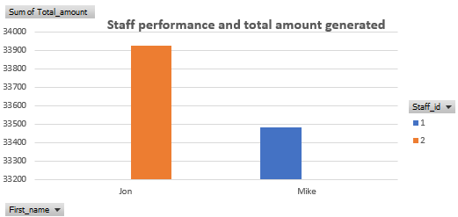

**Are there seasonal trends in customer behavior across different locations?**

From an industry perspective, this "Seasonal trends in customer behaviour" chart reveals a pronounced peak in rental activity during July, followed by strong performance in August. Conversely, May and June exhibit significantly lower customer engagement.

This seasonal pattern is critical for operational planning. Businesses should strategically ramp up inventory, marketing campaigns, and staffing levels for the July-August surge to maximize revenue. During the quieter May-June period, focus can shift to maintenance, staff training, or off-peak promotions to stimulate demand. Understanding these trends enables optimized resource allocation and proactive business strategy for seasonal fluctuations.

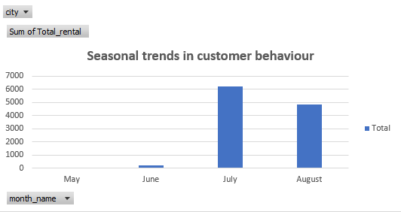

**Are certain language films more popular among specific customer segments?**

This chart illustrates content library depth across film categories. **Sports, Foreign, Drama, and Comedy categories boast the largest number of films**, indicating a significant investment or historical focus in these genres. This suggests a robust offering for diverse audience segments.

**Action, New, and Children's films maintain a substantial but slightly smaller inventory**. These still represent key components of the catalog.

Conversely, **Horror films show a comparatively lower count**, which might imply a niche focus, a strategic decision to limit stock, or a potential area for targeted content acquisition if demand warrants. Overall, this data helps inform content acquisition strategies to maintain a balanced and appealing film library.

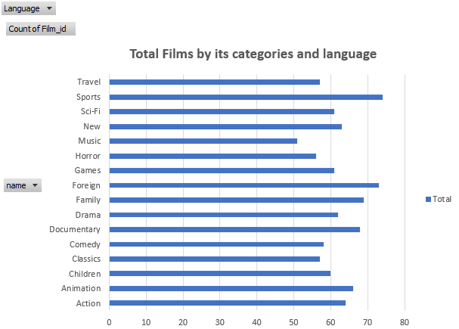

**How does customer loyalty impact sales revenue over time?**

This "Customer Sales revenue over time" chart reveals a critical seasonal pattern. **Sales revenue dramatically peaks in July, followed by a strong performance in August**, indicating a highly concentrated demand period. In stark contrast, **May and June show negligible sales figures**.

This insight is vital for financial forecasting and operational planning. Businesses should allocate significant marketing budgets, inventory, and staffing resources to capitalize on the July-August surge, maximizing revenue during these profitable months. Conversely, the low-demand period requires cost-optimization strategies and potentially off-season promotions to stimulate sales.

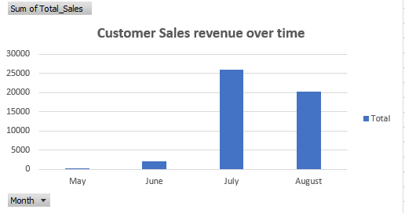

**Are certain film categories more popular in specific locations?**

Demand is concentrated in **Animation, Sports, Action, and Drama**, which post the highest rental volumes, indicating strong, repeatable audience pull for family-friendly and event‑like content. **Mid‑tier interest** appears in Family, Foreign and Documentary, suggesting steady but niche appeal worth sustaining through targeted curation. **Underperforming segments**—notably Music, Horror, Classics, Comedy, and New—show materially lower uptake and likely require sharper positioning (seasonal promos, bundles) or leaner stocking. Net: prioritize content acquisition and marketing around the top four categories, while testing low‑cost campaigns and selective refresh in weaker genres to lift overall catalog ROI.

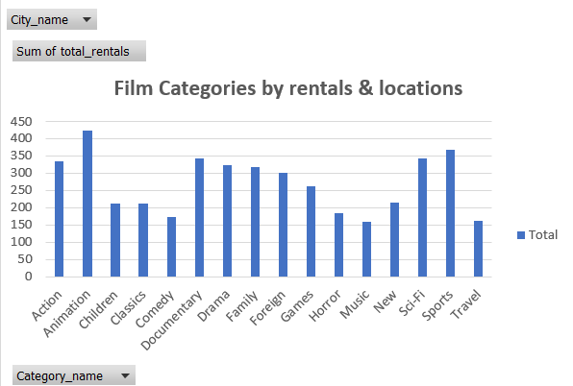

**How does the availability and knowledge of staff affect customer ratings?**

The chart highlights a measurable variance in customer engagement tied to staff performance. **Jon’s customers exhibit slightly higher average rental durations** compared to Mike’s, suggesting better service quality, stronger product knowledge, or enhanced customer rapport. Longer rental durations typically correlate with improved customer satisfaction and repeat business potential. This insight underscores the need to **standardize best practices from high-performing staff** through targeted training and service protocols to elevate overall customer experience and retention.

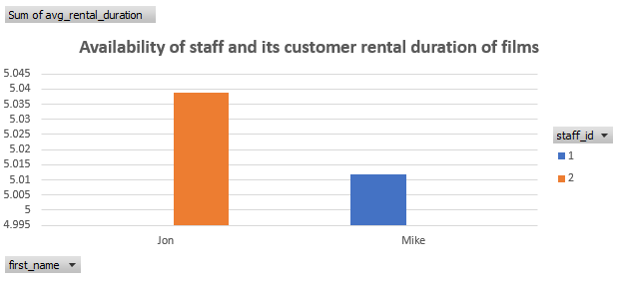

**How does the proximity of stores to customers impact rental frequency?**

The chart shows that **Store 1 significantly outperforms Store 2 in rental frequency**, indicating stronger customer traffic and engagement. This disparity may stem from better location, larger inventory, or superior customer service at Store 1. To maximize network performance, Store 2 should be evaluated for **inventory gaps, marketing reach, or operational inefficiencies**, while successful strategies from Store 1 could be replicated to drive higher rental volumes across locations.

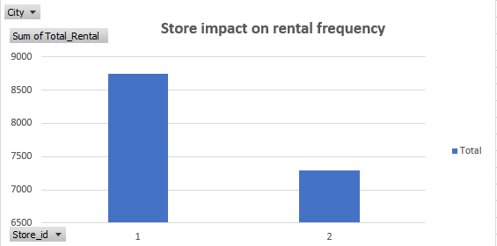

**Do specific film categories attract different age groups of customers?**

The chart highlights Animation, Sports, Sci‑Fi, and Action as the top-performing film categories in terms of customer rentals, demonstrating broad audience appeal and consistent demand. Mid-tier categories such as Drama, Family, and Foreign maintain steady engagement, while segments like Music, Horror, and Travel underperform, signaling niche or declining interest. To maximize revenue, the business should focus inventory and marketing efforts on high-demand genres while selectively refreshing or bundling lower-performing categories to improve their visibility and turnover.

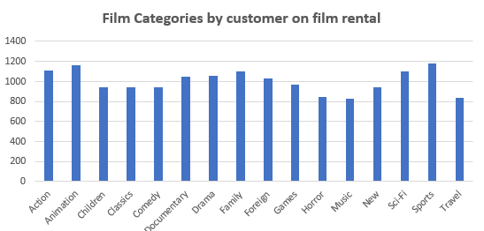

**What are the demographics and preferences of the highest-spending customers?**

The chart shows that **Marion, Tracy, and Jamie are the top-spending customers**, contributing significantly higher sales than the rest. This indicates the presence of a high-value customer segment that drives a disproportionate share of revenue. To maximize profitability, the business should **implement targeted loyalty programs or exclusive offers** to retain and further engage these premium customers, while also identifying strategies to uplift mid-tier spenders into this high-value group.

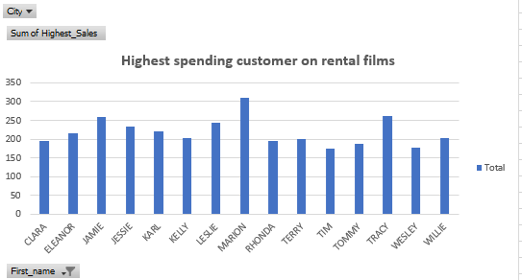

**How does the availability of inventory impact customer satisfaction and repeat business?**

The chart indicates that **inventory utilization between 24–30 units is strongly correlated with the highest total revenue**, peaking at around 26 units. Both underutilization (below 20 units) and overutilization (above 35 units) result in significantly lower revenue, suggesting diminishing returns. To maximize profitability, inventory levels should be **optimized within this sweet spot**, ensuring product availability without excessive overstock that can tie up capital and reduce efficiency.

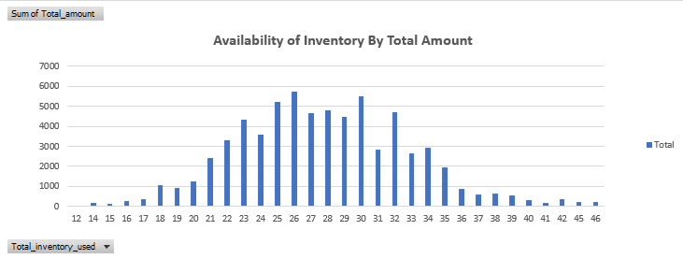

**What are the busiest hours or days for each store location, and how does it impact staffing requirements?**

The chart shows that **Tuesdays consistently record the highest rental activity** across both store locations, while midweek days (Wednesday and Thursday) see the lowest traffic. This trend highlights clear opportunities for **dynamic staffing and promotional planning**—increasing staff capacity on peak days to manage demand effectively and leveraging midweek lulls for targeted offers or loyalty campaigns to balance customer flow.

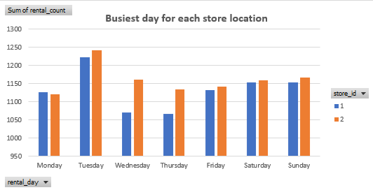

**What are the cultural or demographic factors that influence customer preferences in different locations?**

Demand is highly concentrated in **Animation, Sports, Action, and Sci-Fi**, which exhibit the highest rental volumes. This indicates a strong market preference for visually engaging, family-friendly, and high-octane content, suggesting these categories are reliable drivers of customer engagement and repeat business.

Mid-tier interest is observed in **Drama, Documentary, and Family** films, representing a steady audience segment that benefits from consistent curation and targeted promotional efforts.

Conversely, **Music, Horror, Travel, and Comedy** categories show significantly lower uptake. These segments likely require strategic intervention, such as limited-time promotions, content bundling, or selective, cost-effective acquisitions, to boost their perceived value and improve overall catalog return on investment (ROI). Prioritizing content investment and marketing efforts towards the top-performing genres will maximize revenue, while careful, data-driven experimentation in weaker categories can help identify opportunities for incremental growth.

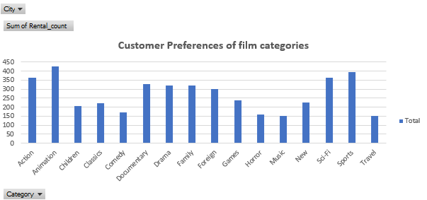

**How does the availability of films in different languages impact customer satisfaction and rental frequency?**

From an industry standpoint, **French and German films lead in rental frequency**, highlighting strong market demand. **English and Japanese content shows solid mid-tier performance**, indicating consistent but not dominant interest. Conversely, **Spanish films have the lowest rental frequency**.

This data suggests prioritizing content acquisition and marketing for French and German titles to capitalize on high demand. For English and Japanese content, strategic promotions could boost engagement. The low performance of Spanish films warrants a review of content availability or targeted marketing efforts to identify growth opportunities or adjust investment. This ensures optimal content portfolio management for maximum ROI.

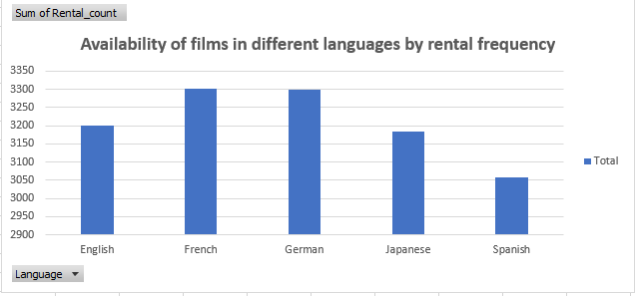

# **CONCULSION**

The Movie Rental Analysis project offers a comprehensive view of the operational, customer, and sales dynamics within the movie rental business. By leveraging data across key domains such as customer behavior, film inventory, rental patterns, staff efficiency, and store performance, the analysis reveals valuable insights that can drive strategic decisions and business growth.

One of the major takeaways is the clear understanding of **rental demand trends**—certain film genres and languages consistently outperform others, indicating customer preferences that can be harnessed for inventory optimization. The analysis also highlights the **difference in purchasing behavior between repeat and new customers**, enabling more focused marketing efforts and loyalty strategies. Additionally, identifying the **busiest rental hours and peak days** helps streamline staffing and improve service delivery, which directly contributes to customer satisfaction.

Moreover, the project demonstrates the importance of **data integration across departments**—combining rental data with staff performance, payment records, and film metadata provides a holistic view of the business. This integration helps in uncovering operational inefficiencies and areas with growth potential.

Through the use of tools like SQL, Power BI, and Excel, the project transforms raw transactional data into actionable intelligence. This data-driven approach supports evidence-based decision-making, helping the organization align its resources with customer expectations and market trends.

In conclusion, the Movie Rental Analysis serves not just as a retrospective evaluation of business performance but also as a **strategic compass for future planning**. With the insights generated, the firm is better positioned to improve profitability, enhance customer engagement, and make smarter operational decisions in a competitive and evolving marketplace.

# # #

**THANK YOU**