Continuous Integration
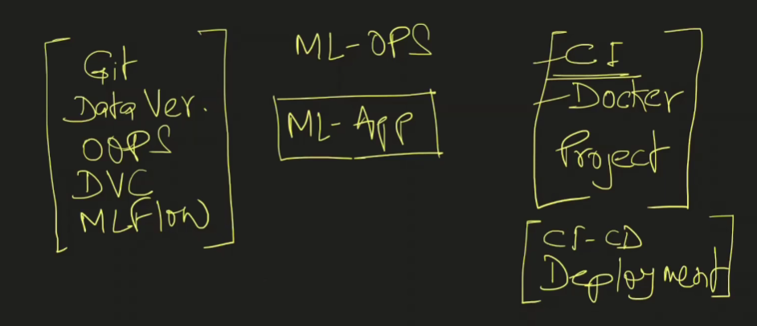
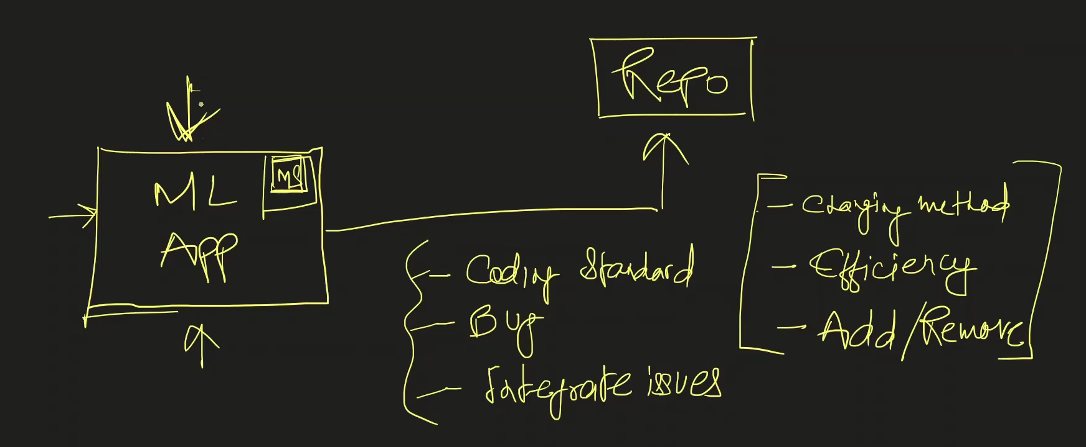

When we make any changes related to method, efficiency improvement in our code then there is a need to test many methods so as to ensure that those changing do not impact coding standards, time complexity, inclusion of bugs or any other integrated workflow. As we mostly work in corner of a project for a microservice it is important than any change in the code gets integrated in the whole project/system successfully without any degradation of app quality.
We need to have server on local or cloud that can test all changes. Server will have OS, python, all dependencies. Server will pull all the codes and perform all the defined tests and give back the report about the execution.

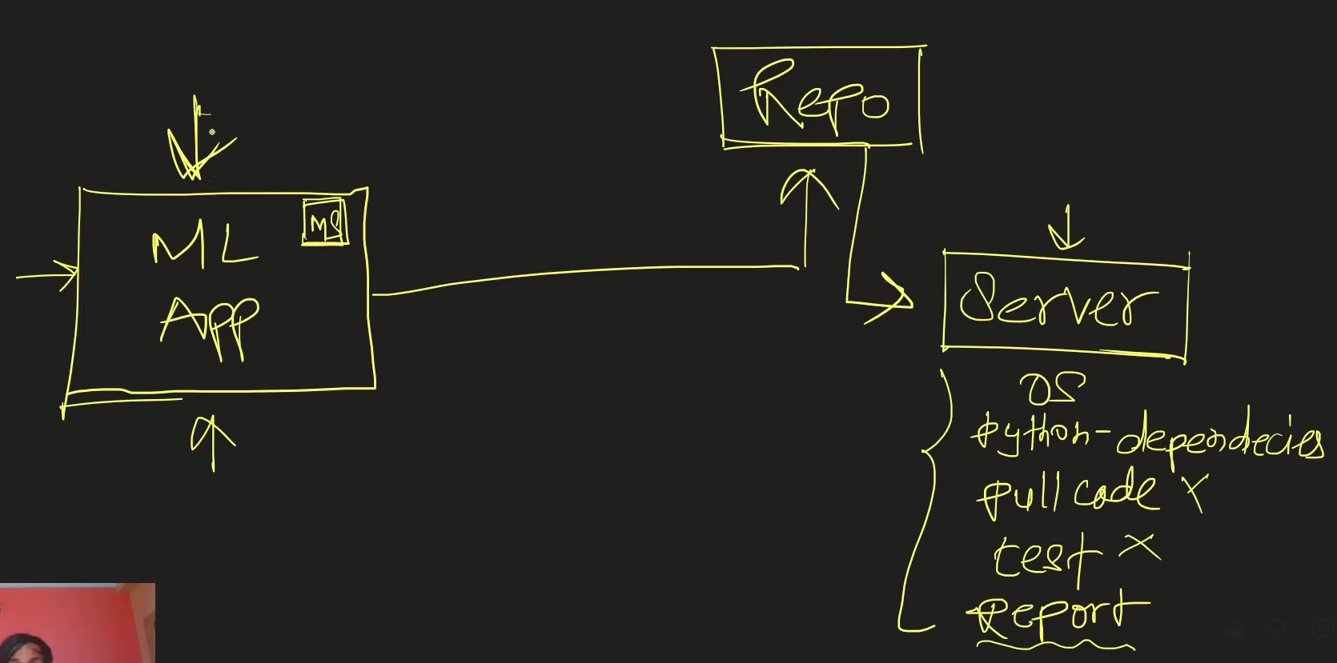
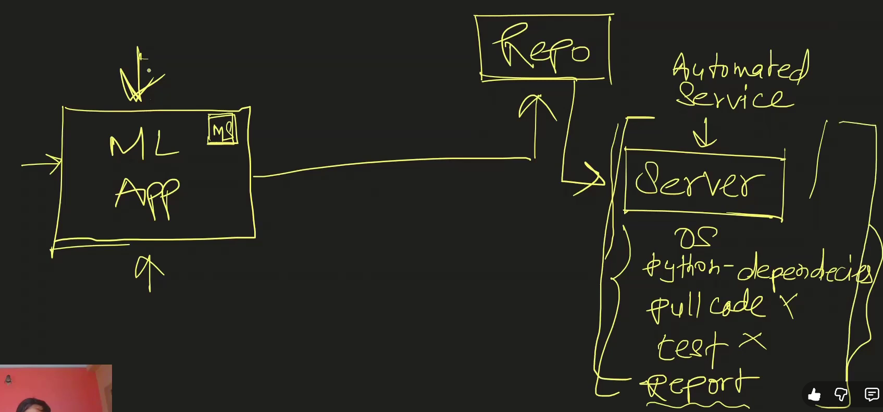
What if can achieve these CI without keeping any manual worker? We can achieve this through CI tool ‘Github Actions’ using YAML file.
