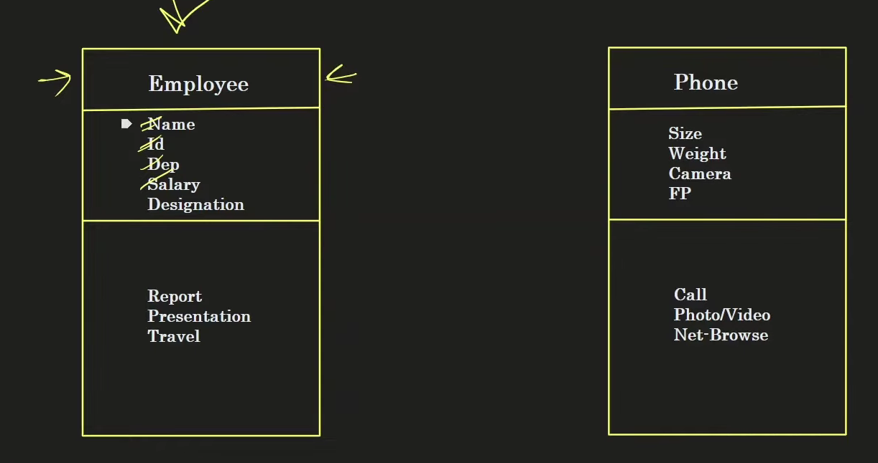
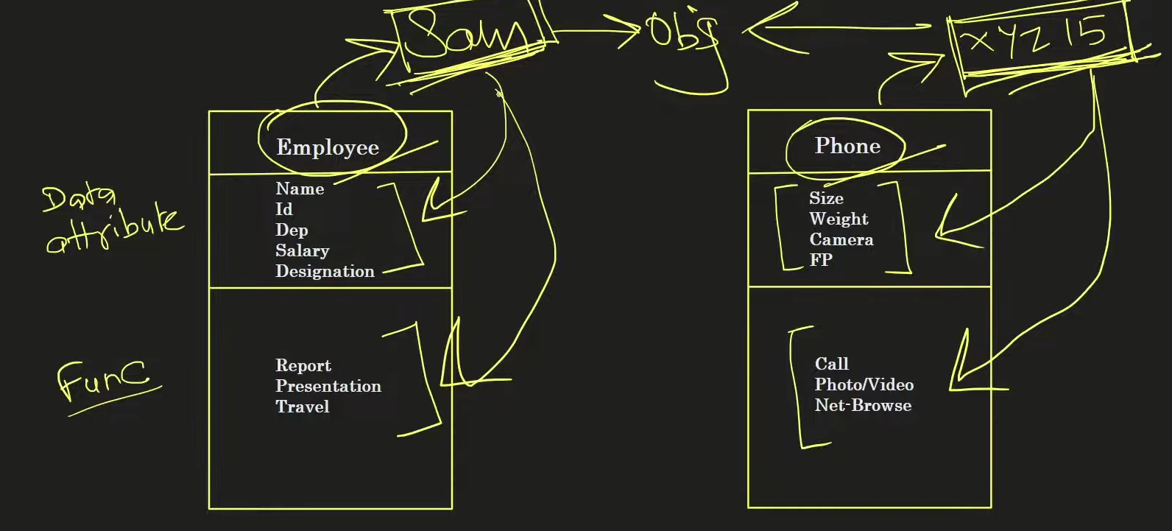
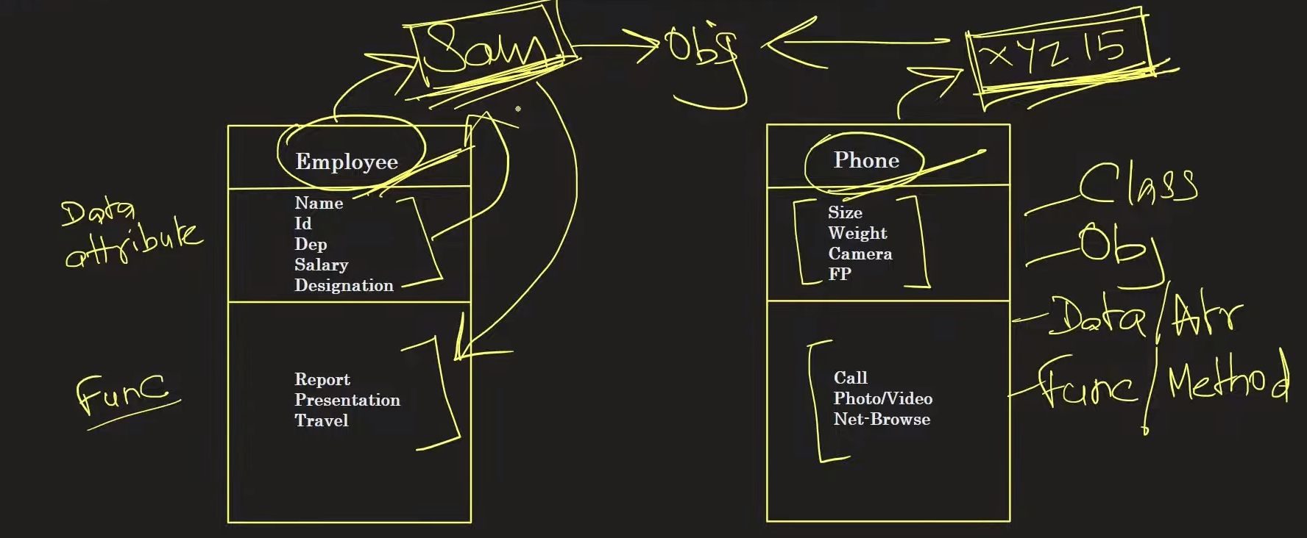
# All the attributes of constructor called automatically at the moment we create an object of that class.
# We create some fixed attributes under constructor so that user can not add specific attributes e.g. when object is calling some attributes are automatically created. There might be a need to get data from some API which require some fixed attributes, automatically connected to internet etc.
As soon as we hit www.facebook.com url facebook page gets connected to internet, database and other places through attributes to connectors.

Q. Why is python an object-oriented programming?
Ans: Everything in python is an object e.g. datatype, data structure etc.
Q. Advantages of OOPS?
Ans:
- We can create our own datatype
a= 'x'
b = 'y'
print(a+b)
>>“xy”
- Code reusability
- Code debugging
- Easy to collaborate

