Claudia Tchokouani

9/10/2023

Professor: Leslie Allen

CMST 385

1. URL: <https://delightful-bush-01ebf1b0f.3.azurestaticapps.net>
2. I faced a lot of challenges with Git. I had problems pushing my files from the master branch to the main branch. After lots of trial and error, I was able to merge branches.
3. I used Visual Studio Code, Validator, Aloft Web Server, Git and Azure to complete this project.
4. I did not use images for this project.
5. Validation information:

I did not include meta tag with a charset for UTF-8

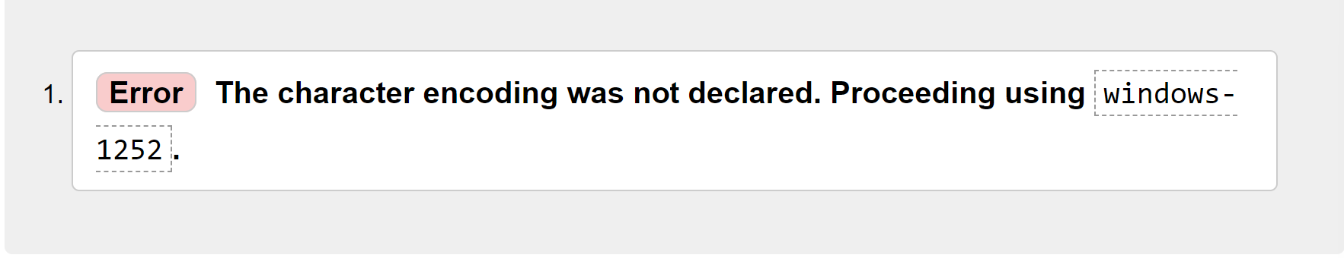

cleared check once <meta> tag was added with charset UTF-8

