Design Practise Exercises

1. Create a competitive game for two players and a ball that does not involve throwing it or kicking it. Prove that is is a game by showing how it contains all the essential elements.

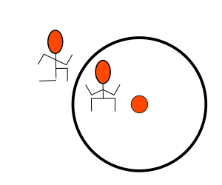
Arean Ball
Description
One player is the defender and the other player the attacker. The two players wrestle each other over a ball that is placed in the center of a circle. At the end of the game, the player with the most points win. Each game will be 3 rounds.
Rules
The attacker must get to the ball, pick it up and place it outside the circle, this score 1 point for the attacker. The defender must prevent the attacker from getting the ball. The attacker has 2 minutes to get the ball out of the ring, if the defender is able to prevent the attacker from placing the ball outside the ring after 2 minutes, the defender score 1 point.
The attacker is not allowed to kick or throw the ball, doing so will result in the defender scoring a point.
The defender is not allowed to pickup, kick or move the ball in anyway, doing so will result in the attacker scoring a point.
The circle is 4 meters in diameter.
Essential Elements of a Game
Play: Each player should think about the situation and make decisions based on the other players strenght, weakness and athletic abaility.
Pretending: The players are pretending to be in an gladiator arena.
Goal: The goal is to score the most points after a set amount of rounds.
Rules: The game has strickt rules on what is allowded and what is not.

2. Using a chessboard and the types of pieces and moves available in chess, devise a cooperative game of some kind for two people, in which they must work together to achieve a victory condition. (You do not need to use the starting conditions of chess, nor all the pieces.) Document the rules and victory condition.

