实验十：运算符重载&继承
实验目的

1．掌握运算符重载的定义、限制和使用
2．掌握派生类的定义，对基类的使用和限制

实验作业
作业一（习题11.13，Complex类）
- 问题描述
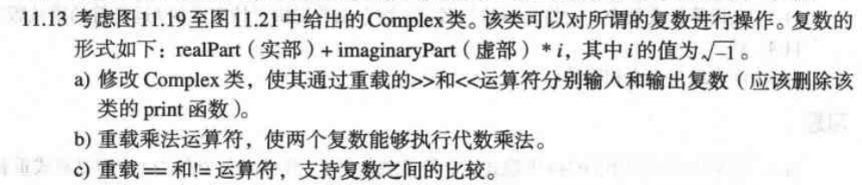
2. 实验提示
1）类定义示例：
自己补充

2）测试函数示例
int main()
{

Complex x, y( 4.3, 8.2 ), z( 3.3, 1.1 ), k;

cout << "Enter a complex number in the form: (a, b)\n? ";
cin >> k; // demonstrating overloaded >>
cout << "x: " << x << "\ny: " << y << "\nz: " << z << "\nk: "

<< k << '\n'; // demonstrating overloaded <<
x = y + z; // demonstrating overloaded + and =
cout << "\nx = y + z:\n" << x << " = " << y << " + " << z << '\n';
x = y - z; // demonstrating overloaded - and =
cout << "\nx = y - z:\n" << x << " = " << y << " - " << z << '\n';
x = y * z; // demonstrating overloaded * and =
cout << "\nx = y * z:\n" << x << " = " << y << " * " << z << "\n\n";

if ( x != k ) // demonstrating overloaded !=
cout << x << " != " << k << '\n';

cout << '\n';
x = k;

if ( x == k ) // demonstrating overloaded ==
cout << x << " == " << k << '\n';

return 0;

} // end main
- 结果示例
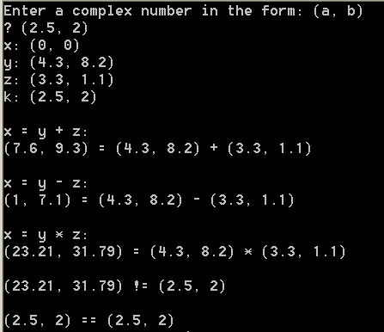
作业二（习题11.14，Hugeint类）
- 问题描述
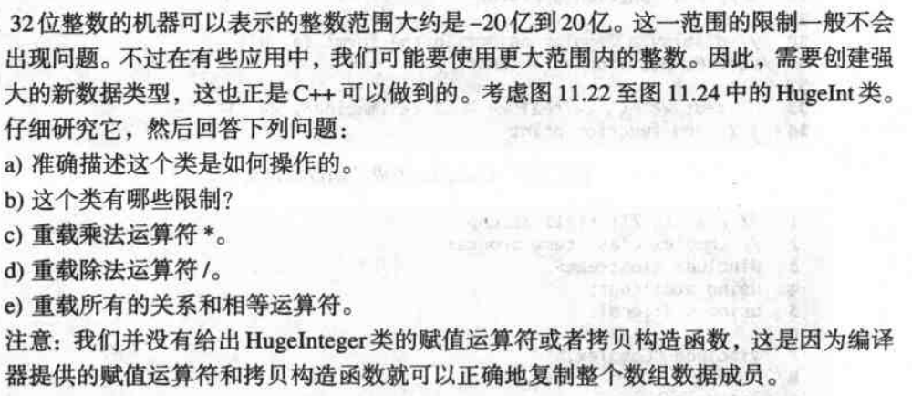
- 类定义参考
#ifndef HUGEINT_H
#define HUGEINT_H
#include <iostream>
using std::ostream;
class HugeInt
{
friend ostream &operator<<( ostream &, const HugeInt & );
public:
HugeInt( long = 0 ); // conversion/default constructor
HugeInt( const char * ); // conversion constructor
// addition operator; HugeInt + HugeInt
HugeInt operator+( const HugeInt & ) const;
// addition operator; HugeInt + int
HugeInt operator+( int ) const;
// addition operator;
// HugeInt + string that represents large integer value
HugeInt operator+( const char * ) const;
bool operator==( const HugeInt & ) const; // equality operator
bool operator!=( const HugeInt & ) const; // inequality operator
bool operator<( const HugeInt & ) const; // less than operator
// less than or equal to operator
bool operator<=( const HugeInt & ) const;
bool operator>( const HugeInt & ) const; // greater than operator

// greater than or equal to operator
bool operator>=( const HugeInt & ) const;
HugeInt operator-( const HugeInt & ) const; // subtraction operator
HugeInt operator*( const HugeInt & ) const; // multiply two HugeInts
HugeInt operator/( const HugeInt & ) const; // divide two HugeInts
int getLength() const;
private:
short integer[ 30 ];
}; // end class HugeInt

#endif
- 结果输出示例
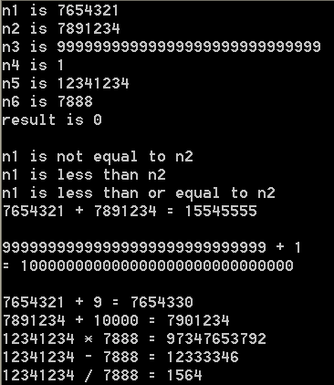

作业三（习题11.15，RationalNumber类）

1．问题描述
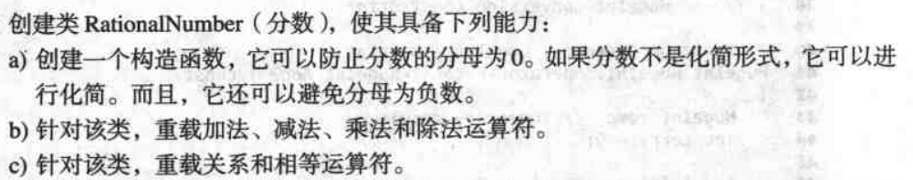
2． 类定义参考
略
3．结果输出示例
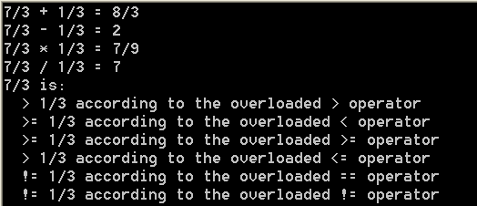
作业四（习题11.17，Polynomial类）

1．问题描述
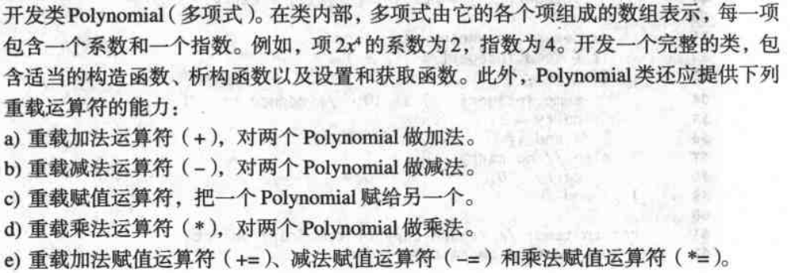
2． 类定义参考
#ifndef POLYNOMIAL_H
#define POLYNOMIAL_H
class Polynomial
{
public:
Polynomial();

Polynomial operator+( const Polynomial& ) const; // addition
Polynomial operator-( const Polynomial& ) const; // subtraction

Polynomial operator*( const Polynomial& ); // multiplication
const & Polynomial operator=( const Polynomial& ); // assignment
Polynomial& operator+=( const Polynomial& );
Polynomial& operator-=( const Polynomial& );
Polynomial& operator*=( const Polynomial& );
void enterTerms();
void printPolynomial() const;
int getNumberOfTerms(); // user should only be able to retrieve value
int getTermExponent( int );
int getTermCoefficient( int );
void setCoefficient( int, int ); // set coefficient of a specific term

~Polynomial(); // destructor
private:
int numberOfTerms;
int exponents[ 100 ]; // exponent array
int coefficients[ 100 ]; // coefficients array
void polynomialCombine( Polynomial& ); // combine common terms
}; // end class Polynomial

#endif

3．测试函数示例
int main()
{
Polynomial a, b, c, t;
a.enterTerms();
b.enterTerms();
t = a; // save the value of a
cout << "First polynomial is:\n";
a.printPolynomial();
cout << "Second polynomial is:\n";
b.printPolynomial();
cout << "\nAdding the polynomials yields:\n";
c = a + b;
c.printPolynomial();
cout << "\n+= the polynomials yields:\n";
a += b;
a.printPolynomial();
cout << "\nSubtracting the polynomials yields:\n";
a = t; // reset a to original value
c = a - b;
c.printPolynomial();
cout << "\n-= the polynomials yields:\n";
a -= b;
a.printPolynomial();
cout << "\nMultiplying the polynomials yields:\n";
a = t; // reset a to original value
c = a * b;
c.printPolynomial();
cout << "\n*= the polynomials yields:\n";
a *= b;
a.printPolynomial();
cout << endl;
return 0;
} // end main

4. 结果输出示例
