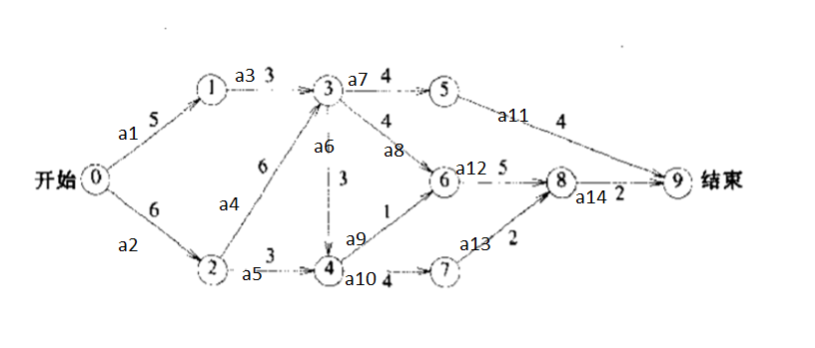

# (a)

e(1)=e(2)=0 e(3)=a1=5 e(4)=e(5)=a2=6 e(6)=e(7)=e(8)=e(4)+a4=12

e(9)=e(10)=e(6)+a6=15 e(11)=e(7)+a7=16 e(12)=e(8)+a(8)=16

e(13)=e(10)+a10=19 e(14)=e(12)+a12=21

关键路径:a2,a4,a8,a12,a14(或a2,a4,a6,a9,a12,a14;或a2,a4,a6,a10,a13,a14),长度为23

l(14)=21 l(11)=19 l(12)=l(14)-a12=16 l(13)=l(14)-a13=19

l(7)=l(11)-a7=15 l(8)=l(12)-a(8)=12 l(9)=l(12)-a9=15

l(10)=l(13)-a10=15 l(6)=l(9)-a6=12 l(5)=l(10)-a5=12

l(4)=l(8)-a4=9 l(3)=l(8)-a3=9 l(2)=l(1)=0

# (b)

最短路径即关键路径:a2,a4,a8,a12,a14(或a2,a4,a6,a9,a12,a14;或a2,a4,a6,a10,a13,a14),长度为23

# (c)

a1,a2,a6,a8,a9,a10,a12,a13,a14

# (d)

a2,a4,a14