4(April)<8(August)<12(December)<2(February)<1(January)<7(July)<6(June)

<3(March)<5(May)<11(November)<10(October)<9(September)

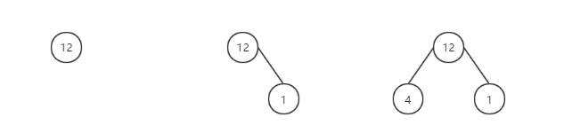-----------------插入JANUARY（1）------------------>-----------------插入APRIL(4)----------------> -----------------插入MARCH(3)---------------->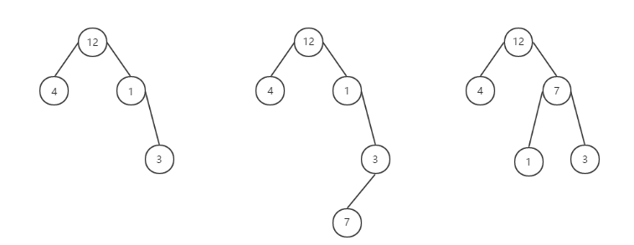----------------------------插入JULY（7）---------------->-----------------------经过RL变换得到----------------->-----继续插入AUGUST（8）---->-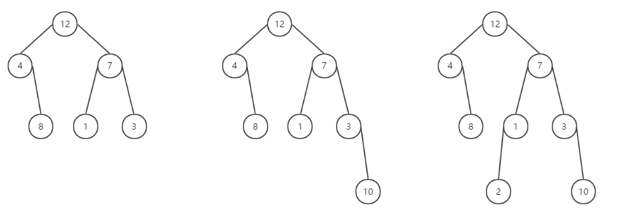-----------------继续插入OCTOBER（10）---------------> -----------经过RR变换------------->  -------------------------------插入NOVEMBER（11）---------------> 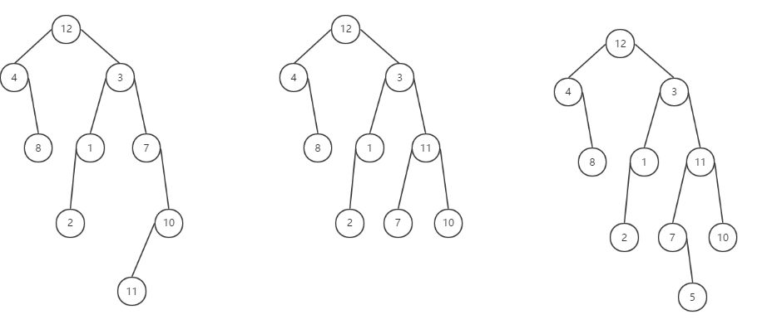------------------------------------------------经过RL变换------------------>

---------------------------继续插入MAY-------------------->----------经过RR变换得到------------------------->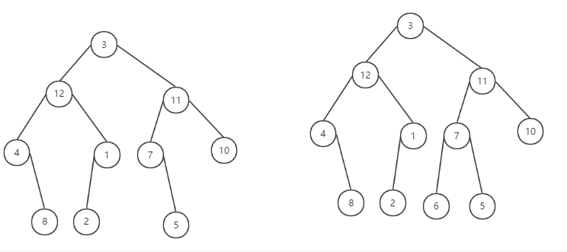----------------------继续插入JUNE-------------------->