II. HIGH LEVEL ARCHITECTURE OF NPSB
Following is the high-level architecture diagram which represents interconnection between banks and NPSB.
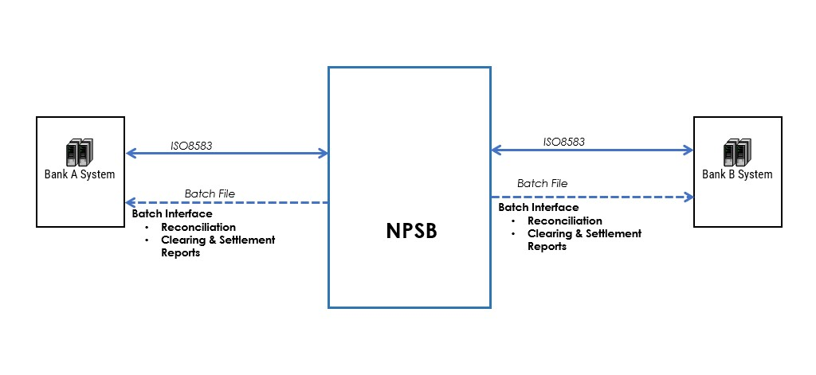

There are two types of interface connection,
- Online ISO8583 for transactions between banks,
- Offline Batch File Interface for file sharing such as reconciliation file and reports file.
Each member of the NPSB can act as both Acquirer and Issuer or Beneficiary of Funds Transfer/ Receiving any Payments.
The Front-End channels of Acquiring bank can be:
- ATM Terminal
- Kiosk
- POS Terminal
- Internet Banking
- Mobile Banking Application
- E-Commerce Merchant

III. ISO8583 MESSAGE FORMAT DESCRIPTION
NPSB is using ISO 8583 version 1987 with some proprietary field used for specific purposes as mentioned in the section of this NPSB specification document.
Following is the detail message format used for NPSB ISO8583 interface with member bank:

A. Message Format Structure
Following is the Message Format structure of ISO8583 used in NPSB:
COMPONENT | DESCRIPTION
Message length header size | Two bytes, high byte first
Length of “message length header” | Not included in calculation for “message length header”
MTI coding | Message Type Identifier. 4 Digits ASCII-coded
Bitmap coding | Binary-coded
Data Element | Contains field's value of each existed field number mentioned in Bitmap

B. Message Header
Each ISO 8583 message is sent in a separate frame. A frame consists of a 2-byte header and a message body. A header contains the length of the following message. The high byte of value is transmitted first, and the low byte of value is transmitted second.
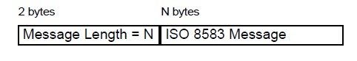

C. MTI
Each ISO 8583 message starts with a Message Type Identifier (MTI), which is a four-digit numeric field identifying the message version, class, function, and originator, as defined by ISO 8583. The MTI field consists of 4 ASCII coded bytes with MTI value. The NPSB interface uses the following values:
- First digit – Version Number, 0: ISO 8583: 1987
- Second digit – Message Class, 1: Authorization, 4: Reversal, 8: Network Management
- Third digit – Message Function: 0: Request, 1: Request Response, 2: Advice, 3: Advice Response
- Fourth digit – Transaction Repeat: 0: Not Repeated Transaction

D. Bitmap
The second component of an ISO 8583 message is one or two "bit maps" referred to as the "Primary Bit Map" and "Secondary Bit Map". Each consists of 8 bytes and is interpreted as 64 individual bits. For the Primary Bit Map, the bits are numbered from the left starting with "1", up to "64". Each bit signifies the presence (1) or the absence (0) in the message of the data element associated with that particular bit, according to its position (i.e. number) within the bit map. The Primary Bit Map must always be present. The first bit of the bit map indicates the presence (1) or the absence (0) of the next bit map. For the Secondary Bit Map, the bits are numbered starting with "65", up to "128". The Secondary Bit Map must be present in a message if the message contains a data element numbered 65 or higher.

E. Data Element Value Format
Following are the fields and its format of ISO8583 message that are used in NPSB:
FIELD | NAME OF THE FIELD | FORMAT | CHARS | LENGTH | CODING
 | Message Type Indicator | FIXED | N | 4 | ASCII
 | Bit Map | FIXED | B | 64 | BIT
2 | Primary Account Number | HLVAR | n | 16..19 | BCD
3 | Processing Code | FIXED | n | 6 | BCD
4 | Amount, Transaction | FIXED | n | 12 | BCD
5 | Amount, Settlement | FIXED | n | 12 | BCD
6 | Amount, Cardholder Billing | FIXED | n | 12 | BCD
7 | Transmission Date & Time | FIXED | n | 10 | BCD
10 | Conversion Rate, Cardholder Billing | FIXED | n | 8 | BCD
11 | System Trace Audit Number | FIXED | n | 6 | BCD
12 | Local Transaction Time | FIXED | n | 6 | BCD
13 | Local Transaction Date | FIXED | n | 4 | BCD
14 | Date, Expiration | FIXED | n | 4 | BCD
18 | Merchant's Type | FIXED | n | 4 | BCD
19 | Acquiring Institution Country Code | FIXED | n | 3 | BCD
20 | Primary Account Number Country Code | FIXED | n | 3 | BCD
22 | Point of Service Entry Mode | FIXED | n | 3 | BCD
23 | Card Sequence Number | FIXED | n | 3 | BCD
25 | POS Condition Code | FIXED | n | 2 | BCD
26 | POS PIN Captured Code | FIXED | n | 2 | BCD
28 | Amount, Transaction Fee | FIXED | an | 9 | ASCII
32 | Acquiring Institution ID, Code | HLVAR | n | 6..11 | BCD
33 | Forwarding Institution Code | HLVAR | n | 6..11 | BCD
35 | Track 2 Data | HLVAR | z | ..37 | BCD
37 | Retrieval Reference Number | FIXED | an | 12 | ASCII
38 | Authorization Code Response | FIXED | an | 6 | ASCII
39 | Response Code | FIXED | an | 2 | ASCII
41 | Card Acceptor Terminal Id. | FIXED | ans | 8 | ASCII
FIELD | NAME OF THE FIELD | FORMAT | CHARS | LENGTH | CODING
42 | Card Acceptor Identification Code | FIXED | ans | 15 | ASCII
43 | Card Acceptor Name/Location | FIXED | ans | 40 | ASCII
45 | Track 1 Data | HLVAR | ans | ..76 | ASCII
46 | Proprietary Field 46 | HLLVAR | ans | 0..999 | ASCII
47 | Proprietary Field 47 | HLLVAR | ans | 0..999 | ASCII
48 | Proprietary Field 48 | HLLVAR | ans | 0..999 | ASCII
49 | Transaction Currency Code | FIXED | n | 3 | BCD
50 | Settlement Currency Code | FIXED | n | 3 | BCD
51 | Cardholder Billing Currency Code | FIXED | n | 3 | BCD
54 | Additional Amounts | HLLVAR | ans | 20..120 | ASCII
55 | ICC Sys Related Data | HLLVAR | b | ..255 | BIN
70 | Network Management Information Code | FIXED | n | 3 | BCD
100 | Receiving Institution Identification Code | HLVAR | n | ..11 | BCD
102 | Account Identification-1 | HLVAR | ans | 0..99 | ASCII
103 | Account Identification-2 | HLVAR | ans | 0..99 | ASCII
104 | Transaction Description | HLVAR | ans | 0..99 | ASCII
112 | Additional Info | HLLVAR | an | ..999 | BIN
125 | Mini Statement Information | HLLVAR | ans | 999 | ASCII
128 | Message Authentication Code | FIXED | an | 64 | BIT
Character information:
- a – Alphabet
- n – Numeric
- s – Symbol
- z – symbols that can be encoded on Track II Coding information:
- BCD – Binary Coded Decimals, left padding for odd length data.
- ASCII – ASCII coded data.
- BIN – Binary data, length specified in bytes.
- BIT – Binary data, length specified in bits.

F. Processing Code of Transaction Type
Following are the processing codes of transaction type (DE3 Subfield 1) that are used in NPSB:
VALUE | DESCRIPTION
00 | Used for Purchase, Preauthorization, or Completion of Preauthorization
01 | Used for ATM Cash Withdrawal or POS Cash Advance
09 | Used for Purchase with Cashout
10 | Used for Bill Payment Debit or Funds Transfer Debit
20 | Used for POS Purchase Refund
28 | Used for QR Merchant Payment Credit, Bill Payment Credit, or Funds Transfer Credit
30 | Used for Balance Inquiry
32 | Used for Mini Statement

G. Field Presentation Options
The following are the field presentations code in NPSB transaction specification:
FIELD PRESENTATION | DESCRIPTION
C | The field is conditional, may or may not be present, depends on certain condition of the transaction
CR | The field should be present with the value inherited from Request message if the field is present in the Request message.
M | The field must be present.
MR | The field must be present with the value inherited from Request message.
C1 | The field will be processed according to the related bank security specification.
O | The field is optional
<FieldPresentationofMess agetoNPSB>/<FieldPresen tationofMessagefromNPS  B> | "/" sign to give more information regarding the field presentation of incoming message to NPSB and outgoing message from NPSB. For example, field presentation "/M" means the field is not necessary if the message is coming to NPSB and the field will present if the message is outgoing from NPSB. Field presentation "MR/M" means the field must present with the value inherited from Request message if the message is coming to NPSB and the field will present if the message is outgoing from NPB

H. Common Fields In NPSB
The following are the common fields that are used in NPSB:

1. Field Value of DE22
There are two sets of the following subfields:
Positions 1–2, PAN and Date Entry Mode: A 2-digit code that identifies the actual method used to enter the cardholder account number. Valid codes are:
"00" Unknown or terminal not used,
"01" Manual (key entry),
"02" Magnetic stripe read,
"03" PAN or Track Read via QR or bar code reader,
"05" Integrated circuit card read; card data reliable,
"07" PAN auto-entry via contactless M/Chip,
"09" PAN entry via electronic commerce, including remote chip,
"79" Chip card at chip-capable terminal was unable to process the transaction using chip technology,
"80" PAN auto-entry via magnetic stripe – the full track data has been read and transmitted in Track-2 Data (Data elements) without alteration or truncation. This mode is used as fallback to PAN auto-entry via ICC when the IC could not be used, "81" PAN auto-entry via electronic commerce,
"82" PAN Auto Entry via Server (issuer, acquirer, or third party vendor system),
"90" Magnetic stripe read and exact content of Track 1 or Track 2 included (CVV check is possible),
"91" PAN auto-entry with contactless Magnetic Stripe - The full Track data has been read from the data on the card and transmitted within the authorization request in Track 2 Data (DE35) or Track 1 (DE45) without alteration or truncation., "95" Integrated circuit card; card data may be unreliable.
Positions 3, PIN Entry Capability: A 1-digit code that identifies the terminal's capability of capturing PINs. Valid codes are:
"0" Unknown,
"1" Terminal can accept PINs,
"2" Terminal cannot accept PINs,
"3" Software-based PIN Entry Capability,
"8" The terminal PIN pad is down, "9" Reserved for future use.

2. Field Value of DE25
Following is the list of possible Point of Service Condition Code (DE25) in NPSB:
Code | Description
00 | Normal transaction of this type
01 | Cardholder not present
02 | Unattended acceptance terminal, customer operated (for example, ATM, Automated Dispensing Machine)
03 | Merchant suspicious of transaction (or card)
05 | Customer present, Card Not Present
08 | Mail/telephone order
10 | Customer identity verified (used for Check Acceptance only)
51 | Request for account number verification without authorisation, or request for account number verification and address verification without authorisation
55 | Request for telecode verification without authorisation
Code | Description
59 | E-commerce request (through public network)
71 | Card present, magnetic stripe cannot be read (key-entered)

3. Response Code Value of DE39
Following is the list of possible response code (DE39) in NPSB:
RC | Description | Category
00 | Approved | Approve
01 | Refer to Card Issuer | Decline
03 | Invalid Merchant | Decline
04 | Pick up card | Decline
05 | Do not honour | Decline
07 | Pick up card, special condition | Decline
12 | Invalid Transaction | Decline
13 | Invalid Amount | Decline
14 | Invalid card number | Decline
17 | Customer cancellation | Information in Reversal
30 | Format Error | Decline
41 | Lost card, pick up | Decline
43 | Stolen card, pick up | Decline
51 | Not sufficient funds | Decline
52 | No checking account | Decline
53 | No savings account | Decline
54 | Expired card | Decline
55 | PIN incorrect | Decline
57 | Transaction not allowed for cardholder | Decline
61 | Exceeds withdrawal amount limit | Decline
62 | Restricted card | Decline
68 | Response received too late or Timeout | Decline
75 | PIN tries exceeded | Decline
78 | No account | Decline
86 | Cannot verify PIN | Decline
91 | Issuer unavailable | Decline
94 | Duplicate transaction | Decline
96 | System malfunction | Decline

4. Additional Amount Information Structure of DE54
After the length subfield, there are six possible sets of the following subfields:
Positions 1–2, Account Type: A 2-digit code identifying the account type affected by the balance inquiry. Valid codes are:
"00" Not Applicable or Not Specified,
"10" Savings Account,
"20" Checking Account.
Positions 3–4, Amount Type: A 2-digit code describing the use of the amount. Valid codes are:
"01" Current ledger (posted) balance,
"02" Current available balance (typically, ledger balance minus outstanding authorisations),
"40" Cashback amount,
"90" Available Credit "91" Credit Limit.
Positions 5–7, Currency Code: A 3-digit code that defines the currency used in Positions 9–20.
Position 8, Amount, Sign: A 1-digit code that defines the value of the amount as either positive or negative. "C" Positive balance,
"D" Negative balance (also used for cashout amounts).
Positions 9–20, Amount: A twelve-character amount that is right-justified and contains leading zeros. The amount also includes an implied decimal relative to the currency code specified in positions 5–7.

