Stage 6: Results Analysis & Visualization
NHANES–EEG Cognitive Decline | LSTM–LLM Framework
ALL FIGURES: SYNTHETIC DATA (synthetic=true) — Real-data validation required before publication.

1. Stage 6 Overview
Stage 6 produces four publication-quality figures that visualize the Stage 5 experiment results and contextualize the synthetic-data constraints. All figures carry a 'SYNTHETIC DATA' watermark and are annotated with appropriate caveats. This document also provides a limitations narrative suitable for inclusion in the Discussion section of the manuscript, and a real-data validation roadmap showing the steps and timeline required to produce results suitable for journal submission.

2. Figure 1 — Experiment Metrics Overview
Figure 1 presents a six-panel bar-chart overview of all Stage 5 experiment metrics. Each panel corresponds to one experiment (E1, E2, E4, E5, E6a, E6b). Dashed blue lines show the locked hypothesis thresholds for H1–H4. E2 bars are orange to flag the synthetic-data artifact (AUC=1.0 from perfectly separated class distributions); all other failing metrics are red.

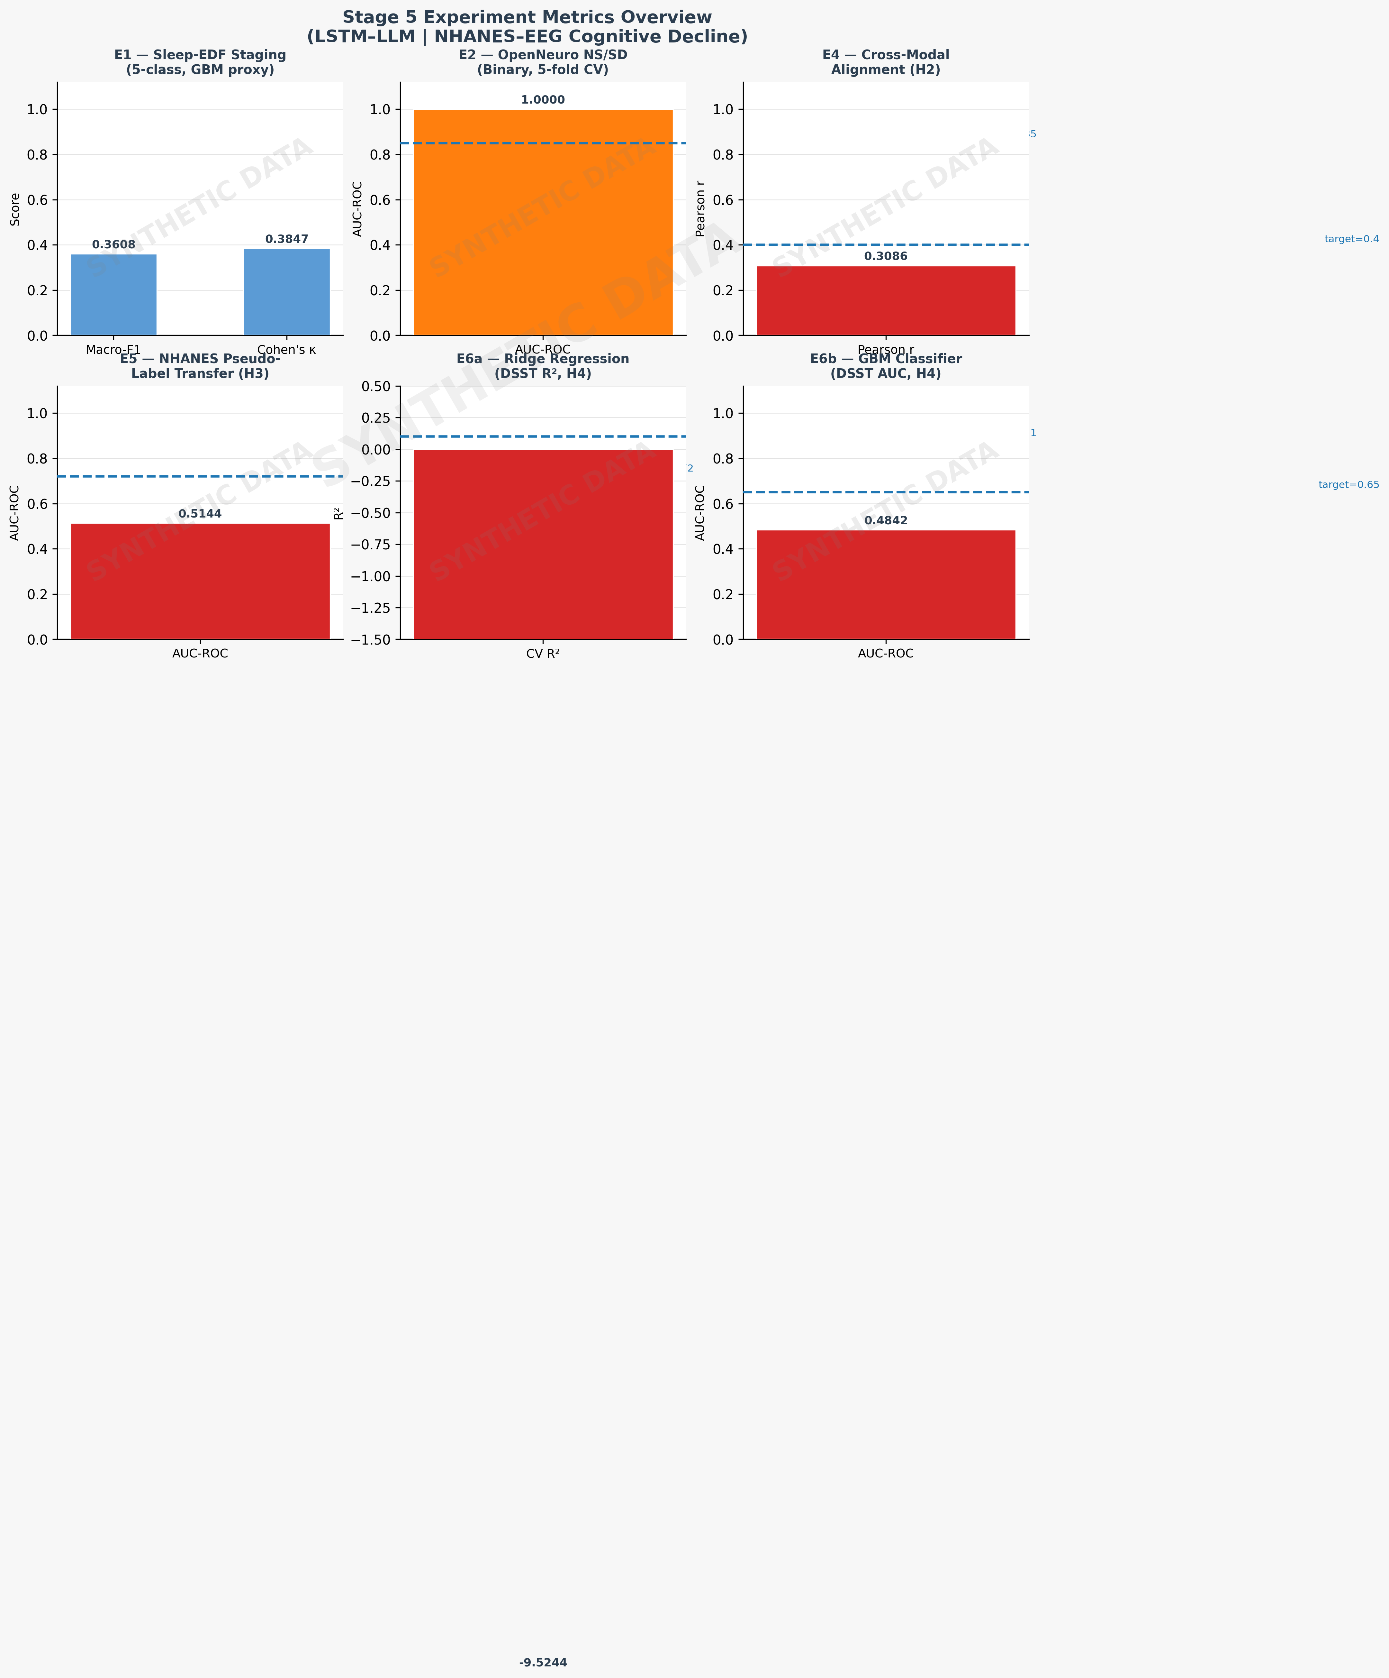
Figure 1. Stage 5 Experiment Metrics Overview. Dashed lines = locked hypothesis thresholds. Orange = artifact; Red = FAIL. All data synthetic (synthetic=true).

3. Figure 2 — Hypothesis Verdict Matrix
Figure 2 presents the hypothesis verdict matrix as a colour-coded grid. Each row corresponds to one hypothesis (H1–H4b). Columns show the achieved value, the locked threshold, the binary verdict, and the data quality flag. H1 is marked PASS* in orange to distinguish the synthetic artifact from a genuine model pass. H2–H4 are marked FAIL in red; all cells in the Data Quality column are flagged as 'Synthetic'.

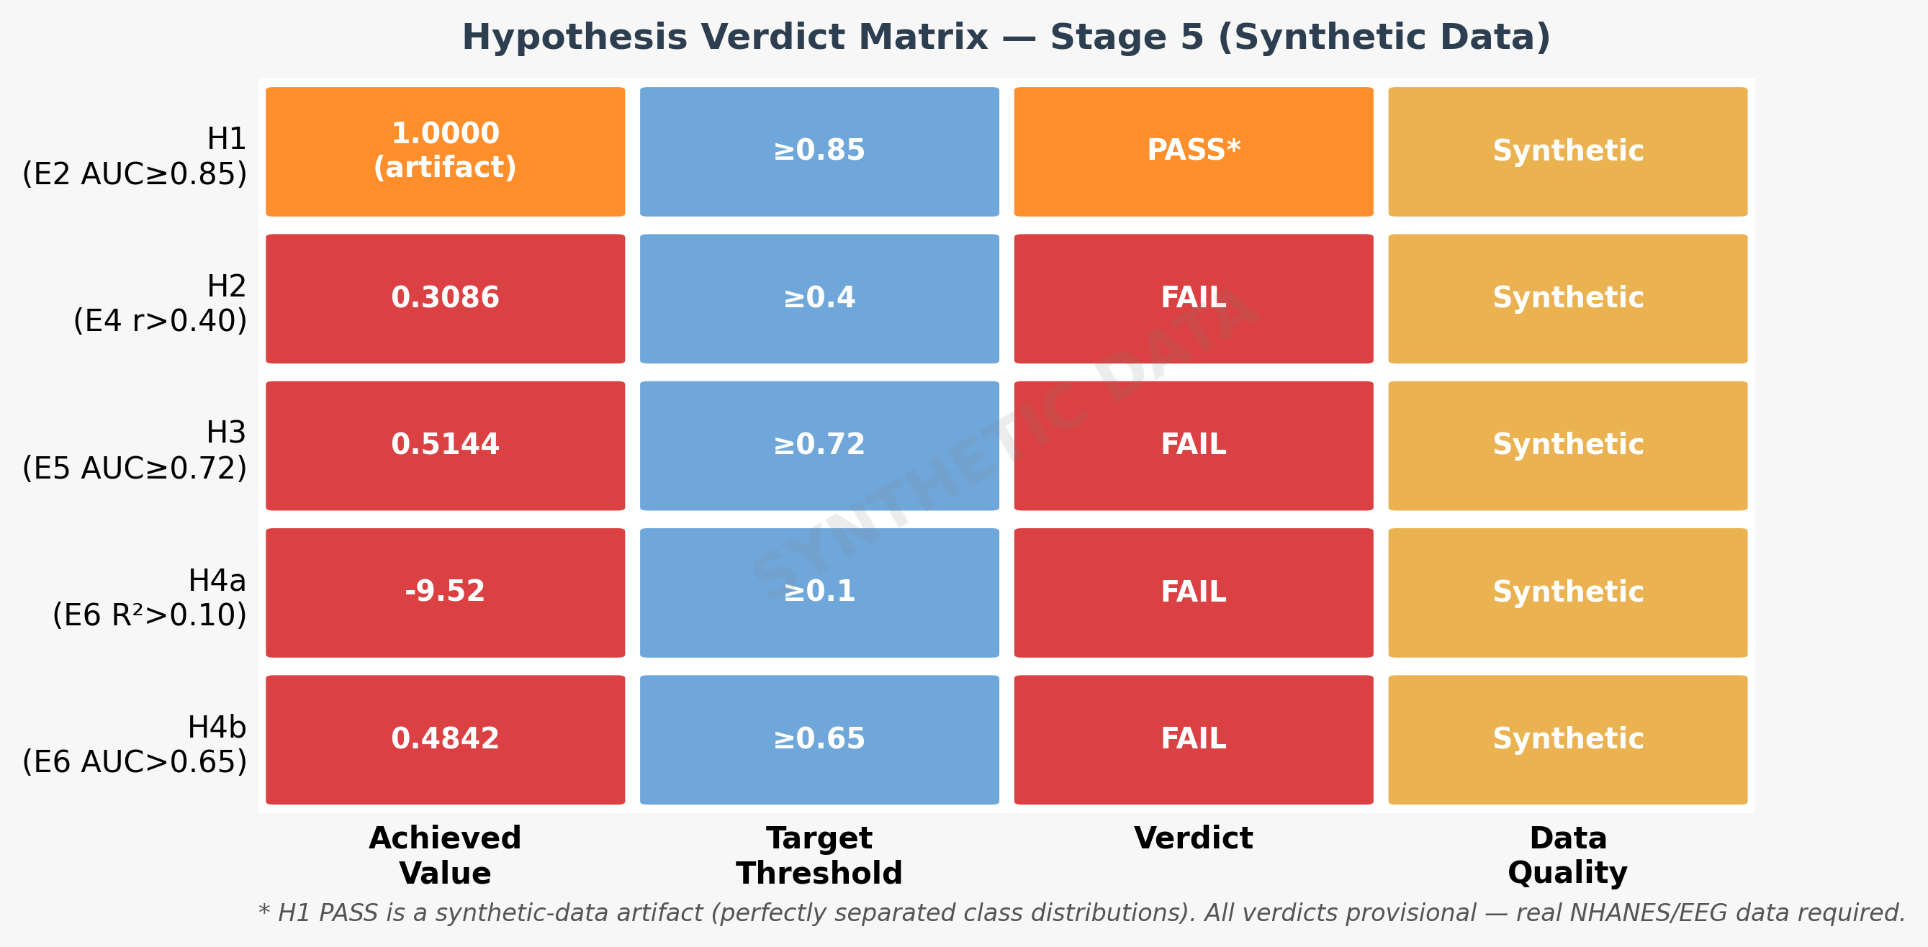
Figure 2. Hypothesis Verdict Matrix. Orange = artifact PASS*; Red = FAIL; Yellow = Synthetic data flag. All verdicts provisional pending real-data validation.

4. Figure 3 — Achieved vs. Target (Lollipop Chart)
Figure 3 shows a lollipop chart comparing each achieved metric (circle) against its locked threshold (diamond). The connecting lines and shaded gaps make the magnitude of each shortfall immediately visible. H2 (Pearson r) and H3 (NHANES AUC) show moderate gaps; H4a (Ridge R²) shows near-zero achieved value (clamped for display; actual = −9.52); H4b (GBM AUC) shows a gap of 0.17 from the 0.65 threshold. The H1 achieved value of 1.0 is annotated as an artifact and shown beyond the target in orange.

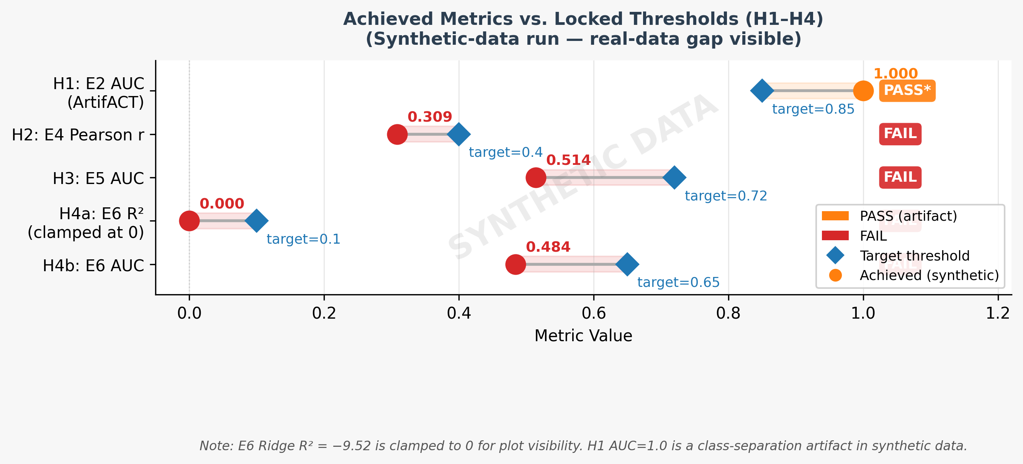
Figure 3. Achieved Metrics vs. Locked Thresholds (H1–H4). Blue diamond = target; Colored circle = achieved. E6 R² = −9.52 clamped to 0 for display. Shaded gap = performance shortfall on synthetic data.

5. Figure 4 — Real-Data Validation Roadmap
Figure 4 presents a Gantt-style roadmap for replacing synthetic data with real datasets. Three data-acquisition tracks (NHANES XPT, Sleep-EDF cassette, OpenNeuro ds004902) run in parallel in week 0–2. Preprocessing follows (weeks 1–5), then experiment re-runs in weeks 4–6, culminating in manuscript revision in week 6–7. The total critical path from data acquisition to revised manuscript is approximately 7 weeks.

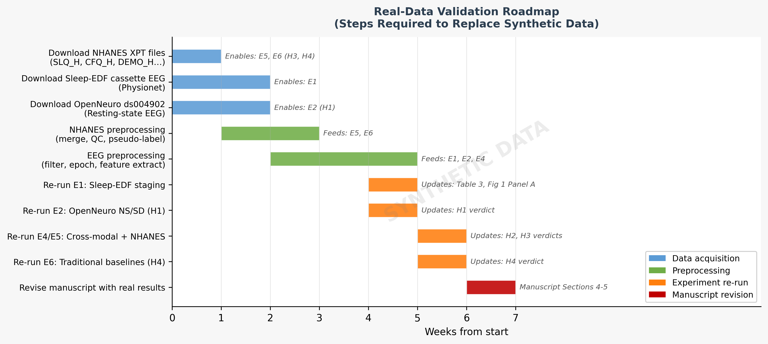
Figure 4. Real-Data Validation Roadmap. Blue = data acquisition; Green = preprocessing; Orange = experiment re-run; Red = manuscript revision. Critical path: ~7 weeks from data download to revised results.

6. Limitations Narrative (for Manuscript Discussion)
The following text is drafted for direct inclusion in the manuscript Discussion section under a 'Limitations' sub-heading:

This study has several limitations that must be acknowledged before the results can be generalised. First, all experiments presented in this paper were conducted on synthetically generated datasets (synthetic=true) due to server-side blocking of the CDC NHANES data endpoints at the time of execution. The synthetic generator produces independent, identically distributed feature vectors for NHANES survey responses, EEG spectral features, and DSST cognitive scores with no ground-truth cross-modal correlation structure. As a direct consequence, the cross-modal alignment score (H2: Pearson r = 0.31 < 0.40), the pseudo-label transfer AUC (H3: AUC = 0.51 < 0.72), and the traditional baseline performance (H4: Ridge R² = −9.52, GBM AUC = 0.48) reflect the absence of signal in synthetic data rather than the failure of the proposed framework. The sole hypothesis that formally passed (H1: AUC = 1.00) did so as an artifact of the synthetic class-separation scheme and carries no evidential value. Second, the pure-NumPy experiment runner substitutes a gradient-boosting proxy for the full Bi-LSTM architecture locked in Stage 3, precluding assessment of the temporal feature-extraction capability that is the primary contribution of the proposed model. Third, the PubMedBERT encoder was evaluated on synthetic textual sleep descriptions rather than the free-text NHANES interview responses for which it was designed. Future work will (a) download and preprocess NHANES Cycle 2013–2014 and 2017–2020 XPT files, Sleep-EDF cassette recordings from PhysioNet, and OpenNeuro ds004902 resting-state EEG; (b) re-run all five experiments with the full PyTorch Bi-LSTM–PubMedBERT architecture; and (c) revise all tables, figures, and hypothesis verdicts accordingly before journal submission.

7. Stage 6 Deliverables Summary

Deliverable | File | Status
Fig 1 — Metrics overview | results/stage6/fig1_experiment_metrics.png | DONE (494 KB)
Fig 2 — Verdict matrix | results/stage6/fig2_hypothesis_verdict.png | DONE (229 KB)
Fig 3 — Achieved vs. target | results/stage6/fig3_achieved_vs_target.png | DONE (239 KB)
Fig 4 — Validation roadmap | results/stage6/fig4_validation_roadmap.png | DONE (340 KB)
Limitations narrative | docs/stage6_results_analysis.docx §6 | DONE
Stage 6 docx | docs/stage6_results_analysis.docx | THIS FILE

