#include <stdio.h>

int partition(int a[], int beg, int end);

void quickSort(int a[], int beg, int end);

void main()

{

int i;

int arr[10]={90,23,101,45,65,23,67,89,34,23};

quickSort(arr, 0, 9);

printf(“Unsorted Array is ”)

printf("90,23,101,45,65,23,67,89,34,23");

printf("\n The sorted array is: \n");

for(i=0;i<10;i++)

printf(" %d\t", arr[i]);

}

int partition(int a[], int beg, int end)

{

int left, right, temp, loc, flag;

loc = left = beg;

right = end;

flag = 0;

while(flag != 1)

{

while((a[loc] <= a[right]) && (loc!=right))

right--;

if(loc==right)

flag =1;

else if(a[loc]>a[right])

{

temp = a[loc];

a[loc] = a[right];

a[right] = temp;

loc = right;

}

if(flag!=1)

{

while((a[loc] >= a[left]) && (loc!=left))

left++;

if(loc==left)

flag =1;

else if(a[loc] <a[left])

{

temp = a[loc];

a[loc] = a[left];

a[left] = temp;

loc = left;

}

}

}

return loc;

}

void quickSort(int a[], int beg, int end)

{

int loc;

if(beg<end)

{

loc = partition(a, beg, end);

quickSort(a, beg, loc-1);

quickSort(a, loc+1, end);

}

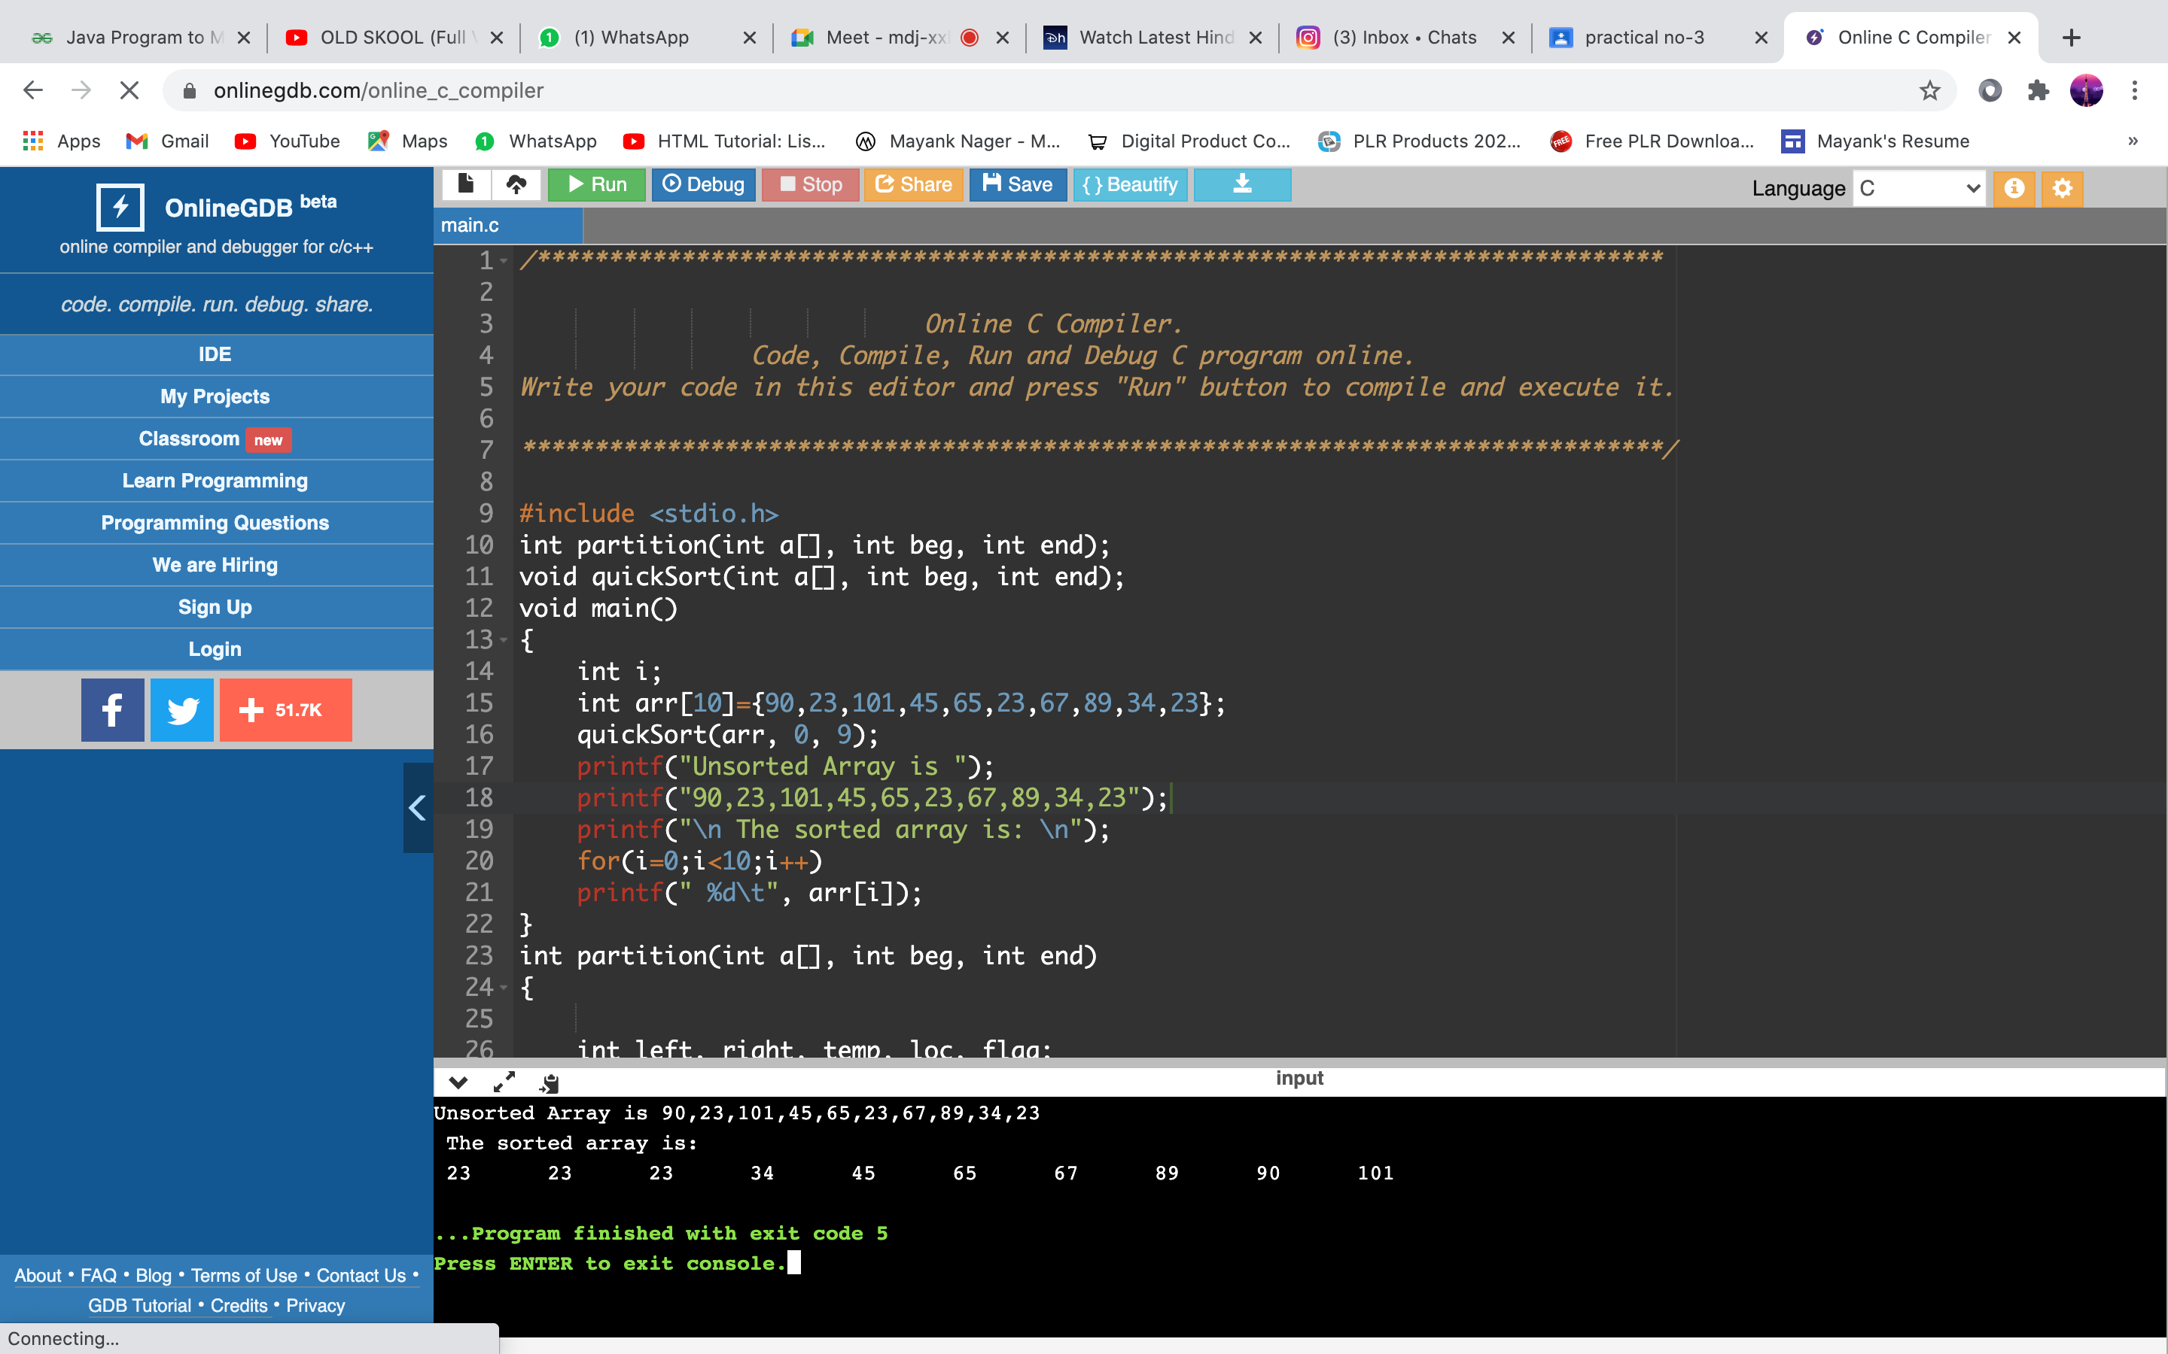

Type to enter a caption.

}