Submitted by: Prakash Chourasia

E: pchourasia1@student.gsu.edu  
Course: CSC 8840

Fall 2014

Lifecycle Monitoring : Human Survival Simulations

**Overview**

Competition for resources, however, is a documented phenomenon among all species, and humanoids were no exception. Members of tribes divided into hunters and gatherers, seeking edible flora and fauna to ensure their survival.

This model attempts to give us some idea of how this competition played out. How long could two tribes survive, and would one ‘win out’ over the other? What kind of food distribution is needed to maximize the possibility of long-term survival? Should a tribe have more hunters than gatherers, or vice versa? Should a tribe be smaller than another competing tribe? These are the questions this model attempts to answer, and does so with some success.

This model will show what situation is best for different tribal survival.   
It may reveal that we cannot predict a tribe’s long-term survival by its initial population size and amount of food available. It will also be a useful stepping-stone for creating more realistic models. And find the ecological balance required on the basis of population of every kind of agent , It may be either animals or vegetarians and non-vegetarians.

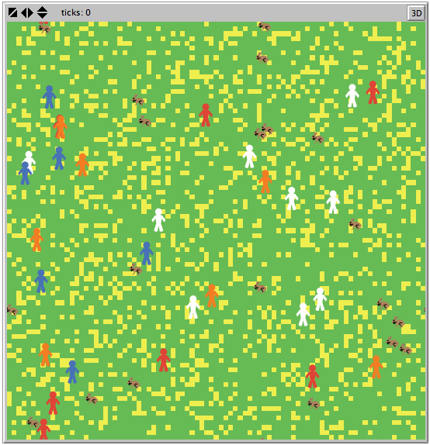

Fig. 1: Example of initialized model. Red and white are Tribe 1, orange and blue are Tribe 2.

**What can we learn?**

We can draw interesting conclusions about what parameters indicate success or failure at long-term survival. Are gatherers more important, or hunters? Will a large rabbit population mean a well-fed tribe, or the destruction of the tribe’s grain stores? This model will show what situation is best for different tribal make-ups. It may reveal that we cannot predict a tribe’s long-term survival by its initial population size and amount of food available. It will also be a useful stepping-stone for creating more realistic models, with predators that prey upon the humanoids, weather phenomena or a greater variety of edible flora and fauna.

**Implementation**

The model was implemented using five different breeds of turtle: two for hunters, two for gatherers and one for rabbits. The initial populations of all breeds are controlled via sliders. Should one-tribe dynamics be preferred, the number of tribes can be toggled with a switch. GO is a continuous procedure.

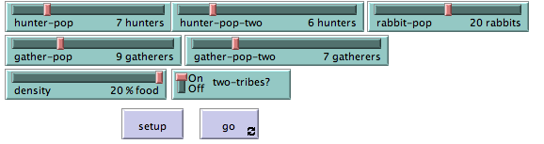

(Widgets available to the NetLogo user for this model)

As seen in Fig. 1, hunters and gatherers are given a humanoid shape, but have different colors to aid in the visualization. Red and white humans are members of Tribe 1, and blue and orange humans are members of Tribe 2. Edible patches are colored yellow. When they are gathered, they thus brightly and obviously displayed:

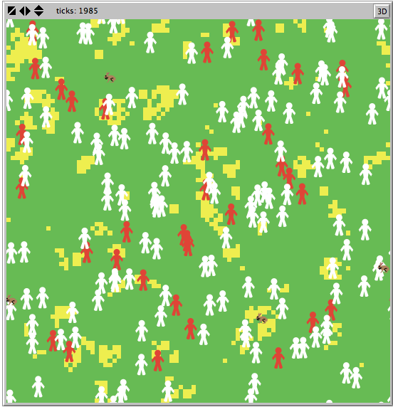

(Fig. 3: Example of sorted piles in NetLogo model mid-run)

Some assumptions:

First, it was assumed that only gatherers would participate in the less strenuous act of collecting plants.

Second, it was assumed that the gatherers would be the only humanoids reproducing, as the females of primitive human species were often responsible for fulfilling that role, while the males ventured out in search of more difficult prey.

The assumption that gatherers did not partake of the fruits of the hunt was also made, due to the constraints of the NetLogo environment. The hunters are assumed to consume the rabbit meat as they go.

**Model Rules**

Initialize:

* Create # of hunters, gatherers, rabbits and scatter.
* Create chosen density of grain to gather and scatter those patches.

At each tick, each gatherer:

* I look for a yellow grain patch.
* When I find a yellow grain patch, I pick it up.
* If I have a grain patch, I take it to another grain pile.
* If I find a grain pile, I put the grain there.
* If I have deposited grain and my energy is less than 70, I can eat a different patch of grain and restore my energy.
* If my energy is greater than 60, I can reproduce; there is a 50% chance either way of the new tribe member being a hunter or a gatherer.
* If there is no grain left on the ground, I continue to search for grain until my energy runs out.
* When my energy drops to 0, I die.

At each tick, each hunter:

* I look for a rabbit.
* When I find a rabbit, I kill it and put it in my ‘pouch’ for later.
* When I have a rabbit in my ‘pouch’ and my energy is less than 70, I eat the rabbit and restore my energy.
* When there are no more rabbits and my energy is less than 70, I eat from the stores of grain and lose some patience.
* When there are no more rabbits and my patience is 0, I attack a member of the other tribe.
* When my energy drops to 0, I die.

At each tick, each rabbit:

* I look for a yellow grain patch.
* When I find a yellow grain patch and my energy is below 40, I eat it and restore my energy.
* If a hunter finds me, I die.
* If my energy drops to 0, I die.
* Each tick there is a chance I reproduce.

**Analysis**

Very detailed, small-step Behavior Space experiments were attempted, but it was immediately clear that with the number of variables in play that the experiments would take over 48 hours to run properly, and give an impossible-to-sort amount of data. The reader is invited to attempt such experiments with this model if they have the time to do so. In order to provide interesting results in a timely manner, a Behavior Space experiment was constructed that varied the hunter population, the gatherer population, the rabbit population and the initial density of edible plant life on the map.

The number of variables in play made any graphical comparison nearly impossible. Too much information had to accompany each point, so charts have been included to describe the phenomena observed.

The multiple runs of the Behavior Space experiment may be examined and sorted according to rabbit population size and initial food density, so that the final hunter and gatherer populations could be fairly compared. Rabbit population was tested at either 20 or 40 rabbits, while food density was tested at 10% or 20%. This made for four unique scenarios in which to test varying initial humanoid populations. The results of the six longest-lived runs are organized below by initial food environment:

|  |  |  |  |  |  |  |
| --- | --- | --- | --- | --- | --- | --- |
| Rabbits: 20 |  |  |  |  |  |  |
| Density: 10 |  | **"Minimum Food"** | | |  |  |
| **Tribe 1** | | **Tribe 2** | | **Total** | **Time** | **Survivor** |
| **Hunters** | **Gatherers** | **Hunters** | **Gatherers** |  |  |  |
| 10 | 10 | 10 | 10 | 40 | 1500 | TIE |
| 10 | 10 | 20 | 10 | 50 | 1500 | Tribe 1 |
| 10 | 10 | 30 | 20 | 70 | 1500 | Tribe 2 |
| 20 | 10 | 10 | 10 | 50 | 1500 | TIE |
| 20 | 10 | 20 | 10 | 60 | 1500 | TIE |
| 20 | 20 | 20 | 10 | 70 | 1500 | Tribe 2 |

(Table 1: Chart of results of testing at ‘minimum initial food’ conditions)

|  |  |  |  |  |  |  |
| --- | --- | --- | --- | --- | --- | --- |
| Rabbits: 20 |  |  |  |  |  |  |
| Density: 20 |  | **Low Rabbits, High Plants** | | |  |  |
| **Tribe 1** | | **Tribe 2** | | **Total** | **Time** | **Survivor** |
| **Hunters** | **Gatherers** | **Hunters** | **Gatherers** |  |  |  |
| 20 | 10 | 10 | 10 | 50 | 2100 | Tribe 2 |
| 10 | 10 | 10 | 10 | 40 | 1900 | TIE |
| 30 | 30 | 20 | 30 | 110 | 1900 | Tribe 1 |
| 10 | 10 | 20 | 10 | 50 | 1800 | TIE |
| 10 | 10 | 30 | 20 | 70 | 1800 | Tribe 2 |
| 20 | 20 | 10 | 10 | 60 | 1800 | Tribe 2 |

(Table 2: Chart of results of testing at low rabbit, high plant density conditions)

|  |  |  |  |  |  |  |
| --- | --- | --- | --- | --- | --- | --- |
| Rabbits: 40 |  |  |  |  |  |  |
| Density: 10 |  | **High Rabbits, Low Plants** | | |  |  |
| **Tribe 1** | | **Tribe 2** | | **Total** | **Time** | **Survivor** |
| **Hunters** | **Gatherers** | **Hunters** | **Gatherers** |  |  |  |
| 20 | 10 | 30 | 10 | 70 | 1600 | TIE |
| 10 | 10 | 10 | 10 | 40 | 1500 | Tribe 1 |
| 10 | 20 | 20 | 10 | 60 | 1500 | Tribe 1 |
| 10 | 30 | 20 | 10 | 70 | 1500 | Tribe 1 |
| 10 | 10 | 10 | 20 | 50 | 1500 | Tribe 2 |
| 10 | 10 | 20 | 20 | 60 | 1500 | Tribe 2 |

(Table 3: Chart of results of testing at high rabbit, low plant density conditions)

|  |  |  |  |  |  |  |
| --- | --- | --- | --- | --- | --- | --- |
| Rabbits: 40 |  |  |  |  |  |  |
| Density: 20 |  | **"Maximum Food"** | | |  |  |
| **Tribe 1** | | **Tribe 2** | | **Total** | **Time** | **Survivor** |
| **Hunters** | **Gatherers** | **Hunters** | **Gatherers** |  |  |  |
| 20 | 20 | 10 | 10 | 60 | 2200 | Tribe 2 |
| 20 | 10 | 10 | 10 | 50 | 1900 | Tribe 2 |
| 20 | 20 | 30 | 20 | 90 | 1800 | Tribe 2 |
| 30 | 10 | 30 | 10 | 80 | 1800 | Tribe 2 |
| 10 | 10 | 10 | 10 | 40 | 1700 | TIE |
| 10 | 10 | 30 | 10 | 60 | 1700 | Tribe 1 |

(Table 4: Chart of results of testing at ‘maximum initial food’ conditions)

Table 1 shows the six longest-running tests from the Behavior Space experiment given the lowest possible initial food conditions. Despite varying initial population parameters, the longest time any member of a tribe survived was 1500 ticks, and that value was repeated multiple times in other runs of the experiment. In this particular scenario, having more hunters than a competing tribe seemed to be of some benefit, possibly because they could eliminate members of the competing tribe once the rabbits died out. However, ties (situations in which the last members of each tribe died simultaneously) were more common than one tribe outliving another, indicating that such little initial food hamstrung both tribes equally.

Table 2 features results from initial conditions of fewer rabbits and a higher plant density. The longest experiment ran 2100 ticks, with Tribe 2 making up the majority of the total population. In this situation, rabbits would die out quickly, leaving it up to the gatherers to provide for the entire tribe. Having an equal or greater number of gatherers than the competing tribe seemed to be helpful in the tests where survival time exceeded 1700 ticks.

Table 3 is a compilation of results from testing with initial conditions of lower plant density and a greater number of rabbits. Since plant matter is the resource with the greatest longevity, it appeared paramount in this situation to have more gatherers in the tribe, so that it could be collected quickly and consumed before energy levels dropped too low. However, the maximum survival time was still 1500 ticks, indicating that this scenario was hardly likely to be sustainable for some time. The competition between the rabbits and the gatherers for edible plants would decimate food stores.

At the end is Table 4, which covers the ‘maximum’ food scenario, with plenty of edible flora and rabbits available. As might be expected, the longest stretch of existence for the two tribes can be found in this scenario, at 2200 ticks. What is surprising is that number is only 100 ticks more than Table 2’s scenario’s maximum. The most successful tests in Table 4 generally relied on having a smaller tribe. This is quite sensible: when food is plentiful, consuming as little of it as possible at a time is the best way to make it last.

**Conclusion**

It is not possible to say with any authority whether the humanoid groups that survived the longest periods had similar dynamics to this model with similar resource configurations, but these results shine an interesting light on a previously murky part of human survival behavior. Further testing with the Behavior Space tool may give more conclusive results as opposed to the most likely outcomes suggested above. Such testing would have been done, but it requires a dedicated computer and at least two days to run, and both time and computer needs did not permit this.