**Day 1 + 2 : Thursday and Friday**

We had to find an idea for the last project we have to do. We first thought about quantifying the reaction of *E. coli* to bleach but Tamara told us that they don’t have special sensors for bleach. However they have a reaction to it (they create a biofilm to resist), it is not suitable for this project theme. Then, we thought about working on another organism (an algae) that react to blue light by changing the pH around it. However, this algae grow very slowly and the pH change is very small (around 0.01) and we don’t have a pH-meter precise enough to measure it. We finally came up with another idea : we are going to work on *Dictyostelium discoideum* and its reaction to folic acid. Indeed, the amoebas of this fungus has chemotaxis to folic acid. When in starvation, they aggregate around it and form a little stem of cells with a spore at its edge. We will change the concentration of folic acid they are exposed to and quantify their reaction by measuring their movement with ImageJ.

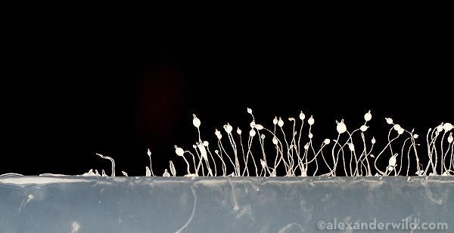

Alexanderwild.com

**Day 3 : Monday**

Today, we focused on our protocol in order to improve it. In fact, we decided to observe the speed of the *Dictyostelium* according to the concentration of folic acids. Thus, we prepared 5 different pastille concentrations of acids in the center of the plate. We put four drops (1µL) situated around the pastille. We did five replicates. Each hours, we measured the distance from the starting point of *Dictyostelium* with a confocal microscope and imageJ (we know the measure of one pixel of the camera and the magnification of the microscope).

We decided to prepare our concentration of folic acids. In literature, we read that *Dictyostelium* react to folic acids at one drop at 1 mol/L 10 fold. Thus, we chose 1 mol/L as positive control. Then, we chose 0.5 mol/L, 1.5 mol/L and 2 mol/L. 0 mol/L is our negative control. We also tested the pH variation. In fact, in literature, they had caustic soda in the folic acids to balance the pH around 7. We found that without caustic soda, the pH is equal to 6.5 while it is equal to 7. Thus our test shown that with our tested-concentrations the pH variation seems to be low and negligible.

*Table 1 : Dissolution of folic acids pastille*

|  |  |  |
| --- | --- | --- |
| Concentrations (mol/L) | Number of pastille (5mg) | Volume of water (mL) |
| 0 | 0 | 20 |
| 0.5 | 1 | 22.7 |
| 1 | 2 | 22.6 |
| 1.5 | 2 | 15.2 |
| 2 | 4 | 22.8 |

**Day 4 - Tuesday:**

Today, we first prepared our 25 agar plates. We chose to put 3 mL in four falcon. Each falcon will be use for the four drops we put on the plate. In this way, we maximize our chance to obtain *Dictyostelium* on the plate. They are replicate of our experiment. We also put some *Dictyostelium discoideum* in liquid LB with *E. coli* to make them grow. We put them in shaking incubation at 22 °C and 180 RPM. We created the python script for our data analysis. We plan to module it when we will have our data.

**Day 5 - Wednesday:**

This morning we put tablets inside the plates. Before putting drops of *Dictyostelium discoideum,* we tried to see them at the microscope. We realised that there were only *E. coli* and not any amibe in the solution prepared the day before in the falcon. This is why we elaborated another experiment :

How *Sordaria fimicola* is influenced in its development by a gradient of pH created by tablets dived in acetic acid at 100% ?

For the protocol we keep the same idea than previously but :

* New organism : *Sordaria fimicola + Lactobacillus acidophilus.* We tested both organism because we weren’t be sure that our organism can grow in one night. Moreover, we weren’t
* Others concentrations :
  + 0% acetic acid ( negative control)
  + 25% acetic acid
  + 75% acetic acid
  + 100% acetic acid (positive control)

**Day 6 : Thursday**

Today, we changed our project (again). Indeed, our organisms had not grow.

It

was found that tomato juice was a proper medium

for lactic acid fermentation, and the probiotic

tomato juice obtained could serve as a health

beverage for vegetarians or consumers who are

allergic to dairy products



Sensor : amino acid-dependent decarboxylase - antiporter systems

Proton consuming decarboxylation reaction

Antiporter : localisation in the membrane and become active when the extracellular pH drops below threshold levels - secondary active transport => one species of solute moves along its electrochemical gradient (move against and in the direction the gradient)

Ici : amino-acid antiporter

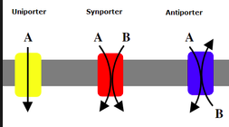

active proteins for survival under acid stress.

