|  |
| --- |
| Reaction of *Lactobacillus acidophilus* to acid environment : lactic acid production |

**Abstract**

*Lactobacillus acidophilus* is fitted to live in human stomach and guts. Indeed, as many other bacteria, it lives in the human body and both organisms find an advantage to it. On one hand, *L. acidophilus* transforms the lactose in lactic acid which is used to form lactate. On the other hand, human is incapable of doing that and need this bacteria to digest lactose. Since the human stomach is very acid (pH is around 2), *L. acidophilus* needs to be able to survive in these conditions. Here we try to show that the production of lactic acid by *L. acidophilus* allows it to regulate its internal pH according to the one of its environment. Thus, it can survive and still accomplish its normal functions. In our study, we prepared three samples of *L. acidophilus* with three different pH in order to quantify the amount of lactic acid produced which increase the acidity of the environment. Our results show no pH variation according to the pH of the solution. Thus, we didn’t observe a production of lactic acid sufficient to change the pH. 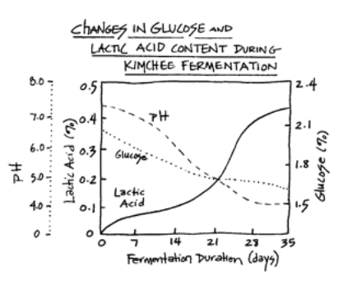

***Lactobacillus acidophilus***

In our stomach, some bacteria survive while the pH is extremely acid (around 2). This pH can causes denaturation of proteins or reduction enzymes activities. For instance, glycolysis is strongly reduced when the pH decreases for *E. coli[1].* However, it is well known now that *Lactobacillus acidophilus* is a strain that could survive well in our stomach[2]. This capacity is enhanced by milk. In fact, Lactobacillus bacteria are gram-positive and acido-tolerant. Moreover, they change sugar into acid lactic during

*Figure 1 : lactic acid production and its impact on the pH -*

*graph from bottlebiology.org*

fermentation. This pathway allows them to regenerate their stock of ATP and NAD. In figure 1, one effect of this pathway is illustrated : while lactic acid production increases, pH decreases drastically. Thus, to survive, Lactobacillus bacteria develops acido-resistance. Recent research study this phenomena. For instance, a team shows that 72 hours of fermentation is enough to decrease the pH of about 0.5[3].

**Acid stress response and acid sensor**

Two different responses are possible : ATR and XAR. ATR is a response to severe acidic stress as pH 3. XAR is a mechanism used by the microorganism to cope with acid stress when there are not adapted in low pH condition. Moreover, the first adapts intracellular pH homeostasis while the second prevents the cells to fall in life-threatening levels1. A lot of different strategies are used by bacteria to cope with acid stress using one of this mechanism. *L. acidophilus* use a ATR system to cope with acid challenge. This bacteria uses an amino-acid antiporter which is activated under a low external pH. The antiporter lets amino-acid substrates pass into the cells. These amino-acid, which are not well studied for *L. acidophilus,* activate an amino acid-dependent decarboxylase system. This system changes a specific amino acids into a substrate of a decarboxylation reaction (see figure 2) which dependent of the amino acid. The product of this system is released in the environment by the amino-acid antiporter 1[4]. With this pathway, they consume proton from the external environment (see figure 3).

*Figure 2 : basic of a decarboxylase reaction. Picture from wikipedia.org*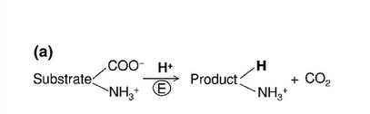

*Figure 3 : pattern of the proton-consuming amino acid-dependent decarboxylase system. Picture from 1*

**Our project**

All our bibliographic work inspired us to study *Lactobacillus acidophilus* as a bacteria acido-resistant. As we said before, *L. acidophilus* produces lactic acid which decreases the external pH. A low pH increases this ability. Thus, we wanted to quantify the pH variation because of lactic acid production of *L. acidophilus* related to the external pH. In this report, we explained first our method and results. Then, we listed potential bias and errors and our self-reflexion about the project.

We had three solutions with three different initial pH. For each solution, we took 7 x 100 µL and 2 x 100 µL of the corresponding control and measured the absorbance over a night with the Tecan spectro. Every hour, we had one value for the absorbance in each wells allowing us to calculate the growth rate. These results could explain the variation of the pH within solutions since the number of bacteria influences directly the amount of acid in the medium released . The Tecan instrument generated a list of absorbance values. Each optical density was the sum of the absorbance of the medium and the absorbance due to the presence of bacteria so we had to subtract the optical density measured for the control.

We represented the growth rates thanks to Python :

Growth rate

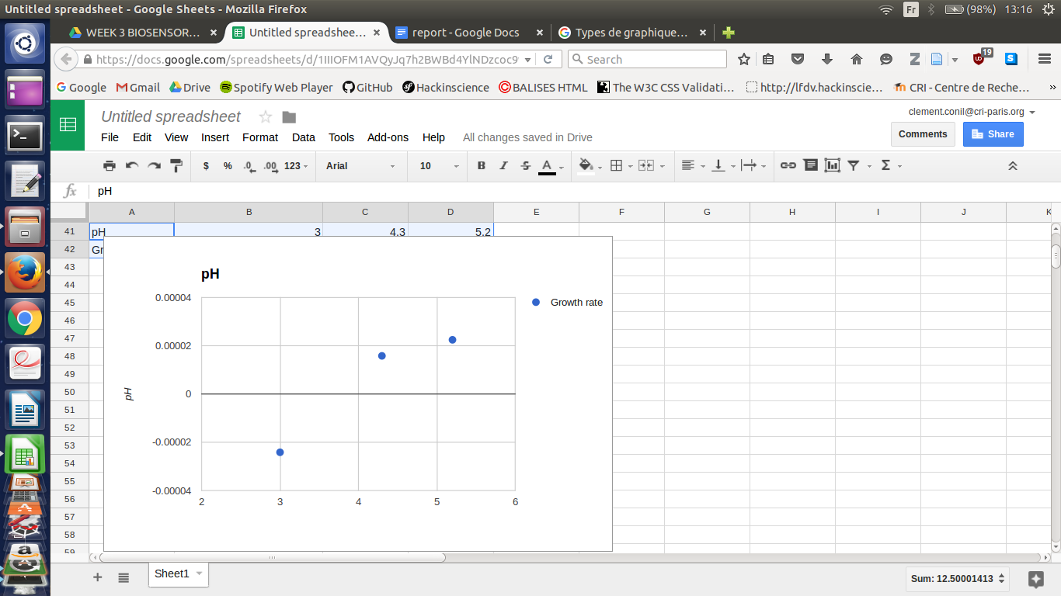pH

Growth rates show an increase of the population for each pH concentration. Solution at pH = 5.2 has the highest growth rate but since we do not know the initial *Lactobacillus acidophilus* concentration and that the same concentration was put in each well, we cannot expect a higher change in the pH solution. However, if we suppose that we introduced the same concentration of *Lactobacillus acidophilus,* we would expect the pH in solutions at pH = 5.2 to have more decreased.

The pH values were obtained at the beginning and at the end of the experiment. We used a pH-prob and dived it into beakers. We made three technical replicates at the end of the experiment when we had to measure the pH after the incubation time. At the beginning we let the pH meter in the solution while adjusting the pH by adding HCl at a high concentration (pH(*HCl*) = 0.6). Here are the results represented with bar plots ; we plotted the control and the solution for each initial pH : 5.2, 4.3 and 3.0. We only plotted the values given at the end of the experiment (12 hours of incubation).

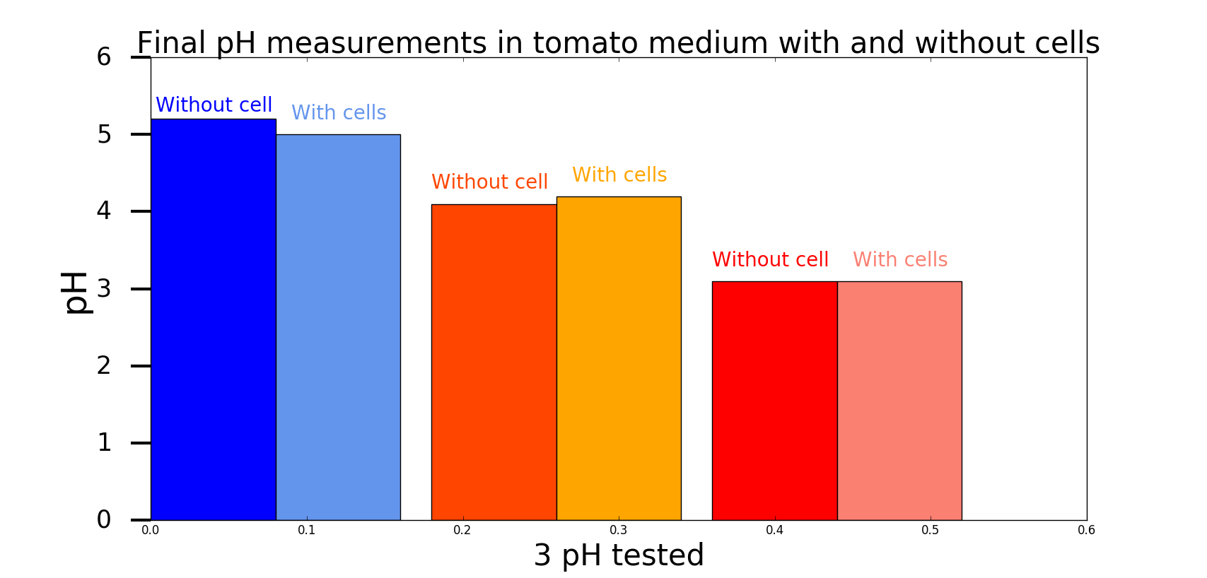

|  |  |  |
| --- | --- | --- |
| **pH(t =0)** | **pH*without cell* (t =12h)** | **pH*with cells* (t =12h)** |
| 5.2 | 5.2 | 5.0 |
| 4.3 | 4.1 | 4.3 |
| 3.0 | 3.1 | 3.1 |

According to pH measurements, there had been a pH variation in the first solution at **pH = 5.2** and that has ended at **pH = 5.0** which means that the final solution was **1.58** times more concentrated in acid than the original one. Controls, solutions without cell in it, stayed at **pH = 5.2** which could underline the role of the bacteria in the pH change. The two other solutions have uncleared results since both controls show unexpected value. Indeed, the second one at **pH (t=0) = 4.3** has a control that has more pH decreased than the non-control (**4.1** and **4.3**). The third solution at **pH(t=0) = 3.0** has changed, in term of acid concentration, the same way than its controls. This result prevent to make a link between the presence of bacteria and the pH change.

The variation of pH in the controls underlines the lack of precision of the tool we used.

To conclude, the results do not prove the role of *Lactobacillus* *acidophilus* in the variation of the pH after 12 hours of incubation. The pH measurements lacks of precision and prevent us from making any conclusion.

1. Peter Lund, Angela Tramonti, Daniela De Biase. *Coping with low pH: molecular strategies in neutralophilic bacteria.* FEMS Microbiology Reviews, Volume 38, Issue 6, November 2014, Pages 1091–1125
2. P.L. Conway, S.L. Gorbach, B.R. Goldin. *Survival of Lactic Acid Bacteria in the Human Stomach and Adhesion to Intestinal Cells*. *Journal of Dairy sciences*,January 1987, Volume 70, Issue 1, Pages 1–12
3. Sukhvir Kaur*, Harjot Pal Kaur and Jyotsana Grover. *Fermentation of Tomato juice by Probiotic Lactic acid bacteria.* IJAPBC Vol. 5(2),Apr-Jun 2016
4. M. Andrea Azcarate-Peril,1 Eric Altermann,1 Rebecca L. Hoover-Fitzula,1 Raul J. Cano,2 and Todd R. Klaenhammer

   *Identification and Inactivation of Genetic Loci Involved with Lactobacillus acidophilus Acid Tolerance,* 