Biosensors - Final week Clément Caporal, Sarah Talon Sampieri, Julien Pichon

Olympic trek of *Volvox aureus* in function of salt concentration

For the last week of Biosensors, we were free to choose our own topic of research. We decided to work on *Volvox aureus*: *Volvox* is a little algae living in freshwater like pounds. This algae have a very specific shape: each colony moves roundly on itself and across the water. Each *Volvox* is attached to another at the boundary of the bubble by a gelatinous substance called mucilage. In order to move, they use ingenious mechanisms called flagella. The flagella vibrating in water allow them to swim. Look at [this video](https://www.youtube.com/watch?v=v6D9OUoD7E4) if you want to see how do *Volvox* flagella look like! The “issue” is that this movement costs energy, exactly like a swimmer in an olympic competition. In our project we decided to record the performance of these green athletes. Finally, as they are very good challengers, we thought of complicating their environment by adding salt in the water in which they will swim!

A difficult trek

This test is a common test in nature: when you put salt in water where there are living organisms, you make their life harder. Here, there is what we call an osmotic pressure. Behind this awkward word, there is a simple explanation: the same phenomenon happens when you stay too long in your bath and your fingers begin to be frightened. Our skin is “large” enough to let the water going in and out. And when you add salt in the medium, your own water is going out to join the salt! So when you put salt in water where there are *Volvox*, they will shrink like your fingers… If you want to know more about osmosis, click [here](https://www.youtube.com/watch?v=SSS3EtKAzYc). Now, our questions is : will they travel more with a lot of salt in water or will they prefer few salt? It’s time organize the race.

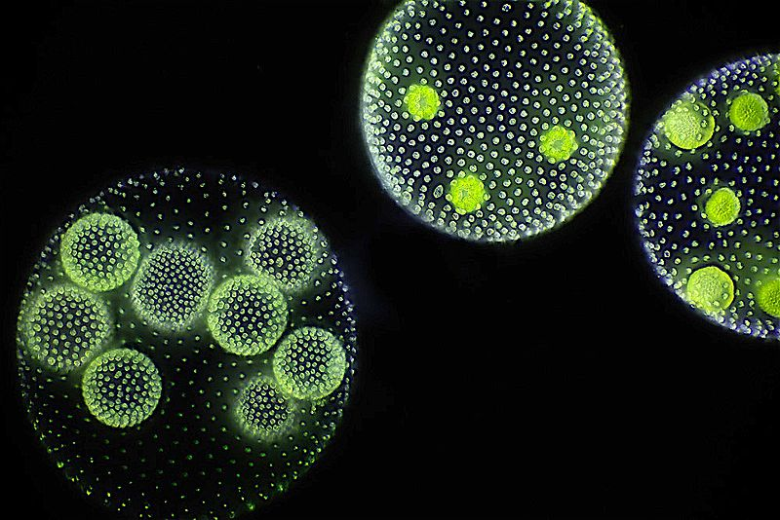

Figure 1: In this figure you can observe colonies of *Volvox*: The bigger colonies which contains the daughter colonies inside.

Preparation of the *Volvox aureus* olympic race

First of all we have to prepare the swimming pool. Each solution in the swimming pool should have a specific amount of salt mixed to water. We didn’t take a random type of water, but we took still water, where there is no chlorine (a chemical ingredient there is in tap water which would kill the *Volvox*). In order to see a real variation of the distance the *Volvox* will travel in function of the concentration of salt we made 5 different solutions. If you want to know how to make these solutions to prepare your own race, you can take a glance at this [video protocol](https://www.youtube.com/watch?v=OKXiIRd8ePY)!

Ready to record the amazing performance of our *Volvox*?

Recording the amazing performance of *Volvox aureus* in salty water

We randomly built 5 teams from 8 to 10 *Volvox*. The competition took place during two days and each race has been filmed. The examinations were very strict regarding the concentration of salt in each of the swimming pools. We used binocular loupes and recorded videos with a camera connected to a computer. A constant blue led was put at the bottom of the slide to excite *Volvox* movement, and a red filter was put between the white light of the microscope and the slides to weaken the effect of this light source on *Volvox* and not to annoy them during their race.

Final result of the olympics of *Volvox* in function of the salt concentration in the swimming pool

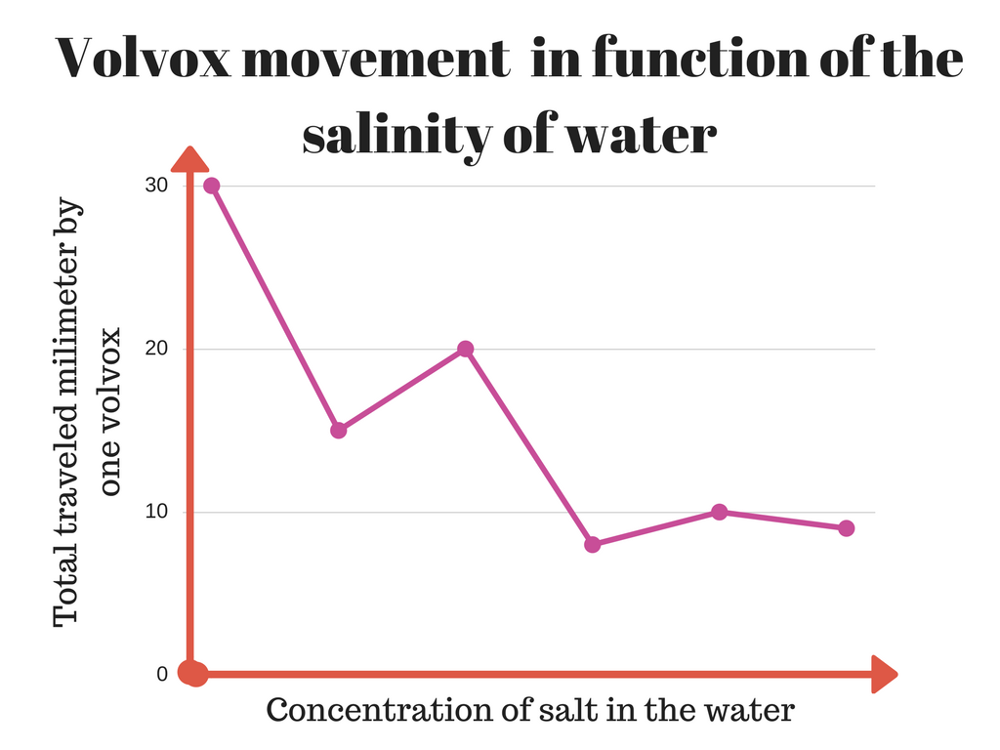

Figure 2: as you can see in this graph, the mobility of *Volvox* decreases according to the concentration of salt in water.

According to our results, it seems that *Volvox* don’t really like salt, more precisely NaCl (There is different kind of salt, NaCl is the salt we use when we cook). We found an article[1] that obtained similar results of us for NaCl.

But why does *Volvox* prefer water with less salt? After the olympic test, we had some hypothesis :

* Due to osmosis, the more salt there is in the media, the more water will try to leave the *Volvox* . To stay alive, *Volvox* have some mechanisms that retain water inside the colony against this normal current of water. But these mechanisms require energy: so there is less energy for the movement of flagella and the mobility of Volvox decreases.
* According to a study[2], *Chlamydomonas*, an organism really closed to *Volvox*, loses its flagella when there is too much salt in the media. If there is no more flagella, *Chlamydomonas* cannot move. So if *Chlamydomonas* and *Volvox* are similar enough, this mechanism can be an explication for the loss of mobility of Volvox.

We can conclude that salt has a meaningful impact on *Volvox* as athletes. We need new experiments to answer to the hypothesis previously stated in this blogpost. For these new experiments, we will have to focus more on the shape and the movement of the flagella!

If you want to know more...

* If you want to know more on our bibliography and all the actual researches on *Volvox*, or just want to know how did we manage to conduct our experiment in details, please take a glance at our [report](https://docs.google.com/document/d/1Wlrd_lZCuyDnlkNQNWjpIhQtIj1HVPenCqejTtATbbE/edit?usp=sharing).
* Here you are the [poster](https://docs.google.com/presentation/d/10fwnLSP1j3f_L72fob8G44Usv_Pc27UB4McuLlLlReI/edit?usp=sharing) of our project and the [presentation](https://docs.google.com/presentation/d/1QehINi7ud5cA9GvDSUYIEvKjDZgcS280MiY7KPJrXr8/edit?usp=sharing).
* To know more on our protocol and remake the experiment by yourself, we also have a [video](https://youtu.be/OKXiIRd8ePY) of our protocol!
* All the documentation needed for the project, with codes and protocol, is available on [Github](https://github.com/learningthruresearch/Biosensors2017/tree/master/Volvuino).
* Follow us on our [Twitter](https://twitter.com/Biosensors_JSC) account and our [storify](https://storify.com/Ccaribou/volvuino-volvox-in-a-salty) to see what we made step by step during our project
* And here for you a nice [video](https://www.youtube.com/watch?v=v6D9OUoD7E4) of dancing *Volvox aureus*, enjoy!

1. 1 « Effect of external ionic environment on phototaxis of Volvox carteri».9/02/2017. Hironobu Sakaguchi - 1979
2. 2 « Volvox, Chlamydomonas, Evolution of Multicellularity | Learn Science at Scitable ».9/02/2017. http://www.nature.com/scitable/topicpage/volvox-chlamydomonas-and-the-evolution-of-multicellularity-14433403.